Lesson 34: Review of the Assumptions

Classwork

|  |  |  |
| --- | --- | --- |
| **Assumption/Fact/Property** | **Guiding Questions/Applications** | **Notes/Solutions** |
| Given two triangles and   so that (Side), (Angle), (Side), then the triangles are congruent.  [SAS] | The figure below is a parallelogram . What parts of the parallelogram satisfy the SAS triangle congruence criteria for and  ? Describe a rigid motion(s) that will map one onto the other. (Consider drawing an auxiliary line.) |  |
| Given two triangles and , if (Angle), (Side), and (Angle), then the triangles are congruent.  [ASA] | In the figure below, is the image of the reflection of across line . Which parts of the triangle can be used to satisfy the ASA congruence criteria? |  |
| Given two triangles and  , if (Side), (Side), and (Side), then the triangles are congruent.  [SSS] | and are formed from the intersections and center points of circles and . Prove by SSS. |  |
| Given two triangles, and , if (Side), (Angle), and (Angle), then the triangles are congruent.  [AAS] | The AAS congruence criterion is essentially the same as the ASA criterion for proving triangles congruent. Why is this true? |  |
| Given two right triangles and with right angles and , if (Leg) and (Hypotenuse), then the triangles are congruent.  [HL] | In the figure below, is the perpendicular bisector of and is isosceles. Name the two congruent triangles appropriately, and describe the necessary steps for proving them congruent using HL. |  |
| The opposite sides of a parallelogram are congruent. | In the figure below, and . Prove is a parallelogram. |  |
| The opposite angles of a parallelogram are congruent. |
| The diagonals of a parallelogram bisect each other. |
| The midsegment of a triangle is a line segment that connects the midpoints of two sides of a triangle; the midsegment is parallel to the third side of the triangle and is half the length of the third side. | is the midsegment of . Find the perimeter of , given the labeled segment lengths. |  |
| The three medians of a triangle are concurrent at the centroid; the centroid divides each median into two parts, from vertex to centroid and centroid to midpoint in a ratio of . | If , , and are medians of , find the lengths of segments , , and , given the labeled lengths. |  |

Problem Set

Use any of the assumptions, facts, and/or properties presented in the tables above to find and/or in each figure below. Justify your solutions.

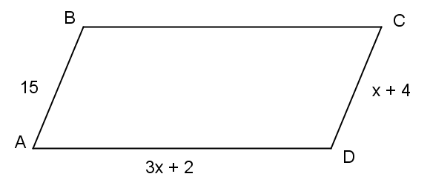

1. Find the perimeter of parallelogram . Justify your solution.

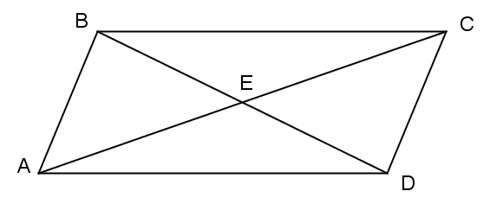

Given parallelogram , find the perimeter of . Justify your solution.

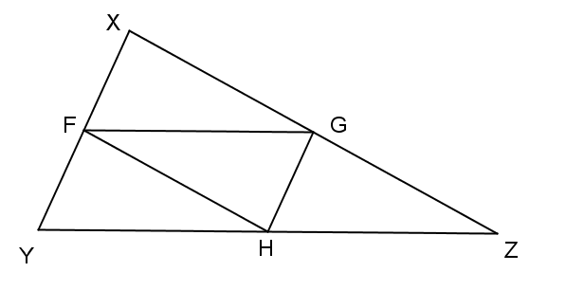

, , and are midpoints of the sides on which they are located. Find the perimeter of . Justify your solution.

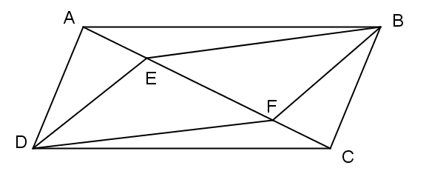

1. is a parallelogram with .   
   Prove that is a parallelogram.
2. 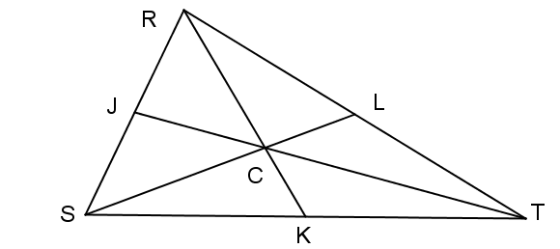 is the centroid of .  
   , ,