|  |
| --- |
|  |

Lesson 34: Review of the Assumptions

**Student Outcomes**

* Students review the principles addressed in Module 1.

Lesson Notes

In Lesson 33, we reviewed many of the assumptions, facts, and properties used in this module to derive other facts and properties in geometry. We continue this review process with the table of facts and properties below, beginning with those related to rigid motions.

Classwork

Review Exercises (40 minutes)

|  |  |  |
| --- | --- | --- |
| Assumption/Fact/Property | Guiding Questions/Applications | Notes/Solutions |
| Given two triangles and   so that (Side), (Angle), (Side), then the triangles are congruent.  [SAS] | The figure below is a parallelogram . What parts of the parallelogram satisfy the SAS triangle congruence criteria for and ? Describe a rigid motion(s) that will map one onto the other. (Consider drawing an auxiliary line.) | , property of a parallelogram  , alternate interior angles  , reflexive property  , SAS  rotation about the midpoint of |
| Given two triangles and , if (Angle), (Side), and (Angle), then the triangles are congruent.  [ASA] | In the figure below, is the image of the reflection of across line . Which parts of the triangle can be used to satisfy the ASA congruence criteria? | ,vertical angles are equal in measure.  , reflections map segments onto segments of equal length.  , reflections map angles onto angles of equal measure. |
| Given two triangles and  , if (Side), (Side), and (Side), then the triangles are congruent.  [SSS] | and are formed from the intersections and center points of circles and . Prove by SSS. | is a common side.  , they are both radii of the same circle.  , they are both radii of the same circle.  Thus, by SSS. |
| Given two triangles, and , if (Side), (Angle), and (Angle), then the triangles are congruent.  [AAS] | The AAS congruence criterion is essentially the same as the ASA criterion for proving triangles congruent. Why is this true? | If two angles of a triangle are congruent to two angles of a second triangle, then the third pair must also be congruent. Therefore, if one pair of corresponding sides is congruent, we treat the given corresponding sides as the included side and the triangles are congruent by ASA. |
| Given two right triangles and with right angles and , if (Leg) and (Hypotenuse), then the triangles are congruent.  [HL] | In the figure below, is the perpendicular bisector of and is isosceles. Name the two congruent triangles appropriately, and describe the necessary steps for proving them congruent using HL. | Given , both and are right triangles. is a common side. Given is isosceles, . |
| The opposite sides of a parallelogram are congruent. | In the figure below, and . Prove is a parallelogram. | , vertical angles are equal in measure.  , and , given.  , ASA.  By similar reasoning, we can show that .  Since and , is a parallelogram because the opposite sides are congruent (property of parallelogram). |
| The opposite angles of a parallelogram are congruent. |
| The diagonals of a parallelogram bisect each other. |
| The midsegment of a triangle is a line segment that connects the midpoints of two sides of a triangle; the midsegment is parallel to the third side of the triangle and is half the length of the third side. | is the midsegment of . Find the perimeter of , given the labeled segment lengths. |  |
| The three medians of a triangle are concurrent at the centroid; the centroid divides each median into two parts, from vertex to centroid and centroid to midpoint in a ratio of . | If , , and are medians of , find the lengths of segments , , and , given the labeled lengths. |  |

Exit Ticket (5 minutes)

Name ___________________________________________________ Date____________________

Lesson 34: Review of the Assumptions

Exit Ticket

The inner parallelogram in the figure is formed from the midsegments of the four triangles created by the outer parallelogram’s diagonals. The lengths of the smaller and larger midsegments are as indicated. If the perimeter of the outer parallelogram is , find the value of *.*

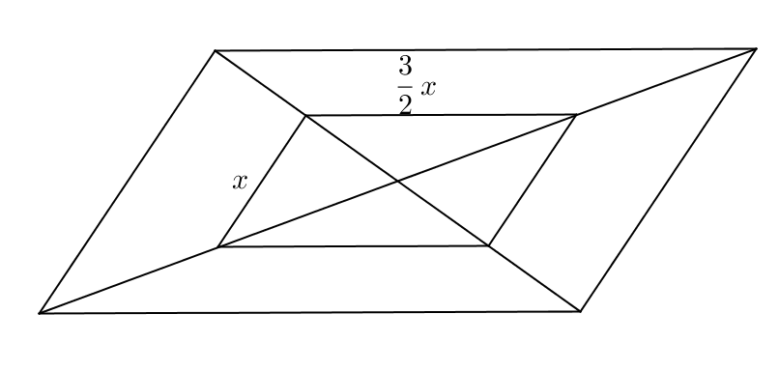Exit Ticket Sample Solutions

The inner parallelogram in the figure is formed from the mid-segments of the four triangles created by the outer parallelogram’s diagonals. The lengths of the smaller and larger mid-segments are as indicated. If the perimeter of the outer parallelogram is , find the value of *.*

Problem Set Sample Solutions

Use any of the assumptions, facts, and/or properties presented in the tables above to find and/or in each figure below. Justify your solutions.

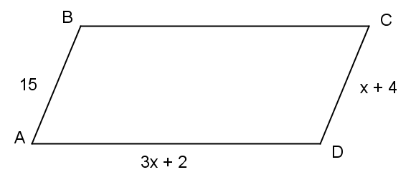

1. Find the perimeter of parallelogram . Justify your solution.

,,

1. 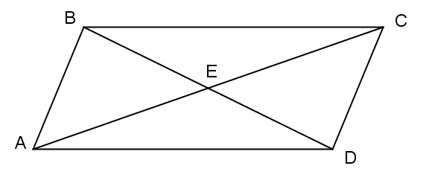

Given parallelogram , find the perimeter of . Justify your solution.

;

;

;

Perimeter

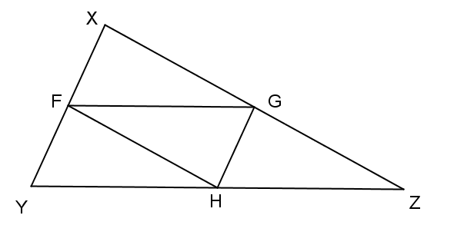

, , and are midpoints of the sides on which they are located. Find the perimeter of . Justify your solution.

. The midsegment is half the length of the side of the triangle it is parallel to.

1. 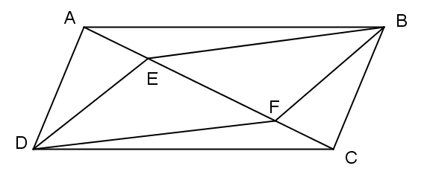 is a parallelogram with .   
   Prove that is a parallelogram.

Given

Property of a parallelogram

*If parallel lines are cut by a transversal, then alternate interior angles are equal in measure*

*SAS*

*Corresponding sides of congruent triangles are congruent*

*Property of a parallelogram*

*If parallel lines are cut by a transversal, then alternate interior angles are equal in measure*

SAS

Corresponding sides of congruent triangles are congruent

is a parallelogram If both sets of opp. sides of a quad. are equal in length, then the quad. is a parallelogram.

1. 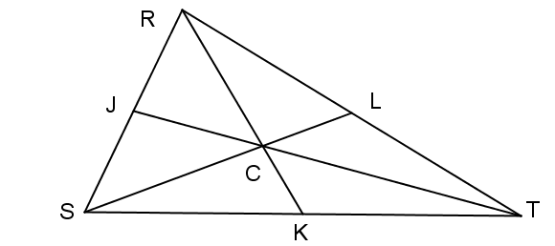 is the centroid of .  
   , ,