Lesson 32: Construct a Nine-Point Circle

Student Outcomes
- Students complete the construction of a nine-point circle.

Lesson Notes
In Lesson 32, students will continue the construction of a nine-point circle. Students will articulate the steps needed to do the construction for each.
Note that the Problem Set exercise is challenging and time-consuming. While a good opportunity to build students’ ability to persevere, it may be modified to lessen the burden of so many constructions.

Classwork
Opening Exercise (5 minutes)
Opening Exercise
During this unit we have learned many constructions. Now that you have mastered these constructions, write a list of advice for someone who is about to learn the constructions you have learned for the first time. What did and did not help you? What tips did you wish you had at the beginning that would have made it easier along the way?

Exploratory Challenge 1 (15 minutes)
Exploratory Challenge 1
Yesterday, we began the nine-point circle construction. What did we learn about the triangle that we start our construction with? Where did we stop in the construction?
We will continue our construction today.

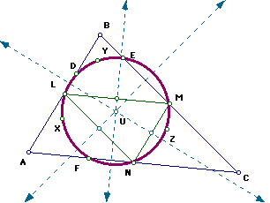
There are two constructions for finding the center of the nine-point circle. With a partner, work through both constructions.
Construction 1
- To find the center of the circle, draw inscribed $△LMN$.
- Find the circumcenter of $△LMN$, and label it as $U$.

Recall that the circumcenter of a triangle is the center of the circle that circumscribes the triangle, which in this case, is the nine-point circle.

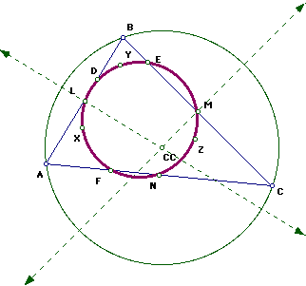
Construction 2
- Construct the circle that circumscribes $△ABC$.
- Find the circumcenter of $△ABC$, which is the center of the circle that circumscribes $△ABC$. Label its center $CC$.
- Draw the segment that joins point $H$ (the orthocenter from the construction of the nine-point circle in Lesson 31) to the point $CC$.
- Find the midpoint of the segment you drew in Step 3, and label that point $U$.

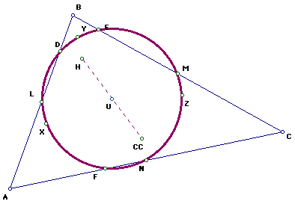
Describe the relationship between the midpoint you found in Step 4 of the second construction and the point $U$ in the first construction.
The Center $U$ is the midpoint of the segment from the orthocenter $H$ to $CC$.

Exploratory Challenge 2 (15 minutes)
Exploratory Challenge 2
Construct a square $ABCD$. Pick a point $E$ between $B$ and $C$, and draw a segment from point $A$ to a point $E$. The segment forms a right triangle and a trapezoid out of the square. Construct a nine-point circle using the right triangle.

Exit Ticket (10 minutes)
Name ___________________________________________________ Date____________________
Lesson 32: Construct a Nine-Point Circle

Exit Ticket

Construct a nine-point circle, and then inscribe a square in the circle (so that the vertices of the square are on the circle).

Exit Ticket Sample Solutions

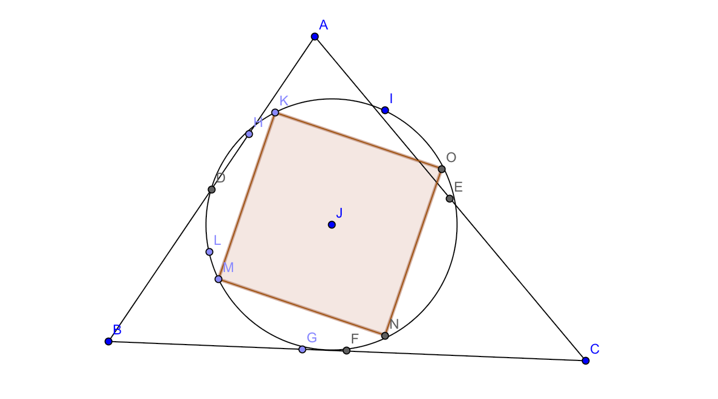
Construct a nine-point circle, and then inscribe a square in the circle (so that the vertices of the square are on the circle).

Problem Set Sample Solutions

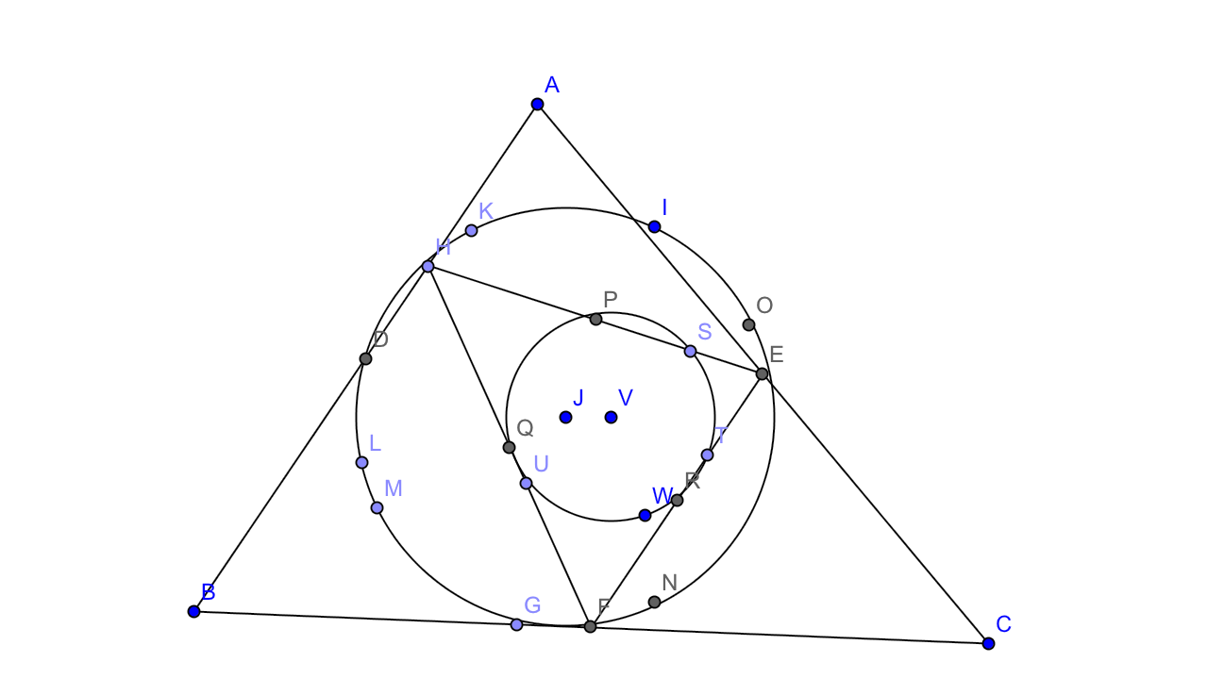
Take a blank sheet of $8\frac{1}{2}$ inch by $11$ inch white paper, and draw a triangle with vertices on the edge of the paper. Construct a nine-point circle within this triangle. Then draw a triangle with vertices on that nine-point circle, and construct a nine-point circle within that. Continue constructing nine-point circles until you no longer have room inside your constructions.

