|  |
| --- |
|  |

Lesson 31: Construct a Square and a Nine-Point Circle

**Student Outcomes**

* Students learn to construct a square and begin to construct a nine-point circle.

Lesson Notes

In Lesson 31, students will use constructions they already know to construct a square and begin the construction of a nine-point circle. Students will articulate the steps needed to do the construction for each. Lessons 31 and 32 are lessons for classes that have been completely successful with all other material. They are also a great opportunity to incorporate technology.

Classwork

Opening Exercise (15 minutes)

Allow students 10 minutes for their attempt, and then share-out steps, or have a student share-out steps. Write their steps on the board so that others actually attempt the instructions as a check.

Opening Exercise

With a partner, use your construction tools and what you learned in Lessons 1–5 to attempt the construction of a square. Once you are satisfied with your construction, write the instructions to perform the construction.

Steps to construct a square:

1. Extend line segment on either side of and .
2. Construct the perpendicular to through ; construct the perpendicular to through .
3. Construct circle : center , radius ; construct circle : center , radius .
4. Select one of the points where circle meets the perpendicular through and call that point . In the same half plane as , select the point where meets the perpendicular through and call that point .
5. Draw segment .

Exploratory Challenge (15 minutes)

Exploratory Challenge

Now, we are going to construct a nine-point circle. What is meant by the phrase “nine-point circle”?

A circle that contains a set of nine points.

Steps to construct a nine-point circle:

1. 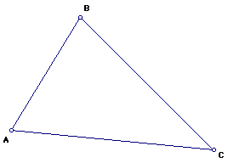Draw a triangle .

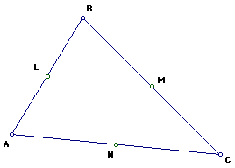

1. Construct the midpoints of the sides ,, and , and label them as , , and , respectively.
2. Construct the perpendicular from each vertex to the opposite side of the triangle (each is called an *altitude*).
3. Label the intersection of the altitude from to as , the intersection of the altitude from to as , and of the altitude from to as .
4. 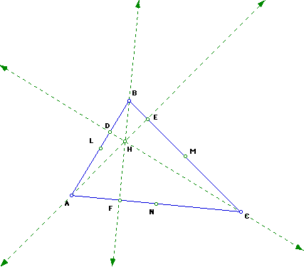The altitudes are concurrent at a point; label it .
5. 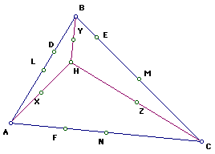Construct the midpoints of , , and label them , , and , respectively.
6. 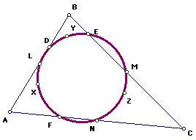The nine points, , , , , , , , , , are the points that define the nine-point circle.

Example (8 minutes)

Example

On a blank white sheet of paper, construct a nine-point circle using a different triangle than you used during the notes. Does the type of triangle you start with affect the construction of the nine-point circle?

It does not matter what size or type of triangle you start with; you can always construct the nine-point circle.

Exit Ticket (7 minutes)

Name ___________________________________________________ Date____________________

Lesson 31: Construct a Square and a Nine-Point Circle

Exit Ticket

Construct a square and a square so that contains and contains .

Exit Ticket Sample Solutions

Construct a square and a square so that contains and contains .

Sample construction might look like the following:

Problem Set Sample Solutions

Construct square and square so that

* 1. Each side of is half the length of each .
  2. contains .
  3. The midpoint of is also the midpoint of .

Sample construction might look like the following: