Lesson 30: Special Lines in Triangles

Classwork
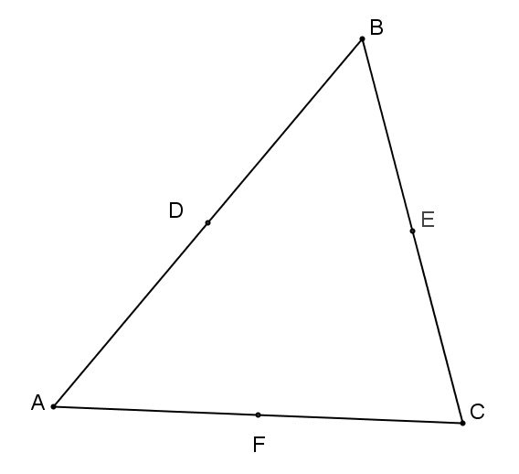
Opening Exercise
In$△ABC$ at the right, $D$ is the midpoint of $\overline{AB}; E$ is the midpoint of $\overline{BC}$, and $F$ is the midpoint of $\overline{AC}$. Complete each statement below.

$\overline{DE}$ is parallel to and measures the length of .

$\overline{DF}$ is parallel to and measures the length of .

$\overline{EF}$is parallel to and measures the length of .

Discussion
In the previous two lessons, we proved that (a) the midsegment of a triangle is parallel to the third side and half the length of the third side and (b) diagonals of a parallelogram bisect each other. We use both of these facts to prove the following assertion:

All medians of a triangle are . That is, the three medians of a triangle (the segments connecting each vertex to the midpoint of the opposite side) meet at a single point. This point of concurrency is called the
, or the center of gravity, of the triangle. The proof will also show a length relationship for each median: The length from the vertex to the centroid is the length from the centroid to the midpoint of the side.

Example 1
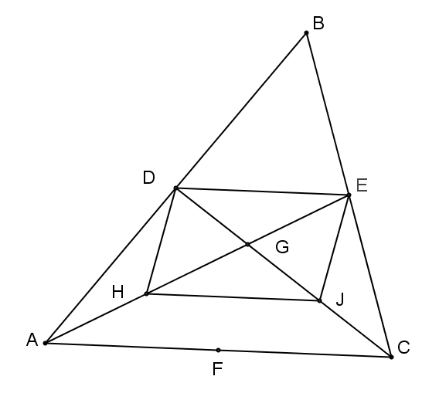
Provide a valid reason for each step in the proof below.
Given: | $△ABC$ with $D$, $E$, and $F$ the midpoints of sides $AB$, $BC$, and $AC$, respectively.
Prove: | The three medians of $△ABC$ meet at a single point.
- Draw $AE$ and $DC$; label their intersection as point $G$.

- Construct and label the midpoint of $AG$ as point $H$ and the midpoint of $GC$
as point $J$.

- $DE∥AC$ ,

- $HJ∥AC$,

- $DE∥HJ$,

- $DE=\frac{1}{2}AC$ and $HJ=\frac{1}{2}AC$,

- $DEJH$ is a parallelogram,

- $HG=EG$ and $JG=DG$,

- $AH=HG$ and $CJ=JG$,

- $AH=HG=GE$ and $CJ=JG=GD$,

- $AG=2GE$ and $CG=2GD$,

- We can complete steps (1)–(11) to include the median from $B$; the third median, $\overline{BF}$, passes through point $G$, which divides it into two segments such that the longer part is twice the shorter.

- The intersection point of the medians divides each median into two parts with lengths in a ratio of 2:1; therefore, all medians are concurrent at that point.

The three medians of a triangle are concurrent at the , or the center of gravity. This point of concurrency divides the length of each median in a ratio of ; the length from the vertex to the centroid is the length from the centroid to the midpoint of the side.

Example 2
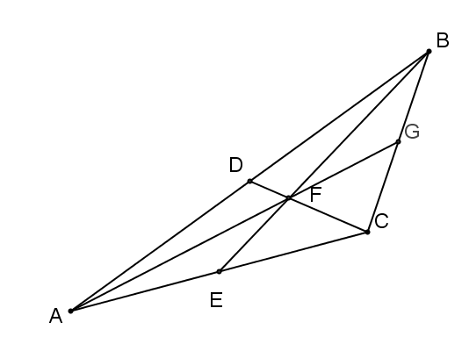
In the figure to the right, $DF=4$, $BF=16$, $AG=30$. Find each of the following measures.
  - $FC=$
  - $DC=$
  - $AF=$
  - $BE=$
  - $FG=$
  - $EF=$

Example 3
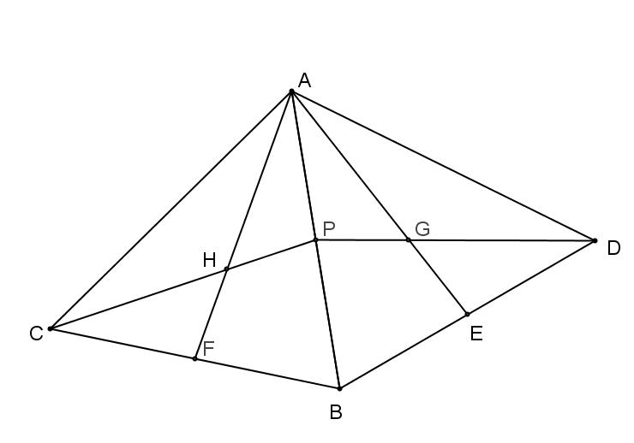
In the figure to the right, $△ABC$ is reflected over $\overline{AB}$ to create $△ABD$. Points $P$, $E$, and $F$ are midpoints of $\overline{AB}$, $\overline{BD}$, and $\overline{BC}$, respectively. If $AH=AG$, prove that $PH=GP$.

Problem Set

Ty is building a model of a hang glider using the template below. To place his supports accurately, Ty needs to locate the center of gravity on his model.
- Use your compass and straightedge to locate the center of gravity on Ty’s model.

- Explain what the center of gravity represents on Ty’s model.

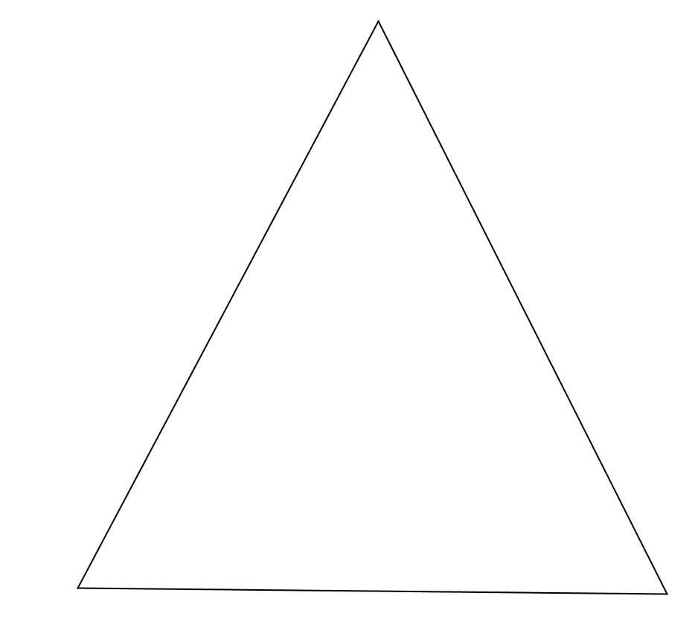
- Describe the relationship between the longer and shorter sections of the line segments you drew as you located the center of gravity.

