|  |
| --- |
|  |

Lesson 30: Special Lines in Triangles

**Student Outcomes**

* Students examine the relationships created by special lines in triangles, namely medians.

Lesson Notes

In Lesson 30, we work with a specific set of lines in triangles, the medians. This is an extension of the work we did in Lesson 29, where we proved that a segment joining the midpoints of two sides of a triangle is parallel to and half the length of the third side, among other proofs.

Classwork

Opening Exercise (5 minutes)

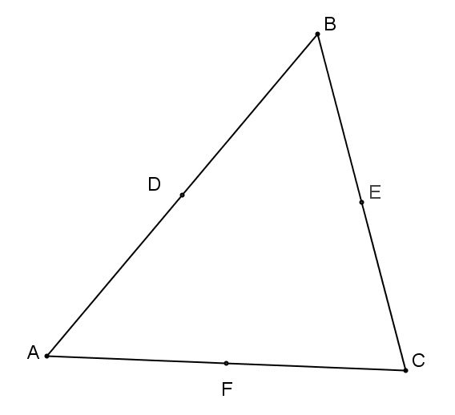Opening Exercise

In at the right, is the midpoint of ; is the midpoint of , and is the midpoint of . Complete each statement below.

is parallel to and measures the length of .

is parallel to and measures the length of .

is parallel to and measures the length of .

Discussion (10 minutes)

Discussion

In the previous two lessons, we proved that (a) the midsegment of a triangle is parallel to the third side and half the length of the third side and (b) diagonals of a parallelogram bisect each other. We use both of these facts to prove the following assertion:

*All medians of a triangle are concurrent* . That is, the three medians of a triangle (the segments connecting each vertex to the midpoint of the opposite side) meet at a single point. This point of concurrency is called the *centroid* , or the center of gravity, of the triangle. The proof will also show a length relationship for each median: The length from the vertex to the centroid is *twice*  the length from the centroid to the midpoint of the side.

Example 1 (10 minutes)

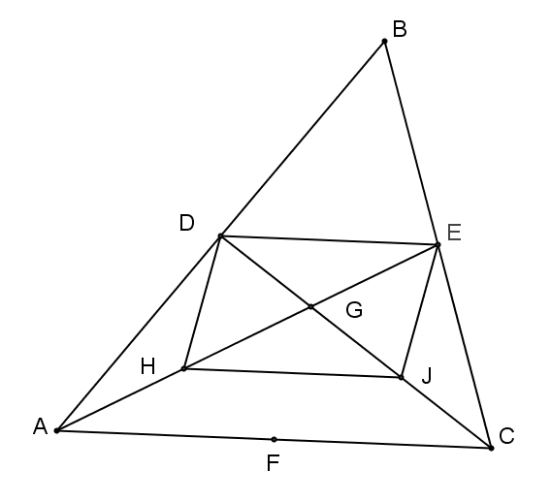  
Example 1

Provide a valid reason for each step in the proof below.

|  |  |  |
| --- | --- | --- |
| Given: | with , , and the midpoints of sides , , and , respectively. | |
| Prove: | The three medians of meet at a single point. |

1. Draw and ; label their intersection as point .
2. Construct and label the midpoint of as point and the midpoint of   
   as point .
3. ,

is a mid-segment of

1. ,

is a mid-segment of

1. ,

If two segments are parallel to the same segment, then they are parallel to each other

1. and ,

Definition of a mid-segment

1. is a parallelogram,

One pair of sides of a quadrilateral are parallel and equal in length

1. and ,

Diagonals of a parallelogram bisect each other

1. and ,

Definition of a midpoint

1. and ,

Substitution property of equality

1. and ,

Partition property or segment addition

1. We can complete steps (1)–(11) to include the median from ; the third median, , passes through point , which divides it into two segments such that the longer part is twice the shorter.
2. The intersection point of the medians divides each median into two parts with lengths in a ratio of ; therefore, all medians are concurrent at that point.

The three medians of a triangle are concurrent at the *centroid* , or the center of gravity. This point of concurrency divides the length of each median in a ratio of ; the length from the vertex to the centroid is *twice*  the length from the centroid to the midpoint of the side.

Example 2 (5 minutes)

Example 2

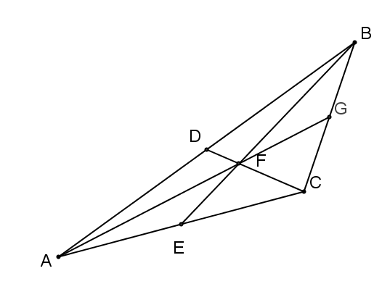In the figure to the right, , , . Find each of the following measures.



Example 3 (10 minutes)

Example 3

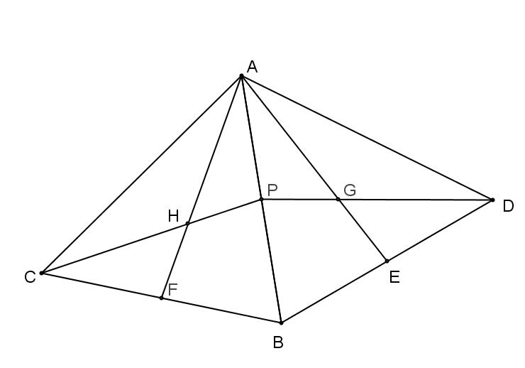In the figure to the right, is reflected over to create . Points , , and are midpoints of , , and , respectively. If , prove that .

is reflected over to create

Segments preserved, rigid motion

Angles preserved, rigid motion

Given

Reflexive property

SAS

Corresponding sides of congruent triangles are equal in measure

Exit Ticket (5 minutes)

Name___________________________________________________ Date____________________

Lesson 30: Special Lines in Triangles

Exit Ticket

, and are all medians of , and is the centroid. , . Find ,, , and .



Exit Ticket Sample Solutions



, , and are all medians of , and is the centroid. , ,. Find ,,, and .

, ,,and

Problem Set Sample Solutions

Ty is building a model of a hang glider using the template below. To place his supports accurately, Ty needs to  
locate the center of gravity on his model.

1. Use your compass and straightedge to locate the center of gravity on Ty’s model.
2. Explain what the center of gravity represents on Ty’s model.

The center of gravity is the centroid.

1. Describe the relationship between the longer and shorter sections of the line segments you drew as you located the center of gravity.

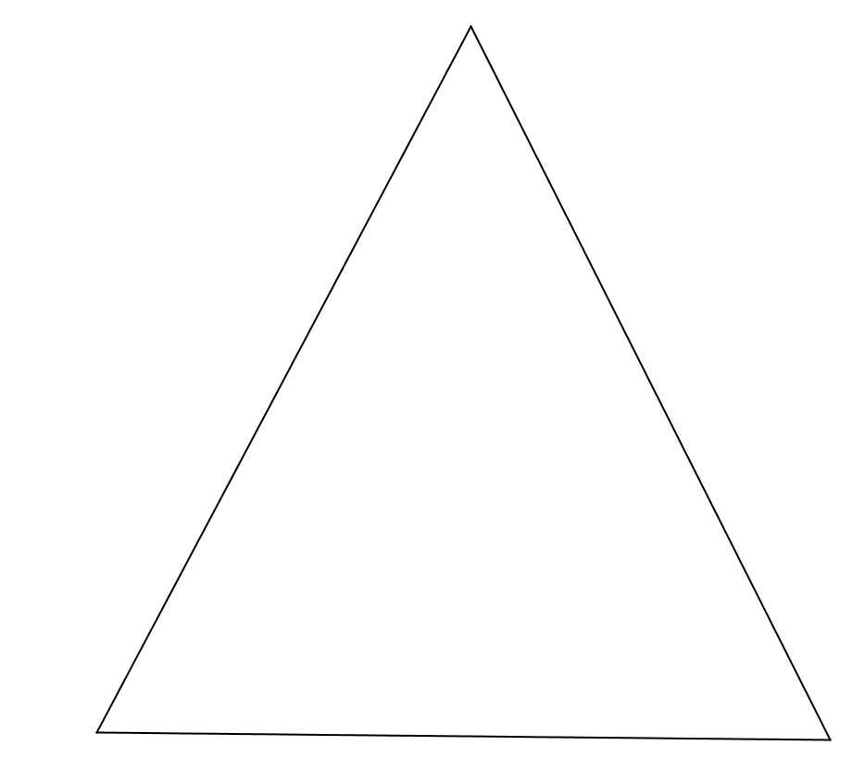The centroid divides the length of each median in a ratio of .