Lesson 29: Special Lines in Triangles

Student Outcomes
- Students examine the relationships created by special lines in triangles, namely mid-segments.

Classwork
Opening Exercise (7 minutes)
Opening Exercise
Construct the midsegment of the triangle below. A midsegment is a line segment that joins the midpoints of two sides of a triangle or trapezoid. For the moment, we will work with a triangle.
- Use your compass and straightedge to determine the midpoints of $\overline{AB}$ and $\overline{AC}$ as $X$ and $Y$, respectively.
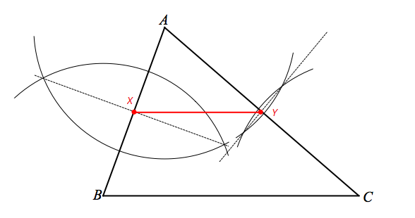
- Draw midsegment $\overline{XY}$.
Compare $∠AXY$ and $∠ABC$; compare $∠AYX$ and $∠ACB$. Without using a protractor, what would you guess is the relationship between these two pairs of angles? What are the implications of this relationship?
$m∠AXY=m∠ABC$,$m∠AYX=m∠ACB$; $\overline{XY}∥\overline{BC}$

Discussion (15 minutes)
Discussion
Note that though we chose to determine the midsegment of $\overline{AB}$ and $\overline{AC}$, we could have chosen any two sides to work with. Let us now focus on the properties associated with a midsegment.
The midsegment of a triangle is parallel to the third side of the triangle and half the length of the third side of the triangle.
We can prove these properties to be true. You will continue to work with the figure from the Opening Exercise.
Given: | $\overline{XY}$ is a midsegment of $△ABC$
Prove: | $\overline{XY}∥\overline{BC}$ and $XY=$ $\frac{1}{2}BC$
Construct the following: In the Opening Exercise figure, draw triangle $△YGC$ according to the following steps. Extend $\overline{XY}$ to point $G$ so that $YG=XY$. Draw $\overline{GC}$.
- What is the relationship between $XY$ and $YG$? Explain why.
Equal, by construction

- What is the relationship between $m∠AYX$ and $m∠GYC$? Explain why.
Equal, vertical angles are equal in measure

- What is the relationship between $\overline{AY}$and $\overline{YC}$? Explain why.
Equal, $Y$ is the midpoint of $\overline{AC}$

- What is the relationship between $△AXY$ and $△CGY$? Explain why.
Congruent, SAS

- What is the relationship between $GC$ and $AX$? Explain why.
Equal, corresponding sides of congruent triangles are equal in length

- Since $AX=BX$, what other conclusion can be drawn? Explain why.
$GC=BX$, substitution

- What is the relationship between $m∠AXY$ and $m∠CGY$? Explain why.
Equal, corresponding angles of congruent triangles are equal in measure

- Based on (7), what other conclusion can be drawn about $\overline{AB}$ and $\overline{GC}$? Explain why.
$$\overline{AB}∥\overline{GC}$$

- What conclusion can be drawn about $BXGC$ based on (7) and (8)? Explain why.
$BXGC$ is a parallelogram, one pair of opposite sides is equal and parallel. Also $\overline{XY}∥\overline{BC}$.

- Based on (9), what is the relationship between $XG$ and $BC$?
$XG=BC$, opposite sides of parallelogram equal

- Since $YG=XY$, $XG=$ $2$ $XY$. Explain why.
Substitution

- This means $BC=$ $2$ $XY$. Explain why.
Substitution

- Or by division, $XY=$ $\frac{1}{2}$ $B$.

Note that steps (9) and (13) demonstrate our Prove statement.
Exercises 1–4 (13 minutes)
Exercises 1–4
Apply what you know about the properties of mid-segments to solve the following exercises.
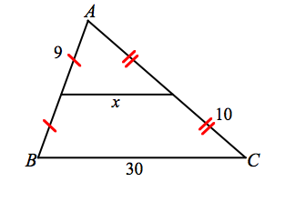  - $x=$ $15$  Perimeter of $△ABC=$ $6$ | 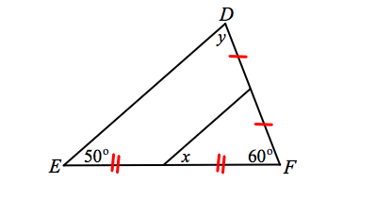  - $x=$ $50°$  $y=$ $70°$

- In $△RST$, the midpoints of each side have been marked by points $X$,$Y$, and $Z$.
- Mark the halves of each side divided by the midpoint with a congruency mark. Remember to distinguish congruency marks for each side.
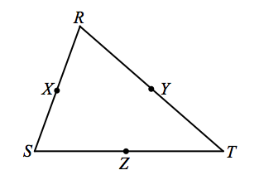
- Draw midsegments $\overline{XY}$, $\overline{YZ}$, and $\overline{XZ}$. Mark each midsegment with the appropriate congruency mark from the sides of the triangle.

  - What conclusion can you draw about the four triangles within$△RST$? Explain Why.
All four are congruent, SSS

  - State the appropriate correspondences among the four triangles within$△RST$.
$△RXY$, $△YZT$, $△XSZ$, $△ZYX$

  - State a correspondence between $△RST$ and any one of the four small triangles.
$△RXY$, $△RST$
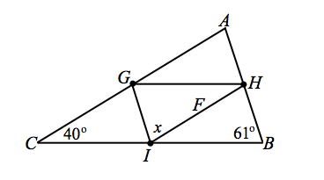
- Find $x$.
$x=$ $9°$

Exit Ticket (5 minutes)
Name ___________________________________________________ Date____________________
Lesson 29: Special Lines in Triangles

Exit Ticket

Use the properties of midsegments to solve for the unknown value in each question.
- $R$ and $S$ are the midpoints of $\overline{XW}$ and$\overline{ WY}$, respectively.
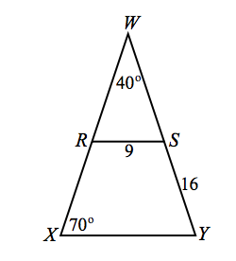
What is the perimeter of $△WXY$?

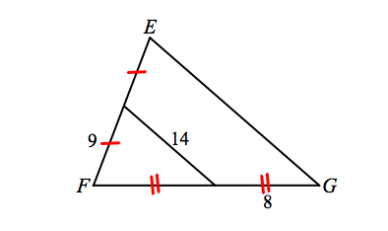
- What is the perimeter of $△EFG$?

Exit Ticket Sample Solutions
Use the properties of midsegments to solve for the unknown value in each question.
- $R$ and $S$ are the midpoints of $\overline{XW}$ and$\overline{WY}$, respectively.
What is the perimeter of $△WXY$? $82$

- What is the perimeter of $△EFG$? $62$

Problem Set Sample Solutions

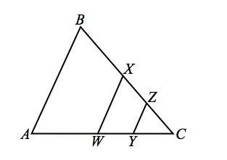
Use your knowledge of triangle congruence criteria to write proofs for each of the following problems.
- $\overline{WX}$ is a midsegment of $△ABC$, and$\overline{YZ}$ is a midsegment of $△CWX$. $BX=AW$.
  - What can you conclude about $∠A$ and $∠B$? Explain why.
$∠A≅∠B$. $BX=AW$ so $CX=CW$, triangle is isosceles.

  - What is the relationship in length between $\overline{YZ}$ and$\overline{AB}$?
$YZ=\frac{1}{4}AB$ or $4YZ=AB$

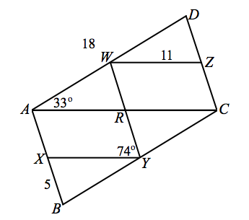
- $W$, $X$,$Y$, and$Z$ are the midpoints of $\overline{AD}$, $\overline{AB}$, $\overline{ BC}$, and $\overline{CD}$ respectively. $AD=18$, $WZ=11$, and$BX=5$. $m∠WAC=33°$, $m∠RYX=74°$.
  - $m∠DZW=$ $74°$
  - Perimeter of $ABYW=$ $38$
  - Perimeter of $ABCD=$ $56$
  - $m∠WAX=$ $107°$
$m∠B=$ $73°$
$m∠YCZ=$ $107°$
$m∠D=$ $73°$
  - What kind of quadrilateral is$ABCD$?
Parallelogram

