Lesson 28: Properties of Parallelograms

Classwork

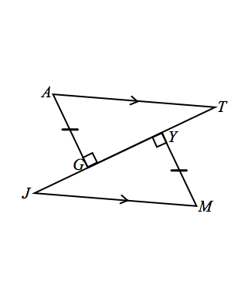Opening Exercise

1. If the triangles are congruent, state the congruence.
2. Which triangle congruence criterion guarantees part 1?
3. corresponds with:

Discussion

How can we use our knowledge of triangle congruence criteria to establish other geometry facts? For instance, what can we now prove about the properties of parallelograms?

To date, we have defined a parallelogram to be a quadrilateral in which both pairs of opposite sides are parallel. However, we have assumed other details about parallelograms to be true too. We assume that:

* Opposite sides are congruent.
* Opposite angles are congruent.
* Diagonals bisect each other.

Let us examine why each of these properties is true.

Example 1

**If a quadrilateral is a parallelogram, then its opposite sides and angles are equal in measure.**  Complete the diagram and develop an appropriate *Given* and *Prove* for this case. Use triangle congruence criteria to demonstrate why opposite sides and angles of a parallelogram are congruent.



|  |  |
| --- | --- |
| Given: |  |
| Prove: |  |

Construction: Label the quadrilateral , and mark opposite sides as parallel. Draw diagonal .

Example 2

**If a quadrilateral is a parallelogram, then the diagonals bisect each other.** Complete the diagram and develop an appropriate *Given* and *Prove* for this case. Use triangle congruence criteria to demonstrate why diagonals of a parallelogram bisect each other. Remember, now that we have proved opposite sides and angles of a parallelogram to be congruent, we are free to use these facts as needed (i.e., ,, ).



|  |  |
| --- | --- |
| Given: |  |
| Prove: |  |

Construction: Label the quadrilateral . Mark opposite sides as parallel. Draw diagonals and .

Now we have established why the propertiesof parallelograms that we have assumed to be true are in fact true. By extension, these facts hold for any type of parallelogram, including rectangles, squares, and rhombuses. Let us look at one last fact concerning rectangles. We established that the diagonals of general parallelograms bisect each other. Let us now demonstrate that a rectangle has congruent diagonals.

**Example 3**

**If the parallelogram is a rectangle, then the diagonals are equal in length.**  Complete the diagram and develop an appropriate *Given* and *Prove* for this case. Use triangle congruence criteria to demonstrate why diagonals of a rectangle are congruent. As in the last proof, remember to use any already proven facts as needed.

|  |  |
| --- | --- |
| Given: |  |
| Prove: |  |



Construction: Label the rectangle . Mark opposite sides as parallel, and add small squares at the vertices to indicate angles. Draw diagonal and .

**Converse Properties**: Now we examine the converse of each of the properties we proved. Begin with the property and prove that the quadrilateral is in fact a parallelogram.

Example 4

**If the opposite angles of a quadrilateral are equal, then the quadrilateral is a parallelogram.**  Draw an appropriate diagram, and provide the relevant *Given* and *Prove* for this case.

|  |  |
| --- | --- |
| Given: |  |
| Prove: |  |



Construction: Label the quadrilateral . Mark opposite angles as congruent. Draw diagonal . Label and as . Label the four angles created by as , , , and .

Example 5

**If the opposite sides of a quadrilateral are equal, then the quadrilateral is a parallelogram.** Draw an appropriate diagram, and provide the relevant *Given* and *Prove* for this case.

|  |  |
| --- | --- |
| Given: |  |
| Prove: |  |



Label the quadrilateral , and mark opposite sides as equal. Draw diagonal .

**Example 6**

**If the diagonals of a quadrilateral bisect each other, then the quadrilateral is a parallelogram.** Draw an appropriate diagram, and provide the relevant *Given* and *Prove* for this case. Use triangle congruence criteria to demonstrate why the quadrilateral is a parallelogram.

|  |  |
| --- | --- |
| Given: |  |
| Prove: |  |



Construction: Label the quadrilateral , and mark opposite sides as equal. Draw diagonals and.

Example 7

**If the diagonals of a parallelogram are equal in length, then the parallelogram is a rectangle.** Complete the diagram, and develop an appropriate *Given* and *Prove* for this case.

|  |  |
| --- | --- |
| Given: |  |
| Prove: |  |



Construction: Label the quadrilateral . Draw diagonals and .

Problem Set

Use the facts you have established to complete exercises involving different types of parallelograms.

1. Given: , .

Prove: is a rhombus

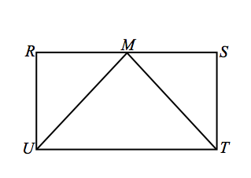

1. Given: Rectangle , is the midpoint of .

Prove: is isosceles.

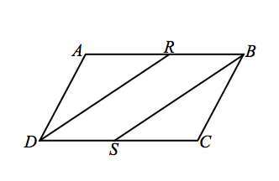

1. Given: is a parallelogram, bisects , bisects .

Prove: is a parallelogram.

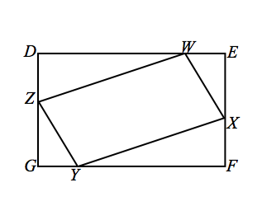

1. Given: is a rectangle, , .

Prove: is a parallelogram.

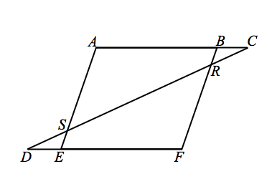

1. Given: Parallelogram , .  
   Prove: .