|  |
| --- |
|  |

Lesson 28: Properties of Parallelograms

**Student Outcomes**

* Students complete proofs that incorporate properties of parallelograms.

**Lesson Notes**

Throughout this module, we have seen the theme of building new facts with the use of established ones. We see this again in Lesson 28, where triangle congruence criteria are used to demonstrate why certain properties of parallelograms hold true. We begin establishing new facts using only the definition of a parallelogram and the properties we have assumed when proving statements*.* Students combine the basic definition of a parallelogram with triangle congruence criteria to yield properties taken for granted in earlier grades, such as opposite sides of a parallelogram are parallel.

Classwork

Opening Exercise (5 minutes)

Opening Exercise

1. 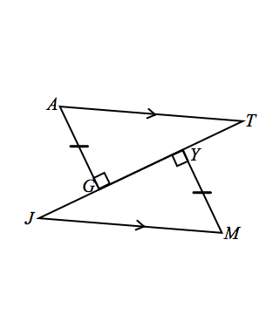If the triangles are congruent, state the congruence.
2. Which triangle congruence criterion guarantees part 1?

AAS

1. corresponds with:

Discussion/Examples 1–7 (35 minutes)

Discussion

How can we use our knowledge of triangle congruence criteria to establish other geometry facts? For instance, what can we now prove about the properties of parallelograms?

To date, we have defined a parallelogram to be a quadrilateral in which both pairs of opposite sides are parallel. However, we have assumed other details about parallelograms to be true too. We assume that:

* Opposite sides are congruent.
* Opposite angles are congruent.
* Diagonals bisect each other.

Let us examine why each of these properties is true.

Example 1

If a quadrilateral is a parallelogram, then its opposite sides and angles are equal in measure. Complete the diagram and develop an appropriate *Given* and *Prove* for this case. Use triangle congruence criteria to demonstrate why opposite sides and angles of a parallelogram are congruent.

|  |  |
| --- | --- |
| Given: | Parallelogram (, ). |
| Prove: | ,, ,. |

Construction: Label the quadrilateral , and mark opposite sides as parallel. Draw diagonal .

Proof:

*Parallelogram Given*

*If parallel lines are cut by a transversal, then alternate interior angles are equal in measure*

*Reflexive property*

*If parallel lines are cut by a transversal, then alternate interior angles are equal in measure*

*ASA*

*, Corresponding sides of congruent triangles are equal in length*

*Corresponding angles of congruent triangles are equal in measure*

*,*

*Angle addition postulate*

*Addition property of equality*

*Substitution property of equality*

Example 2

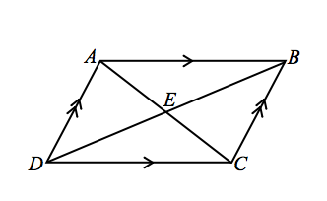If a quadrilateral is a parallelogram, then the diagonals bisect each other. Complete the diagram and develop an appropriate *Given* and *Prove* for this case. Use triangle congruence criteria to demonstrate why diagonals of a parallelogram bisect each other. Remember, now that we have proved opposite sides and angles of a parallelogram to be congruent, we are free to use these facts as needed (i.e., , ,,).

|  |  |
| --- | --- |
| Given: | Parallelogram . |
| Prove: | Diagonals bisect each other,. |

Construction: Label the quadrilateral . Mark opposite sides as parallel. Draw diagonals and .

Proof:

Parallelogram Given

*If parallel lines are cut by a transversal, then alternate interior angles are equal in measure*

*Vertical angles are equal in measure*

Opposite sides of a parallelogram are equal in length

AAS

, Corresponding sides of congruent triangles are equal in length

Now we have established why the properties of parallelograms that we have assumed to be true are in fact true. By extension, these facts hold for any type of parallelogram, including rectangles, squares, and rhombuses. Let us look at one last fact concerning rectangles. We established that the diagonals of general parallelograms bisect each other. Let us now demonstrate that a rectangle has congruent diagonals.

Students may need a reminder that a rectangle is a parallelogram with four right angles.

Example 3

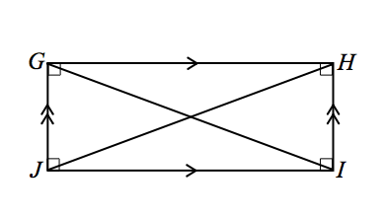If the parallelogram is a rectangle, then the diagonals are equal in length. Complete the diagram and develop an appropriate *Given* and *Prove* for this case. Use triangle congruence criteria to demonstrate why diagonals of a rectangle are congruent. As in the last proof, remember to use any already proven facts as needed.

|  |  |
| --- | --- |
| Given: | Rectangle . |
| Prove: | Diagonals are equal in length, . |

Construction: Label the rectangle . Mark opposite sides as parallel, and add small squares at the vertices to indicate angles. Draw diagonal and .

Proof:

Rectangle Given

Opposite sides of a parallelogram are equal in length

Reflexive property

, are right angles Definition of a rectangle

SAS

Corresponding sides of congruent triangles are equal in length

Converse Properties: Now we examine the converse of each of the properties we proved. Begin with the property and prove that the quadrilateral is in fact a parallelogram.

Example 4

If the opposite angles of a quadrilateral are equal, then the quadrilateral is a parallelogram. Draw an appropriate diagram, and provide the relevant *Given* and *Prove* for this case.

|  |  |
| --- | --- |
| Given: | *Quadrilateral with , .* |
| Prove: | Quadrilateral is a parallelogram. |

**Construction: Label the quadrilateral . Mark opposite angles as congruent. Draw diagonal . Label and as . Label the four angles created by as , , , and .

Proof:

*Quadrilateral with , Given*

*, Angle addition*

Substitution

, Angles in a triangle add up to

Subtraction property of equality, substitution

Subtraction property of equality

Additive inverse property

Addition property of equality

Addition and subtraction properties of equality

Division property of equality

Addition property of equality

Substitution and subtraction properties of equality

, If two lines are cut by a transversal such that a pair of alternate interior angles are equal in measure, then the lines are parallel

Quadrilateral is a parallelogram Definition of a parallelogram

Example 5

If the opposite sides of a quadrilateral are equal, then the quadrilateral is a parallelogram. Draw an appropriate   
diagram, and provide the relevant *Given* and *Prove* for this case.

|  |  |
| --- | --- |
| Given: | Quadrilateral with,. |
| Prove: | Quadrilateral is a parallelogram. |

**Construction: Label the quadrilateral , and mark opposite sides as equal. Draw diagonal .

Proof:

Quadrilateral with, Given

Reflexive property

SSS

Corresponding angles of congruent triangles are congruent

, If two lines are cut by a transversal and the alternate interior angles are congruent, then the lines are parallel

Quadrilateral is a parallelogram Definition of a parallelogram

Example 6

If the diagonals of a quadrilateral bisect each other, then the quadrilateral is a parallelogram. Draw an appropriate diagram, and provide the relevant *Given* and *Prove* for this case. Use triangle congruence criteria to demonstrate why the quadrilateral is a parallelogram.

|  |  |
| --- | --- |
| Given: | Quadrilateral , diagonals and bisect each other. |
| Prove: | Quadrilateral is a parallelogram. |

Construction: Label the quadrilateral , and mark opposite sides as equal. Draw diagonals and.

Proof:

Quadrilateral , diagonals and bisect each other Given

, Definition of a segment bisector

*, Vertical angles are equal in measure*

, SAS

, Corresponding angles of congruent triangles are congruent

, If two lines are cut by a transversal such that a pair of alternate interior angles are congruent, then the lines are parallel

Quadrilateral is a parallelogram Definition of a parallelogram

Example 7

If the diagonals of a parallelogram are equal in length, then the parallelogram is a rectangle. Complete the diagram, and develop an appropriate *Given* and *Prove* for this case.

|  |  |
| --- | --- |
| Given: | Parallelogram with diagonals of equal length, . |
| Prove: | is a rectangle. |

Construction: Label the quadrilateral . Draw diagonals and .

Proof:

Parallelogram with diagonals of equal length, Given

, Reflexive property

Opposite sides of a parallelogram are congruent

, SSS

*, Corresponding angles of congruent triangles are equal in measure*

*, If parallel lines are cut by a transversal, then interior angles on the same side are supplementary*

*, Substitution property of equality*

*, Division property of equality*

*Substitution property of equality*

is a rectangle. Definition of a rectangle

Exit Ticket (5 minutes)

Name ___________________________________________________ Date____________________

Lesson 28: Properties of Parallelograms

Exit Ticket

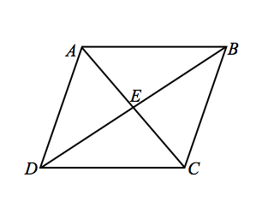

Given: Equilateral parallelogram (i.e., a rhombus) with diagonals and .

Prove: Diagonals intersect perpendicularly.

Exit Ticket Sample Solutions

Given: Equilateral parallelogram (i.e., a rhombus) with diagonals and .

Prove: Diagonals intersect perpendicularly.

Rhombus Given

, Diagonals of a parallelogram bisect each other

Definition of equilateral parallelogram

SSS

*Corr. angles of congruent triangles are equal in measure*

*Angles at a point sum to . Since all four angles are congruent, each angle measures .*

Problem Set Sample Solutions

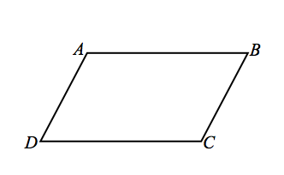

Use the facts you have established to complete exercises involving different types of parallelograms.

1. Given: , ,.

Prove: is a rhombus.

Construction: Draw diagonal .

, Given

Reflexive property

SSS

, Corresponding sides of congruent triangles are equal in length

Transitive property

is a rhombus Definition of a rhombus

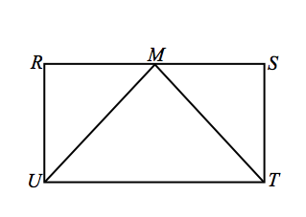

1. Given: Rectangle , is the midpoint of .

Prove: is isosceles.

Rectangle Given

Opposite sides of a rectangle are congruent

, are right angles Definition of a rectangle

is the midpoint of Given

Definition of a midpoint

SAS

Corresponding sides of congruent triangles are congruent

is isosceles Definition of an isosceles triangle

1. 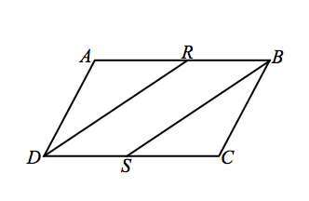Given: is a parallelogram, bisects , bisects .

Prove: is a parallelogram.

is a parallelogram; Given

bisects , bisects

Opposite sides of a parallelogram are congruent

, Opposite angles of a parallelogram are congruent

, Definition of angle bisector

Angle addition

Substitution

, Addition

, Division

Substitution

ASA

Corresponding angles of congruent triangles are congruent

Supplements of congruent angles are congruent

is a parallelogram Opposite angles of quadrilateral are congruent

1. 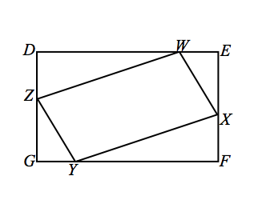Given: is a rectangle, , .

Prove: is a parallelogram.

, Opposite sides of a rectangle are congruent

is a rectangle; Given

,

; Segment addition

Substitution

Substitution

Subtraction

*Definition of a rectangle*

, are right triangles Definition of right triangle

HL

Corresponding sides of congruent triangles are congruent

; Partition property or segment addition

Subtraction property of equality

SAS

Corresponding sides of congruent triangles are congruent

is a parallelogram Both pairs of opposite sides are congruent

1. 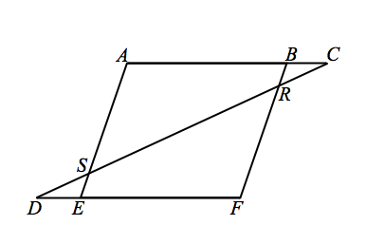Given: Parallelogram , .

Prove: .

*If parallel lines cut by a transversal, then alternate interior angles are equal in measure*

Opposite angles of a parallelogram are congruent

Supplements of congruent angles are congruent

Given

AAS

Corresponding sides of congruent triangles are equal in length