Lesson 27: Triangle Congruency Proofs
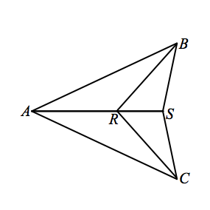
Classwork
Exercises
- Given: $AB=AC,$ $RB=RC$.
Prove: $SB=SC$.

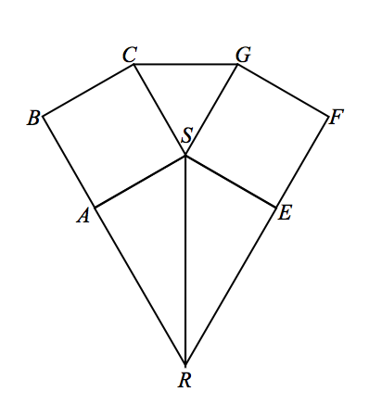
- Given: Square $ABCS≅$ Square $EFGS,$
$\overset{⃡}{RAB}$, $\overset{⃡}{REF}$.
Prove: $△ASR≅ESR$.

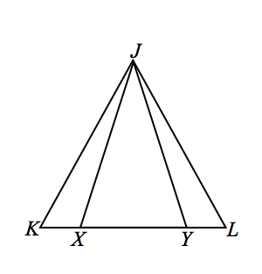
- Given: $JK=JL, JX=JY.$
Prove: $KX=LY$.

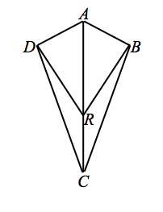
- Given: $AD⊥DR$,$AB⊥BR$,
$\overline{AD}≅\overline{AB}$.
Prove: $∠DCR=∠BCR$.

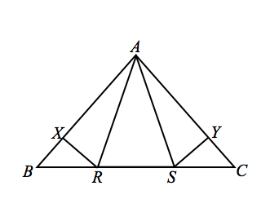
- Given: $AR=AS, BR=CS$,
$RX⊥AB$,$SY⊥AC$.
Prove: $BX=CY$.

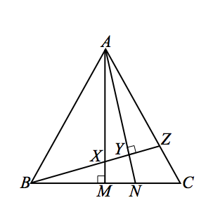

- Given: $AX=BX$, $∠AMB=∠AYZ=90°$.
Prove: $NY=NM$.

Problem Set

Use your knowledge of triangle congruence criteria to write a proof for the following:
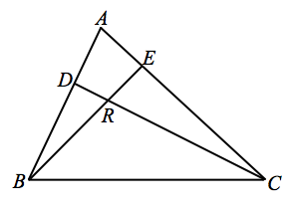
In the figure $\overline{BE}≅\overline{CE}$, $DC⊥AB$, $BE⊥AC$, prove $\overline{AE}≅\overline{RE}.$

