Lesson 27: Triangle Congruency Proofs

Student Outcomes
- Students complete proofs requiring a synthesis of the skills learned in the last four lessons.

Classwork
Exercises 1–6 (40 minutes)
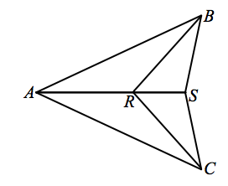
Exercises 1–6
- Given: $AB=AC$, $RB=RC$.
Prove: $SB=SC$.
$AB=AC$, $RB=RC$ Given
$AR=AR$ Reflexive property
$△ARC≅△ARB$ SSS
$m∠ARC=m∠ARB$ Corresponding angles of congruent triangles are equal in measure
$m∠ARC+m∠SRC=180$, $m∠ARB+m∠SRB=180$ Linear pairs form supplementary angles
$m∠SRC=m∠SRB$ Angles supplementary to either the same angle or to congruent angles are equal in measure
$SR=SR$ Reflexive property
$△SRB≅△SRC$ SAS
$SB=SC$ Corresponding sides of congruent angles are equal in length

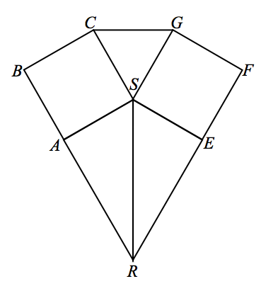
- Given: Square $ABCS≅$ Square $EFGS$,
$\overset{⃡}{RAB}$, $\overset{⃡}{REF}$.
Prove: $△ASR≅ESR$.
Square $ABCS≅$ Square $EFGS$ Given
$AS=ES$ Corresponding sides of congruent squares are equal in length
$SR=SR$ Reflexive property
$∠BAS$and$∠FES$are right angles Definition of square
$∠BAS$ and$∠SAR$form a linear pair Definition of linear pair
$∠FES$and$∠SER$form a linear pair Definition of linear pair
$∠SAR$and $∠SER$are right angles Two angles that are supplementary and congruent each measure $90°$ and are, therefore, right angles
$△ASR$ and $△ESR$ are right triangles Definition of right triangle
$△ASR≅ △ESR$ HL
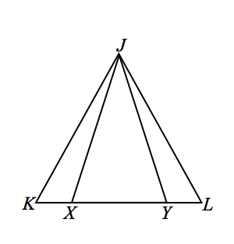
- Given: $JK=JL$,$JX=JY$.
Prove: $KX=LY$.
$JX=JY$ Given
$m∠JXY=m∠JYX$ Base angles of an isosceles triangle are equal in measure
$m∠JXK+m∠JXY=180$,
$m∠JYL+m∠JYX=180$ Linear pairs form supplementary angles.
$m∠JXK+m∠JXY=m∠JYL+m∠JYX$ Substitution property of equality
$m∠JXK+m∠JXY=m∠JYL+m∠JXY$ Substitution property of equality
$m∠JXK=m∠JYL$ Angles supplementary to either the same angle or congruent angles are equal in measure
$JK=JL$ Given
$m∠K=m∠L$ Base angles of an isosceles triangle are equal in measure
$△JXK≅△JYL$ AAS
$KX=LY$ Corresponding sides of congruent triangles are equal in length
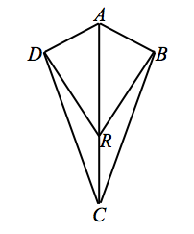
- Given: $\overline{AD}⊥\overline{DR}, \overline{AB}⊥\overline{BR}$,
$\overline{AD}≅\overline{AB}$.
Prove: $∠DCR≅∠BCR$.
$\overline{AD}⊥\overline{DR}$, $\overline{AB}⊥\overline{BR}$ Given
$△ADR$ and$△ABR$ are right triangles Definition of right triangle
$\overline{AD}≅\overline{AB}$ Given
$\overline{AR}≅\overline{AR}$ Reflexive property
$△ADR≅△ABR$ HL
$∠ARD≅ARB$ Corresponding angles of congruent triangles are congruent
$m∠ARD+m∠DRC=180$,
$m∠ARB+m∠BRC=180$ Linear pairs form supplementary angles.
$m∠ARD+m∠DRC=m∠ARB+m∠BRC$ Transitive property
$m∠DRC=m∠BRC$ Angles supplementary to either the same angle or congruent angles are equal in measure
$\overline{DR}≅\overline{BR}$ Corresponding sides of congruent triangles are congruent
$\overline{RC}≅\overline{RC}$ Reflexive property
$△DRC≅△BRC$ SAS
$∠DRC≅∠BRC$ Corresponding angles of congruent triangles are congruent

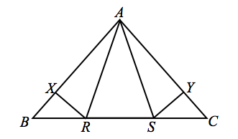
- Given: $AR=AS$, $BR=CS$,
$\overline{RX}⊥\overline{AB}$,$\overline{SY}⊥\overline{AC}$.
Prove: $BX=CY$.

$AR=AS$ Given
$m∠ARS=m∠ASR$ Base angles of an isosceles triangle are equal in measure
$m∠ARS+m∠ARB=180$,
$m∠ASR+m∠ASC=180$ Linear pairs form supplementary angles
$m∠ARS+m∠ARB=m∠ASR+m∠ASC$ Transitive property
$m∠ARB=m∠ASC$ Subtraction
$BR=CS$ Given
$△ARB≅ △ASC$ SAS
$∠ABR≅∠ACS$ Corresponding angles of congruent triangles are congruent
$\overline{RX}⊥\overline{AB}, \overline{SY}⊥\overline{AC}$ Given
$m∠RXB=90°=m∠SYC$ Definition of perpendicular line segments.
$△BRX≅ △SYC$ AAS
$BX=CY$ Corresponding sides of congruent triangles are equal in length

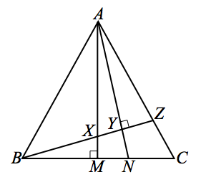
- Given: $AX=BX$, $m∠AMB=m∠AYZ=90°$.
Prove: $NY=NM$.
$AX=BX$ Given
$m∠AMB=m∠AYZ=90°$ Given
$m∠BXM=m∠AXY$ Vertical angles are equal in measure
$△BXM≅△AXY$ AAS
$BX+XY=BY$, $AX+XM=AM$ Segments add
$XM=XY$ Corresponding sides of congruent triangles are equal in length
$BY=AM$ Substitution property of equality
$m∠BYN=90˚$ Vertical angles are equal in measure
$m∠AMB+m∠AMN=180°$ Linear pairs form supplementary angles
$m∠AMN=90°$ Subtraction property of equality
$m∠MNY=m∠MNY$ Reflexive property
$△BYN≅△AMN$ AAS
$NY=NM$ Corresponding sides of congruent triangles are equal in length

Exit Ticket (5 minutes)
Name ___________________________________________________ Date____________________
Lesson 27: Triangle Congruency Proofs

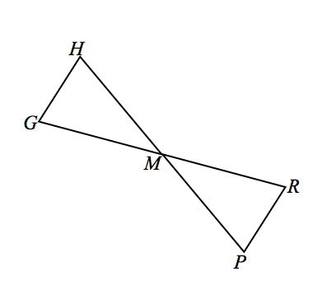
Exit Ticket

Given: $M$ is the midpoint of $GR$, ∠$G ≅$∠$R$.
Prove: $△GHM≅ △RPM$.

Exit Ticket Sample Solutions
Given: $M$ is the midpoint of $GR$, ∠$G =$ ∠$R$.
Prove: $△GHM≅△RPM$.
$M$ is the midpoint of GR Given
∠$G ≅$∠$R$ Given
$GM = RM$ Definition of midpoint
∠$HMG ≅$∠$PMR$ Vertical angles are congruent.
$△GHM≅△RPM$ ASA

Problem Set Sample Solutions

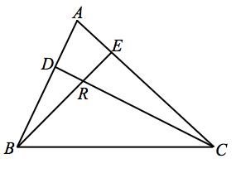
Use your knowledge of triangle congruence criteria to write a proof for the following:
In the figure $\overline{BE}≅\overline{CE}$, $\overline{DC}⊥\overline{AB}$,$\overline{BE}⊥\overline{AC}$, prove $\overline{AE}≅\overline{RE}$.

$m∠ERC=m∠BRD$ Vertical angles are equal in measure
$\overline{DC}⊥\overline{AB},\overline{BE}⊥\overline{AC}$ Given
$m∠BDR=90°$,$m∠REC=90°$ Definition of perpendicular lines
$m∠ABE=m∠RCE$ Sum of the angle measures in a triangle is $180°$
$m∠BAE=m∠BRD$ Sum of the angle measures in a triangle is $180°$
$m∠BAE=m∠ERC$ Substitution property of equality
$\overline{BE}≅\overline{CE}$ Given
$△BAE≅△CRE$ AAS
$\overline{AE}≅\overline{RE}$ Corresponding sides of congruent triangles are congruent

