Lesson 28
Objective: Celebrate progress in fluency with adding and subtracting within 10 (and 20). Organize engaging summer practice.

Suggested Lesson Structure
 Fluency Practice (10 minutes)
 Application Problem (5 minutes)
 Culminating Activity (35 minutes)
 Student Debrief (10 minutes)
Total Time (60 minutes)
Fluency Practice (10 minutes)
- Sprint: Count Dots K.CC.5 (10 minutes)
Sprint: Count Dots (10 minutes)
Materials: (S) Count Dots Sprint
Note: This Sprint is the one students completed on the first day of school. Repeating it in the final days of school will likely bring students joy as they recognize the ease at which they are able to do it after a year of mathematical growth. Be sure to assign a counting sequence for early finishers!
Application Problem (5 minutes)
Darnel answered 30 problems on Side B of his Count Dots Sprint today. He was proud because he answered 20 more problems today than he did on the first day of school. How many problems did he answer on the first day of school?

Note: This compare with smaller unknown problem challenges students by suggesting the wrong operation.

Culminating Activity (35 minutes)
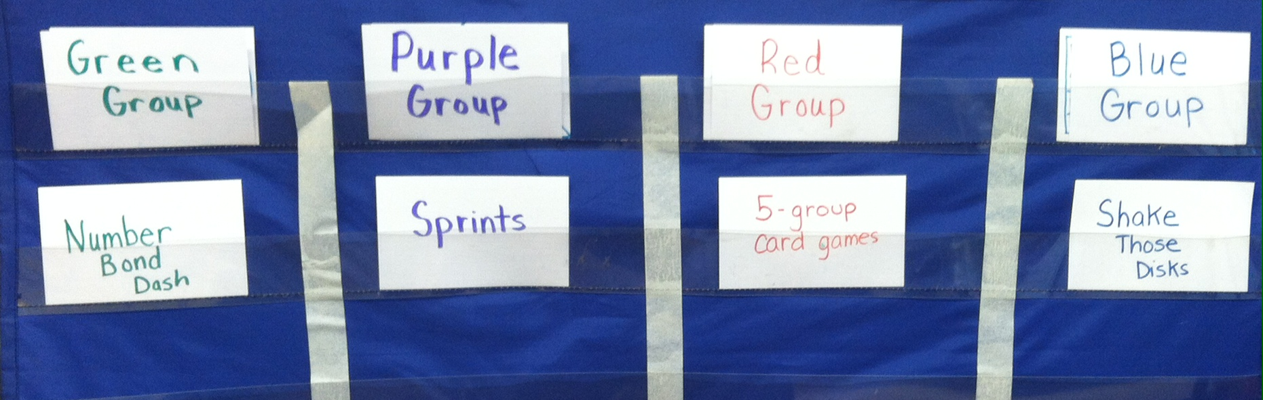
Materials: (T) Organizational chart for center assignments (example to right)
(S) 5-group cards (from G1–M1–Lesson 5), numeral cards (from G1─M1─Lesson 36), personal white board, Target Practice template, Race to the Top template, die
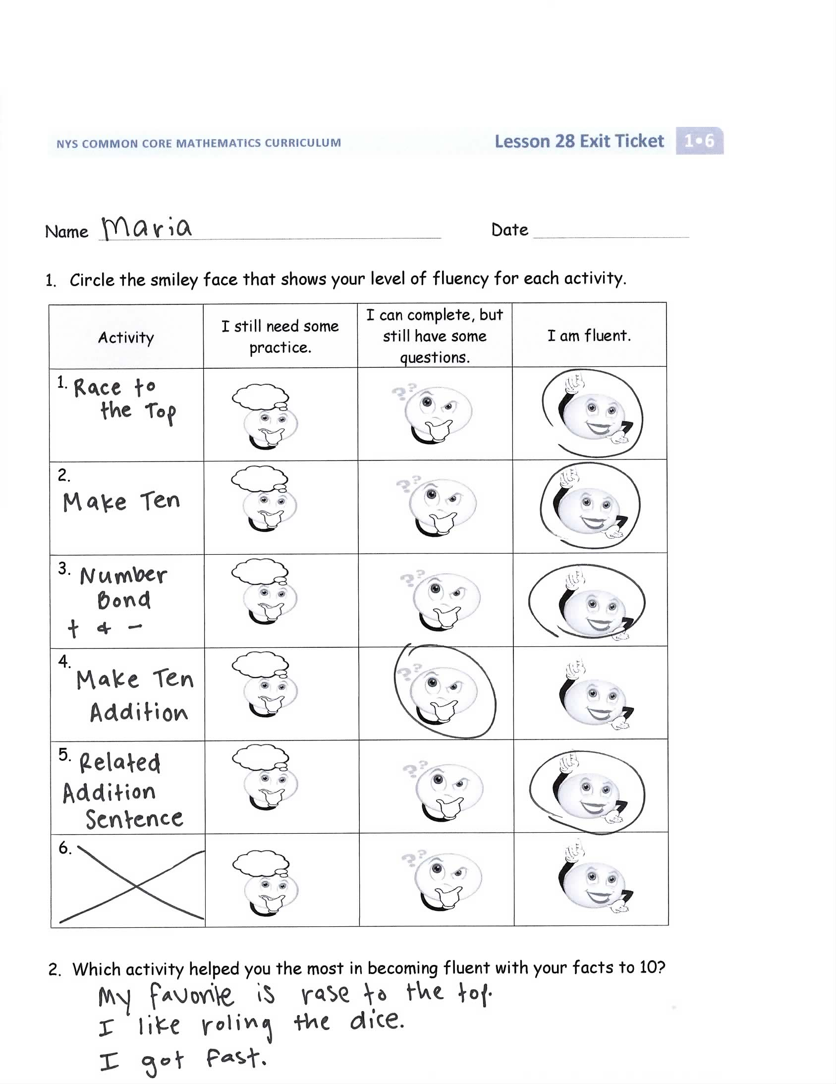
Note: In the next two lessons, students will revisit some of their favorite fluency activities from the year to celebrate and reflect on their progress.
Take the steps listed below to prepare for the culminating activity:
- Choose from the suggested activities or select other fluency favorites based on the needs and interests of your class.
- Prepare materials and stations.
- Write the names of the activities you select on the Exit Ticket before photocopying it for today’s lesson. (See the picture to the right.) This is an opportunity for students to reflect on their progress.
Note: Students will be working with these centers again tomorrow as a host to guests who might be parents, support teachers, or kindergarten buddies.
T: Today we are going to celebrate our fluency progress. Think about the fluency activities we did this year. Which were your favorites?

NOTES ON
MULTIPLE MEANS OF ENGAGEMENT:
It is important to provide students with the math tools they need to play these games successfully. Support students with use of manipulatives and possibly their personal white boards.
T: How did they help you improve your counting, adding, and subtracting skills? Share your ideas with your partner.
S: Happy Counting helped me count forward and backward. Sprints helped me with addition and subtraction facts. Coin drops helped with counting on.
T: Great! Today I have some of those activities set up at centers. You will start at one center and rotate at my signal to the other centers.
Review instructions for each center and assign partners. Students spend about five minutes at each center.
Choose from the fluency celebration centers suggested below. Set up the number of centers that works best for the class.
Missing Part: Make Ten
Materials: (S) 5-group or digit cards (from G1–M1–Lesson 5)
Each partner holds a card up to his or her forehead. The partner tells how many more is needed to make ten. Students must guess the cards on their foreheads. Partners can play simultaneously, each putting a card to his or her forehead.
Target Practice
Materials: (S) Personal white boards with Target Practice template, die per pair
Follow directions on the game board.
Race to the Top
Materials: (S) Personal white boards with Race to the Top insert, 2 dice per pair
Partners take turns rolling the dice, saying an addition sentence and recording the sums on the graph. The game ends when time runs out or one of the columns reaches the top of the graph.
Subtraction with Cards
Materials: (S) 1 pack of numeral cards 0─10 (from G1─M1─Lesson 36)
Partners combine their digit cards and place them face down between them.
- Each partner flips over two cards and subtracts the smaller number from the larger one.
- The partner with the smallest difference keeps the cards played by both players in that round.
- If the differences are equal, the cards are set aside and the winner of the next round keeps the cards from both rounds.
- The player with the most cards at the end of the game wins.
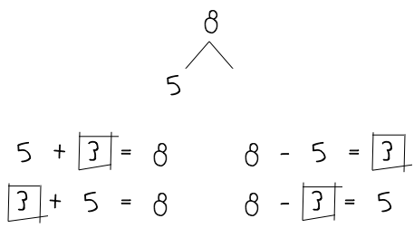
Number Bond Addition and Subtraction
Materials: (S) Personal white boards, die per pair
Allow partners to choose a number less than 20 for their whole and roll the die to determine one of the parts.
- Both students write two addition and two subtraction sentences with a square for the unknown number in each equation and solve for the missing number.
- They then exchange boards and check each other’s work.
Make Ten Addition and Take from Ten Subtraction with Partners
Materials: (S) Personal white boards
Partners alternate practicing the make ten and take from ten strategies.
Make Ten Addition:
- Partners choose an addend for each other from 1 to 10.
- 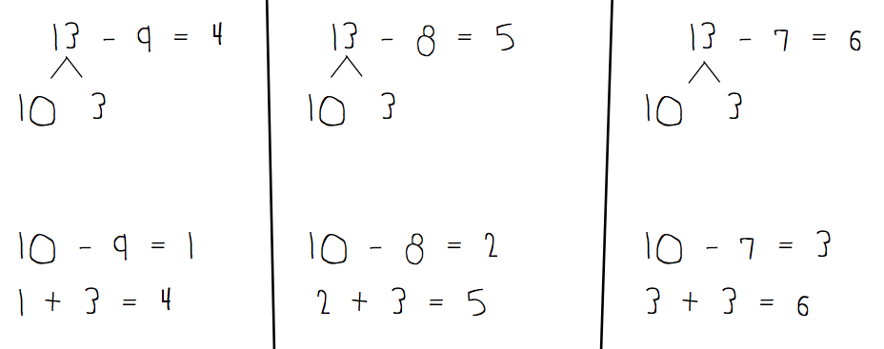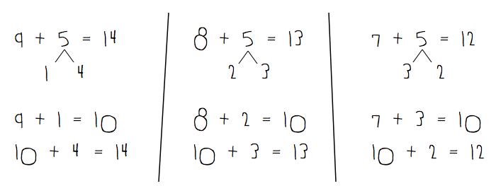On their personal boards, students add their number to 9, 8, and 7. Remind students to write the two addition sentences they learned in G1─Module 2.
- Partners then exchange boards and check each other’s work.
Take from Ten Subtraction:
- Partners choose a minuend for each other between 10 and 20.
- On their personal boards, students subtract 9, 8, and 7 from their number. Remind students to write the two number sentences, (e.g., to solve 13 – 8, they write 10 – 8 = 2, 2 + 3 = 5).
- Partners then exchange boards and check each other’s work.
Analogous Addition Sentences
Partner A
4 + 3 = 7
14 + 3 = 17
24 + 3 = 27
34 + 3 = 37

Partner B
3 + 4 = 7
13 + 4 = 17
23 + 4 = 27
33 + 4 = 37
STEP 2
Partner A
4
14
24
34
Partner B
3
13
23
33
STEP 1
Materials: (S) Personal white boards, dice
- Step 1: Each partner rolls a die and writes the number rolled. They then make a list, adding 1 ten to their number on each new line up to 3 tens. (See diagram to the right.)
- Step 2: Students write equations, adding the number on their partners’ die to each line.
- Partners exchange boards and check each other’s work.
Note: This game can be modified by using dice that have more than 6 sides, as students should be ready to add numbers to 20 and add multiples of 10 to these numbers.

Student Debrief (10 minutes)
Lesson Objective: Celebrate progress in fluency with adding and subtracting within 10 (and 20). Organize engaging summer practice.
The Student Debrief is intended to invite reflection and active processing of the total lesson experience.

NOTES ON
MULTIPLE MEANS OF REPRESENTATION:
Teachers should feel a sense of pride as they see their students demonstrate strategies to make math easy. It is also exciting when students are able to explain how they are thinking and relate concepts to one another.
Invite students to review their center work today. They should reflect on their work with a partner before sharing as a class. Guide students in a conversation to debrief the centers and reflect on their learning.
You may choose to use any combination of the questions below to lead the discussion.
- What is something you did today that you could not do before you came to first grade?
- Which of today’s centers seemed easy? How does your experience today compare with the first time you did them?
- Are there any activities that were still a little challenging? What might you do to get better?
- Which of these games might be fun to play over the summer so you can keep your math skills sharp?
Exit Ticket (3 minutes)
After the Student Debrief, instruct students to complete the Exit Ticket. A review of their work will help you assess the students’ understanding of the concepts that were presented in the lesson today and plan more effectively for future lessons. You may read the questions aloud to the students.

Name Date
Number correct:
A
*Write the number of dots. Try to find ways to group the dots to make counting easier!
1 |  |  | 16
2 |  |  | 17
3 |  |  | 18
4 |  |  | 19
5 |  |  | 20
6 |  |  | 21
7 |  |  | 22
8 |  |  | 23
9 |  |  | 24
10 |  |  | 25
11 |  |  | 26
12 |  |  | 27
13 |  |  | 28
14 |  |  | 29
15 |  |  | 30
Name Date
Number correct:
B
*Write the number of dots. Try to find ways to group the dots to make counting easier!
1 |  |  | 16
2 |  |  | 17
3 |  |  | 18
4 |  |  | 19
5 |  |  | 20
6 |  |  | 21
7 |  |  | 22
8 |  |  | 23
9 |  |  | 24
10 |  |  | 25
11 |  |  | 26
12 |  |  | 27
13 |  |  | 28
14 |  |  | 29
15 |  |  | 30

Name Date

- Circle the smiley face that shows your level of fluency for each activity.
Activity | I still need some practice. | I can complete, but still have some questions. | I am fluent.
1.

2.

3.

4.

5.

6.

2. Which activity helped you the most in becoming fluent with your facts to 10?

Name Date

- Teach a family member some of our counting activities. Check all the activities you do together.
- Happy Count by ones.
- Happy Count by tens.
- Count by ones the Say Ten way.
- Count by tens the Say Ten way. First start at 0, then start at 7.
- Movement counting—count while doing squats, arm rolls, jumping jacks, etc.

- Write the numbers from 91 to 120:
91 |  | 93

105

119

- Count backwards by tens from 97 to 7.
97, ____, 77, ____, ____, ____, ____, ____, ____, ____.

- On the back of your paper, write as many of your sums and differences within 20 that you can. Circle the ones that were hard for you at the beginning of the year!
Target Practice
Target Number:
Choose a “target number” and write it in the circle on the top of the page. Roll a die. Write the number rolled in the circle at the end of an arrow. Then, make a bull’s-eye by writing the number needed to make your target in the other circle.

Name Date
Race to the Top!

2 | 3 | 4 | 5 | 6 | 7 | 8 | 9 | 10 | 11 | 12

5-group cards. Copy double-sided on card stock to make 5-group cards and single-sided for matching games.
Numerals
0 | 1 | 2 | 3
4 | 5 | 6 | 7
8 | 9 | 10 | 10
10 | 10 | 5 | 5
5-group cards.
5-groups

