Lesson 26: Triangle Congruency Proofs

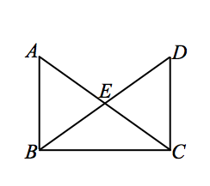
Classwork
Exercises 1–6
- Given: $\overline{AB}⊥\overline{BC}$,$\overline{BC}⊥\overline{DC}$.
$\overline{DB}$ bisects $∠ABC$, $\overline{AC}$ bisects $∠DCB$.
$EB=EC$.
Prove: $△BEA≅△CED$.

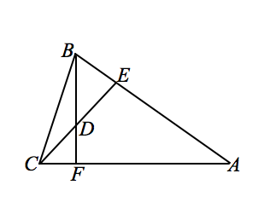

- Given: $BF⊥AC, CE⊥AB.$
$AE=AF$.
Prove: $△ACE≅ABF$.

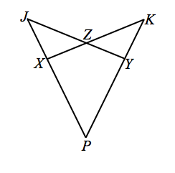
- Given: $XJ=YK$,$PX=PY$,$∠ZXJ=∠ZYK$.
Prove: $JY=KX$.

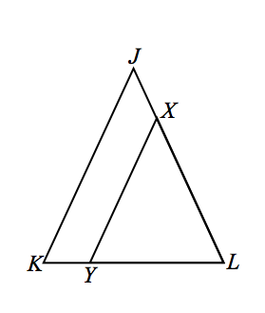

- Given: $JK=JL$,$\overline{JK}∥\overline{XY}$.
Prove: $XY=XL$.

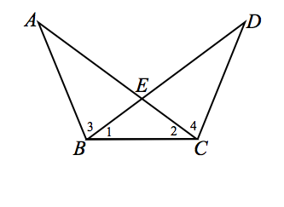
- Given: $∠1≅∠2$,$∠3≅∠4$.
Prove: $\overline{AC}≅\overline{BD}$.

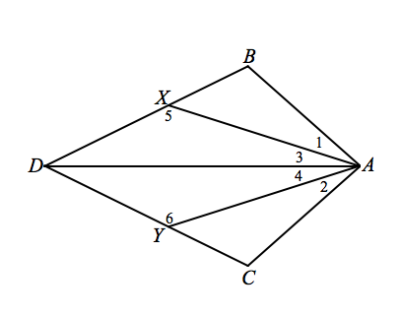
- Given: $m∠1=m∠2$,$m∠3=m∠4$,$AB=AC$.
Prove: (a) $△ABD≅ △ACD$.
(b) $m∠5=m∠6$.

Problem Set

Use your knowledge of triangle congruence criteria to write a proof for the following:
In the figure $\overline{RX}$ and $\overline{RY}$ are the perpendicular bisectors of $\overline{AB}$ and $\overline{AC}$, respectively.
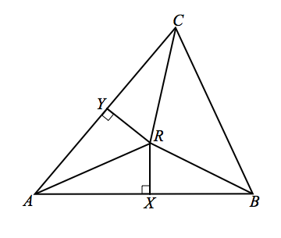
Prove: (a) $△RAX≅△RAY$.
(b) $\overline{RA}≅\overline{RB}≅\overline{RC}$.

