Lesson 26: Triangle Congruency Proofs

Student Outcomes
- Students complete proofs requiring a synthesis of the skills learned in the last four lessons.

Classwork
Exercises 1–6 (40 minutes)
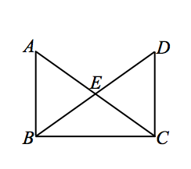
Exercises 1–6
- Given: $\overline{AB}⊥\overline{BC}, \overline{BC}⊥\overline{DC}$.
$\overline{DB}$ bisects $∠ABC$, $\overline{AC}$ bisects $∠DCB$.
$EB=EC$.
Prove: $△BEA≅△CED$.

$\overline{AB}⊥\overline{BC}$, $\overline{BC}⊥\overline{DC}$ Given
$m∠ABC=90°$, $m∠DCB=90°$ Definition of perpendicular lines
$m∠ABC=m∠DCB$ Transitive property
$\overline{DB}$ bisects $∠ABC$, $\overline{AC}$ bisects $∠DCB$ Given
$m∠ABE=45°$, $m∠DCE=45°$ Definition of an angle bisector
$EB=EC$ Given
$m∠AEB=m∠DEC$ Vertical angles are equal in measure
$△BEA≅ △CED$ ASA
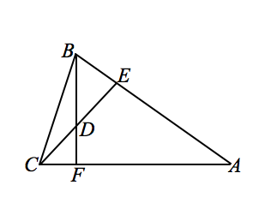
- Given: $\overline{BF}⊥\overline{AC}, \overline{CE}⊥\overline{AB}$.
$AE=AF$.
Prove: $△ACE≅ABF$.

$\overline{BF}⊥\overline{AC}$, $\overline{CE}⊥\overline{AB}$ Given
$m∠BFA=90°$, $m∠CEA=90°$ Definition of perpendicular
$AE=AF$ Given
$m∠A=m∠A$ Reflexive property
$△ACE≅ △ABF$ ASA

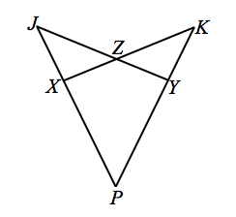
- Given: $XJ=YK, PX=PY, ∠ZXJ≅∠ZYK$.
Prove: $JY=KX$.

$XJ=YK$,$PX=PY$,$∠ZXJ≅∠ZYK$ Given
$\overline{JP}≅\overline{KP}$ Segment addition
$m∠JZX=m∠KZY$ Vertical angles are equal in measure.
$△JZX≅△KZY$ AAS
$∠J≅∠K$ Corresponding angles of congruent triangles are congruent
$∠P≅∠P$ Reflexive property
$△PJY≅ △PKX$ AAS
$\overline{JY}≅\overline{KX}$ Corresponding sides of congruent triangles are congruent
$JY=KX$ Definition of congruent segments
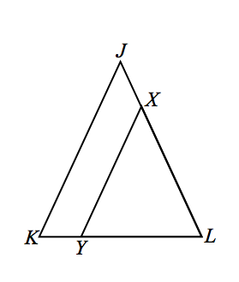
- Given: $JK=JL$,$\overline{JK}∥\overline{XY}$.
Prove: $XY=XL$.

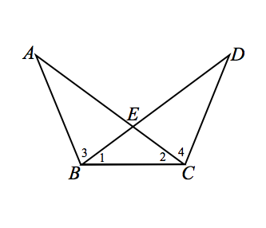
$JK=JL$ Given
$m∠K=m∠L$ Base angles of an isosceles triangle are equal in measure
$\overline{JK}∥\overline{XY}$ Given
$m∠K=m∠XYL$ When two parallel lines are cut by a transversal, corresponding angles are equal in measure
$m∠XYL=m∠L$ Transitive property
$XY=XL$ If two angles of a triangle are congruent, then the sides opposite the angles are equal in length

- Given: $∠1≅∠2$, $∠3≅∠4$.
Prove: $\overline{AC}≅\overline{BD}$.

$∠1≅∠2$ Given
$\overline{BE}≅\overline{CE}$ When two angles of a triangle are congruent, it is an isosceles triangle
$∠3≅∠4$ Given
$∠AEB≅∠DEC$ Vertical angles are congruent
$△ABC≅ △DCB$ ASA
$∠A≅∠D$ Corresponding angles of congruent triangles are congruent
$\overline{BC}≅\overline{BC}$ Reflexive property
$△ABC≅ △DCB$ AAS
$\overline{AC}≅\overline{BD}$ Corresponding sides of congruent triangles are congruent

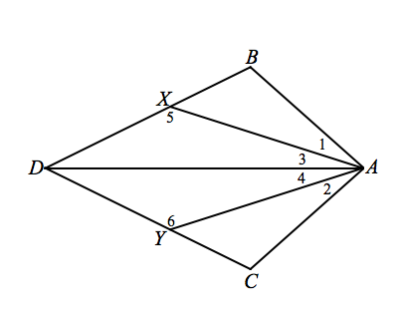
- Given: $m∠1=m∠2$,$m∠3=m∠4$,$AB=AC$.
Prove: (a) $△ABD≅ △ACD$.
(b) $∠5≅∠6$.
$m∠1=m∠2$,$m∠3=m∠4$ Given
$m∠1+m∠3=m∠DAB$,
$m∠2+m∠4=m∠DAC$ Angle addition postulate
$m∠DAB=m∠DAC$ Substitution property of equality
$AD=AD$ Reflexive property
$△ABD≅ △ACD$ SAS
$∠BDA≅∠VDA$ Corresponding angles of congruent triangles are congruent
$△DXA≅ △DYA$ ASA
$∠5≅∠6$ Corresponding angles of congruent triangles are congruent

Exit Ticket (5 minutes)
Name ___________________________________________________ Date____________________
Lesson 26: Triangle Congruency Proofs

Exit Ticket

Identify the two triangle congruence criteria that do NOT guarantee congruence. Explain why they do not guarantee congruence and provide illustrations that support your reasoning.

Exit Ticket Sample Solutions

Identify the two triangle congruence criteria that do NOT guarantee congruence. Explain why they do not guarantee congruence and provide illustrations that support your reasoning.
Students should identify AAA and SSA as the two types of criteria that do not guarantee congruence. Appropriate illustrations should be included with their justifications.

Problem Set Sample Solutions

Use your knowledge of triangle congruence criteria to write a proof for the following:
In the figure $\overline{RX}$ and $\overline{RY}$ are the perpendicular bisectors of $\overline{AB}$ and $\overline{AC}$, respectively.
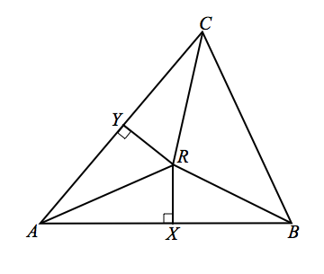
Prove: (a) $△RAX≅ △RAY$.
(b) $\overline{RA}≅\overline{RB}≅\overline{RC}$.
$\overline{RX}$ is the perpendicular bisector of $\overline{AB}$ Given
$\overline{RY}$ is the perpendicular bisector of $\overline{AC}$ Given
$m∠RYA=90°$, $m∠RXA=90°$ Definition of perpendicular bisector
$\overline{AR}≅\overline{AR}$ Reflexive property
$△RAX$,$△RAY$ are right triangles Definition of right triangle
$△RAX≅ △RAY$ HL
$m∠RYC=90°$, $m∠RXB=90°$ Definition of perpendicular bisector
$\overline{AX}≅\overline{XB}$, $\overline{AY}≅\overline{YC}$ Definition of perpendicular bisector
$\overline{YR}≅\overline{YR}$, $\overline{XR}≅\overline{XR}$ Reflexive property
$△RAY≅ △RCY$, $△RAX≅ △RBX$ SAS
$△RBX≅ △RAX≅ △RAY≅ △RCY$ Transitive property
$\overline{RA}≅\overline{RB}≅\overline{RC}$ Corresponding sides of congruent triangles are congruent

