Lesson 27
Objective: Share and critique peer strategies for solving problems of varied types.

Suggested Lesson Structure
 Fluency Practice (13 minutes)
 Concept Development (37 minutes)
 Student Debrief (10 minutes)
Total Time (60 minutes)
Fluency Practice (13 minutes)
- Core Fluency Differentiated Practice Sets 1.OA.6 (5 minutes)
- Standards Check: Shapes 1.G.1, 1.G.2 (8 minutes)
Core Fluency Differentiated Practice Sets (5 minutes)
Materials: (S) Core Fluency Practice Sets from G1–M6–Lesson 1
Note: Give the appropriate Practice Set to each student. Help students become aware of their improvement. After students do today’s Practice Sets, ask them to stand if they tried a new level today or improved their score from the previous day. Consider having students clap once for each person standing to celebrate improvement.
Students complete as many problems as they can in 90 seconds. Assign a counting pattern and start number for early finishers, or have them practice make ten addition or subtraction on the back of their papers. Collect and correct any Practice Sets completed within the allotted time.
Standards Check: Shapes (8 minutes)
Materials: (T) Two-dimensional shape flashcards, three-dimensional objects used in G1–M5–Lesson 3
(S) Personal white boards with shapes template
Note: This activity reviews the attributes and names of two-dimensional and three-dimensional shapes. Remember that a square is also a rectangle and a rhombus, and a cube is also a rectangular prism.
- Invite students to look at their templates and read the names of the two-dimensional shapes and attributes with you. Show a shape card or object. Students circle the name(s) of the shape and complete the attributes section. Repeat for all two-dimensional shapes.
- Invite students to look at their templates and read the names of the three-dimensional shapes and attributes with you. Show a three-dimensional object. Students circle the name(s) of the shape and complete the attributes section. Repeat for all two-dimensional shapes.
- Show two- or three-dimensional shapes. Ask students to circle the other shapes that could be used, if any, to create them.
Concept Development (37 minutes)
Materials: (T) Chart paper (S) Problem Set
Students sit at the tables next to their partner with their materials.
Note: In today’s lesson, students work on their Problem Set and solve varied problem types they encountered throughout the year. Selected pairs of students then discuss their methods for solving the problems and explain their work. After they share, the whole class participates in a discussion as students make comments and suggestions and ask each other questions.
- How does your work or tape diagram help you solve the problem?
MP.3
- A compliment I could give you is….
MP.3
MP.3
- A question I have for you is….
MP.3
- One way you might improve your work would be….
- Let’s look for similarities and differences in our drawings and strategies.
Suggested Delivery of Instruction for Sharing and Critiquing Peer Strategies
1. Solve varied problem types using the RDW process.

NOTES ON
MULTIPLE MEANS OF ENGAGEMENT:
Observe levels of student understanding and select the most appropriate problem type to focus on during today’s Concept Development.
For each story problem, invite two pairs of students to model their work on chart paper while the others work independently or in pairs. Choose new pairs for each problem and consider selecting students who use varied strategies for solving.
As students work, circulate and provide support. Some students may feel stuck and struggle with picking the appropriate method or choosing between a single or a double tape diagram to use. Encourage and support them in learning to persevere and make sense of the problems.
2. In partnerships, share and critique peer strategies.
Give students one to two minutes to explain their methods of solving and how they found their solution with their partners or with another pair of students.
3. As a class and with partners, share and critique peer strategies.
For Problems 1 and 2, share and critique peer strategies as a class. For about one minute, have the demonstrating students share their methods and explain their work. The rest of the class may raise questions, and the presenters respond to feedback and questions from their peers. For the remaining problems, have students share and critique with their partner using the chart with question frames. Finally, all students return to their work and make improvements.
Problem 1 (Add to with change unknown.)

NOTES ON
MULTIPLE MEANS
OF ACTION AND EXPRESSION:
If students struggle with computation, use smaller numbers or numbers that are close together so students can focus on how to interpret and solve different problem types.

Nine letters came in the mail on Monday. Some more letters were delivered on Tuesday. Then there were 13 letters. How many letters were delivered on Tuesday?
Note: Students have worked with this problem type throughout the year. Some students may use addition to solve while others use subtraction. It is important to see that different operations can be used as long as the story problem has been analyzed accurately.
Problem 2 (Take apart with addend unknown.)
Ben and Tamra found a total of 18 seeds in their watermelon slices. Ben found 7 seeds in his slice. How many seeds did Tamra find?
Note: Like Problem 1, students may solve using addition or subtraction. Larger numbers are used within the problem, which may also promote conversation about place value as students discuss their solution strategies.
Problem 3 (Add to with start unknown.)
Some children were playing on the playground. Eight children came to join, and now there are 14 children. How many children were on the playground in the beginning?
Note: Problem 3 is challenging because it begins with an unknown. If you are noticing that both members of a partnership are struggling, remind them to read the story one sentence at a time and check that their drawing represents each sentence. Students might use concrete manipulatives and then draw after they understand the relationships within the problem.
Problem 4 (Compare with difference unknown.)
Willie walked for 7 minutes. Peter walked for 14 minutes. How much shorter in time was Willie’s walk?
Note: This problem challenges students to notice that they are working with a comparison problem type.
Problem 5 (Compare with bigger unknown.)
Emi saw 12 ants walking in a row. Fran saw 6 more ants than Emi. How many ants did Fran see?
Note: Students must recognize that the second sentence in this story problem only gives part of the necessary information to determine how many ants Fran saw. Support students with questions such as, “Who are the characters? Who saw more ants? What can you draw?”
Problem 6 (Compare with smaller unknown)
Shanika has 13 cents in her front pocket. She has 8 fewer cents in her back pocket. How many cents does Shanika have in her back pocket?
Note: Problem 6 presents some of the same challenges as Problem 5, this time using the term fewer. Support students with questions such as, “Are you comparing or are you putting together? What are you comparing? What can you draw?”
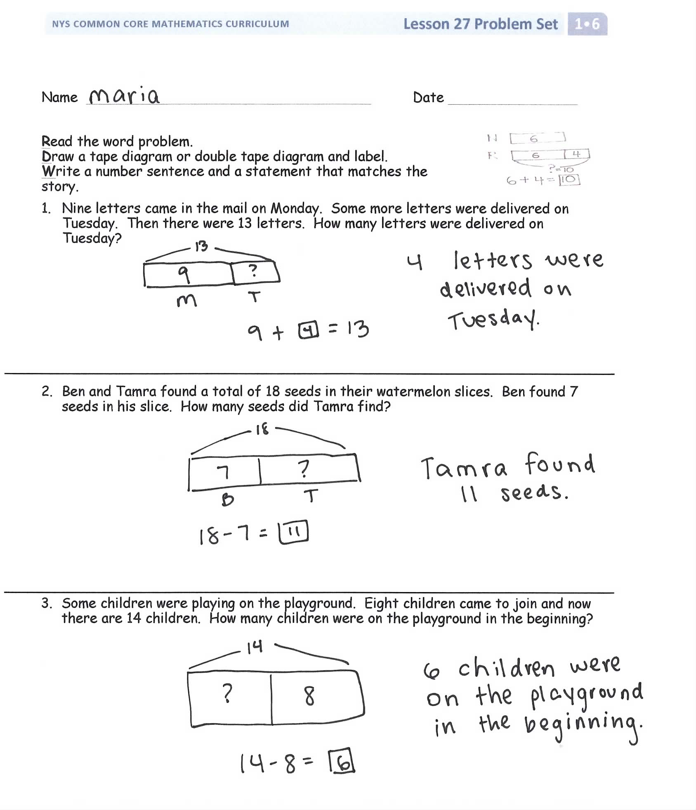
Problem Set (10 minutes)
Students should do their personal best to complete the Problem Set within the allotted 10 minutes. For some classes, it may be appropriate to modify the assignment by specifying which problems they work on first. Some problems do not specify a method for solving. Students solve these problems using the RDW approach used for Application Problems.
Student Debrief (10 minutes)
Lesson Objective: Share and critique peer strategies for solving problems of varied types.
The Student Debrief is intended to invite reflection and active processing of the total lesson experience.
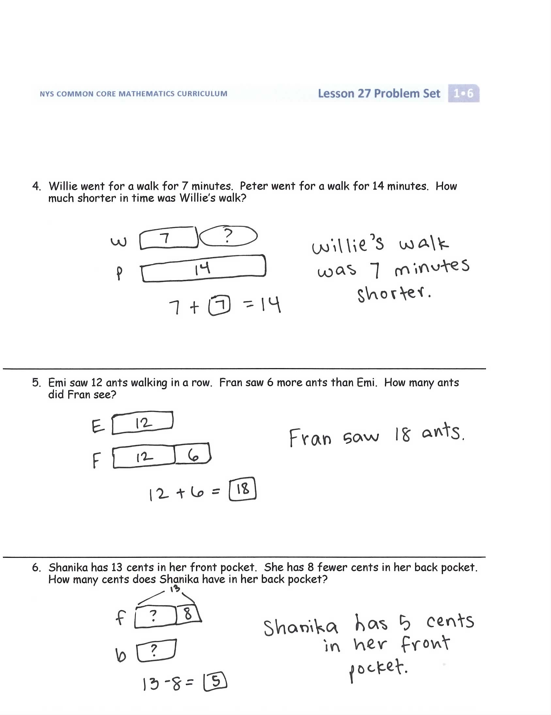
Invite students to review their solutions for the Problem Set. They should check work by comparing answers with a partner before going over answers as a class. Look for misconceptions or misunderstandings that can be addressed in the Debrief. Guide students in a conversation to debrief the Problem Set and process the lesson.
You may choose to use any combination of the questions below to lead the discussion.
- Which problems did you and your partner find challenging today? How did your discussion help you to solve the problem or to improve your strategies for solving the problem?
- What were some of the similarities in the way you and your partner drew and solved the problems? What were some of the differences?
- How did seeing your partner’s work help improve your own work? Show your improvement to the class.
- What compliments did you give your partner about her work? Show the class an example of your partner’s work.
Exit Ticket (3 minutes)
After the Student Debrief, instruct students to complete the Exit Ticket. A review of their work will help you assess the students’ understanding of the concepts that were presented in the lesson today and plan more effectively for future lessons. You may read the questions aloud to the students.

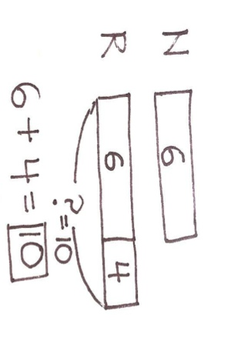
Name Date

Read the word problem.
Draw a tape diagram or double tape diagram and label.
Write a number sentence and a statement that matches the story.

- Nine letters came in the mail on Monday. Some more letters were delivered on Tuesday. Then there were 13 letters. How many letters were delivered on Tuesday?

- Ben and Tamra found a total of 18 seeds in their watermelon slices. Ben found 7 seeds in his slice. How many seeds did Tamra find?

- Some children were playing on the playground. Eight children came to join, and now there are 14 children. How many children were on the playground in the beginning?

- Willie went for a walk for 7 minutes. Peter went for a walk for 14 minutes. How much shorter in time was Willie’s walk?

- Emi saw 12 ants walking in a row. Fran saw 6 more ants than Emi. How many ants did Fran see?

- Shanika has 13 cents in her front pocket. She has 8 fewer cents in her back pocket. How many cents does Shanika have in her back pocket?

Name Date

Read the word problem.
Draw a tape diagram or double tape diagram and label.
Write a number sentence and a statement that matches the story.
- Emi tried on 8 fewer costumes than Nikil. Emi tried on 4 costumes. How many costumes did Nikil try on?

Name Date

Read the word problem.
Draw a tape diagram or double tape diagram and label.
Write a number sentence and a statement that matches the story.
- Eight students lined up to go to art. Some more lined up to go to music. Then there were 12 students in line. How many students lined up to go to music?

- Peter rode his bike 5 blocks. Rose rode her bike 13 blocks. How much shorter was Peter’s ride?

- Lee and Anton collected 16 leaves on their walk. Nine of the leaves were Lee’s. How many leaves were Anton’s?

- The team counted 11 soccer balls inside the net. They counted 5 fewer soccer balls outside of the net. How many soccer balls were outside of the net?

- Julio saw 14 cars drive by his house. Julio saw 6 more cars than Shanika. How many cars did Shanika see?

- Some students were eating lunch. Four students joined them. Now there are 17 students eating lunch. How many students were eating lunch in the beginning?
2-D SHAPES  circle  triangle  rectangle  rhombus  square  trapezoid  hexagon | 3-D SHAPES  sphere  cone  cylinder  rectangular prism  cube
____ corners  ____ square corners  ____ sides  Are all sides the same length?  yes no | ____ corners  ____ faces  ____ straight edges  Are all faces the same shape?  yes no

