Lesson 8: Representing Proportional Relationships with Equations

Classwork
Points to remember:
- Proportional relationships have a constant ratio, or unit rate.
- The constant ratio, or unit rate of $\frac{y}{x}$, can also be called the constant of proportionality.

Discussion Notes
How could we use what we know about the constant of proportionality to write an equation?

Example 1: Do We have Enough Gas to Make it to the Gas Station?
Your mother has accelerated onto the interstate beginning a long road trip and you notice that the low fuel light is on, indicating that there is a half a gallon left in the gas tank. The nearest gas station is $26$ miles away. Your mother keeps a log where she records the mileage and the number of gallons purchased each time she fills up the tank. Use the information in the table below to determine whether you will make it to the gas station before the gas runs out. You know that if you can determine the amount of gas that her car consumes in a particular number of miles, then you can determine whether or not you can make it to the next gas station.
Mother’s Gas Record
Gallons | Miles driven
$$8$$ | $$224$$
$$10$$ | $$280$$
$$4$$ | $$112$$
  - Find the constant of proportionality and explain what it represents in this situation.

  - Write equation(s) that will relate the miles driven to the number of gallons of gas.

  - Knowing that there is a half-gallon left in the gas tank when the light comes on, will she make it to the nearest gas station? Explain why or why not.

  - Using the equation found in part (b), determine how far your mother can travel on $18$ gallons of gas. Solve the problem in two ways: once using the constant of proportionality and once using an equation.

  - Using the constant of proportionality, and then using the equation found in part (b), determine how many gallons of gas would be needed to travel $750$ miles.

Example 2: Andrea’s Portraits
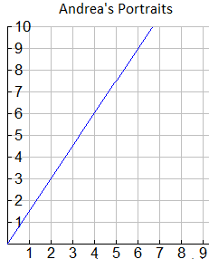
Andrea is a street artist in New Orleans. She draws caricatures (cartoon-like portraits) of tourists. People have their portrait drawn and then come back later to pick it up from her. The graph below shows the relationship between the number of portraits she draws and the amount of time in hours she needs to draw the portraits.
Number of portraits drawn (N)
Time spent drawing portraits (T)

  - Write several ordered pairs from the graph and explain what each ordered pair means in the context of this graph.

  - Write several equations that would relate the number of portraits drawn to the time spent drawing the portraits.

  - Determine the constant of proportionality and explain what it means in this situation.

Lesson Summary
If a proportional relationship is described by the set of ordered pairs that satisfies the equation $y=kx$, where $k$ is a positive constant, then $k$ is called the constant of proportionality. The constant of proportionality expresses the multiplicative relationship between each $x$-value and its corresponding $y$-value.

Problem Set

Write an equation that will model the proportional relationship given in each real-world situation.
- There are $3$ cans that store $9$ tennis balls. Consider the number of balls per can.
  - Find the constant of proportionality for this situation.
  - Write an equation to represent the relationship.

- In $25$ minutes Li can run $10$ laps around the track. Determine the number of laps she can run per minute.
  - Find the constant of proportionality in this situation.
  - Write an equation to represent the relationship.

- Jennifer is shopping with her mother. They pay $\$2$ per pound for tomatoes at the vegetable stand.
  - Find the constant of proportionality in this situation.
  - Write an equation to represent the relationship.

- It costs $\$15$ to send $3$ packages through a certain shipping company. Consider the number of packages per dollar.
  - Find the constant of proportionality for this situation.
  - Write an equation to represent the relationship.
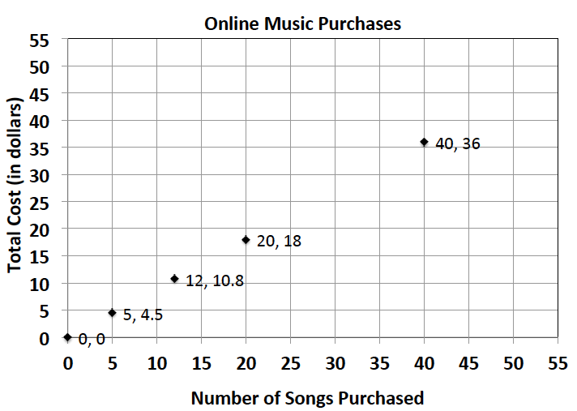
- On average, Susan downloads $60$ songs per month. An online music vendor sells package prices for songs that can be downloaded on to personal digital devices. The graph below shows the package prices for the most popular promotions. Susan wants to know if she should buy her music from this company or pay a flat fee of $\$58.00$ per month offered by another company. Which is the better buy?
  - Find the constant of proportionality for this situation.
  - Write an equation to represent the relationship.
  - Use your equation to find the answer to Susan’s question above. Justify your answer with mathematical evidence and a written explanation.

- Allison’s middle school team has designed t-shirts containing their team name and color. Allison and her friend Nicole have volunteered to call local stores to get an estimate on the total cost of purchasing t-shirts. Print-o-Rama charges a set-up fee, as well as a fixed amount for each shirt ordered. The total cost is shown below for the given number of shirts. Value T’s and More charges $\$8$ per shirt. Which company should they use?
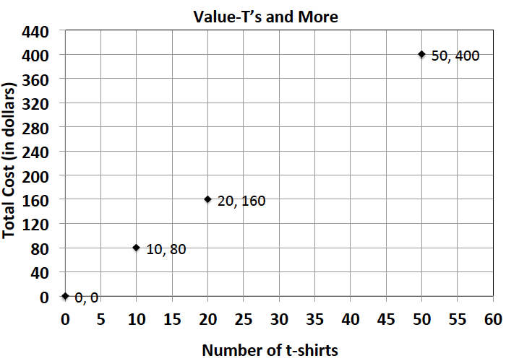
Print-o-Rama

# shirts | Total cost
$$10$$ | $$95$$
$$25$$
$$50$$ | $$375$$
$$75$$
$$100$$

  - Does either pricing model represent a proportional relationship between the quantity of t-shirts and the total cost? Explain.
  - Write an equation relating cost and shirts for Value T’s and More.
  - What is the constant of proportionality Value T’s and More? What does it represent?
  - How much is Print-o-Rama’s set-up fee?
  - Write a proposal to your teacher indicating which company the team should use. Be sure to support your choice. Determine the number of shirts that you need for your team.

