Lesson 26

Objective: Solve *compare with bigger or smaller unknown* problem types.

Suggested Lesson Structure

 Fluency Practice (15 minutes)

 Concept Development (35 minutes)

 Student Debrief (10 minutes)

**Total Time (60 minutes)**

Fluency Practice (15 minutes)

* Core Fluency Differentiated Practice Sets **1.OA.6** (5 minutes)
* Standards Check: Time  **1.MD.3** (5 minutes)
* Fluency Favorite or Standards Review (5 minutes)

Core Fluency Differentiated Practice Sets (5 minutes)

Materials: (S) Core Fluency Practice Sets from G1–M6–Lesson 1

Note: Give the appropriate Practice Set to each student. Students who completed all questions correctly on their most recent Practice Set should be given the next level of difficulty. All other students should try to improve their scores on their current levels.

Students complete as many problems as they can in 90 seconds. Assign a counting pattern and start number for early finishers, or have them practice make ten addition or subtraction on the back of their papers. Collect and correct any Practice Sets completed within the allotted time.

Standards Check: Time (5 minutes)

Materials: (T/S) Personal white boards with time template

Note: This review fluency provides an opportunity to monitor which students can tell and write time in hours and half hours. When students draw hands for times to the half hour, make sure the hour hand is approximately halfway between the numbers.

T: Draw hands on the template’s analog clock to show times to the hour and half hour.

S: (Write the time on the digital clock, and fill in the appropriate sentence frame.)

T: Write times to the hour and half hour on the digital clock.

S: (Draw the hands on the analog clock, and fill in the appropriate sentence frame.)

Fluency Favorite or Standards Review (5 minutes)

If needed, repeat one of the Standards Check fluency activities. If not, select a class favorite fluency activity or begin the Concept Development.

Concept Development (35 minutes)

Materials: (S) Problem Set

Note: By working with double tape diagrams as related to the varying comparison problem types, students have a way to approach any comparison problem.

* How do we set up our story as a tape diagram?

**MP.3**

* Read carefully and determine who has more.
* Is every part of the story represented in your tape diagram?

Suggested Delivery of Instruction for Solving Word Problems

1. Model the problem, calculate, and write a statement.

|  |  |
| --- | --- |
|  | NOTES ON  MULTIPLE MEANS OF REPRESENTATION: |

Encourage students who have difficulty moving to the tape diagram representation as the position of the unknown changes to draw a number bond as part of their work. Some students more easily relate to the tape diagram through its similarities with number bonds.

Choose two pairs of students to work on chart paper while the others work independently or in pairs at their seats. Review the following questions before beginning the first problem:

* How do we set up our story into a double tape diagram?
* Read carefully. Who has more?
* Is every part of the story represented in your tape diagram?

As students work, circulate and support. Some students may feel stuck and struggle with choosing the appropriate method to use. Encourage and support them in learning to persevere and make sense of the problems.

|  |  |
| --- | --- |
|  | NOTES ON  MULTIPLE MEANS  OF ACTION AND EXPRESSION: |
| If students do not have experience with a context such as the one used in Problem 2, act out the problem with a few student volunteers before having the class begin to draw and solve the problem. | |

**MP.1**

**MP.3**

After three minutes, have the two pairs of students share their labeled diagrams. Allow students to briefly question their peers until it is agreed the diagrams or drawings represent the story correctly. Then, give everyone two to three minutes to finish work on that question. All students should write their equations and statements of the answer.

2. Assess the solution for reasonableness.

**MP.3**

Give all students one to two minutes to assess and explain the reasonableness of their solution to a partner. For about one  
minute, have the demonstrating students receive and respond to feedback and questions from their peers.

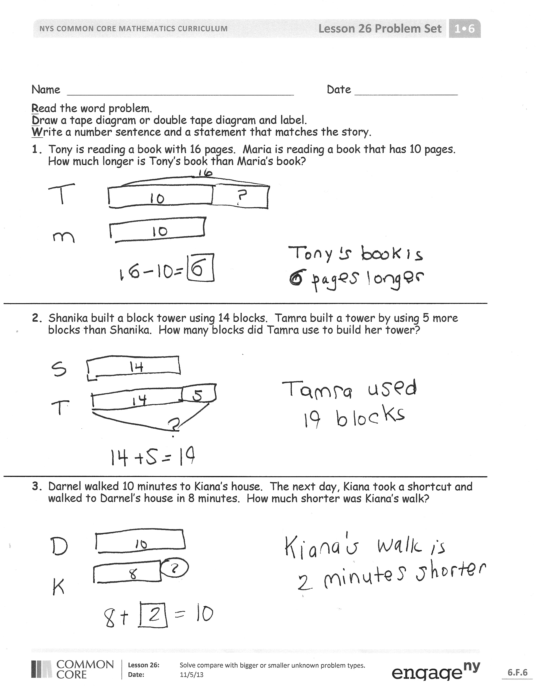3. As a class, notice the ways the drawing depicts the story and the solution.

Ask questions to help students recognize how each part of their diagram matches the story and solution. This will help students begin to see how the same process can help them solve varying word problems. Keep at least one chart paper sample of each solution for reference later in the lesson.

Problem 1 (*Compare with difference unknown.)*

Tony is reading a book with 16 pages. Maria is reading a book with 10 pages. How much longer is Tony’s book?

Note: After the students have explained their tape diagram and solution accurately, point to sections of the tape diagram and ask the class questions such as, “What does this part represent? How do you know?”

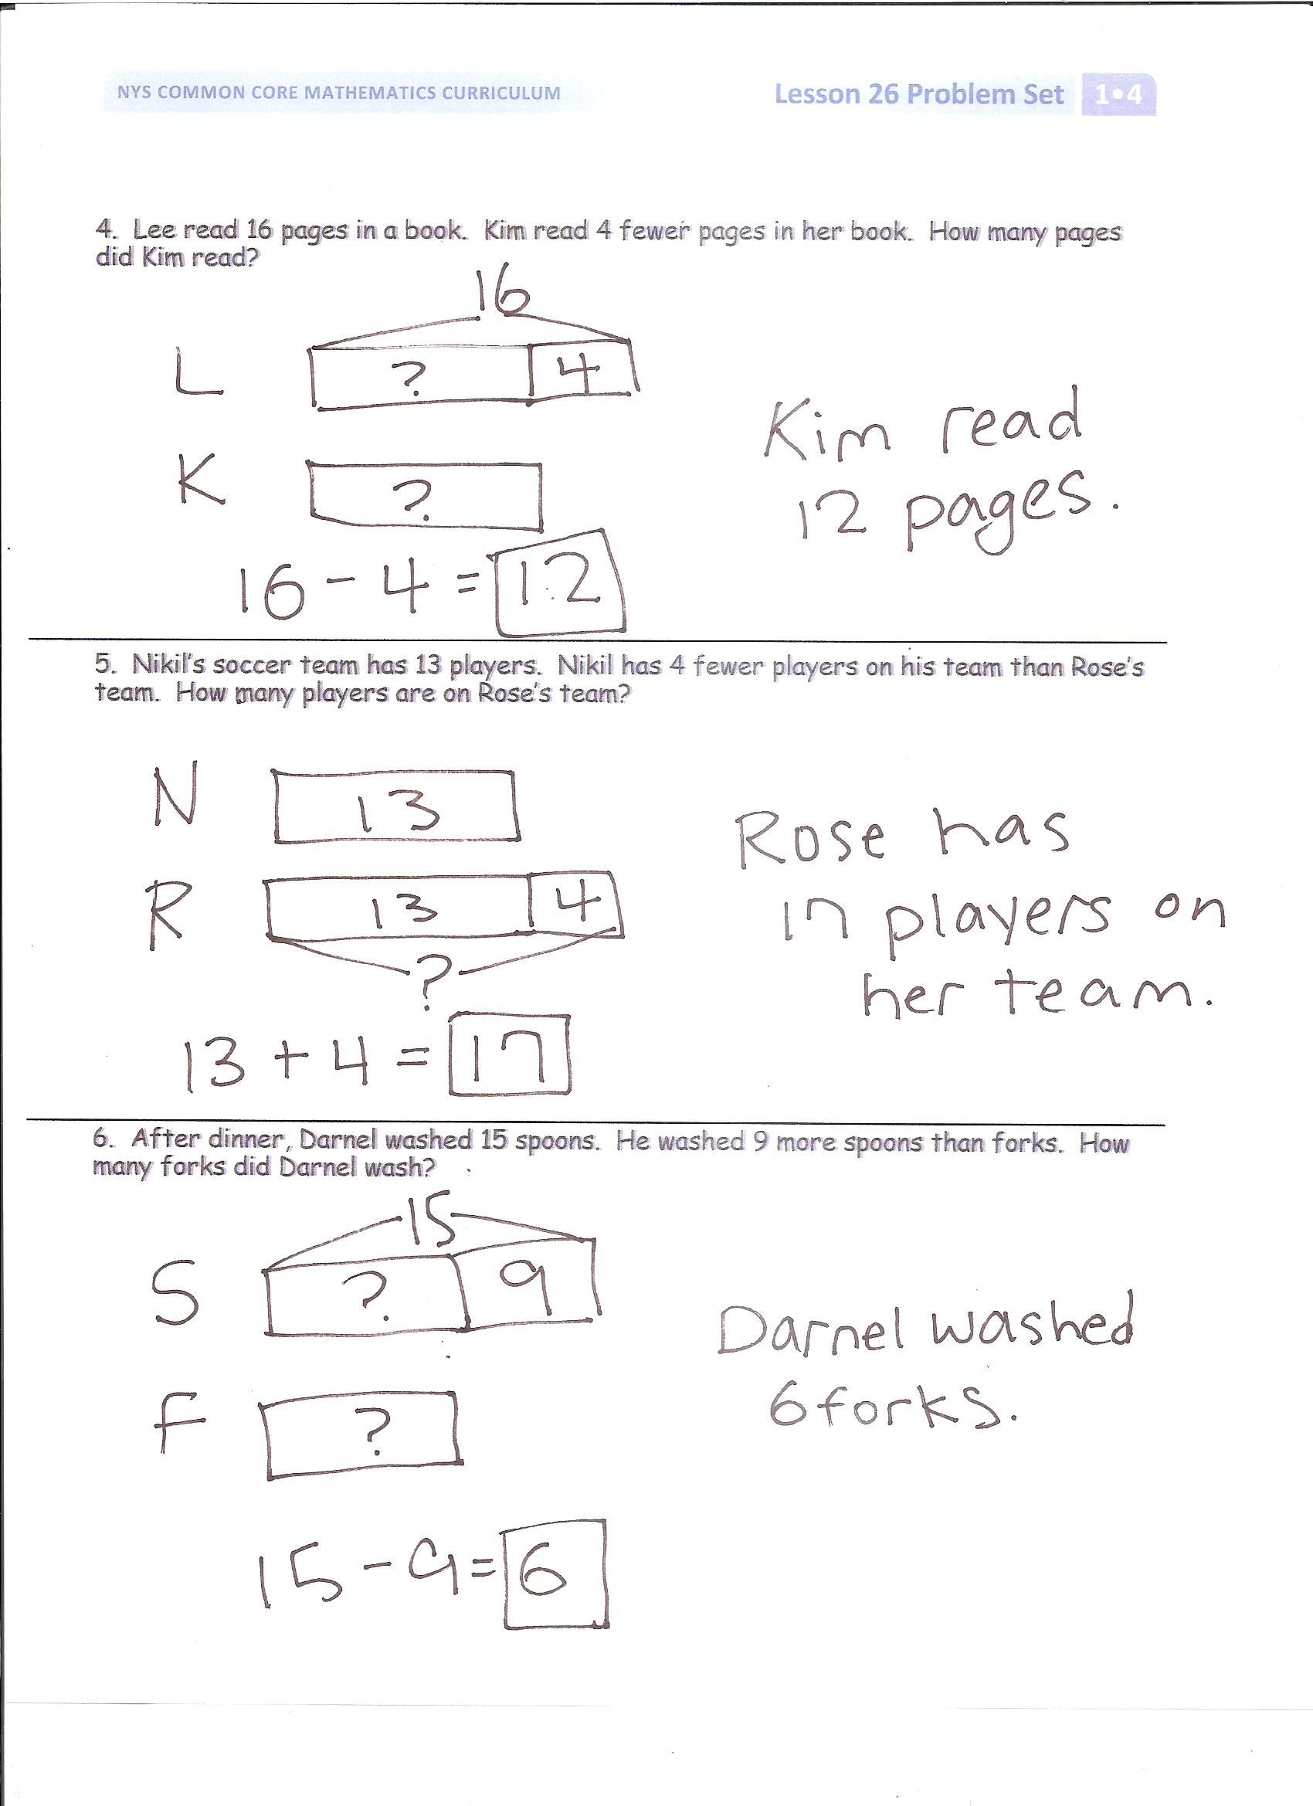For the next five problems have only the students at the board share their work, so that students have time to work through and discuss all six problems. Choose one or two probing questions similar that will support student development as needed.

Problem 2 (*Compare with bigger unknown.)*

Shanika built a block tower using 14 blocks. Tamra built a tower by using 5 more blocks than Shanika. How many blocks did Tamra use to build her tower?

Note: For many children, Problem 2 will be more challenging to solve than Problem 1, because one of the sets being compared (Tamra’s) has a missing part. Some students may quickly find an accurate solution from adding the two numbers (14 + 5) but may not demonstrate understanding in their drawing.

Problem 3 (*Compare with difference unknown.)*

Darnel walked for 10 minutes to get to Kiana’s house. The next day, Kiana took a shortcut and walked to Darnel’s house in 8 minutes. How much shorter in time was Kiana’s walk?

Note: Problem 3 brings students back to a *compare with difference unknown* problem type, which they should be gaining confidence in solving. Celebrate the strategies students are using to achieve such successes as a motivator to continue persevering at problems they initially find challenging.

Problem 4 (*Compare with smaller unknown*.)

Lee read 16 pages in a book. Kim read 4 fewer pages in her book. How many pages did Kim read?

Note: Students sometimes struggle with the term fewer, making Problem 4 more challenging. Using relatively small differences (such as 4) can support students in visualizing the problem and learning the vocabulary.

Problem 5 (*Compare with bigger unknown. More* or *fewer* suggest the incorrect operation.)

Nikil’s soccer team has 13 players. Nikil has 2 fewer players on his team than Rose’s team. How many players are on Rose’s team?

Note: Problem 5 is challenging because *fewe*r *than* suggests the incorrect operation. Similar to Problem 4, the small difference between the two team sizes (2 players) is intentionally selected to support students in working with this challenging problem type.

Problem 6 (*Compare with smaller unknown.* *More* or *fewer* suggest the incorrect operation.)

After dinner, Darnel washed 15 spoons. He washed 9 more spoons than forks. How many forks did Darnel wash?

Note: Problem 6 uses *more than*, but students must subtract to find the number of forks that were washed. As a final problem, notice that the difference between the two sets being compared is 9, a much larger difference than used in the previous two problems.

Problem Set (10 minutes)

Students should do their personal best to complete the Problem Set within the allotted 10 minutes. For some classes, it may be appropriate to modify the assignment by specifying which problems they work on first. Some problems do not specify a method for solving. Students solve these problems using the RDW approach used for Application Problems.

Student Debrief (10 minutes)

**Lesson Objective:** Solve *compare with bigger or smaller unknown* problem types.

The Student Debrief is intended to invite reflection and active processing of the total lesson experience.

Invite students to review their solutions for the Problem Set. They should check work by comparing answers with a partner before going over answers as a class. Look for misconceptions or misunderstandings that can be addressed in the Debrief. Guide students in a conversation to debrief the Problem Set and process the lesson.

You may choose to use any combination of the questions below to lead the discussion.

* Look at Problem 1. What did you draw? How did your drawing help you solve the problem?
* Look at Problem 3. How is your drawing similar or different from the drawing you made for Problem 1?
* Look at Problem 4. How was setting up your drawing similar to Problem 5? Explain your thinking.
* Why is it important to read the stories carefully? When you see the words *more than,* does it always mean you have to add to find your solution? Use examples from your Problem Set to support your thinking.

Exit Ticket (3 minutes)

After the Student Debrief, instruct students to complete the Exit Ticket. A review of their work will help you assess the students’ understanding of the concepts that were presented in the lesson today and plan more effectively for future lessons. You may read the questions aloud to the students.

Name Date

**R**ead the word problem.   
**D**raw a tape diagram or double tape diagram and label. 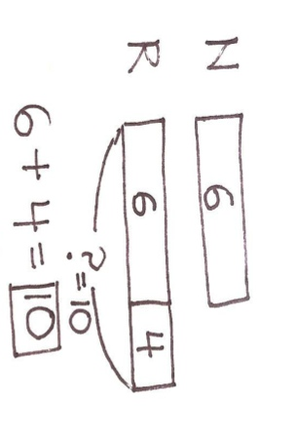  
**W**rite a number sentence and a statement that matches the story.

1. Tony is reading a book with 16 pages. Maria is reading a book that has 10 pages. How much longer is Tony’s book than Maria’s book?
2. Shanika built a block tower using 14 blocks. Tamra built a tower by using 5 more blocks than Shanika. How many blocks did Tamra use to build her tower?
3. Darnel walked 10 minutes to get to Kiana’s house. The next day, Kiana took a shortcut and walked to Darnel’s house in 8 minutes. How much shorter in time was Kiana’s walk?
4. Lee read 16 pages in a book. Kim read 4 fewer pages in her book. How many pages did Kim read?
5. Nikil’s soccer team has 13 players. Nikil has 4 fewer players on his team than Rose’s team. How many players are on Rose’s team?
6. After dinner, Darnel washed 15 spoons. He washed 9 more spoons than forks. How many forks did Darnel wash?

Name Date

**R**ead the word problem.   
**D**raw a tape diagram or double tape diagram and label.   
**W**rite a number sentence and a statement that matches the story.

1. Maria jumped off the diving board into the pool 3 fewer times than Emi. Maria jumped off the diving board 14 times. How many times did Emi jump off the diving board?

Name Date

**R**ead the word problem.   
**D**raw a tape diagram or double tape diagram and label.   
**W**rite a number sentence and a statement that matches the story.

1. Fatima walks 15 blocks home from school. Ben walks 8 blocks. How much longer is Fatima’s walk home from school than Ben’s?
2. Maria bought a basket with 13 strawberries in it. Darnel bought a basket with 4 more strawberries than Maria. How many strawberries did Darnel’s basket have in it?
3. Tamra has 5 books checked out from the library. Kim has 11 books checked out from the library. How many fewer books does Tamra have checked out than Kim?
4. Kiana picked 12 apples from the tree. She picked 6 fewer apples than Willie. How many apples did Willie pick from the tree?
5. During recess, Emi found 16 rocks. She found 5 more rocks than Peter. How many rocks did Peter find?
6. The first grade football team has 12 players. The first grade team has 6 fewer players than the second grade team. How many players are on the second grade team?



:

It is ___ o’clock. It is half past ___.