Lesson 25
Objective: Solve compare with bigger or smaller unknown problem types.

Suggested Lesson Structure
 Fluency Practice (15 minutes)
 Concept Development (35 minutes)
 Student Debrief (10 minutes)
Total Time (60 minutes)
Fluency Practice (15 minutes)
- Grade 1 Core Fluency Sprint 1.OA.6 (10 minutes)
- Standards Check: Add and Subtract Tens 1.NBT.4, 1.NBT.5 (5 minutes)
Grade 1 Core Fluency Sprint (10 minutes)
Materials: (S) Core Fluency Sprint (G1–M5–Lesson 1)
Note: Based on the needs of your class, select a Sprint from yesterday’s materials. There are several possible options available.
- Re-administer the Sprint from the day before.
- Administer the next Sprint in the sequence.
- Differentiate. Administer two different Sprints. Simply have one group do a counting activity on the back of their Sprint while the other Sprint is corrected.
Standards Check: Add and Subtract Tens (5 minutes)
Materials: (S) Personal white boards
Note: This fluency activity monitors students’ ability to add and subtract tens. All students must be able to find ten more or less than a number mentally.
T: What’s ten more than 25?
S: 35.
T: Write the number sentence.
S: (Write 25 + 10 = 35.)
T: What’s ten less than 25?
S: 15.
T: Write the number sentence.
S: (Write 25 – 10 = 15.)
T: Prove it. Draw quick tens and ones.
S: (Draw.)
Repeat with the suggested problem types. Alternate directing students to prove it with a number sentence, a number bond, or quick tens and ones. Include opportunities for students to prove a subtraction problem with an addition sentence (e.g., prove 10 less than 60 is 50 by writing 50 + 10 = 60).
- Mentally calculate 10 more/less than any two-digit number.
- Add and subtract multiples of 10 from multiples of 10, (e.g., 90 – 20; 40 + 50)
- Calculate multiples of 10 more than any two-digit number (e.g., 37 + 40).
Concept Development (35 minutes)
Materials: (T) Chart paper (S) Personal white boards
Note: As students approach each problem, give them the opportunity to persevere and make sense of the problem on their own before intervening. When you feel support is necessary, encourage the student to slow down and read each sentence carefully. During the Student Debrief, recognize the students who have been successful at persevering.
MP.1
Students sit in the meeting area or at their tables with their personal white boards.
Problems 1 and 2: Compare with bigger and smaller unknown problem types with more or fewer suggesting the correct operation.
T: Let’s read our story together.
S/T: Ben played 9 songs on his banjo. Lee played 3 more songs than Ben. How many songs did Lee play?
T: On your personal board, draw and then write a number sentence to match the story. (Circulate and observe students’ solutions.)
S: (Draw and solve.)
T: (Choose a student who made a double tape diagram.) Tell us how you drew your tape diagram.
S: First, I made Ben’s and Lee’s tapes to be equal but I know that’s not true. Lee played 3 more songs. So I drew a more tape next to Lee’s tape and wrote a 3 in it. Then I put 9 in Ben’s tape. I know Lee’s first tape is 9 because it’s the same size as Ben’s tape. Lee’s tape is now 9 and 3. That’s 12 songs.
T: Excellent! What number sentence did we use to match the story?
S: 9 + 3 = 12.
T: What does the nine describe in the story and in our model? (Point.)
S: Ben’s songs.
T: The three? (Point.)
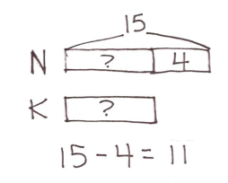S: The extra songs Lee played. The 3 more songs of Lee.
T: The 12? (Point.)
S: How many songs Lee played.
T: Give me a statement answering the question.
S: Lee played 12 songs.
Repeat the process using the problem given below:
Nikil hopped on one leg 15 times in a row. Kim hopped 4 fewer times. How many times did Kim hop on one leg?
Problem 3: Compare with smaller unknown problem type with more suggesting the incorrect operation.
T: Let’s read our next story problem together.
S/T: Shanika went down the slide 15 times. She went down 3 more times than Fran. How many times did Fran go down the slide?
T: Let’s draw a double tape diagram since we need to find out how many times Fran went down the slide.
T: (Write S and F and draw same size tapes as shown to the right.) We need to first ask ourselves what?
S: Who has more?
T: Yes! Read the story again carefully. (Wait.) Who has more? Who went down the slide more times?
S: Shanika!
T: (Draw a more tape next to Shanika’s first tape.) How many more?
S: 3 more!
T: (Write 3 in the more tape.) Let’s go back to the story and read the first sentence.
S/T: Shanika went down the slide 15 times.
T: Where should we put the 15? Turn and talk to your partner.
S: We can put it in the first part of Shanika’s tape.
T: Who agrees? Who disagrees? (Choose a student who disagrees.) Tell us why. (Demonstrate as the student explains.)
S: If we put 15 in the first part of her tape, then it will show that Shanika went down the slide 18 times because her tape will show 15 and 3.
T: You’re correct. That does not match the first sentence of our story problem, so where would we write 15?
S: Draw the arms to include both parts of Shanika’s tape. The whole tape is 15!
T: (Demonstrate.) Yes! That makes sense! Let’s read the second sentence.
S/T: She went down 3 more times than Fran.
T: Did we take care of that in our drawing? How?
S: Yes! We added a more tape for Shanika and wrote 3 inside.
T: Let’s read the last sentence.
S/T: How many times did Fran go down the slide?
T: Fran’s tape gets the question mark since that’s the unknown. Turn and talk to your partner about how you can solve Fran’s amount.
S: We know that the first part of Shanika’s tape is equal to Fran’s tape, so we can just figure out Shanika’s first part. That’s easy to do. We know the total is 15 and one part is 3. 15 – 3 gives us the other part. It’s 12! Shanika’s first part is 12, so Fran’s tape must be 12, too!
T: So how many times did Fran go down the slide?
S: 12 times!
T: Take a moment to match the story to the model with your partner.
T: (Allow students sharing time.) What number sentence can we use to match this problem?
S: 15 – 3 = 12.
T: Tell your partner what each number in the sentence is telling about in the story and then tell a statement that answers the question.
S: (Discuss referents.) Shanika went down the slide 12 times.
Repeat the process using the problem below:
Martha picked up 15 rocks on the beach. She picked up 8 more than Peter. How many rocks did Peter pick up at the beach?
Problem 4: Compare with bigger unknown problem type with fewer suggesting the incorrect operation.
T: Let’s read the next story.
S/T: Anton caught 10 fireflies. He caught 7 fewer fireflies than Julio. How many fireflies did Julio catch?
T: Set up your tape diagram so it shows who the characters are. Make your tapes so they start out having the same amount.
S: (Draw two same-size tapes with labels A and J as shown to the right.)
T: I love how you made each boy have equal size tapes. But is this true?

NOTES ON
MULTIPLE MEANS FOR ACTION AND EXPRESSION:
If students struggle with word problems, consider using either smaller numbers or encouraging students to include circle representations for the objects and then draw rectangles around the circles to create the tape diagrams.
S: No!
T: We have to ask…?
S: Who has more!
T: Okay! Read carefully and find out who has more. Then add the more tape in your drawing.
S: (Develop tape diagram as the teacher circulates and gives support to students.)
T: (Select a student who showed 7 more for Julio.)
S: I know that Julio has 7 more because the story said Anton caught 7 fewer fireflies, so I gave Julio the more tape and wrote 7 inside.
T: Excellent. Now that we have our tape diagram all set up, let’s read the first sentence.
S/T: Anton caught 10 fireflies.
T: Decide where this information will go in your tape diagram.
S: (Write 10 in Anton’s tape.)
T: Read the next sentence.
S: He caught 7 fewer fireflies than Julio.
T: Check your tape diagram. Did we include this information correctly?
S: Yes!

NOTES ON
MULTIPLE MEANS OF REPRESENTATION:
Some students may find it helpful to use linking cubes to represent the problems. Students can use different color linking cubes for each part being represented, and then draw the tape diagrams to match their concrete representations.

T: Explain to your partner how you showed this in your tape diagram.
S: Anton caught 7 fewer fireflies, so that means Julio caught 7 more. We added the “more” tape to Julio’s first tape.
T: How many fireflies did Julio catch? Where does the question mark for the unknown go?
S: All of Julio’s tape! Draw arms to include both parts.
T: How many fireflies did Julio catch? Go ahead and solve. Turn and talk to your partner about how you got your answer.
S: (Solve and discuss.)
T: How did you find your answer?
S: I know that Julio’s first part is the same as Anton’s tape. That’s 10. Julio had 7 more. So 10 + 7 = 17. Julio caught 17 fireflies!
T: Excellent work. I’m especially proud of how carefully you read to find out who had more in every story.
Repeat the process using:
Darnel has 13 baseball cards. He has 4 fewer than Willie. How many baseball cards does Willie have?
Problem Set (10 minutes)
Students should do their personal best to complete the Problem Set within the allotted 10 minutes. For some classes, it may be appropriate to modify the assignment by specifying which problems they work on first. Some problems do not specify a method for solving. Students solve these problems using the RDW approach used for Application Problems.

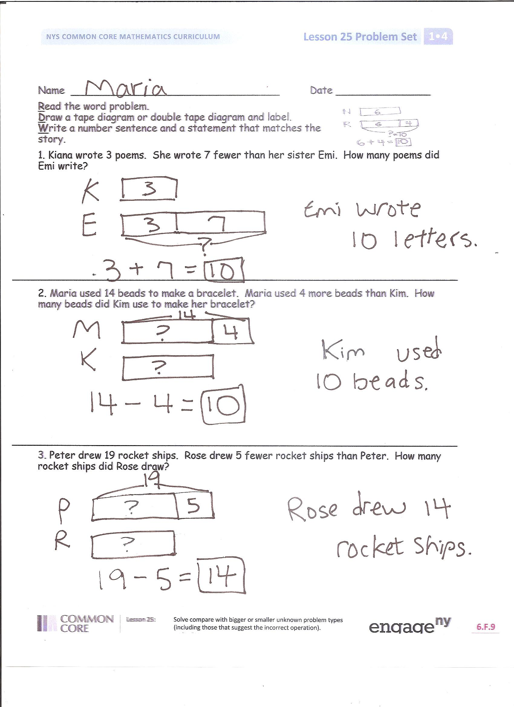
Student Debrief (10 minutes)

Lesson Objective: Solve compare with bigger or smaller unknown problem types.
The Student Debrief is intended to invite reflection and active processing of the total lesson experience.

Invite students to review their solutions for the Problem Set. They should check work by comparing answers with a partner before going over answers as a class. Look for misconceptions or misunderstandings that can be addressed in the Debrief. Guide students in a conversation to debrief the Problem Set and process the lesson. You may choose to use any combination of the questions below to lead the discussion.
- How was setting up your tape diagram for Problem 4 different from Problem 5?
- Why is it easier to use a double tape diagram when we are comparing amounts?

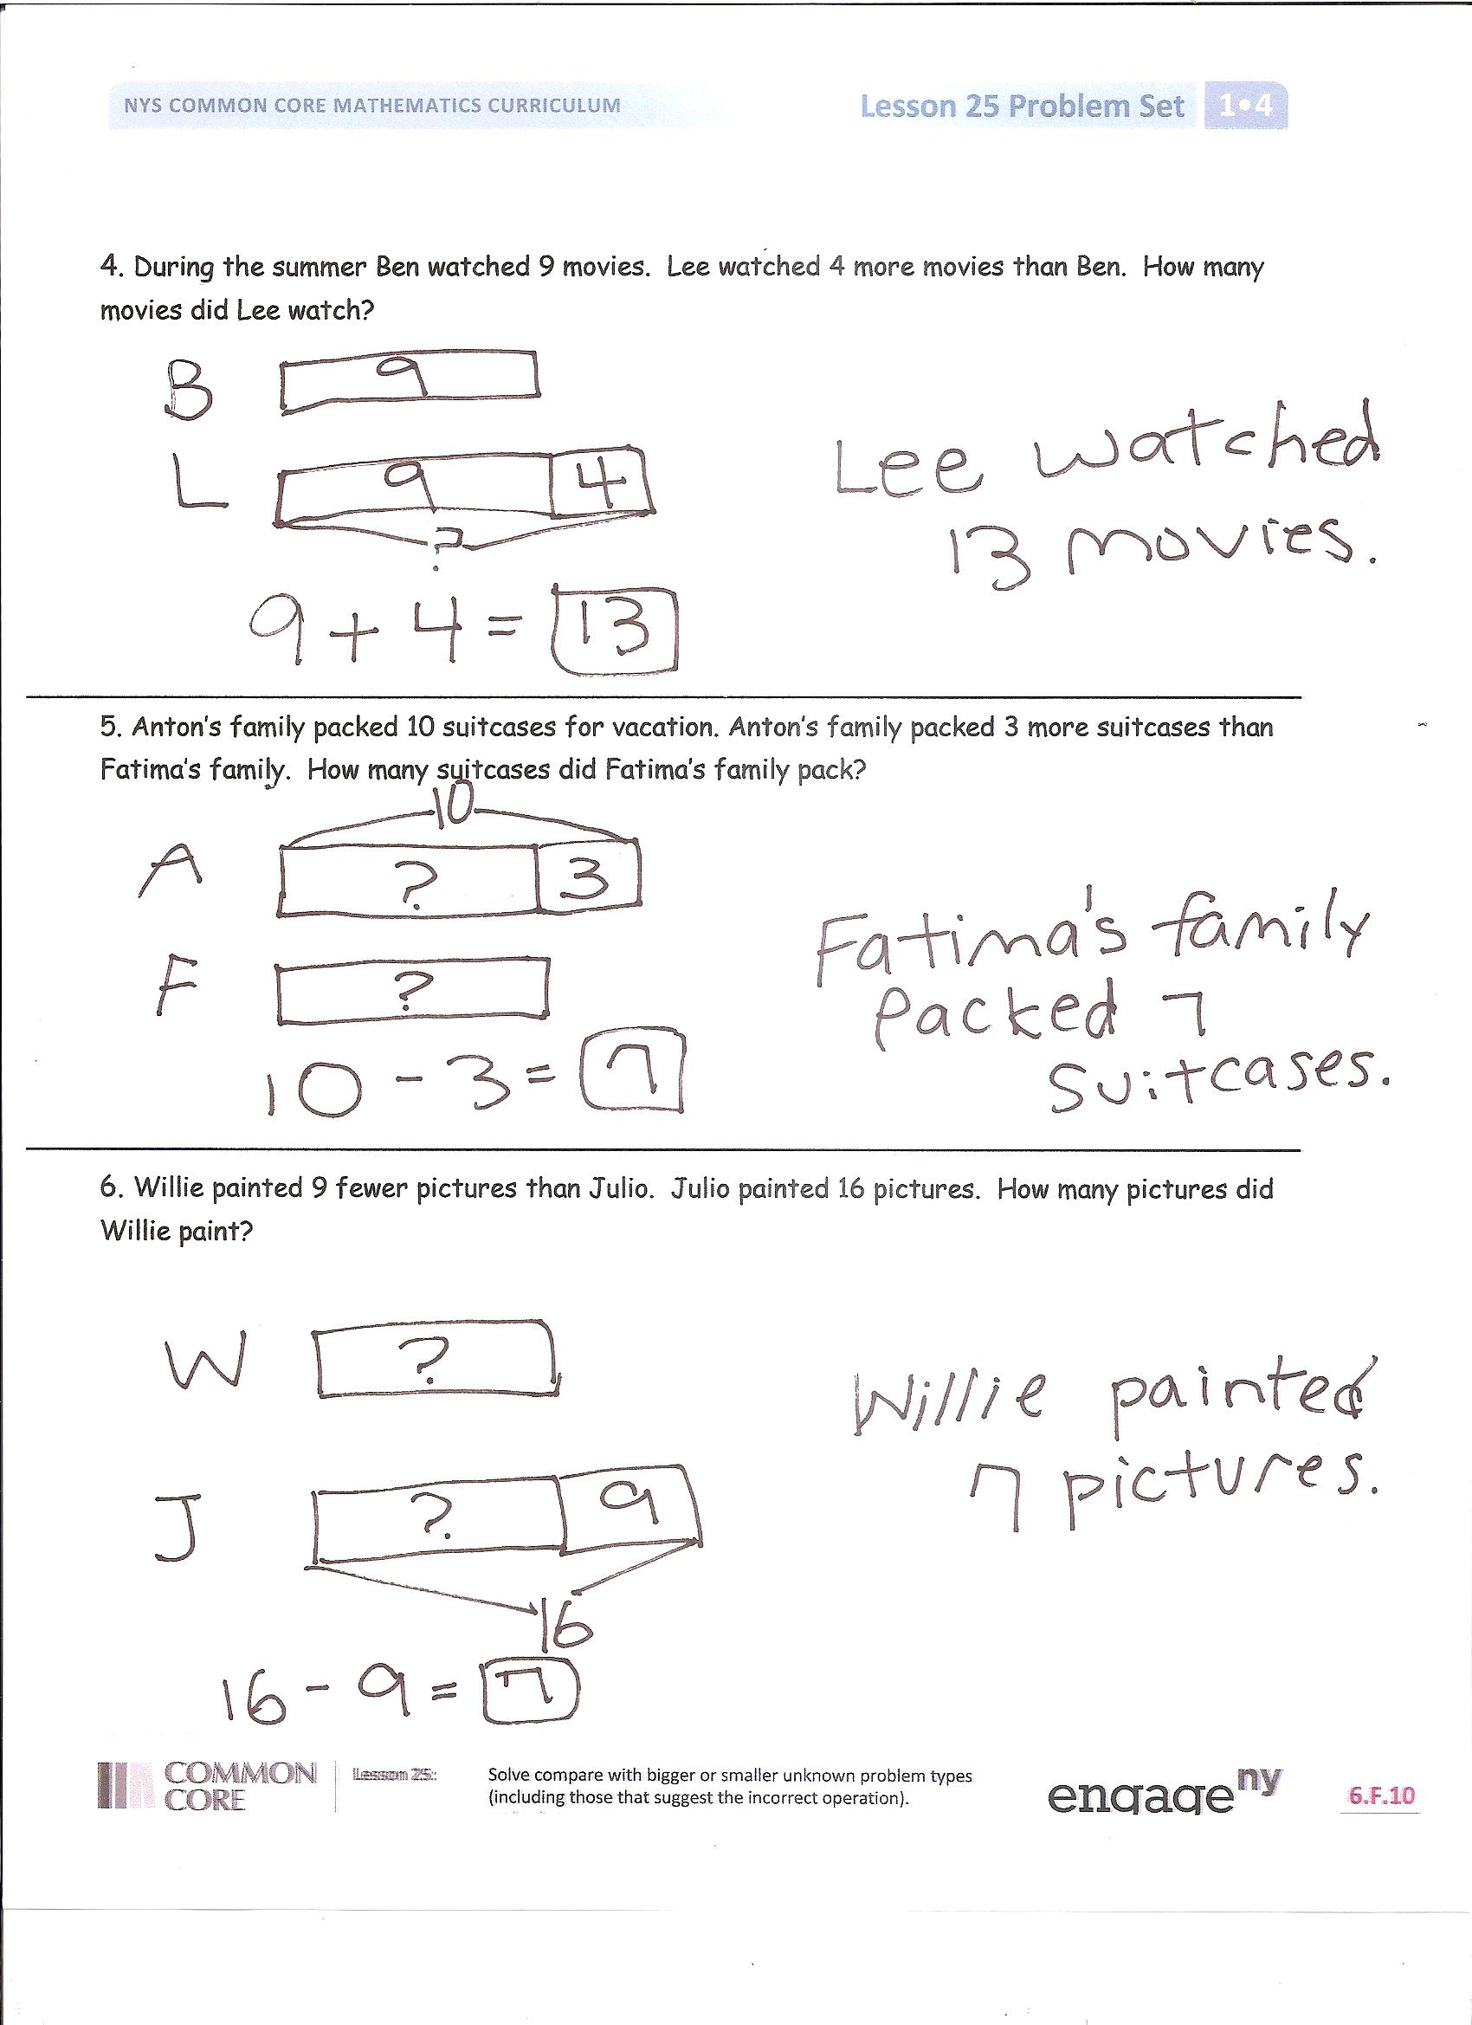
- Why is it important to read every part of the story problem carefully? Give an example using your problem set or from today’s lesson.

- Sometimes going slower when we do math means we are getting smarter. Find an example from your work today when you slowed down to get a problem correct.

Exit Ticket (3 minutes)

After the Student Debrief, instruct students to complete the Exit Ticket. A review of their work will help you assess the students’ understanding of the concepts that were presented in the lesson today and plan more effectively for future lessons. You may read the questions aloud to the students.

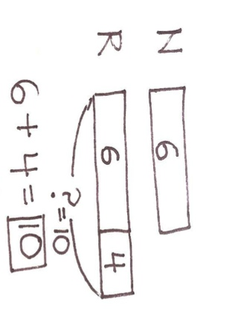
Name Date

Read the word problem.
Draw a tape diagram or double tape diagram and label.
Write a number sentence and a statement that matches the story.
- Kiana wrote 3 poems. She wrote 7 fewer than her sister Emi. How many poems did Emi write?

- Maria used 14 beads to make a bracelet. Maria used 4 more beads than Kim. How many beads did Kim use to make her bracelet?

- Peter drew 19 rocket ships. Rose drew 5 fewer rocket ships than Peter. How many rocket ships did Rose draw?

- During the summer Ben watched 9 movies. Lee watched 4 more movies than Ben. How many movies did Lee watch?

- Anton’s family packed 10 suitcases for vacation. Anton’s family packed 3 more suitcases than Fatima’s family. How many suitcases did Fatima’s family pack?

- Willie painted 9 fewer pictures than Julio. Julio painted 16 pictures. How many pictures did Willie paint?

Name Date

Read the word problem.
Draw a tape diagram or double tape diagram and label.
Write a number sentence and a statement that matches the story.

- Willie splashed in 7 more puddles after the rainstorm than Julio. Willie splashed in 11 puddles. How many puddles did Julio splash in after the rainstorm?

Name Date

Read the word problem.
Draw a tape diagram or double tape diagram and label.
Write a number sentence and a statement that matches the story.

- Julio listened to 7 songs on the radio. Lee listened to 3 more songs than Julio. How many songs did Lee listen to?

- Shanika caught 14 ladybugs. She caught 4 more ladybugs than Willie. How many ladybugs did Willie catch?

- Rose packed 3 more boxes than her sister to move to their new house. Her sister packed 11 boxes. How many boxes did Rose pack?

- Tamra decorated 13 cookies. Tamra decorated 2 fewer cookies than Emi. How many cookies did Emi decorate?

- Rose’s brother hit 12 tennis balls. Rose hit 6 fewer tennis balls than her brother. How many tennis balls did Rose hit?

- With his camera, Darnel took 5 more pictures than Kiana. He took 13 pictures. How many pictures did Kiana take?

