Lesson 25: Congruence Criteria for Triangles—AAS and HL

Classwork
Opening Exercise
Write a proof for the following question. Once done, compare your proof with a neighbor’s.

Given: $DE=DG$, $EF=GF$
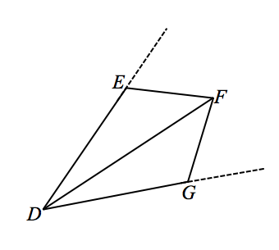
Prove: $DF$ is the angle bisector of $∠EDG$

Proof:

Exploratory Challenge
Today we are going to examine three possible triangle congruence criteria, Angle-Angle-Side (AAS), Side-Side-Angle (SSA), and Angle-Angle-Angle (AAA). Ultimately, only one of the three possible criteria will ensure congruence.
Angle-Angle-Side Triangle Congruence Criteria (AAS): Given two triangles $ABC$ and $A'B'C'$. If $AB=A'B'$ (Side), $m∠B=m∠B'$ (Angle), and $m∠C=m∠C'$ (Angle), then the triangles are congruent.

Proof:
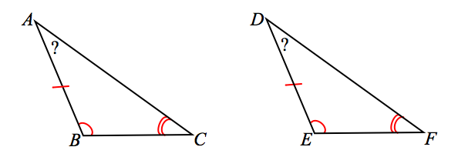
Consider a pair of triangles that meet the AAS criteria. If you knew that two angles of one triangle corresponded to and were equal in measure to two angles of the other triangle, what conclusions can you draw about the third angles of each triangle?
Since the first two angles are equal in measure, the third angles must also be equal in measure.
Given this conclusion, which formerly learned triangle congruence criteria can we use to determine if the pair of triangles are congruent?

Therefore, the AAS criterion is actually an extension of the triangle congruence criterion.
Note that when using the Angle-Angle-Side triangle congruence criteria as a reason in a proof, you need only state the congruence and “AAS.”

Hypotenuse-Leg Triangle Congruence Criteria (HL): Given two right triangles $ABC$ and $A'B'C'$with right angles $B$ and $B'$, if $AB=A'B'$ (Leg) and $AC=A'C'$ (Hypotenuse), then the triangles are congruent.

Proof:
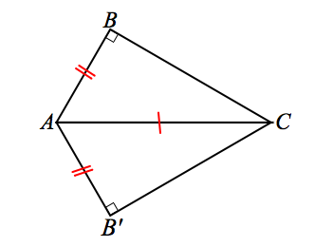
As with some of our other proofs, we will not start at the very beginning, but imagine that a congruence exists so that triangles have been brought together such that $A=A^{'}$ and $C=C'$; the hypotenuse acts as a common side to the transformed triangles.

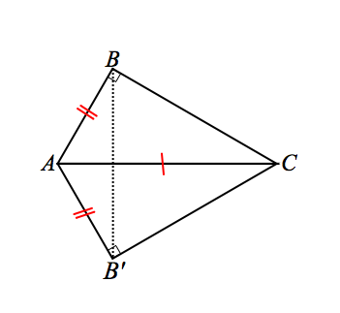
Similar to the proof for SSS, we add a construction and draw $\overline{BB'}$.
$△ABB'$ is isosceles by definition, and we can conclude that base angles $m∠ABB^{'}=m∠AB'B$. Since $∠CBB^{'}$ and $∠CB^{'}B$ are both the complements of equal angle measures ($∠ABB^{'}$ and $∠AB'B$), they too are equal in measure. Furthermore, since $m∠CBB^{'}=m∠CB^{'}B$, the sides of $△CBB^{'}$opposite them are equal in measure$: BC=B'C'$.
Then, by SSS, we can conclude $△ABC≅△A'B'C'$. Note that when using the Hypotenuse-Leg triangle congruence criteria as a reason in a proof, you need only state the congruence and “HL.”

Criteria that do not determine two triangles as congruent: SSA and AAA
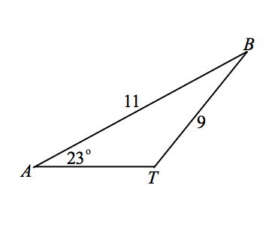
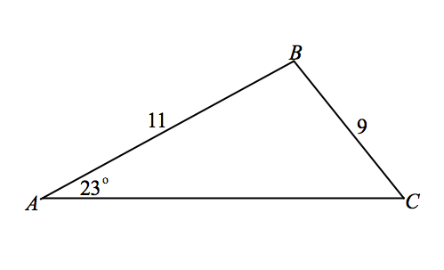
Side-Side-Angle (SSA): Observe the diagrams below. Each triangle has a set of adjacent sides of measures $11$ and $9$, as well as the non-included angle of $23°$. Yet, the triangles are not congruent.
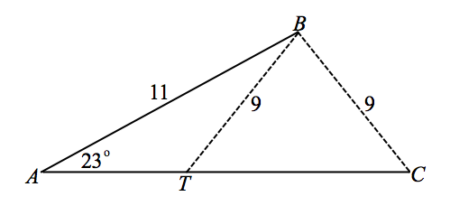
Examine the composite made of both triangles. The sides of lengths $9$ each have been dashed to show their possible locations.
The triangles that satisfy the conditions of SSA cannot guarantee congruence criteria. In other words, two triangles under SSA criteria may or may not be congruent; therefore, we cannot categorize SSA as congruence criterion.

Angle-Angle-Angle (AAA): A correspondence exists between $△ABC$ and $△DEF$. Trace $△ABC$ onto patty paper, and line up corresponding vertices.
Based on your observations, why isn’t AAA categorizes as congruence criteria? Is there any situation in which AAA does guarantee congruence?
Even though the angle measures may be the same, the sides can be proportionally larger; you can have similar triangles in addition to a congruent triangle.

List all the triangle congruence criteria here:

List the criteria that do not determine congruence here:

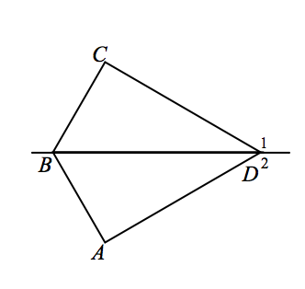
Examples
- Given: $\overline{BC}⊥\overline{CD}$,$\overline{AB}⊥\overline{AD}$ $, m∠1=m∠2$
Prove: $△BCD≅ △BAD$

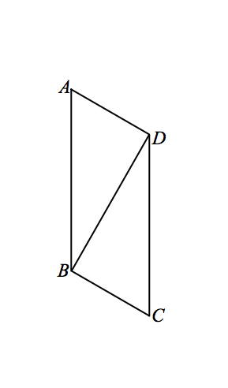

- Given: $AD⊥BD$, $BD⊥BC$,$AB=CD$
Prove: $△ABD≅ △CDB$

Problem Set

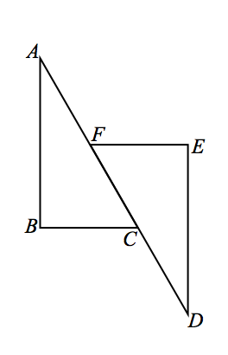
Use your knowledge of triangle congruence criteria to write proofs for each of the following problems.
- Given: $\overline{AB}⊥\overline{BC}$,$\overline{DE}⊥\overline{EF}$,$\overline{BC}∥\overline{EF}$,$AF=DC$
Prove: $△ABC≅ △DEF$

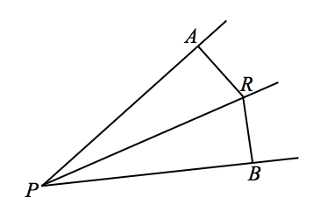
- In the figure, $\overline{PA}⊥\overline{AR}$ and $\overline{PB}⊥\overline{RB}$and $R$ is equidistant from $\overset{⃡}{PA}$ and $\overset{⃡}{PB}$. Prove that $\overline{PR}$ bisects $∠APB$.

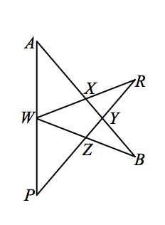

- Given: $∠A≅∠P$,$∠B≅∠R$, $W$ is the midpoint of $\overline{AP}$
Prove: $\overline{RW}≅\overline{BW}$

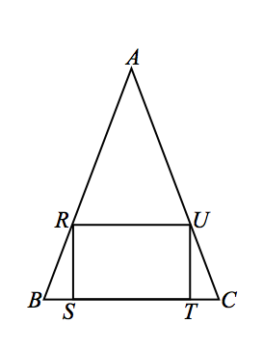

- Given: $BR=CU$, rectangle $RSTU$
Prove: $△ARU$ is isosceles

