|  |
| --- |
|  |

Lesson 25: Congruence Criteria for Triangles—AAS and HL

**Student Outcomes**

* Students learn why any two triangles that satisfy the AAS or HL congruence criteria must be congruent.
* Students learn why any two triangles that meet the AAA or SSA criteria are not necessarily congruent.

Classwork

Opening Exercise (7 minutes)

Opening Exercise

Write a proof for the following question. Once done, compare your proof with a neighbor’s.

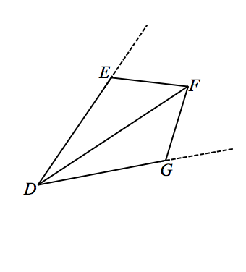Given: ,

Prove: is the angle bisector of

Given

Given

Reflexive property

SSS

Corresponding angles of congruent triangles are congruent.

is the angle bisector of Definition of an angle bisector

Exploratory Challenge (25 minutes)

The included proofs of AAS and HL are not transformational; rather, they follow from ASA and SSS, already proved.

Exploratory Challenge

Today we are going to examine three possible triangle congruence criteria, Angle-Angle-Side (AAS), Side-Side-Angle (SSA), and Angle-Angle-Angle (AAA). Ultimately, only one of the three possible criteria will ensure congruence.

Angle-Angle-Side Triangle Congruence Criteria (AAS): Given two triangles and . If (Side), (Angle), and (Angle), then the triangles are congruent.

*Proof:*

Consider a pair of triangles that meet the AAS criteria. If you knew that two angles of one triangle corresponded to and were equal in measure to two angles of the other triangle, what conclusions can you draw about the third angles of each triangle?

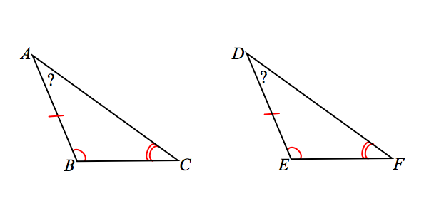Since the first two angles are equal in measure, the third angles must also be equal in measure.

Given this conclusion, which formerly learned triangle congruence criteria can we use to determine if the pair of triangles are congruent?

ASA

Therefore, the AAS criterion is actually an extension of the  *ASA*  triangle congruence criterion.

Note that when using the Angle-Angle-Side triangle congruence criteria as a reason in a proof, you need only state the congruence and “AAS.”

Hypotenuse-Leg Triangle Congruence Criteria (HL): Given two right triangles and with right angles and , if (Leg) and (Hypotenuse), then the triangles are congruent.

*Proof:*

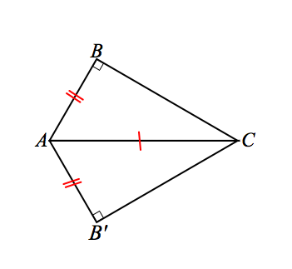As with some of our other proofs, we will not start at the very beginning, but imagine that a congruence exists so that triangles have been brought together such that and ; the hypotenuse acts as a common side to the transformed triangles.

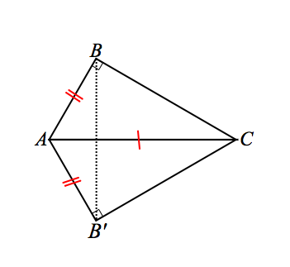Similar to the proof for SSS, we add a construction and draw .

is isosceles by definition, and we can conclude that base angles . Since and are both the complements of equal angle measures ( and ), they too are equal in measure. Furthermore, since , the sides of opposite them are equal in measure: .

Then, by SSS, we can conclude . Note that when using the Hypotenuse-Leg triangle congruence criteria as a reason in a proof, you need only state the congruence and “HL.”

Criteria that *do not* determine two triangles as congruent: SSA and AAA

Side-Side-Angle (SSA): Observe the diagrams below. Each triangle has a set of adjacent sides of measures and , as well as the non-included angle of . Yet, the triangles are not congruent.

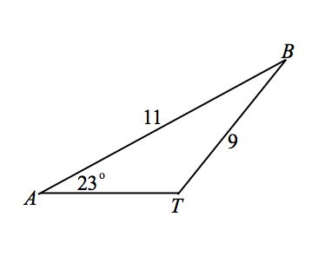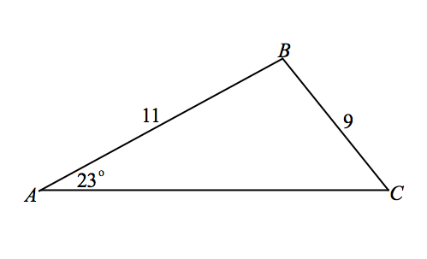

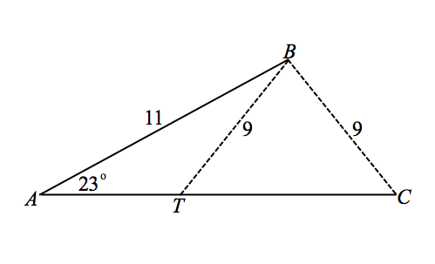Examine the composite made of both triangles. The sides of lengths each have been dashed to show their possible locations.

The triangles that satisfy the conditions of SSA cannot *guarantee* congruence criteria. In other words, two triangles under SSA criteria may or may not be congruent; therefore, we cannot categorize SSA as congruence criterion.

Angle-Angle-Angle (AAA): A correspondence exists between and . Trace onto patty paper, and line up corresponding vertices.

Based on your observations, why isn’t AAA categorized as congruence criteria? Is there any situation in which does guarantee congruence?

Even though the angle measures may be the same, the sides can be proportionally larger; you can have similar triangles in addition to a congruent triangle.

List all the triangle congruence criteria here:

SSS, SAS, ASA, AAS, HL

List the criteria that do not determine congruence here:

SSA, AAA

**Examples (8 minutes)**

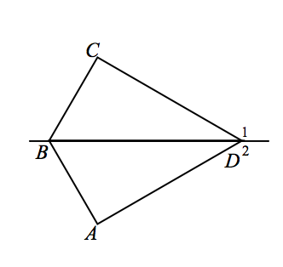Examples

1. Given: , ,

Prove:

*Given*

*Given*

*Given*

*Reflexive property*

*Linear pairs form supplementary angles*

*Linear pairs form supplementary angles*

*If two angles are equal in measure, then their supplements are equal in measure*

*Definition of perpendicular line segments*

*AAS*

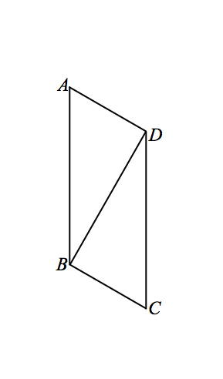

1. Given: ,,

Prove:

Given

Given

is a right triangle Definition of perpendicular line segments

is a right triangle Definition of perpendicular line segments

Given

Reflexive property

HL

Exit Ticket (5 minutes)

Name ___________________________________________________ Date____________________

Lesson 25: Congruence Criteria for Triangles—AAS and HL

Exit Ticket

1. Sketch an example of two triangles that meet the AAA criteria but are not congruent.
2. Sketch an example of two triangles that meet the SSA criteria that are not congruent.

Exit Ticket Sample Solutions

1. Sketch an example of two triangles that meet the AAA criteria but are not congruent.

Responses should look something like the example below.

1. Sketch an example of two triangles that meet the SSA criteria that are not congruent.

Responses should look something like the example below.

Problem Set Sample Solutions

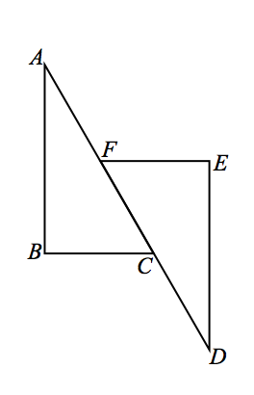  
Use your knowledge of triangle congruence criteria to write proofs for each of the following problems.

1. Given:

Prove:

Given

Given

Given

Given

Definition of perpendicular lines

When two parallel lines are cut by a transversal, the alternate interior angles are equal in measure

Reflexive property

Addition property of equality

Segment addition

AAS

1. 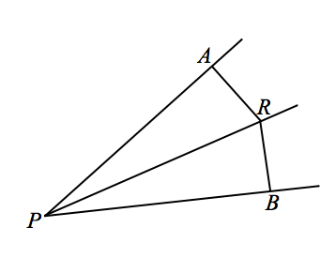In the figure, and and is equidistant from and . Prove that bisects .

Given

Given

Given

*Definition of perpendicular lines*

, are right triangles Definition of right triangle

Reflexive property

HL

Corresponding angles of congruent triangles are congruent.

bisects Definition of an angle bisector

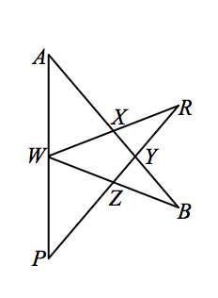

1. Given: ,, is the midpoint of

Prove:

Given

Given

is the midpoint of Given

Definition of midpoint

AAS

Corresponding sides of congruent triangles are congruent.

1. 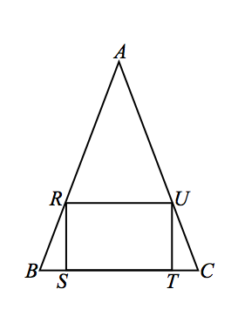Given: , rectangle

Prove: is isosceles

*Given*

*Rectangle Given*

*Definition of a rectangle*

*When two para. lines are cut by a trans., the corr. angles are equal in measure*

*When two para. lines are cut by a trans., the corr. angles are equal in measure*

*, Definition of a rectangle*

*Linear pairs form supplementary angles.*

*Linear pairs form supplementary angles.*

*Subtraction property of equality*

*and are right triangles Definition of right triangle*

*Definition of a rectangle*

*HL*

*Corresponding angles of congruent triangles are equal in measure*

*Substitution property of equality*

*is isosceles If two angles in a triangle are equal in measure, then it is isosceles.*