Lesson 24: Congruence Criteria for Triangles—ASA and SSS

Classwork
Opening Exercise
Use the provided $30°$ angle as one base angle of an isosceles triangle. Use a compass and straight edge to construct an appropriate isosceles triangle around it.

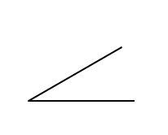

Compare your constructed isosceles triangle with a neighbor’s. Does the use of a given angle measure guarantee that all the triangles constructed in class have corresponding sides of equal lengths?

Discussion
Today we are going to examine two more triangle congruence criteria, Angle-Side-Angle (ASA) and Side-Side-Side (SSS), to add to the SAS criteria we have already learned. We begin with the ASA criteria.
Angle-Side-Angle Triangle Congruence Criteria (ASA): Given two triangles $ABC$ and $A'B'C'$. If $m∠CAB=m∠C^{'}A^{'}B^{'}$ (Angle), $AB=A'B'$ (Side), and $m∠CBA=m∠C^{'}B^{'}A^{'}$ (Angle), then the triangles are congruent.
Proof:
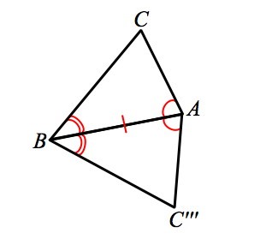
We do not begin at the very beginning of this proof. Revisit your notes on the SAS proof, and recall that there are three cases to consider when comparing two triangles. In the most general case, when comparing two distinct triangles, we translate one vertex to another (choose congruent corresponding angles). A rotation brings congruent, corresponding sides together. Since the ASA criteria allows for these steps, we begin here.

In order to map $△ABC'''$ to $△ABC$, we apply a reflection $r$ across the line $AB$. A reflection will map $A$ to $A$ and $B$ to $B$, since they are on line $AB$. However, we will say that $r\left(C'''\right)=C^{*}$. Though we know that $r\left(C'''\right)$ is now in the same half-plane of line $AB$ as $C$, we cannot assume that $C^{'''}$ maps to $C$. So we have $r$($△ABC''')=△ABC^{*}$. To prove the theorem, we need to verify that $C^{*}$ is $C$.
By hypothesis, we know that $∠CAB≅∠C'''AB$ (recall that $∠C'''AB$ is the result of two rigid motions of $∠C^{'}A^{'}B^{'}$, so must have the same angle measure as $∠C^{'}A^{'}B^{'}$). Similarly, $∠CBA≅∠C'''BA$. Since $∠CAB≅r\left(∠C^{'''}AB\right)≅∠C^{*}AB$, and $C$ and $C^{*}$ are in the same half-plane of line $AB$, we conclude that $\vec{AC}$ and $\vec{AC^{*}}$ must actually be the same ray. Because the points $A$ and $C^{*}$ define the same ray as $\vec{AC}$, the point $C^{*}$ must be a point somewhere on $\overset{⃑}{AC}$. Using the second equality of angles, $∠CBA≅r\left(∠C^{'''}BA\right)≅∠C^{*}BA$, we can also conclude that $\vec{BC}$ and $\vec{BC^{*}}$ must be the same ray. Therefore, the point $C^{*}$ must also be on $\vec{BC}$. Since $C^{*}$ is on both $\vec{AC}$ and $\vec{BC}$, and the two rays only have one point in common, namely $C$, we conclude that $C=C^{*}$.
We have now used a series of rigid motions to map two triangles onto one another that meet the ASA criteria.

Side-Side-Side Triangle Congruence Criteria (SSS): Given two triangles $ABC$ and $A’B’C’$. If $AB=A'B'$ (Side), $AC=A'C'$ (Side), and $BC=B'C'$ (Side) then the triangles are congruent.
Proof:
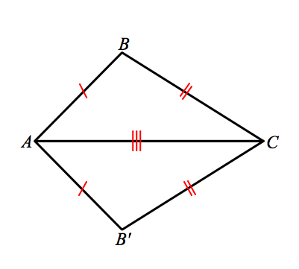
Again, we do not need to start at the beginning of this proof, but assume there is a congruence that brings a pair of corresponding sides together, namely the longest side of each triangle.
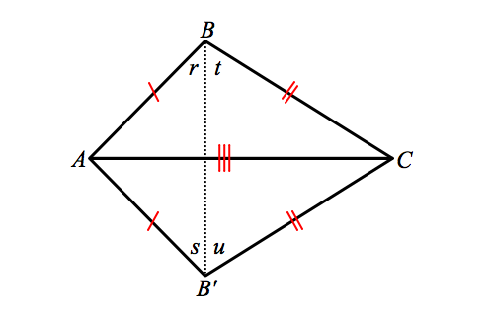
Without any information about the angles of the triangles, we cannot perform a reflection as we have in the proofs for SAS and ASA. What can we do? First we add a construction: Draw an auxiliary line from $B$ to $B'$, and label the angles created by the auxiliary line as $r$, $s$, $t$, and $u$.
Since$AB=AB'$ and $CB=CB'$, $△ABB'$ and $△CBB'$ are both isosceles triangles respectively by definition. Therefore, $r=s$ because they are base angles of an isosceles triangle $ABB'$. Similarly, $m∠t=m∠u$ because they are base angles of $△CBB'$. Hence, $∠ABC=$ $m∠r+m∠t=m∠s+m∠u=∠AB^{'}C$. Since $m∠ABC=m∠AB'C$, we say that
$△ABC≅△AB'C$ by SAS.
We have now used a series of rigid motions and a construction to map two triangles that meet the SSS criteria onto one another. Note that when using the Side-Side-Side triangle congruence criteria as a reason in a proof, you need only state the congruence and “SSS.” Similarly, when using the Angle-Side-Angle congruence criteria in a proof, you need only state the congruence and “ASA.”
Now we have three triangle congruence criteria at our disposal: SAS, ASA, and SSS. We will use these criteria to determine whether or not pairs of triangles are congruent.

Exercises
Based on the information provided, determine whether a congruence exists between triangles. If a congruence exists between triangles or if multiple congruencies exist, state the congruencies and the criteria used to determine them.
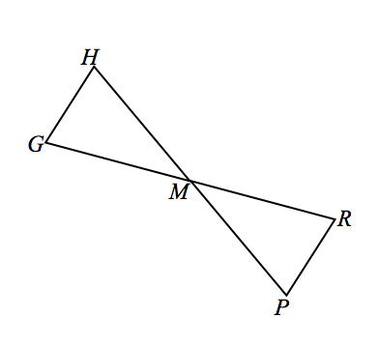
- Given: $M$ is the midpoint of $\overline{HP}$, $m∠H=m∠P$.

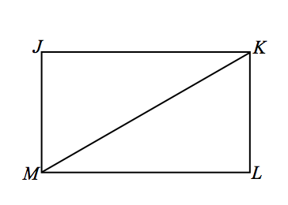
- Given: Rectangle $JKLM$ with diagonal $KM$.

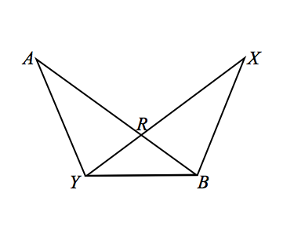

- Given: $RY=RB$, $AR=XR.$

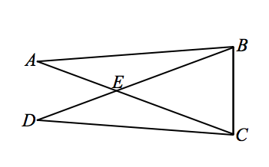
- Given: $m∠A=m∠D$,$AE=DE$.

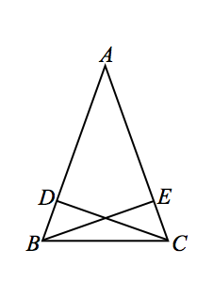
- Given: $AB=AC$, $BD=\frac{1}{4}AB,$ $CE=\frac{1}{4}AC$.

Problem Set

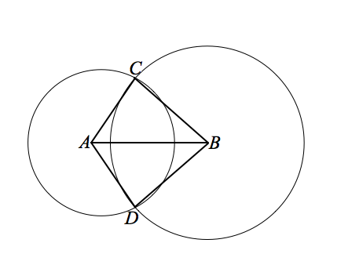
Use your knowledge of triangle congruence criteria to write proofs for each of the following problems.

- Given: Circles with centers $A$ and $B$ intersect at $C$ and $D$.
Prove: $∠CAB≅∠DAB.$

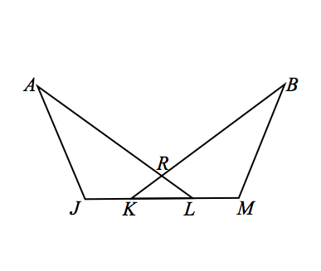

- Given: $∠J≅∠M$, $JA=MB$, $JK=KL=LM.$
Prove: $\overline{KR}≅\overline{LR}$.

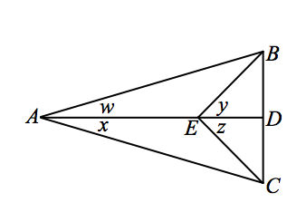
- Given: $m∠w=m∠x$ and $m∠y=m∠z$.
Prove: (1) $△ABE≅ △ACE$
(2) $AB=AC$ and $\overline{AD}⊥\overline{BC}$

- After completing the last exercise, Jeanne said, “We also could have been given that $∠w≅∠x$ and $∠y≅∠z$. This would also have allowed us to prove that$△ABE≅△ACE$.” Do you agree? Why or why not?

