Lesson 24: Congruence Criteria for Triangles—ASA and SSS

Student Outcomes
- Students learn why any two triangles that satisfy the ASA or SSS congruence criteria must be congruent.

Lesson Notes
This is the third lesson in the congruency topic. So far, students have studied the SAS triangle congruence criteria and how to prove base angles of an isosceles triangle are congruent. Students examine two more triangle congruence criteria in this lesson: ASA and SSS. Each proof assumes the initial steps from the proof of SAS; ask students to refer to their notes on SAS to recall these steps before proceeding with the rest of the proof. Exercises will require the use of all three triangle congruence criteria.

Classwork
Opening Exercise (7 minutes)
Opening Exercise
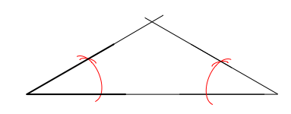
Use the provided $30°$ angle as one base angle of an isosceles triangle. Use a compass and straight edge to construct an appropriate isosceles triangle around it.
Compare your constructed isosceles triangle with a neighbor’s. Does the use of a given angle measure guarantee that all the triangles constructed in class have corresponding sides of equal lengths?
No, side lengths may vary.

Discussion (25 minutes)
There are a variety of proofs of the ASA and SSS criteria. These follow from the SAS criteria, already proved in Lesson 22.
Discussion
Today we are going to examine two more triangle congruence criteria, Angle-Side-Angle (ASA) and Side-Side-Side (SSS),
to add to the SAS criteria we have already learned. We begin with the ASA criteria.
Angle-Side-Angle Triangle Congruence Criteria (ASA): Given two triangles $ABC$ and $A'B'C'$. If $m∠CAB=m∠C^{'}A^{'}B^{'}$ (Angle), $AB=A'B'$ (Side), and $m∠CBA=m∠C^{'}B^{'}A^{'}$ (Angle), then the triangles are congruent.
Proof:
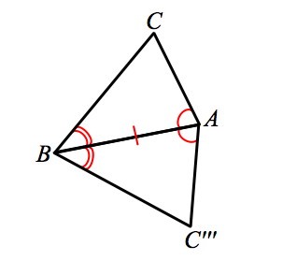
We do not begin at the very beginning of this proof. Revisit your notes on the SAS proof, and recall that there are three cases to consider when comparing two triangles. In the most general case, when comparing two distinct triangles, we translate one vertex to another (choose congruent corresponding angles). A rotation brings congruent, corresponding sides together. Since the ASA criteria allows for these steps, we begin here.
In order to map $△ABC'''$ to $△ABC$, we apply a reflection $r$ across the line $AB$. A reflection will map $A$ to $A$ and $B$ to $B$, since they are on line $AB$. However, we will say that $r\left(C'''\right)=C^{*}$. Though we know that $r\left(C'''\right)$ is now in the same half-plane of line $AB$ as $C$, we cannot assume that $C^{'''}$ maps to $C$. So we have $r(△ABC''')=△ABC^{*}$. To prove the
theorem, we need to verify that $C^{*}$ is $C$.
By hypothesis, we know that $∠CAB≅∠C'''AB$ (recall that $∠C'''AB$ is the result of two rigid motions of $∠C^{'}A^{'}B^{'}$, so must have the same angle measure as $∠C^{'}A^{'}B^{'}$). Similarly, $∠CBA≅∠C'''BA$. Since $∠CAB≅r\left(∠C^{'''}AB\right)≅∠C^{*}AB$, and $C$ and $C^{*}$ are in the same half-plane of line $AB$, we conclude that $\vec{AC}$ and $\vec{AC^{*}}$ must actually be the same ray. Because the points $A$ and $C^{*}$ define the same ray as $\vec{AC}$, the point $C^{*}$ must be a point somewhere on $\overset{⃑}{AC}$. Using the second equality of angles, $∠CBA≅r\left(∠C^{'''}BA\right)≅∠C^{*}BA$, we can also conclude that $\vec{BC}$ and $\vec{BC^{*}}$ must be the same ray. Therefore, the point $C^{*}$ must also be on $\vec{BC}$. Since $C^{*}$ is on both $\vec{AC}$ and $\vec{BC}$, and the two rays only have one point in common, namely $C$, we conclude that $C=C^{*}$.
We have now used a series of rigid motions to map two triangles onto one another that meet the ASA criteria.

Side-Side-Side Triangle Congruence Criteria (SSS): Given two triangles $ABC$ and $A’B’C’$. If $AB=A'B'$ (Side), $AC=A'C'$ (Side), and $BC=B'C'$ (Side) then the triangles are congruent.

Proof:
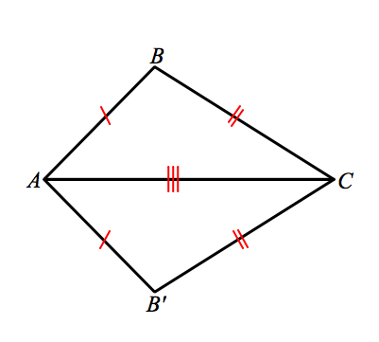
Again, we do not start at the beginning of this proof, but assume there is a congruence that brings a pair of corresponding sides together, namely the longest side of each triangle.

Without any information about the angles of the triangles, we cannot perform a reflection as we have in the proofs for SAS and ASA. What can we do? First we add a construction: Draw an auxiliary line from $B$ to $B'$, and label the angles created by the auxiliary line as $r$,$s$, $t$, and $u$.
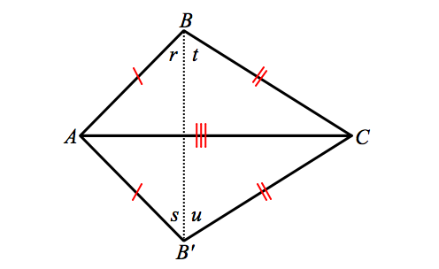

Since$AB=AB'$ and $CB=CB'$, $△ABB'$ and $△CBB'$ are both isosceles triangles respectively by definition. Therefore, $r=s$ because they are base angles of an isosceles triangle $ABB'$. Similarly, $m∠t=m∠u$ because they are base angles of $△CBB'$. Hence, $∠ABC=$ $m∠r+m∠t=m∠s+m∠u=∠AB^{'}C$. Since $m∠ABC=m∠AB'C$, we say that
$△ABC≅△AB'C$ by SAS.
We have now used a series of rigid motions and a construction to map two triangles that meet the SSS criteria onto one another. Note that when using the Side-Side-Side triangle congruence criteria as a reason in a proof, you need only state the congruence and “SSS.” Similarly, when using the Angle-Side-Angle congruence as a reason in a proof, you need only state the congruence and “ASA.”
Now we have three triangle congruence criteria at our disposal: SAS, ASA, and SSS. We will use these criteria to determine whether or not pairs of triangles are congruent.

Exercises (6 minutes)
These exercises involve applying the newly developed congruence criteria to a variety of diagrams.
Exercises
Based on the information provided, determine whether a congruence exists between triangles. If a congruence exists between triangles or if multiple congruencies exist, state the congruencies and the criteria used to determine them.
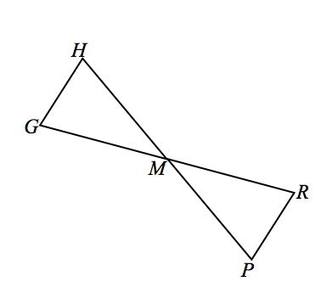
- Given: $M$ is the midpoint of $\overline{HP}$, $m∠H=m∠P$.
$△GHM≅△RPM$, ASA

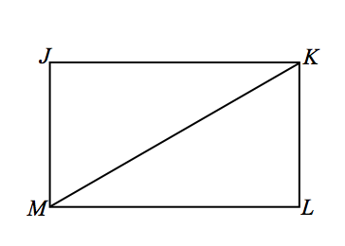
- Given: Rectangle $JKLM$ with diagonal $\overline{KM}$.
$△JKM≅△LMK$, SSS/SAS/ASA

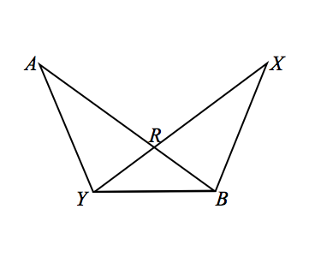
- Given: $RY=RB$, $AR=XR$.
$△ARY≅ △XRB$, SAS
$△ABY≅ △XBY$, SAS

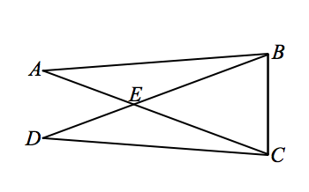
- Given: $m∠A=m∠D$, $AE=DE$.
$△AEB≅△DEC$, ASA
$△DBC≅△ACB$, SAS/ASA
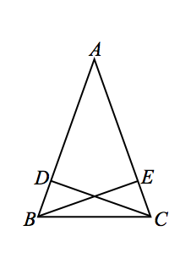

- Given: $AB=AC$, $BD=\frac{1}{4}AB$, $CE=\frac{1}{4}AC$.
$△ABE≅△ACD$, SAS

Exit Ticket (7 minutes)
Name ___________________________________________________ Date____________________
Lesson 24: Congruence Criteria for Triangles—ASA and SSS

Exit Ticket

Based on the information provided, determine whether a congruence exists between triangles. If a congruence exists between triangles or if multiple congruencies exist, state the congruencies and the criteria used to determine them.
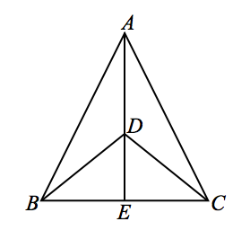
Given: $BD=CD$, $E$ is the midpoint of $\overline{BC.}$

Exit Ticket Sample Solutions
Based on the information provided, determine whether a congruence exists between triangles. If a congruence exists between triangles or if multiple congruencies exist, state the congruencies and the criteria used to determine them.

Given: $BD=CD$, $E$ is the midpoint of $BC$.
$△ABE≅△ACD$, SAS

Problem Set Sample Solutions
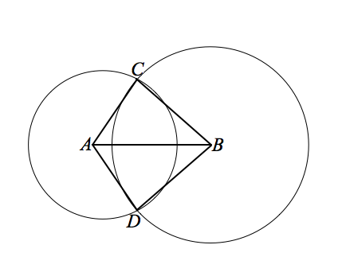
Use your knowledge of triangle congruence criteria to write proofs for each of the following problems.
- Given: Circles with centers $A$ and $B$ intersect at $C$ and $D$.
Prove: $∠CAB≅∠DAB$.
$CA=DA$ Radius of circle
$CB=DB$ Radius of circle
$AB=AB$ Reflexive property
$△CAB≅△DAB$ SSS
$∠CAB≅∠DAB$ Corresponding angles of congruent triangles are congruent
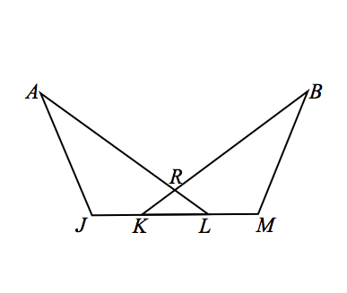
- Given: $m∠J=m∠M$, $JA=MB$, $JK=KL=LM$.
Prove: $\overline{KR}≅\overline{LR}$.
$m∠J=m∠M$ Given
$JA=MB$ Given
$JK=KL=LM$ Given
$JL= JK+KL$ Partition property or segments add
$KM= KL+LM$ Partition property or segments add
$KL=KL$ Reflexive property
$JK+KL=KL+LM$ Addition property of equality
$JL=KM$ Substitution property of equality
$△AJL≅△BMK$ SAS
$∠RKL≅∠RLK$ Corresponding angles of congruent triangles are congruent
$\overline{KR}≅\overline{LR}$ If two angles of a triangle are congruent, the sides opposite those angles are congruent

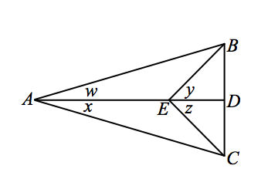
- Given: $m∠w=m∠x$ and $m∠y=m∠z$.
Prove: (1) $△ABE≅ △ACE$.
(2) $AB=AC$ and $\overline{AD}⊥\overline{BC}$.
$m∠y=m∠z$ Given
$m∠AEB=m∠AEC$ Supplements of equal angles are equal in measure
$AE = AE$ Reflexive property
$m∠w=m∠x$ Given
$∴∆ABE≅∆ACE$ ASA
$∴\overline{AB}≅\overline{AC}$ Corresponding sides of congruent triangles are congruent
$AD=AD$ Reflexive property
$△CAD≅ △BAD$ SAS
$m∠ADC=m∠ADB$ Corresponding angles of congruent triangles are equal in measure
$m∠ADC+m∠ADB=180°$ Linear pairs form supplementary angles.
$2\left(m∠ADC\right)=180°$ Substitution property of equality
$m∠ADC=90°$ Division property of equality
$\overline{AD}⊥\overline{BC}$ Definition of perpendicular lines

- After completing the last exercise, Jeanne said, “We also could have been given that $∠w≅∠x$ and $∠y≅∠z$. This would also have allowed us to prove that $△ABE≅△ACE$.” Do you agree? Why or why not?
Yes; any time angles are equal in measure, we can also say that they are congruent. This is because rigid motions preserve angle measure; therefore, any time angles are equal in measure, there exists a sequence of rigid motions that carries one onto the other.

