Grade 6: Module 4: Unit 2: Lesson 9
Mid-Unit Assessment: Comparing and Contrasting Two Texts: Simulated Research

Long-Term Targets Addressed (Based on NYSP12 ELA CCLS)
I can compare how different authors present the same idea or event. (RI.6.9)
I can conduct short research projects to answer a question. (W.6.7)
I can use several sources in my research. (W.6.7)
I can refocus or refine my question when appropriate. (W.6.7)
I can gather relevant information from a variety of sources. (W.6.8)
I can assess the credibility of each source I use. (W.6.8)
I can quote or paraphrase what others say about my topic while avoiding plagiarism. (W.6.8)
I can provide a list of sources I used to gather information in a bibliography. (W.6.8)
I can use a variety of strategies to determine the meaning of unknown words and phrases. (L.6.4)
  - I can use context to determine the meaning of a word or phrase.
  - I can use common Greek and Latin affixes (prefixes) and roots as clues to help me determine the meaning of a word.
  - I can use resource materials (glossaries, dictionaries, thesauruses) to help me determine or clarify the pronunciation, meaning of key words and phrases, and parts of speech.
  - I can check the accuracy of my guess about the meaning of a word or phrase by using resource materials.
Supporting Learning Targets | Ongoing Assessment
- I can gather relevant information from research materials.  - I can assess the credibility of the article “DDT Spray Scares Mosquitoes Away, Study Finds.”  - I can compare and contrast the authors’ presentation of ideas for “DDT Spray Scares Mosquitoes Away, Study Finds” and “You Think You Have It Tough?”  - I can use multiple strategies help me determine the meaning of a word. | - Mid-Unit 2 Assessment: Comparing and Contrasting Two Texts: Simulated Research

Agenda | Teaching Notes
- Opening  - Unpacking Learning Targets and Assessment Prompt  (5 minutes)  - Work Time  - Mid-Unit 2 Assessment: Simulated Research Task: “DDT Spray Scares Mosquitoes Away, Study Finds”  (15 minutes)  - Mid-Unit 2 Assessment: Comparing and Contrasting Authors’ Presentation (15 minutes)  - Mid-Unit 2 Assessment: Research Vocabulary (5 minutes)  - Closing and Assessment  - Reflecting on Learning Targets (5 minutes)  - Homework | - At this point, students have completed their research from several sources, both print and digital. They have also been comparing and contrasting authors’ presentations of ideas, specifically how the author introduces the idea, the claim, what type of evidence the author uses, and how the author uses other text features.  - Thus, in this mid-unit assessment, students are asked to read two informational articles: “DDT Spray Scares Mosquitoes Away, Study Finds” and “You Think You Have It Tough?” After reading “DDT Spray Scares Mosquitoes Away, Study Finds,” students are asked to complete a “simulated research” page identical to a page in their researcher’s notebooks.  - This on-demand assessment is meant to assess students’ ability to do independent research. However, students’ researcher’s notebooks should be referenced when assessing students’ ability to conduct an ongoing research project.  - After reading “You Think You Have It Tough?” students are asked to compare and contrast these two authors’ presentations of malaria and the use of DDT. Students will use the Comparing and Contrasting Authors’ Presentation graphic organizer identical to the one they have been using throughout this unit  - Finally, students will complete a Research Vocabulary graphic organizer identical to the one they’ve used since the beginning of this unit. Students are invited to complete the process of giving an initial idea for a word’s definition using context clues and/or root words and affixes, then confirming or revising their definition using resource materials such as a dictionary.  - Although the author of “You Think You Have It Tough?” does not specifically mention the use of DDT in the article, at this point in the module, students should be able to make the connection between mosquitoes and malaria and the use of DDT.  - The article “DDT Spray Scares Mosquitoes Away, Study Finds” is a high Lexile in qualitative measures. However, it is appropriate to this task because by now students should be familiar with much of the vocabulary that makes this a complex text.  - Sample student responses are provided in the supporting materials. These responses are just examples; actual student responses will vary.

Agenda | Teaching Notes (continued)
- In advance: Read the articles used in this mid-unit assessment (see supporting materials). Also read the sample student response for the simulated research page and comparing authors’ presentations to familiarize yourself with the expectations for students.
- Be sure students have access to their Credibility Checklist, which they have been using throughout their research. This will be necessary for completing the simulated research page.
- Be sure students have access to a resource material, such as a print or online dictionary, to determine word meanings.
- Post: Learning targets; Mid-Unit 2 Assessment prompt.

Lesson Vocabulary | Materials
compare, contrast | - Mid-Unit 2 Assessment: Comparing and Contrasting Two Texts: Simulated Research (one per student and one to display)  - “DDT Spray Scares Mosquitoes Away, Study Finds” (assessment text; one per student)  - “You Think You Have It Tough?” (assessment text; one per student)  - Mid-Unit 2 Assessment: Comparing and Contrasting Two Texts: Simulated Research graphic organizer (one per student)  - Mid-Unit 2 Assessment: Comparing and Contrasting Two Texts: Simulated Research graphic organizer, sample student response (for teacher reference)  - Mid-Unit 2 Assessment: Comparing and Contrasting Authors’ Presentations graphic organizer (one new blank per student)  - Mid-Unit 2 Assessment: Comparing and Contrasting Authors’ Presentations graphic organizer: sample student response (for teacher reference)  - Mid-Unit 2 Assessment: Research Vocabulary: Using Multiple Strategies to Determine the Meaning of Words graphic organizer (one new blank per student)  - Dictionaries (one per student)  - Credibility Checklist (one new blank per student)

Opening | Meeting Students’ Needs
A. Unpacking Learning Targets and Assessment Prompt (5 minutes)
- In advance, display and distribute the Mid-Unit 2 Assessment: Comparing and Contrasting Two Texts: Simulated Research. Tell students:
  - “Today you will be reading two articles: ‘DDT Spray Scares Mosquitoes Away, Study Finds’ and ‘You Think You Have It Tough?’ Both of these are informational articles about mosquitoes, malaria, and DDT.
  - “After reading the first article, ‘DDT Spray Scares Mosquitoes Away, Study Finds,’ complete a Simulated Research graphic organizer identical to the ones you have been completing in your researcher’s notebooks.
  - “After reading the second article, ‘You Think You Have It Tough?’, complete a Comparing and Contrasting Authors’ Presentations graphic organizer identical to the one you have used in previous lessons.”
  - “Finally, for each word on the Research Vocabulary: Using Multiple Strategies to Determine the Meaning of Words graphic organizer, use a strategy such as context clues or root words and affixes to make an initial determination for the word’s meaning. Then use a resource material, such as a dictionary, to confirm or revise that meaning.”
- Invite students to read along as you read aloud the mid-unit assessment prompt. Ask students to Think-Pair-Share:
  - “Based on this prompt, describe to a partner, in your own words, what you think you will be doing in your assessment today.”
- Confirm for students that they will be reading two articles today. They will be completing graphic organizers and note-taking tools identical to the ones they have been using throughout their research process.
- Ask:
  - “Are there any clarifying questions about this prompt?”
- Give students the opportunity to ask any questions about the prompt or the assessment.
- Tell students the purpose of this assessment is to give them the opportunity to show their mastery of learning targets that they have been working on for the last couple of weeks. Tell students that you would like to review those learning targets now.

Opening (continued) | Meeting Students’ Needs
- Read aloud, or invite a student to read aloud, today’s learning targets:
  - “I can gather relevant information from research materials.”
  - “I can assess the credibility of the article ‘DDT Spray Scares Mosquitoes Away, Study Finds.’”
  - “I can compare and contrast the authors’ presentation of ideas for ‘DDT Spray Scares Mosquitoes Away, Study Finds’ and ‘You Think You Have It Tough?’”
  - “I can use multiple strategies help me determine the meaning of a word.”
- Ask:
  - “Looking at these learning targets, and the assessment prompt, how do you think you will be showing your mastery of the learning targets?”
  - Listen for example such as: “We’ll read the article and pretend like we’re doing it for research, so we’ll fill in our researcher’s notebook” and “We’ll have to decide if the article we read is credible using our Credibility Checklist” and “We’ll have figure out the meaning of new words using the strategies we have learned.”

Work Time | Meeting Students’ Needs
A. Mid-Unit 2 Assessment: Simulated Research Task: “DDT Spray Scares Mosquitoes Away, Study Finds”
(15 minutes)
- Distribute the informational article “DDT Spray Scares Mosquitoes Away, Study Finds” and the Mid-Unit 2 Assessment: Comparing and Contrasting Two Texts: Simulated Research graphic organizer to each student.
- Remind students that, as always, they will need to read all, or parts of, this article multiple times to truly find meaning in it. The first time they’ll read to get the overall flow; the second time they should begin to collect the necessary information and evidence they need to complete the graphic organizer.
- Point out that students will use a Credibility Checklist exactly like the one they’ve used in previous lessons.
- Tell students they will return to this article once more for the second part of this assessment in which they compare and contrast authors’ presentations. They can start thinking about how this article is introduced, what claim is made, what kinds of evidence the author includes, and how the author uses (or does not use) additional text features.
- Give students 15 minutes to read this article and complete the graphic organizer. Circulate and support students as they work, specifically refocusing students who may become distracted and asking prompting questions of students who get stuck.

Work Time (continued) | Meeting Students’ Needs
B. Mid-Unit 2 Assessment: Comparing and Contrasting Authors’ Presentations (15 minutes)
- After 15 minutes, begin to distribute the article “You Think You Have It Tough?” and the Comparing and Contrasting Authors’ Presentations graphic organizer.
- Once these are distributed, pause students in their work. Assure them that they will have additional time to complete what they are working on, but you would like to introduce them to the second part of their task.
- Tell them that in the second part of this assessment, they will be reading a new article. Students will not have to complete the simulated research task, however. Their focus will be on comparing this author’s presentation of ideas (malaria, mosquitoes, and DDT) with that of the article they just completed.
- Remind students of the different ways they learned to analyze an author’s presentation: by thinking about how the author introduces the ideas, what types of evidence the author uses, and how (or if) the author uses additional text features.
- Remind students that by thinking of each of these things individually, they can describe “overall” how the author has presented the event.
- Finally, remind students that they have practiced the skill of thinking about which author is more effective in presenting information or arguing their side of something. Today, they will continue to show their mastery of that skill.
- Tell students they will have the next 15 minutes to read this second article, and then complete the Comparing Authors’ Presentation graphic organizer.
- Circulate and support students as they work. Specifically, some students will be helped by prompting questions and the ability to “verbally rehearse” their answer with you before writing it down.

Work Time (continued) | Meeting Students’ Needs
C. Mid-Unit 2 Assessment: Research Vocabulary (5 minutes)
- After 15 minutes, begin to distribute the Research Vocabulary: Using Multiple Strategies to Determine the Meaning of Words graphic organizer.
- Pause students in their work. Again, tell them that if they need additional time, it will be provided to them, but you would like to introduce them to the final piece of this assessment.
- Review the graphic organizer with students. Tell them that this graphic organizer is identical to the one they have been using in their own research, and they should use it in the exact same way they have been practicing.
- Point out to students that for the purposes of this assessment, the words they’ll work with have been chosen for them. Point out that all of the words come from their reading, specifically the article “DDT Spray Scares Mosquitoes Away, Study Finds.”
- Remind students of the multiple strategies they have been practicing: using context clues, using root words and affixes, and using resource materials such as a dictionary. Tell students they should look closely at the word, and its context, to determine their strategy.
- Point out to students that dictionaries have been made available to them. These dictionaries can be used to help them confirm or revise their initial determination of the words’ meanings.
- Give students 5 minutes to complete the vocabulary section of the assessment.

Closing and Assessment | Meeting Students’ Needs
A. Reflecting on Learning Targets (5 minutes)
- Ask students to turn and talk:
  - “Look back at today’s learning targets. What is one area that you feel is a ‘star’ for you? What is one area that you’d call a ‘step,’ or an area in which you need more work?”
- As time permits, invite volunteers to share their thoughts whole group.
Homework | Meeting Students’ Needs
- None.

Grade 6: Module 4: Unit 2: Lesson 9
Supporting Materials
Mid-Unit 2 Assessment:
Comparing and Contrasting Two Texts
Simulated Research

Name:
Date:

Learning Targets

  - I can compare how different authors portray the same idea or event. (RI.6.9)
  - I can conduct short research projects to answer a question. (W.6.7)
  - I can use several sources in my research. (W.6.7)
  - I can refocus or refine my question when appropriate. (W.6.7)
  - I can gather relevant information from a variety of sources. (W.6.8)
  - I can assess the credibility of each source I use. (W.6.8)
  - I can quote or paraphrase what others say about my topic while avoiding plagiarism. (W.6.8)
  - I can use common Greek and Latin affixes (prefixes) and roots as clues to help me determine the meaning of a word (e.g., audience, auditory, audible). (L.6.4b)
  - I can use resource materials (glossaries, dictionaries, thesauruses) to help me determine or clarify the pronunciation, meaning of key words and phrases, and parts of speech. (L.6.4c)
  - I can check the accuracy of my guess about the meaning of a word or phrase by using resource materials. (L.6.4d)

Directions:
    - Today you will be reading two articles: “DDT Spray Scares Mosquitoes Away, Study Finds” and “You Think You Have It Tough?” Both are informational articles about mosquitoes, malaria, and DDT.
    - After reading the first article, “DDT Spray Scares Mosquitoes Away, Study Finds,” complete the simulated research page identical to the pages you have been completing in your researcher’s notebook.
    - After reading the second article, “You Think You Have It Tough?”, complete the Comparing and Contrasting Authors’ Presentation graphic organizer identical to the one from previous lessons.

DDT Spray Scares Mosquitoes Away, Study Finds
(Assessment Text)

Reuters, UK Edition
Washington
Date: August 9, 2007

(Reuters)—Mosquitoes that carry malaria, dengue fever and yellow fever avoid homes that have been sprayed with DDT, researchers reported on Wednesday.

The chemical not only repels the disease-carrying insects physically, but its irritant and toxic properties helps keep them away, the researchers reported in the Public Library of Science journal PLoS ONE.

They estimate that DDT spray reduced the risk of disease transmission by nearly three-quarters.

Malaria affects more 40 percent of the world’s population, killing more than a million people every year, most of them young children.

DDT use has been discontinued in most countries because of fears the pesticide may cause cancer and because of its potential effects on animals such as birds.

But the World Health Organization last year recommended the use of DDT in places like Africa where malaria is still common, saying the benefits outweighed the risks.

In the study, Dr. Donald Roberts of the Uniformed Services University of the Health Sciences in Bethesda, Maryland and colleagues tested DDT against Aedes aegypti mosquitoes in Thailand.

This species of mosquito does not carry malaria but it can transmit dengue and yellow fever.

“In huts sprayed with DDT, 59 of the 100 mosquitoes would not enter. Of the 41 that enter, 2 would die and fall to the floor,” the researchers wrote.

Only 27 mosquitoes could theoretically bite and survive.

They said over a 24-hour period, DDT use would reduce the risk of a mosquito bite by 73 percent.

The researchers said the effects should hold for other species of mosquitoes, including Anopheles mosquitoes, which do transmit malaria.
DDT Spray Scares Mosquitoes Away, Study Finds
(Assessment Text)

“The historical record of malaria control operations show that DDT is the most cost-effective chemical for malaria control. Even now DDT is still considered to be the cheapest and most effective chemical for use in house spray operations,” the researchers wrote.

Two other chemicals were also effective, the researchers found. “In huts sprayed with alphacypermethrin, all 100 mosquitoes would enter the house. Of the 100 that entered, 15 would die. Of the remaining 85, 46 would exit prematurely and 9 of those would die,” they wrote.

This translated to 61 percent effectiveness.

“In huts sprayed with dieldrin, all 100 mosquitoes would enter the house,” they wrote. Just eight mosquitoes that could take a blood meal and survive for a 92 percent protection, but it was likely the mosquitoes could develop resistance to this chemical, they said.

From reuters.com, August 9, 2007 © 2007 reuters.com. All rights reserved. Used by permission and protected by the Copyright Laws of the United States. The printing, copying, redistribution, or retransmission of this Content without express written permission is prohibited.

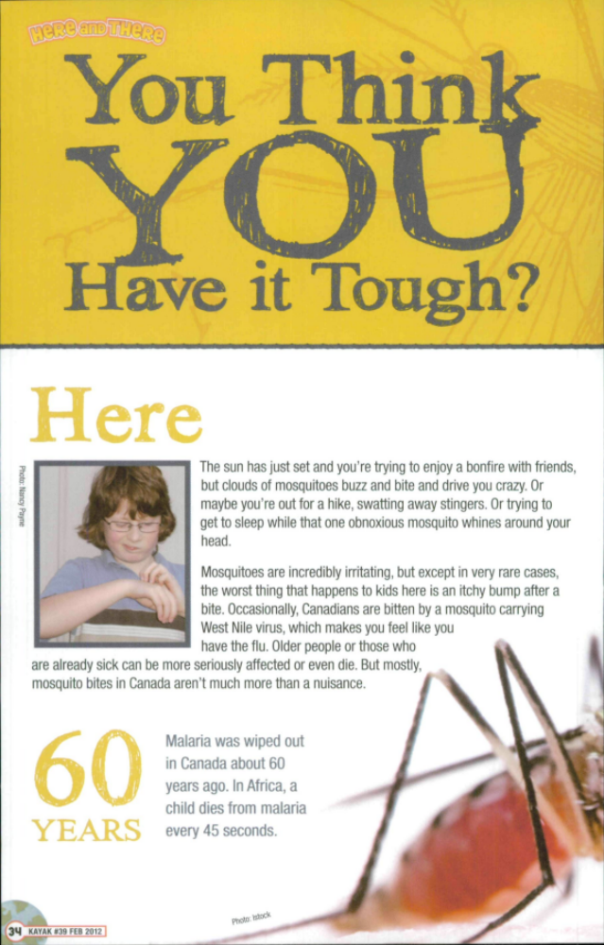

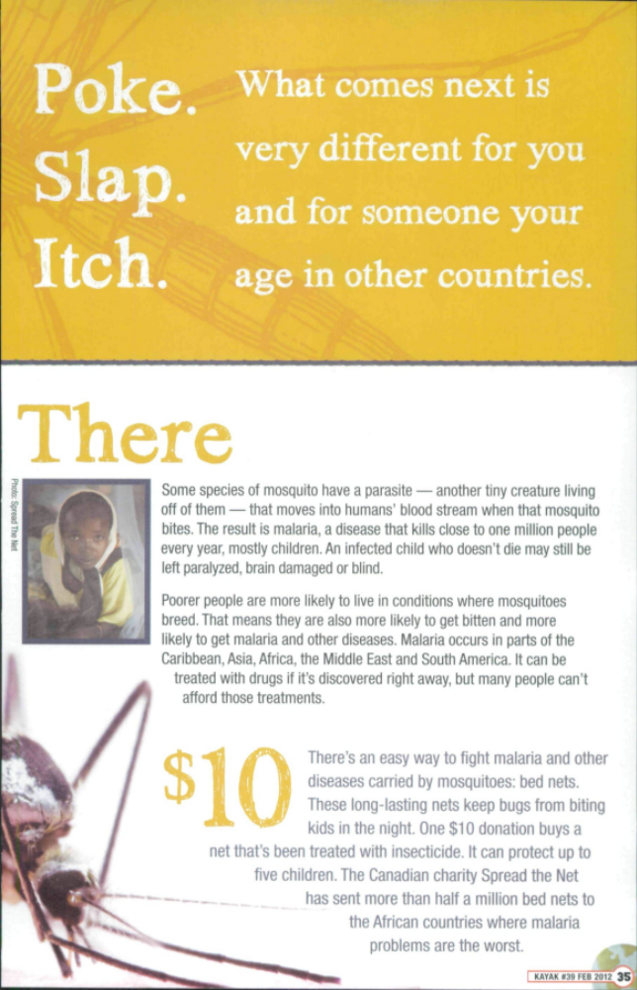
Reproduced with the permission of Canada's History Society.

Mid-Unit 2 Assessment: Comparing and Contrasting Two Texts:
Simulated Research Graphic Organizer

Name:
Date:

Source Information | Claims/Central Ideas  (Paraphrase the Benefits or Harmful Consequences) | Details/Evidence
Source Title:
Author:
Date:
Source Type (newspaper article, book, Web site, video, etc.):

Credible? Yes / No
(Use your Credibility Checklist to guide you.)
Does this source help you refocus or refine your research question in any way? How?

What new questions you would like answered before making your claim about DDT?

Comparing and Contrasting Authors’ Presentations Graphic Organizer

Name:
Date:

Text 1:  Title: “DDT Spray Scares Mosquitoes Away, Study Finds” | Compare and Contrast  the Authors’ Presentations | Text 2:  Title: “You Think You  Have It Tough?”
How does the author introduce the article? | How are they similar?  How are they different? | How does the author introduce the article?
What claim does the author make? | How are they similar?  How are they different? | What claim does the author make?
What type of evidence does the author include? | How are they similar?  How are they different? | What type of evidence does the author include?
How does the author use text features (photographs, graphs, diagrams, etc.)? | How are they similar?  How are they different? | How does the author use text features (photographs, graphs, diagrams, etc.)?
Comparing and Contrasting Authors’ Presentations Graphic Organizer

Which article is more effective in providing information or in building an argument? Why?

Research Vocabulary: Using Multiple Strategies to Determine the Meaning of Words

Name:
Date:

- Each of these words comes from the article “DDT Spray Scares Mosquitoes Away, Study Finds.”
- Refer to the article in order to use context clues to determine word meaning.
- Refer to your affixes list in order to use affixes + root words to determine word meaning.
- Refer to a resource material to confirm or revise your initial meaning.

Word from the Text | What do you think it means? | What strategy helped you determine the meaning?  (CC = Context Clues, A+R = Affixes + Root Words, RM = Resource Material) | What is the dictionary’s definition of this word?
1. transmission
2. discontinued
3. colleagues

Credibility Checklist

Name:
Date:

Title of Article:____________________

Source Information | Most Credible | Fairly Credible | Least Credible
Author | Expert in the field | Educated on topic | Little or no information about author
Date | Recently published or revised | Outdated | No date listed
Source Type | Official Web sites, institutional sites, academic journals, reputable news sources | Published material | Unfamiliar Web sites
Publisher | Publisher’s relationship to the topic is balanced or neutral | Publisher is sponsored by a trusted source | Clearly biased or favoring a position for a purpose

Mid-Unit 2 Assessment: Comparing and Contrasting Two Texts:
Simulated Research Graphic Organizer
Sample Student Response
(for Teacher Reference)

Source Information | Claims/Central Ideas  (Paraphrase the Benefits or Harmful Consequences) | Details/Evidence
Source Title:  DDT Spray Scares Mosquitos Away, Study Finds | - DDT is a very effective in fighting off malaria.  - Malaria affects a huge number of people in the world.  - DDT should work on several different types of mosquitoes that carry diseases.  - There are other pesticides that work, but not as well as DDT. | - “They estimate that DDT spray reduced the risk of disease transmission by nearly three-quarters.”  - “Malaria affects more than 40 percent of the world’s population, killing more than a million people every year, most of them young children.”  - “In huts sprayed with dieldrin, all 100 mosquitoes would enter the house.”  - “But it was likely the mosquitoes could develop resistance to this chemical, they said.”
Author:
N/A
Date:
August 9, 2007
Source Type (newspaper article, book, Web site, video, etc.):
Article
Credible? Yes / No
(Use your Credibility Checklist to guide you.)
Does this source help you refocus or refine your research question in any way? How?
What new questions you would like answered before making your claim about DDT?

(Answers will vary in this section. The important thing to look for is students include evidence to support their thinking.)
Comparing and Contrasting Authors’ Presentations: Sample Student Response
(Answers, for Teacher Reference)

Text 1:  Title: “DDT Spray Scares Mosquitoes Away, Study Finds” | Compare and Contrast  the Authors’ Presentations | Text 2:  Title: “You Think You  Have It Tough?”
How does the author introduce the article? | How are they similar?  How are they different? | How does the author introduce the article?
The author introduces the article by immediately providing information about DDT and malaria. | They are similar because they are both talking about mosquitoes.  They are different because one is more personal and talking to the reader, while the other is more informational. | The author introduces the article by asking me to imagine a situation in which I am being bitten by mosquitoes.
What claim does the author make? | How are they similar?  How are they different? | What claim does the author make?
What type of evidence does the author include? | How are they similar?  How are they different? | What type of evidence does the author include?
The author includes lots of statistics about malaria.  The author includes lots of statistics about DDT and its effect on mosquitoes.  The author gives evidence from scientists. | They are similar because they both include statistics and facts.  One difference is that the author of “DDT Spray Scares Mosquitoes Away, Study Finds” provides many more statistics and the names of scientists who have studied it. | The author gives facts about mosquitoes in Canada.  The author gives facts about mosquitoes in other parts of the world.  The author provides facts about malaria and how many people die.
Comparing and Contrasting Authors’ Presentations: Sample Student Response
(Answers, for Teacher Reference)

How does the author use text features (photographs, graphs, diagrams, etc.)? | How are they similar?  How are they different? | How does the author use text features (photographs, graphs, diagrams, etc.)?
This author does not include any text features. | They are not similar because only one of the articles uses text features.  They are different because the author of “You Think You Have It Tough” uses photographs of children and mosquitoes. | The author shows pictures of kids from different parts of the world. This helps me to imagine the real people struggling with malaria.  The author uses sidebars with facts to show important information.  The author uses large text for important questions or ideas.

Which article is more effective in providing information or in building an argument? Why?

(Answers will vary in this section. The important thing to look for is students include evidence to support their thinking. Consider referring to the NYS 2-point short response rubric for scoring guidance.)

