Lesson 24
Objective: Use dimes and pennies as representations of numbers to 120.

Suggested Lesson Structure
 Fluency Practice (13 minutes)
 Application Problem (5 minutes)
 Concept Development (32 minutes)
 Student Debrief (10 minutes)
Total Time (60 minutes)
Fluency Practice (13 minutes)
- Grade 1 Core Fluency Sprint 1.OA.6 (10 minutes)
- Standards Check: Place Value 1.NBT.2 (3 minutes)
Grade 1 Core Fluency Sprint (10 minutes)
Materials: (S) Core Fluency Sprint from G1–M5–Lesson 1
Note: Choose a Sprint based on the needs of the class.
- Core Addition Sprint
- Core Addition Sprint 2
- Core Subtraction Sprint
- Core Fluency Sprint: Totals of 5, 6, and 7
- Core Fluency Sprint: Totals of 8, 9, and 10
Standards Check: Place Value (3 minutes)
Materials: (T/S) Personal white boards
Note: This activity monitors students’ understanding of place value.
Write a number on your personal board, but do not show students.
T: My number has 1 ten and 3 ones. What’s my number?
S: 13.
T: (Show the board.) What’s the value of this 1? (Pause, then snap.)
S: 10.
T: What’s the value of this 3? (Pause, then snap.)
S: 3.
Repeat with the following suggested sequence: 22, 27, 66, 63, 36, 90, and 99. Alternate saying the number in the ones place first and saying the number in the tens place first. For the last minute, write a two-digit number and ask students to write the value of one of the digits on their personal boards.
T: (Show 53.) Write the value of the 5.
S: (Write 50.)
Application Problem (5 minutes)
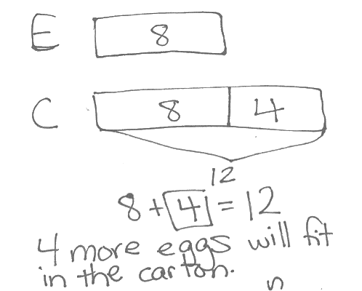There are 8 eggs in the carton. The carton can hold 12 eggs. How many more eggs will fit in the carton?
Note: Today's problem is a put together with addend unknown problem type where students are looking for a missing part. A single bar is effective, especially since we are talking about one carton of eggs that looks like a single tape.
However, some students may want to model the problem with two bars, in a sense comparing the given part with the known total. This does make sense, especially considering they have been working with comparison problems recently. Both solutions are modeled.
Concept Development (32 minutes)
Materials: (T) 12 dimes, 10 pennies (plastic or real), projector (S) 12 dimes, 10 pennies (plastic or real), personal white board
Students begin lesson at their desks or tables, seated next to their partner with all materials.
T: (Write 80 on the board.) Use your coins to represent this number. Draw a matching place value chart on your personal board.
S: (Use 8 dimes. Some may use 7 dimes and 10 pennies, which is considered correct as long as the student’s place value chart matches his chosen representation.)
T: If I used only dimes to represent 80, how many dimes would I need?
S: 8 dimes!
T: How many tens in 80?
S: 8 tens!
Repeat the process with the following suggested sequence: 50, 68, 82.
T: (Write 90 on the board.) Use your coins to represent this number. Draw a matching place value chart on your personal board.
S: (Use 9 dimes.)
T: If I used only dimes to represent 90, how many dimes would I need?
S: 9 dimes!
T: How many tens in 90?
S: 9 tens!
T: (Write 92 on the board.) Use your coins to represent this number. Draw a matching place value chart on your personal board.
S: (Use 9 dimes and 2 pennies.)
T: How many dimes would I need?
S: 9 dimes!
T: How many pennies?
S: 2 pennies!
T: How many tens and how many ones is this?
S: 9 tens and 2 ones.
T: (Write 100 on the board.) How many tens are in 100? Use your dimes to show 100 cents. (Wait as students count out 10 dimes.)
S: (Show 10 dimes.)
T: How many dimes did we use to make 100 cents?
S: 10 dimes!
T: How many tens do you have?
S: 10 tens.
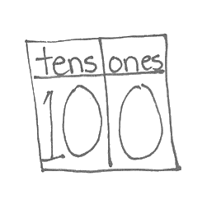
T: (Next to 100, add a place value chart showing 10 tens.)
T: Do we need any additional pennies?
S: No.
T: (Write 0 in the ones place on the place value chart.)
T: (Point to the place value chart.) 10 tens 0 ones is…?
S: 100.
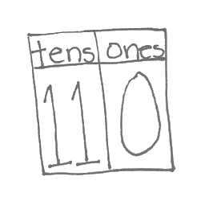
T: Let’s add 1 more dime. (Wait as students add 1 dime to their collection.) How many dimes do you have now?
MP.4
S: 11 dimes!
T: Draw a place value chart on your personal white board to show 11 tens 0 ones. (Wait as students show this.)
T: (Write 100 + 10 on the board.) We added ten cents to one hundred cents. How many cents do we have now?
S: 110 cents.
T: How many tens in 110 cents?
S: 11 tens!

T: Let’s add 1 more dime. (Wait as students add 1 dime to their collection.) How many dimes do you have now?
S: 12 dimes!
T: Draw a place value chart on your personal white board to show 12 tens 0 ones. (Wait as students show this.)

NOTES ON
MULTIPLE MEANS OF REPRESENTATION:
Some students may have difficulty determining the value of coins when two different coins are used. Have them count one type of coin at a time and use their personal white boards to help them keep track of what they have counted.

T: (Write 100 + 20 on the board.) We had 100 cents. Then we added 2 more dimes for 20 more cents. How many cents do we have now?
S: 120 cents.
T: Look at your dimes. How many tens in 120 cents?
S: 12 tens!
Note: Some students may be familiar with the value of a dollar and may bring up that 100 cents is 1 dollar or that 120 cents is $1.20. Let them know they are correct, but refocus them back to the number of tens (dimes) and ones (pennies), as that is the focus of this lesson.
Project the following sequences of coins, and have students determine their total value:
- 4 dimes, 8 pennies

NOTES ON
MULTIPLE MEANS OF ENGAGEMENT:
Continue to challenge advanced students. As an extension to the lesson, add 2 or 4 nickels to the sequence to the left and have students share their strategy to solve. They may count the nickels as nickels, count the nickels together as a ten, or ask to exchange two nickels for one dime.
- 4 dimes, 10 pennies
- 4 dimes, 12 pennies
- 5 pennies, 6 dimes
- 15 pennies, 6 dimes
- 10 dimes, 10 pennies
If students need more practice or support representing the numbers or the coins, continue presenting more two-digit numbers.
If students demonstrate strong skills in representing numbers to 120 using dimes and pennies, connect their understanding with their addition work from Topics C and D as shown below:
T: (Write 52 on the board.) Partner A, use your coins to represent this number using as many dimes as you can.
T: (Write 20 on the board.) Partner B, use your coins to represent this number using as many dimes as you can.
T: (Add an addition symbol between the numbers to create an expression.) Add your coins together. How much do you have? (Wait as students add coins.)
S: 72 cents!
T: On your personal board, solve 52 + 20. (Wait as students solve.) How did you solve this problem?
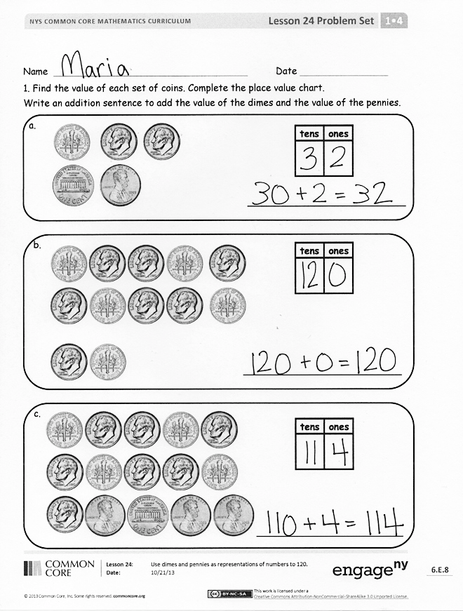
S: I lined up my numbers and added the ones with ones and the tens with tens. There were only 2 ones. 5 tens + 2 tens is 7 tens. The total is 72. I did the same thing. It’s just like adding the dimes with the dimes. There were 2 pennies. Then 5 dimes plus 2 dimes was 7 dimes. That makes 72 cents! I added 2 tens. 52, 62, 72. That’s like counting on the dimes.
Repeat the process using the following suggested sequence: 52 + 24, 59 + 30, 59 + 31, 59 + 34. As students share their solution strategies, ask them to make connections between their coins and their written notation. What similarities do they notice? What number bonds do they see represented by the coin combinations?
Problem Set (10 minutes)
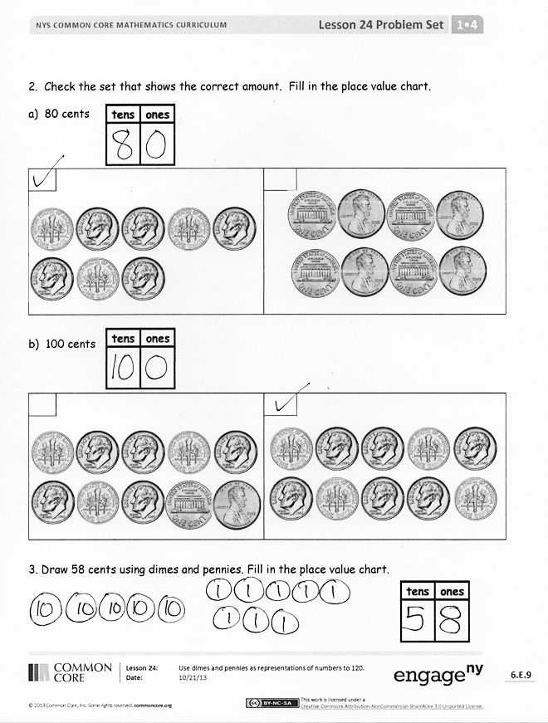
Students should do their personal best to complete the Problem Set within the allotted 10 minutes. For some classes, it may be appropriate to modify the assignment by specifying which problems they work on first. Some problems do not specify a method for solving. Students solve these problems using the RDW approach used for Application Problems.
Student Debrief (10 minutes)
Lesson Objective: Use dimes and pennies as representations of numbers to 120.
The Student Debrief is intended to invite reflection and active processing of the total lesson experience.
Invite students to review their solutions for the Problem Set. They should check work by comparing answers with a partner before going over answers as a class. Look for misconceptions or misunderstandings that can be addressed in the Debrief. Guide students in a conversation to debrief the Problem Set and process the lesson.
You may choose to use any combination of the questions below to lead the discussion.
- Look at Problem 2(a). How did you determine which set of 8 would make 80 cents? What is the value of the other set? How would a place value chart for 8 pennies look compared to the place value chart for 8 dimes?
- Look at Problem 2(b). What is the value of the set that does not equal 100 cents? How would you show this value in a place value chart?
- Look at Problem 3. What is another way to show 58 cents?
Exit Ticket (3 minutes)
After the Student Debrief, instruct students to complete the Exit Ticket. A review of their work will help you assess the students’ understanding of the concepts that were presented in the lesson today and plan more effectively for future lessons. You may read the questions aloud to the students.

Name Date

- Find the value of each set of coins. Complete the place value chart to match.
Write an addition sentence to add the value of the dimes and the value of the pennies.
a.

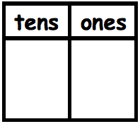
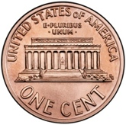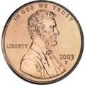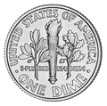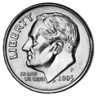

2. Check the set that shows the correct amount. Fill in the place value chart to match.

c.
_________________________

b.
___________________________
___________________________
a. 80 cents

b. 100 cents

- Draw 58 cents using dimes and pennies. Fill in the place value chart.

Name Date

- Find the value of the set of coins. Complete the place value chart to match.
Write an addition sentence to add the value of the dimes and the value of the pennies.

Name Date

- Find the value of each set of coins. Complete the place value chart.
Write an addition sentence to add the value of the dimes and the value of the pennies.

a.

2. Check the set that shows the correct amount. Fill in the place value chart to match.
___________________________

_________________________

b.
c.
___________________________
110 cents

3. a. Draw 79 cents using dimes and pennies. Fill in the place value chart to match.

b. Draw 118 cents using dimes and pennies. Fill in the place value chart to match.

