Lesson 23
Objective: Count on using pennies from any single coin.

Suggested Lesson Structure
 Fluency Practice (13 minutes)
 Application Problem (5 minutes)
 Concept Development (32 minutes)
 Student Debrief (10 minutes)
Total Time (60 minutes)
Fluency Practice (13 minutes)
- Core Fluency Differentiated Practice Sets 1.OA.6 (5 minutes)
- Standards Check: Subtraction Within 20 1.OA.6 (8 minutes)
Core Fluency Differentiated Practice Sets (5 minutes)
Materials: (S) Core Fluency Practice Sets from G1–M6–Lesson 1
Note: Give the appropriate Practice Set to each student. Students who completed all questions correctly on their most recent Practice Set should be given the next level of difficulty. All other students should try to improve their scores on their current levels.
Students complete as many problems as they can in 90 seconds. Assign a counting pattern and start number for early finishers, or have them practice make ten addition or subtraction on the back of their papers. Collect and correct any Practice Sets completed within the allotted time.
Standards Check: Subtraction within 20 (8 minutes)
Materials: (S) Personal white boards
Note: This fluency activity shows which strategies students are using to add within 20. Students may show their work with a number bond, the arrow way, multi-step equations, or listing numbers to show how to count on.
Write the following list of strategies:
- Count on or back.
- Think of the addition problem.
- Take from ten.
- Use place value and a helper problem.
Say an addition expression. Students use their personal white board to solve. Choose students who used different strategies to share what they did, or instruct students to share their strategies with a partner.
Suggested sequence:
- 15 – 1, 18 – 2
- 18 – 4, 19 – 7
- 12 – 3, 11 – 2
- 15 – 9, 17 – 8
- 16 – 14, 18 – 15
Application Problem (5 minutes)
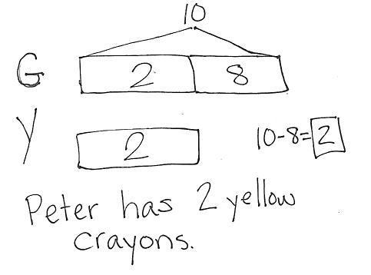
Peter has 8 more green crayons than yellow crayons. Peter has 10 green crayons. How many yellow crayons does Peter have?
Note: Today's problem is a compare with smaller unknown where the problem suggests the wrong operation. Students are expected to have worked with these problems in Grade 1, but mastery is not expected until the end of Grade 2. Consider scaffolding such as, “Set up your tape diagram to first show the same number of green crayons and yellow crayons. Does Peter have more green crayons or yellow crayons? Add another section of tape (the more tape) to the green crayons. How many more green crayons does he have than yellow crayons?”
Concept Development (32 minutes)
Materials: (T) 1 quarter, 3–5 dimes, 2–4 nickels, 15 pennies (plastic or real), projector (S) 1 quarter, 3–5 dimes, 2–5 nickels, 25 pennies (plastic or real), 1 six-sided die per pair of students
Gather students in the meeting area with personal boards. Coins and dice are not needed until students play the game towards the end of the Concept Development.
T: (Project 1 quarter.) What is the name of this coin?
S: A quarter!
T: What is its value?
S: 25 cents.
T: (Add 1 penny to the quarter being projected.) How much money is shown now?
S: 26 cents!
T: How do you know?
S: You added one penny. That’s one cent more.
T: What is 1 quarter plus 1 penny, a quarpenny? No such thing! But we can add their values! Let’s try.
T: Tell me an addition sentence that puts together the value of the quarter and the value of the penny.
S: 25 + 1 = 26.
T: Tell me an addition sentence that puts together the value of a dime and the value of 3 pennies.
S: 10 + 3 = 13.
T: So a dime and 3 pennies would be how much money?
S: 13 cents.
T: Try some more!
Repeat the process by projecting the following sequence of coins:
- 1 quarter, add 3 pennies

NOTES ON
MULTIPLE MEANS OF EXPRESSION:
Some students may have difficulty keeping track of counted and uncounted coins. Invite students to place their own coins out to match the teacher set of coins. Using these coins, students may rearrange the coins or slide the coins over as they count.
- 3 dimes, add 6 pennies
(Use 5-group formation to show the 6 pennies. Discuss why the 5-group formation helps you know the total amount of pennies without counting.)
- 1 nickel, add 4 pennies
- 4 pennies and 1 nickel
(Have students explain which coins they counted first and why. Accept both preferences.)
Practice counting on pennies using the following sequence:
- 3 pennies, 1 nickel
- 3 pennies, 1 quarter
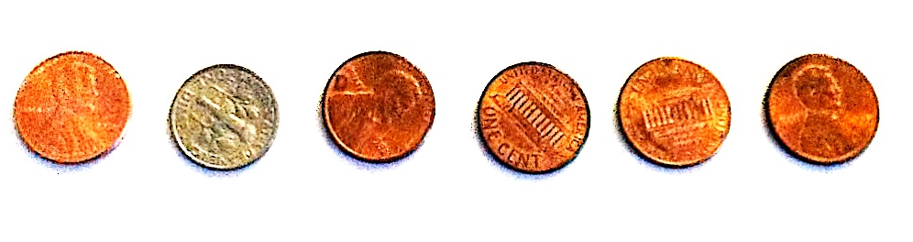
- 4 pennies, 1 quarter
T: (Show 1 penny, 1 dime, 4 pennies.) How can we group these to make it easier to count?
S: Put all the pennies together!
T: Great! Which will we be starting with, the dime or the pennies?
S: The dime!
T: That is just easier, I agree. So let’s move all the pennies together and place them after the dime. (Move first penny next to 4 pennies.)

NOTES ON
MULTIPLE MEANS OF ENGAGEMENT:
Have students who may have difficulty keeping track of their total coin value between turns use their personal white board to keep track of their totals as they play.
T: Tell me an addition sentence that puts together the value of a dime, the value of 4 pennies, and the value of 1 penny.
S: 10 + 4 + 1 = 15.
Continue to practice counting on pennies, regardless of the order of the coins using the following sequence:
- 2 pennies, 1 dime, 2 pennies
- 2 pennies, 1 quarter, 3 pennies
- 1 quarter, 7 pennies
(Be sure to use the 5-group formation when presenting the 7 pennies. Discuss how the formation can help students use the make ten strategy to add.)
If time permits, have partners play First to 50 Cents (a version of Coin Exchange). The objective of the game is to be the first player with 50 cents.
First to 50 Cents
Players A and B begin with 1 quarter.
- Player A rolls the die and adds that many pennies to the quarter.
- Player B rolls the die and adds that many pennies to the quarter.
- Players continue to take turns until someone has at least 50 cents, trading pennies for nickels or dimes. No player who has 25 pennies can win!
Players might trade pennies for nickels, dimes, and finally, a quarter, as they play.
Problem Set (10 minutes)
Students should do their personal best to complete the Problem Set within the allotted 10 minutes. For some classes, it may be appropriate to modify the assignment by specifying which problems they work on first. Some problems do not specify a method for solving. Students solve these problems using the RDW approach used for Application Problems.
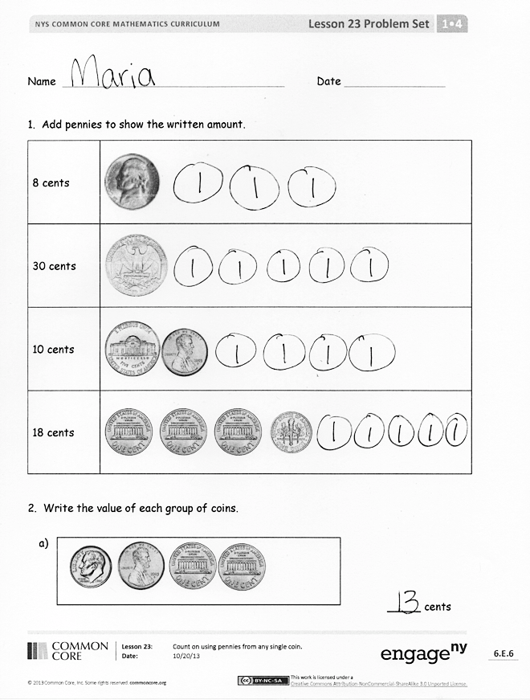
Student Debrief (10 minutes)
Lesson Objective: Count on using pennies from any single coin.
The Student Debrief is intended to invite reflection and active processing of the total lesson experience.
Invite students to review their solutions for the Problem Set. They should check work by comparing answers with a partner before going over answers as a class. Look for misconceptions or misunderstandings that can be addressed in the Debrief. Guide students in a conversation to debrief the Problem Set and process the lesson.
You may choose to use any combination of the questions below to lead the discussion.
- Look at Problem 2. How do 5-group formations help you count coins quickly?
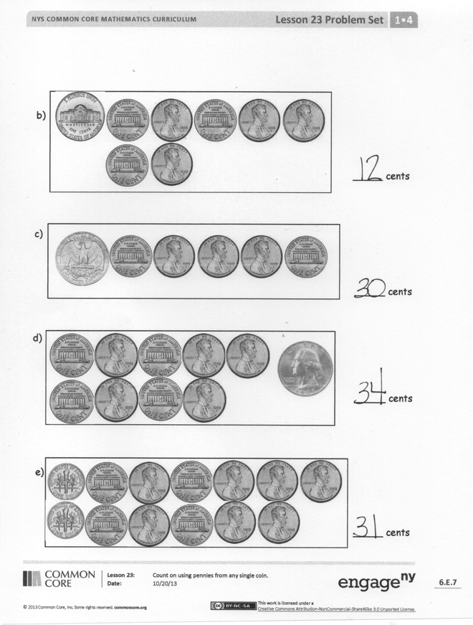
- Three dimes and 1 dime is 4 dimes. Three pennies and 1 penny is 4 pennies. Why is it that 3 dimes and 1 penny don’t equal 4 cents? What do we need to do in order to add dimes and pennies together? What is our label, or unit, to add 3 dimes and 1 penny in a number sentence? (30 cents + 1 cent = 31 cents. We change the unit to cents, so that they have the same unit, which can be added together.)
- Look at Problem 2(b). How many cents are there? Look at Problem 2(c). How many cents are there? Why is the value of 2(c) greater than the value of 2(b), even though 2(b) has more coins?
Exit Ticket (3 minutes)
After the Student Debrief, instruct students to complete the Exit Ticket. A review of their work will help you assess the students’ understanding of the concepts that were presented in the lesson today and plan more effectively for future lessons. You may read the questions aloud to the students.

Name Date

- Add pennies to show the written amount.
8 cents | 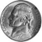
30 cents | 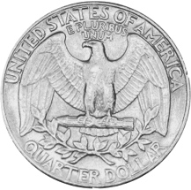
10 cents | 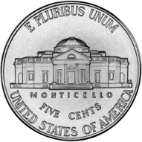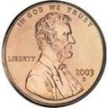
18 cents | 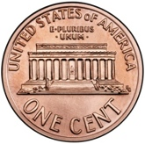

- Write the value of each group of coins.
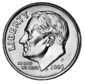

a.

_____ cents

b.

_____ cents

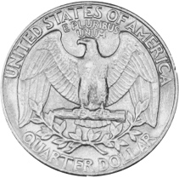

c.

_____ cents

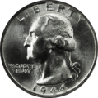
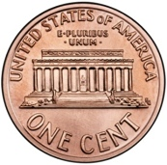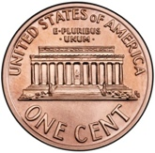

_____ cents

d.

_____ cents

e.
Name Date

- Add pennies to show the written amount.
9 cents
29 cents

Name Date

- Add pennies to show the written amount.
15 cents
28 cents | 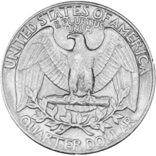
22 cents | 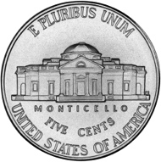
32 cents

- Write the value of each group of coins.

a.

_____ cents

c.

_____ cents

e.

_____ cents

b.

_____ cents

d.

_____ cents

