Lesson 22
Objective: Identify varied coins by their image, name, or value. Add one cent to the value of any coin.

Suggested Lesson Structure
 Fluency Practice (13 minutes)
 Application Problem (5 minutes)
 Concept Development (32 minutes)
 Student Debrief (10 minutes)
Total Time (60 minutes)
Fluency Practice (13 minutes)
- Core Fluency Differentiated Practice Sets 1.OA.6 (5 minutes)
- Standards Check: Addition Within 20 1.OA.6 (8 minutes)
Core Fluency Differentiated Practice Sets (5 minutes)
Materials: (S) Core Fluency Practice Sets from G1–M6–Lesson 1
Note: Give the appropriate Practice Set to each student. Students who completed all questions correctly on their most recent Practice Set should be given the next level of difficulty. All other students should try to improve their scores on their current levels.
Students complete as many problems as they can in 90 seconds. Assign a counting pattern and start number for early finishers, or have them practice make ten addition or subtraction on the back of their papers. Collect and correct any Practice Sets completed within the allotted time.
Standards Check: Addition within 20 (8 minutes)
Materials: (S) Personal white boards
Note: This fluency activity shows which strategies students are using to add within 20. Students may show their work with a number bond, the arrow way, multi-step equations, or listing numbers to show how to count on.
Write the following list of strategies:
- Count all.
- Count on.
- Make ten.
- Use a doubles fact.
- Use a helper problem (e.g., to solve 15 + 3, add 5 and 3 first).
Say an addition expression. Students use their personal boards to solve. Choose students who used different strategies to share what they did, or instruct students to share their strategies with a partner.
Suggested sequence:
- 9 + 2, 3 + 9, 2 + 8 + 2
- 5 + 6, 7 + 6, 4 + 4 + 6
- 15 + 1, 3 + 16
- 13 + 4, 12 + 7
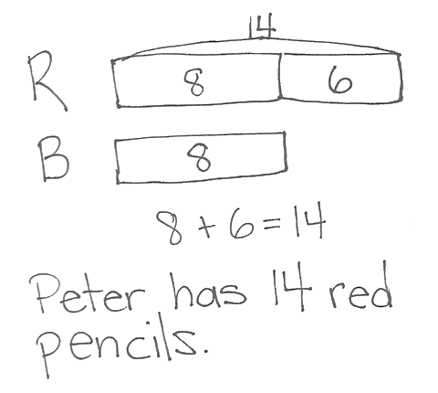
Application Problem (5 minutes)
Peter has 6 more red pencils than blue pencils. He has 8 blue pencils. How many red pencils does he have?
Note: Today's problem is a compare with bigger unknown problem type. Because yesterday’s Application Problem suggested an incorrect operation, students may expect the same experience with today’s problem. Encourage students to read through the entire problem, checking that their drawing and solution make sense for all sentences in the story problem. Having students check their work helps them to become better problem solvers. Be sure to point this out.
Concept Development (32 minutes)
Materials: (T) 5–10 different quarters (e.g., various commemorative quarters), 5 dimes, 5 nickels (possibly with different images), 20 pennies, 1 dollar coin if available (real or plastic), projector
(S) 1 quarter, 2–5 dimes, 3–5 nickels, 10–20 pennies (real or plastic), 1 six-sided die, spinner template (G1–M6–Lesson 20), paper clip, pencil per pair, personal white boards

NOTES ON
MULTIPLE MEANS OF ENGAGEMENT:
If you have started a classroom economy, use students’ coins to have them identify the image, name, and value of coins. Allow students to trade their pennies (or nickels) for larger coins if they have enough to do so.
Gather students in the meeting area with their materials. Distribute 1 or 2 coins to each student as they come to the meeting area.
T: I had all of these coins at home. Tell your partner the name and value of the coin(s) you have. Explain how you know what coin it is. (Wait as students share. You might have them pass their coin to the right until each student has had a chance to identify all the major coins.)
T: Let’s sort them into piles of the same coin. (Call out each coin. Students holding that type of coin place their coins in a common pile in the middle of the group.)
T: (Point to the pennies.) What kind of coins are these?
S: Pennies!
T: What is the value of 1 penny?
S: 1 cent!
T: (Push forward 1 nickel.) What is the name of this coin?
S: It’s a nickel.
T: What is its value?
S: 5 cents.
T: Use a complete sentence. A nickel’s value is…?
S: A nickel’s value is 5 cents.
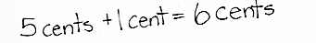
T: (Push 1 penny next to the nickel.) If I have 1 nickel and 1 penny, how many cents do I have altogether?
S: 6 cents!
T: How do you know?
MP.4
S: 5 + 1 = 6. 5 cents plus one more cent is 6 cents.
T: (Draw 1 nickel and 1 penny on chart paper, including their individual value and their total value, as shown at right.)

NOTES ON
MULTIPLE MEANS OF ENGAGEMENT:
Engage students in a home-hunt for quarters, pennies, and nickels with various images. When students bring in their findings, have them sort and name the coin and its value. Encourage students to share interesting observations.
Repeat the process, first with 1 dime and 1 penny, and then with 1 quarter and 1 penny. Finally, push forward the dollar coin.
T: (Push forward 1 dollar coin.) Does anyone know the name of this coin?
S: It’s a dollar coin! (If students do not know, introduce this as a dollar coin.)
T: A dollar coin is worth 100 cents!
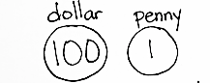
S: (Push 1 penny next to the dollar coin.) If I have 1 dollar coin whose value is 100 cents and 1 penny, how many cents do I have altogether?
S: 101 cents!
T: (Add dollar coin and penny to chart paper, including their individual value and their total value.)
Based on students’ ability to identify the name, value, and image of each coin, choose one of the games played during the past two days. To practice coin values of dime, nickel, and penny, play Coin Trade. To practice adding on coins as well as trading coins, play 25 Cents.

Coin Trade
If students are ready, include the quarter and use the new spinner at the end of this lesson.
Each player has 10 pennies (or 25 pennies if using the new spinner).
- Partner A spins the spinner.
- Partner A trades pennies for the coin selected. (For instance, if she lands on a nickel, she trades 5 pennies for 1 nickel. If she lands on a dime, she trades 10 pennies for 1 dime. If she lands on a quarter, she trades all coins for 1 quarter.)
- Partner B takes a turn.
- The person with the most pennies at the end of the game is the winner.
As play continues, students might land on the coins they already have, such as landing on a penny when they have 10 pennies. Students may trade one of their pennies for a new penny. Play the game for about five minutes.
25 Cents
For students who are ready for greater challenges, you can choose to make the goal 50 cents or 100 cents.
- Put 25 pennies in a pot in the middle.
- Player A rolls die and takes that number of pennies.
- Player B rolls die and does the same.
- On each turn, players roll the die, add the additional pennies, and exchange their pennies for larger coins if possible. For instance, if Player A has 6 pennies, he may trade 5 pennies for 1 nickel. If Player B has 1 nickel and 5 pennies, she may trade the coins for 1 dime.
- Play continues until a player can exchange his coins for 1 quarter, explaining that he has 25 cents.
Problem Set (10 minutes)
Students should do their personal best to complete the Problem Set within the allotted 10 minutes. For some classes, it may be appropriate to modify the assignment by specifying which problems they work on first. Some problems do not specify a method for solving. Students solve these problems using the RDW approach used for Application Problems.
Student Debrief (10 minutes)
Lesson Objective: Identify varied coins by their image, name, or value. Add one cent to the value of any coin.
The Student Debrief is intended to invite reflection and active processing of the total lesson experience.
Invite students to review their solutions for the Problem Set. They should check work by comparing answers with a partner before going over answers as a class. Look for misconceptions or misunderstandings that can be addressed in the Debrief. Guide students in a conversation to debrief the Problem Set and process the lesson.
You may choose to use any combination of the questions below to lead the discussion.
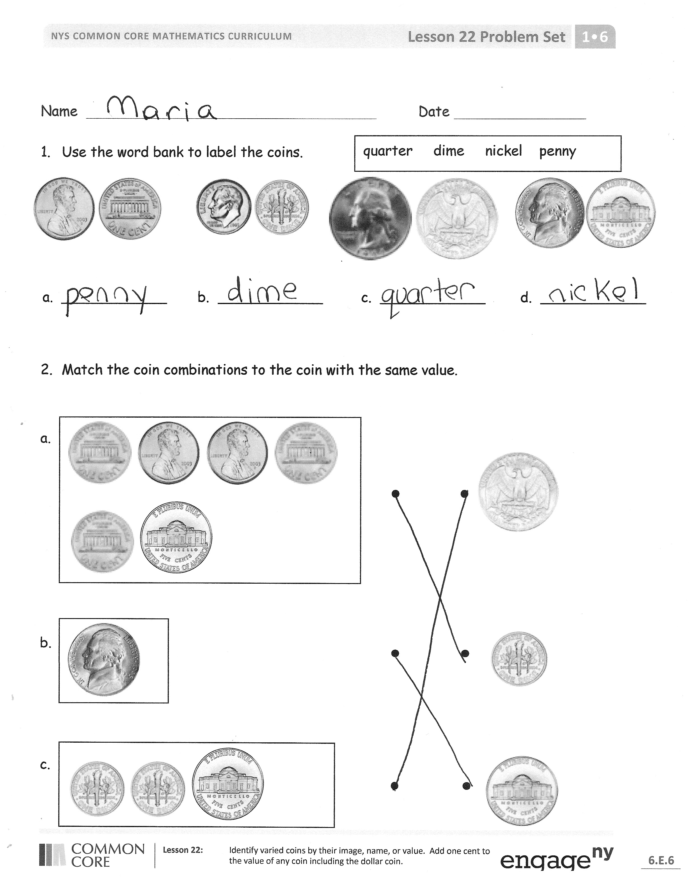
- Look at Problem 2. What other combinations of coins could you use to have the same value as a quarter? As a dime? As a nickel?
- Look at Problem 3. What are some ways to tell a nickel from a quarter?
- Create other problems like those in Problem 5. Who can identify the coin with the same value?
- What new coin did we see today? (Dollar coin.) Have you seen the dollar coin before? Where have you seen or used it?
Exit Ticket (3 minutes)
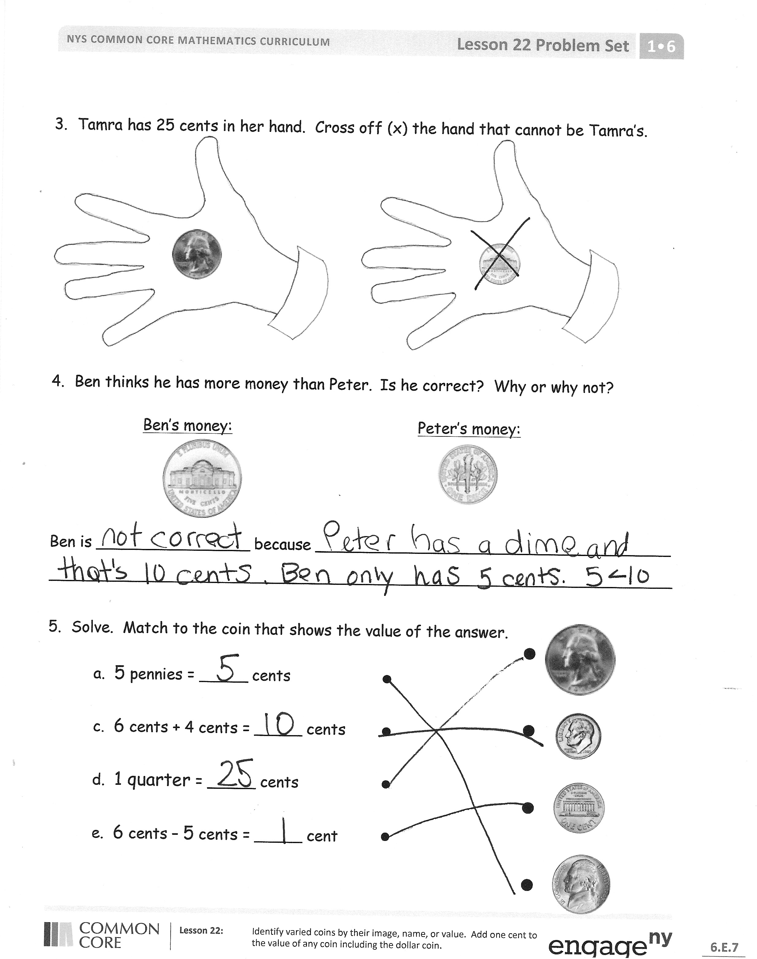
After the Student Debrief, instruct students to complete the Exit Ticket. A review of their work will help you assess the students’ understanding of the concepts that were presented in the lesson today and plan more effectively for future lessons. You may read the questions aloud to the students.
Name Date
quarter dime nickel penny
- Use the word bank to label the coins.
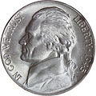
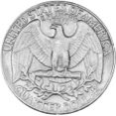
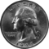
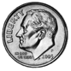
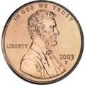
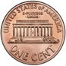

a. ____________ b. ____________ c. ____________ d. ____________

- Match the coin combinations to the coin on the right with the same value.
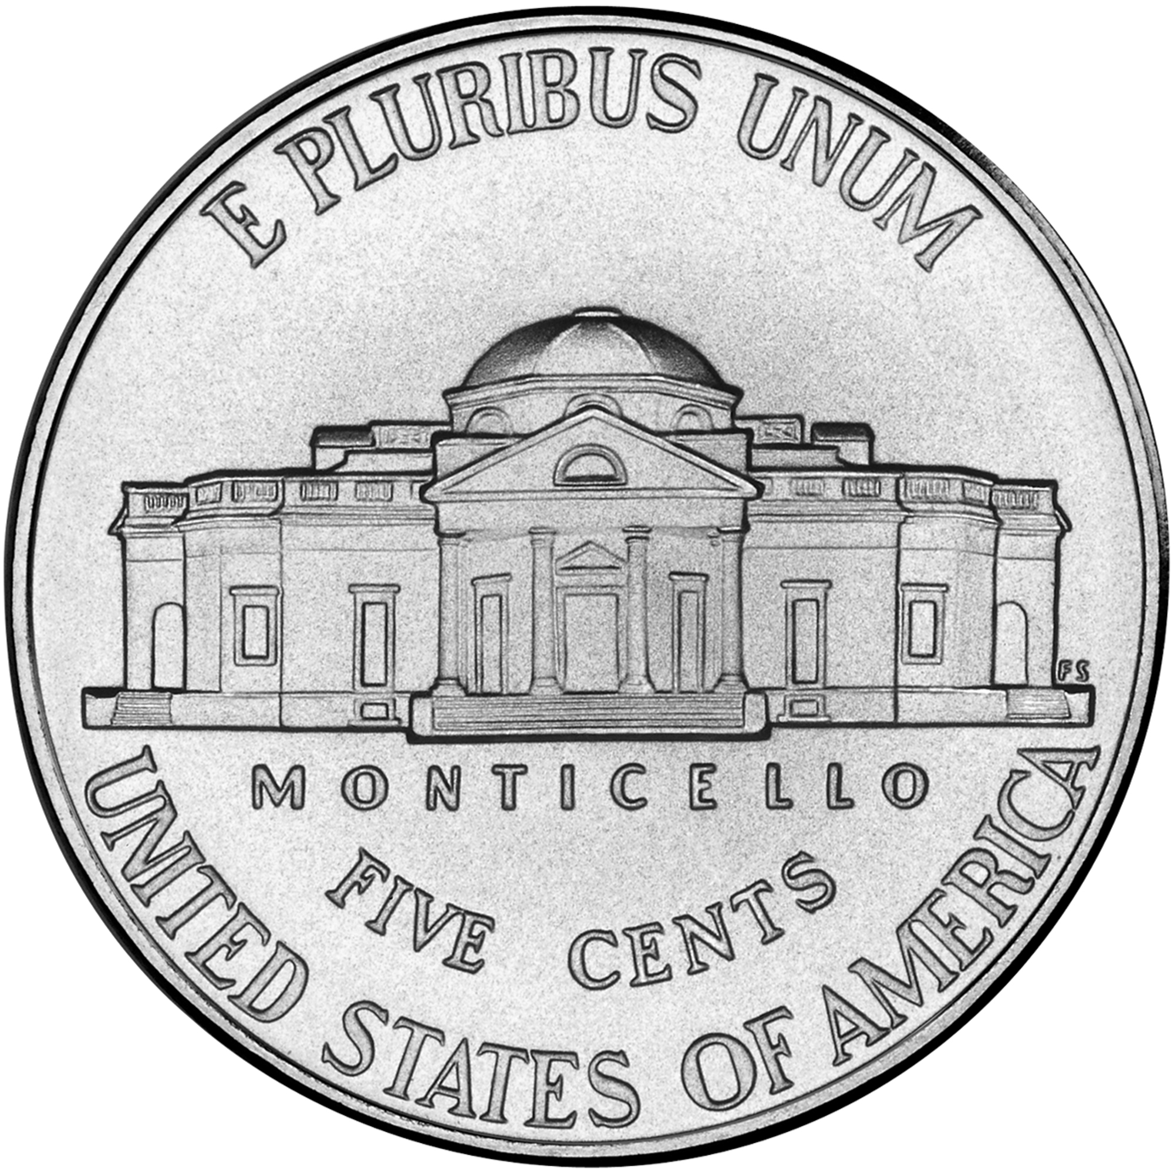
a.

b.

c.

- Tamra has 25 cents in her hand. Cross off (x) the hand that cannot be Tamra’s.
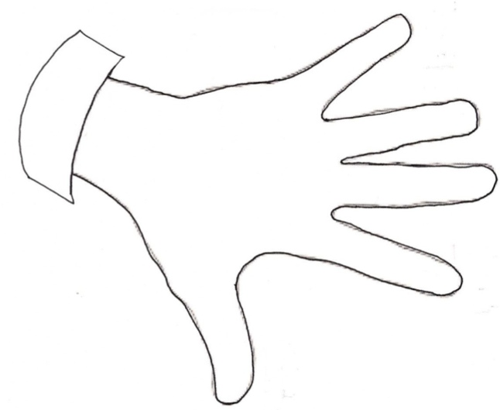
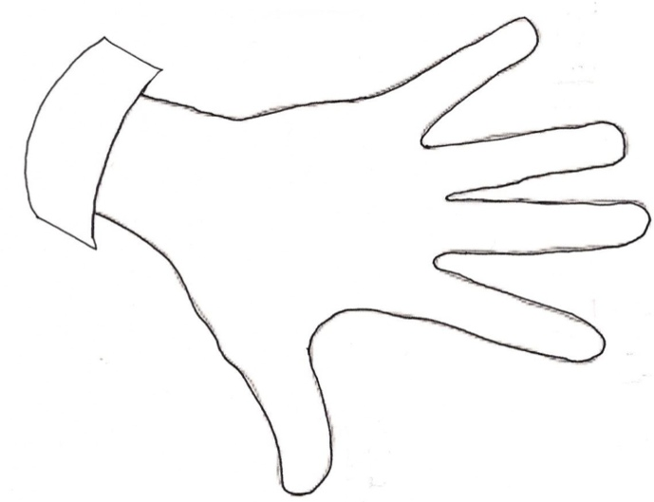

- Ben thinks he has more money than Peter. Is he correct? Why or why not?

Ben’s Money Peter’s Money

Ben is ________________ because _____________________________________
_________________________________________________________________
- Solve. Match each statement to the coin that shows
the value of the answer.

a. 5 pennies = _____ cents

b. 6 cents + 4 cents = _____ cents

c. 1 quarter = _____ cents

d. 6 cents – 5 cents = _____ cent

Name Date

Draw a line to match each coin to its correct name.
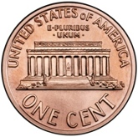
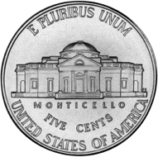
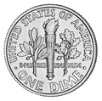
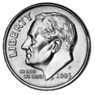

nickel

dime

penny

quarter

Name Date

- Match the label to the correct coins and write the value. There will be more than one match for each coin name.
nickel

cents
dime

cents
quarter
cents
penny
cent
a.

b.

c.

d.

- Lee has one coin in his pocket and Pedro has 3 coins. Pedro has more money than Lee. Draw a picture to show the coins each boy might have.
Lee’s pocket

Pedro’s pocket

- Bailey has 4 coins in her pocket and Ingrid has 4 coins. Ingrid has more money than Bailey. Draw a picture to show the coins each girl might have.

Coin Spinner with Quarter
Ingrid’s pocket

Bailey’s pocket

