Lesson 21
Objective: Identify quarters by their image, name, or value. Decompose the value of a quarter using pennies, nickels, and dimes.

Suggested Lesson Structure
 Fluency Practice (10 minutes)
 Application Problem (5 minutes)
 Concept Development (35 minutes)
 Student Debrief (10 minutes)
Total Time (60 minutes)
Fluency Practice (10 minutes)
- Grade 1 Core Fluency Sprint 1.OA.6 (10 minutes)
Grade 1 Core Fluency Sprint (10 minutes)
Materials: (S) Core Fluency Sprint (G1–M5–Lesson 1)
Note: Based on the needs of the class, select a Sprint from yesterday’s materials. There are several possible options available.
- Re-administer the Sprint from the day before.
- Administer the next Sprint in the sequence.
- Differentiate. Administer two different Sprints. Simply have one group do a counting activity on the back of their Sprint while the other Sprint is corrected.
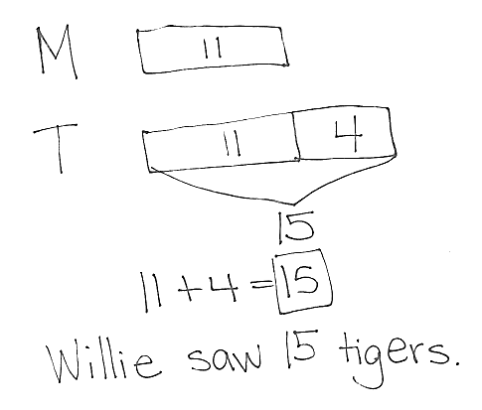
Application Problem (5 minutes)
Willie saw 11 monkeys at the zoo. He saw 4 fewer monkeys than tigers. How many tigers did he see at the zoo?
Note: Today's problem is a compare with bigger unknown where the problem suggests the wrong operation. Students are expected to have worked with these problems in Grade 1, but mastery is not expected until the end of Grade 2. Consider scaffolding such as, “Set up your tape diagram to first show the same number of monkeys and tigers. Which animal did Willie see more of, monkeys or tigers? Add another section of tape (the more tape) to the tigers. How many more tigers than monkeys did Willie see?”
Concept Development (35 minutes)
Materials: (T) 4 quarters, 5 dimes, 5 nickels, 25 pennies (plastic or real), chart paper (S) 1 quarter, 3 dimes, 3 nickels, 15 pennies (plastic or real), 1 six-sided die per set of partners, Problem Set
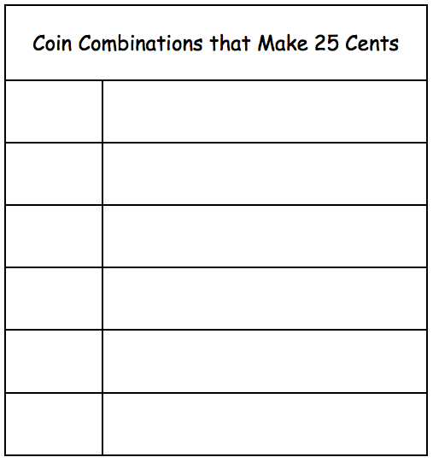
Note: Prepare the chart shown to the right prior to the lesson.
Gather students in the meeting area with their coins. Hold the Problem Set to the side.
T: Sort your coins into piles like we did yesterday so that we can find the coins we want more quickly. (Wait as students sort coins.)
T: Put your finger on one dime. What is the value of one dime?
S: 10 cents!
T: Put your finger on one penny. What is the value of one penny?
S: 1 cent!
T: Put your finger on one nickel. What is the value of one nickel?
S: 5 cents!
T: What is the unit for each of these coins?
S: Cents!
T: You have 1 new coin. Pick up the new coin. Look at it closely and describe what you notice about this coin.
S: It’s bigger than the other coins. It has bumpy edges, like the dime. The penny and the nickel have smooth edges. There is an eagle on this one. This one has a state’s name on it!
T: This coin is called a quarter. Let’s all say quarter.
S: Quarter!
T: Some quarters have different images on the back. Many have eagles on them, but others have different pictures and names of the states on them. (Show a few different images of quarters.) But no matter what, a quarter has a value of 25 cents.
T: Let’s use our coins to make 25 cents in different ways and record them on our chart.
T: How many pennies make 25 cents?
S: 25 pennies!
T: Count out 25 pennies. Please arrange them in 5-groups. I’ll give you about one minute.
T: To draw 1 penny we make a circle and write the value of the coin on it. (Demonstrate.) What is the value of 1 penny?
S: 1 cent.
T: Here is your chart. (Distribute Problem Set to students.)
T: Quickly draw one penny and show me your work. (Check work.) Now you have about one minute to draw 25 pennies in the first row of the Problem Set. Use the 5-group way.
T: How many tens do you see?
S: 2!
T: How many ones do you see?
S: 25!
T: How many ones are not grouped in a ten?
S: 5
T: Go down one row. What coins do we want to use to make 25 cents now?
MP.4
S: Dimes and pennies!
T: Look at your 25 pennies without touching them. What is a way to trade to make 25 cents with dimes and pennies? Talk to your partner.
S: I can trade 10 pennies for 1 dime. I can trade 20 pennies for 2 dimes. I could put 2 dimes and 5 pennies. I can put 1 dime and 15 pennies.
T: Go ahead and change pennies for dimes. Put the dimes where the pennies used to be. (Allow time for students to work.)
T: To draw 1 dime we make a circle and write the value of the dime on it. What is the value of 1 dime?
S: 10 cents.
T: What will you draw on the circle to show a dime?

NOTES ON
MULTIPLE MEANS OF
ENGAGEMENT:
To immerse students in coins more fully, consider a classroom economy program for the duration of the year. Provide students with plastic or real coins for completing their classroom tasks. The money earned can be pooled towards a class goal, or used individually in a class store.
S: 10.
T: Record one way you used dimes and pennies to make 25 cents.
T: Which was simpler, drawing 25 pennies or the dimes and pennies?
S: The dimes and pennies!
T: If you are ready to do the rest of the problems on your own in the chart, you may return to your desk with your coins and Problem Set. I will continue working here on the carpet with those who want to work together.
Continue the process, emphasizing systematic trading, and inviting alternate ways to use the coins indicated. Close by returning to the quarter.

NOTES ON
MULTIPLE MEANS OF EXPRESSION:
For students that need visual reminders of the names and values of the coins, hang chart paper with the name, value, and image of each coin.
T: How many quarters make 25 cents?
S: 1!
T: (Write 1 before quarter, draw a circle, and write 25 within it on the last row of the Problem Set).
T: What is the easiest coin to use to show 25 cents?
S: A quarter!
T: Take a moment to review with your partner all the ways that you showed that have the same value as a quarter.
On a rainy day, engage students in a game of 25 Cents. The object of the game is to be the first player to exchange their money for 1 quarter.
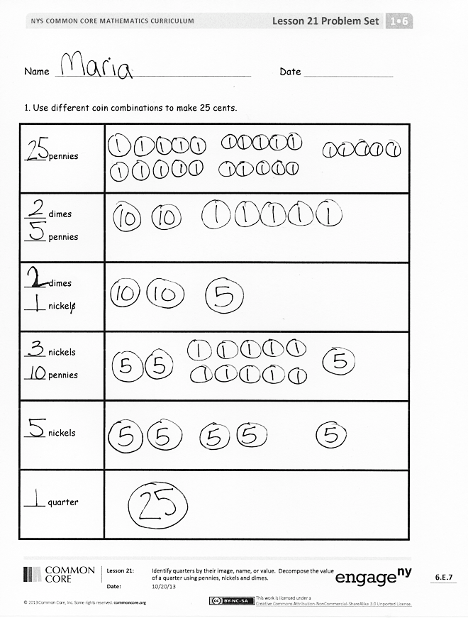
- Put coins in a pot in the middle.
- Player A rolls die and takes that number of pennies.
- Player B rolls die and does the same.
- On each turn, players roll the die, add the additional pennies, and exchange their pennies for larger coins if possible. For instance, if Player A has 6 pennies, she may trade 5 pennies for 1 nickel. If Player B has 1 nickel and 5 pennies, he may trade the coins for 1 dime.
- Play continues until a player can exchange their coins for 1 quarter, explaining that they have 25 cents.
Problem Set (10 minutes)
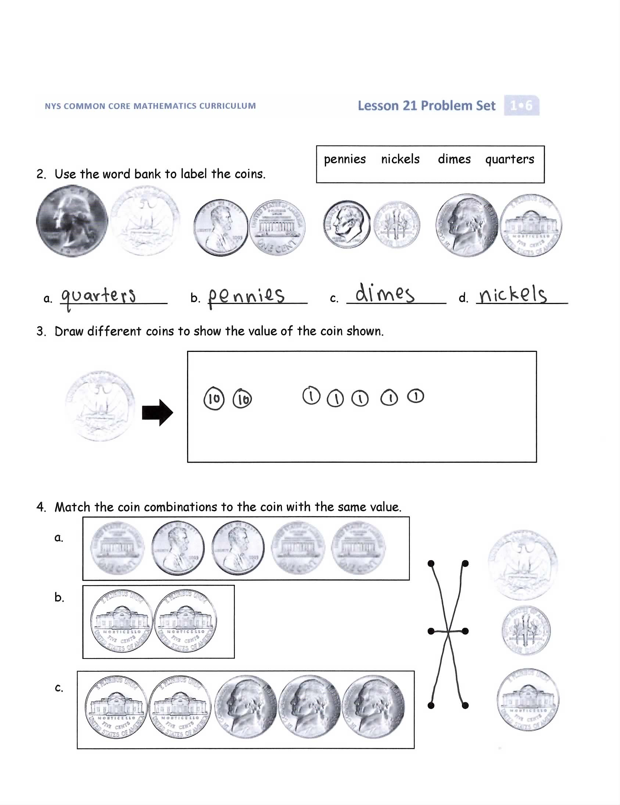
Students should do their personal best to complete the Problem Set within the allotted 10 minutes. For some classes, it may be appropriate to modify the assignment by specifying which problems they work on first. Some problems do not specify a method for solving. Students solve these problems using the RDW approach used for Application Problems.
Student Debrief (10 minutes)
Lesson Objective: Identify quarters by their image, name, or value. Decompose the value of a quarter using pennies, nickels, and dimes.
The Student Debrief is intended to invite reflection and active processing of the total lesson experience.
Invite students to review their solutions for the Problem Set. They should check work by comparing answers with a partner before going over answers as a class. Look for misconceptions or misunderstandings that can be addressed in the Debrief. Guide students in a conversation to debrief the Problem Set and process the lesson.
You may choose to use any combination of the questions below to lead the discussion.
- Look at Problem 4. How many more nickels did you need to make 25 cents than you needed to make 10 cents?
- What attributes of the coins help you recognize each?
- What is the name of the coin that has a value of 25 cents? (Quarter.)
- Where do you see quarters? What coins could you use to buy a snack that costs 55 cents?
Exit Ticket (3 minutes)
After the Student Debrief, instruct students to complete the Exit Ticket. A review of their work will help you assess the students’ understanding of the concepts that were presented in the lesson today and plan more effectively for future lessons. You may read the questions aloud to the students.

Name Date

- Use different coin combinations to make 25 cents.
____ pennies
____ dimes
____ pennies
____ dimes
____ nickels
____ nickels
____ pennies
____ nickels
____ quarter

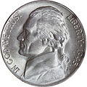
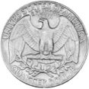
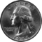
- Use the word bank to label the coins.
pennies nickels dimes quarters
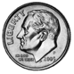
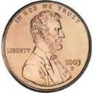
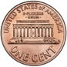
a. ______________ b. _____________ c. _____________ d. ____________

- Draw different coins to show the value of the coin shown.

- Match the coin combinations to the coin with the same value.
a.
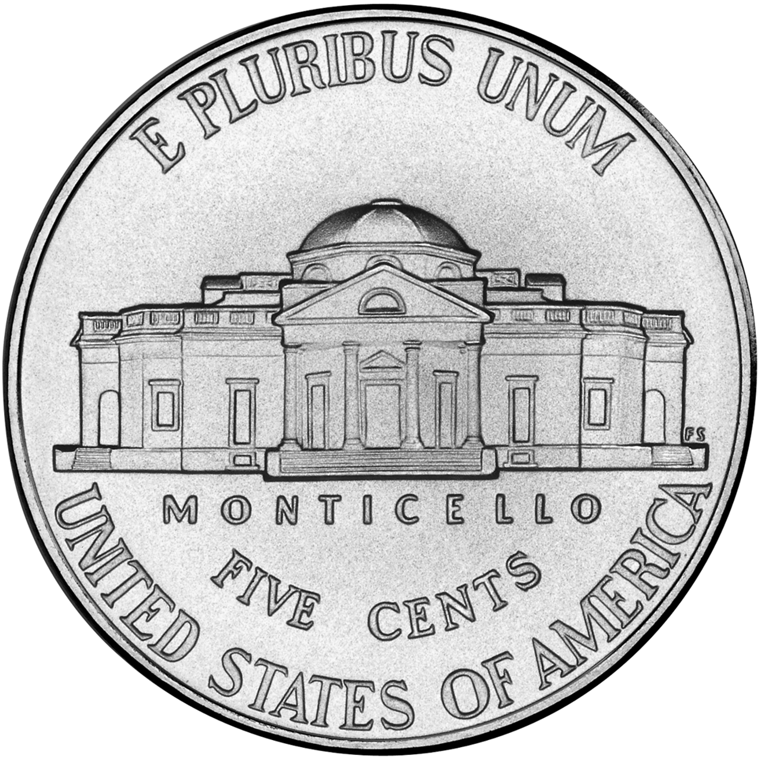
b.

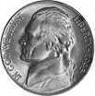
c.

Name Date

Use the word bank to write the names of the coins.
dime nickel penny quarter

a. ______________ b. _____________ c. _____________ d. ____________

Name Date

- Use the word bank to label the coins.
dime nickel penny quarter

a. ___________ b. _____________ c. _____________ d. ____________
- Write the value of each coin.
- The value of one dime is _______ cent(s).
- The value of one penny is _______ cent(s).
- The value of one nickel is _______ cent(s).
- The value of one quarter is _______ cent(s).

- Your mom said she will give you 1 nickel or 1 quarter. Which would you take, and why?
_________________________________________________________________
_________________________________________________________________
_________________________________________________________________
_________________________________________________________________
4. Lee has 25 cents in his piggy bank. Which coin or coins could be in his bank?
  - Draw to show the coins that could be in Lee’s bank.

- Draw a different set of coins that could be in Lee’s bank.

