Lesson 20
Objective: Identify pennies, nickels, and dimes by their image, name, or value. Decompose the values of nickels and dimes using pennies and nickels.

Suggested Lesson Structure
 Fluency Practice (15 minutes)
 Application Problem (5 minutes)
 Concept Development (30 minutes)
 Student Debrief (10 minutes)
Total Time (60 minutes)
Fluency Practice (15 minutes)
- Grade 1 Core Fluency Sprint 1.OA.6 (10 minutes)
- Standards Check: True or False Number Sentences 1.NBT.3 (5 minutes)
Grade 1 Core Fluency Sprint (10 minutes)
Materials: (S) Core Fluency Sprint from G1–M5–Lesson 1
Note: Choose a Sprint based on the needs of the class.
- Core Addition Sprint
- Core Addition Sprint 2
- Core Subtraction Sprint
- Core Fluency Sprint: Totals of 5, 6, and 7
- Core Fluency Sprint: Totals of 8, 9, and 10
Standards Check: True or False Number Sentences (5 minutes)
Materials: (S) Personal white board
Write a true or false number sentence. Students write a happy face on their personal boards if the number sentence is true. If the sentence is false, students write it with the correct symbol. Notice which problem types are difficult for them.
Use the first two columns as the suggested sequence. At each checkpoint, decide whether students are ready for the next column or if you should continue with similar problem types. The third column is provided as a possible opportunity for a few students who would really enjoy a challenge.
a. 5 > 4  b. 50 > 40  c. 57 > 75  d. 16 < 51  Checkpoint. | e. 40 + 5 = 45  f. 73 = 7 + 30  g. 82 < 8 tens 2 ones  h. 97 > 9 ones 7 tens  Checkpoint. | i. 9 + 7 = 10 + 6  j. 16 + 10 = 26 – 10  k. 12 – 6 > 9  l. 90 < 89 + 1
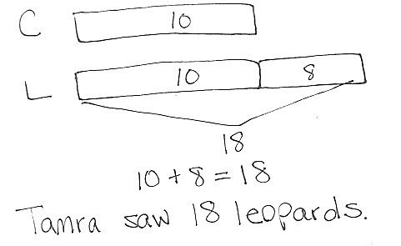
Application Problem (5 minutes)
Tamra saw 10 cheetahs at the zoo. She saw 8 more leopards than cheetahs. How many leopards did she see?
Note: Today's problem is a compare with bigger unknown problem type. Some students may incorrectly solve the problem because of their reliance on the term more, rather than on their understanding of the comparison. Look at students’ drawings to see how they made meaning of the problem.
Concept Development (30 minutes)
Materials: (T) 10 dimes, 15 pennies, and 3 nickels (plastic or real) (S) 5 dimes, 15 pennies, 3 nickels (plastic or real), personal white board; (optional) spinner template, paper clip, pencil
Gather students in the meeting area with their materials.
T: (Lay out or project 1 dime.) What is the name of this coin?
S: A dime.
T: What is the value of one dime?
S: 10 cents!
T: Take out your dime and show it to me. (Wait as students take it out. On chart paper, record the dime using a circle with the number 10 in it.)
T: I want a number of pennies to equal the value of a dime. How many pennies would I need?
S: 10 pennies!
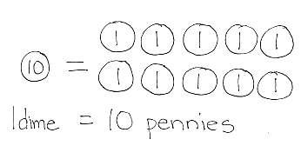
T: Why would I need 10 pennies to have 1 dime?
S: Pennies are worth 1 cent. You need 10 pennies to make 10 cents. A dime is the same as 10 pennies.
T: So, 1 dime (point to dime on chart paper) is equal to 10 pennies. Count the pennies for me as I draw, and when we get to 10, don’t say 10 pennies but…
S: 1 dime!
T: Count as I point.
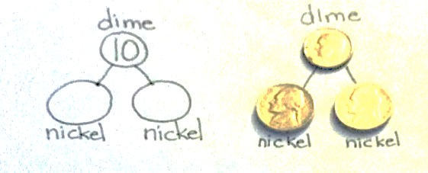
S: 1 penny, 2 pennies, 3 pennies, …9 pennies, 1 dime.
T: (Hold up or project a nickel.) Two of these together have the same value as a dime. (Create a number bond with the coins, as shown to the right. Record the number bond, leaving out the value of the nickels.)
T: What is the value of this coin? Turn and talk with a partner, and make a number bond to show your thinking. Tell your partner how you know. (Wait as students discuss.)

NOTES ON
MULTIPLE MEANS OF REPRESENTATION:
Make sure both parts are the same number in the students’ number bonds. Since they are both the same kind of coin, the two parts must be the same value.

T: What is the value?
S: 5 cents! (After students show boards, add the value 5 to the two number bond parts.)
T: How do you know?
S: The number bond needs the same number for both parts. So it must be 2 fives to make 10. It’s like a doubles fact. 5 + 5 = 10, so they must be five cents each. I have nickels at home. I know they are worth 5 cents.
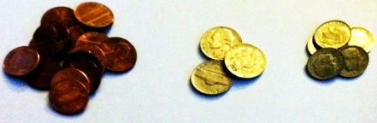
T: This coin is called a nickel. Find all the nickels in your bag. (Wait as students identify the nickels.)
T: Sort the rest of your coins into piles so we can easily get what we need for today’s lesson. Put each pile on your personal board and write the name and value of the coin under the pile. (Wait as students sort dimes, pennies, and nickels.)
T: What is one of the ways we made 10 cents?
S: We made 10 cents with 10 pennies. We made 10 cents with 1 dime. We made 10 cents with 2 nickels. We made 10 cents with a nickel (5 cents) and 5 pennies (1 cent each).
T: (Display 2 nickels.) Two nickels is 10 cents. How many cents will I have when I put down 1 more nickel? (Wait as students determine the answer. Have them turn and talk as necessary.)
S: 15 cents!

NOTES ON
MULTIPLE MEANS OF REPRESENTATION:
If students struggle to generate combinations of coins, guide students through trading pennies for a nickel or a dime using questions such as, “How many pennies would we need to trade for a nickel? Do we have enough to do this?”

T: Work with a partner to make 15 cents in different ways. (Wait and listen as students lay out coins to make 15 cents.)
T: How did you make 15 cents?
S: We used 15 pennies. Pennies are worth 1 cent. 15 pennies is 15 cents. We used 1 dime and 5 pennies. That’s 1 ten and 5 ones. We did like you did. We got 3 nickels. We used 1 dime and 1 nickel to make 15, since it’s 10 and 5. We used 2 nickels and 5 pennies. The two nickels make 10, and then 5 more pennies makes 15. (As each student shares, record their combinations on the chart paper.)
Use the following suggested sequence, asking students to work with a partner to create a coin combination that has the given value. Record the combinations for each value on chart paper.
- 6 cents
- 11 cents
- 16 cents
- 20 cents
After students have successfully shown ways to make the above totals, provide the following riddles.
T: (Project or write 2 + 3.) I want to use 1 coin to represent the total of 2 + 3. Which coin would I use? Tell a partner.
T: Which coin could represent the total of 2 + 3?
S: A nickel!
T: How do you know?
S: 2 + 3 = 5. A nickel has a value of 5 cents.
Repeat the process with the following examples:
- 1 coin to represent the total of 6 + 4
- 1 coin to represent the total of 5 + 1 + 4
- 1 coin to represent the total of 1 + 0 or the value of 6 – 5.
- 1 coin to represent the total of 4 + 1
- 2 coins to represent the total of 17 + 3
- 2 coins to represent the total of 2 + 8
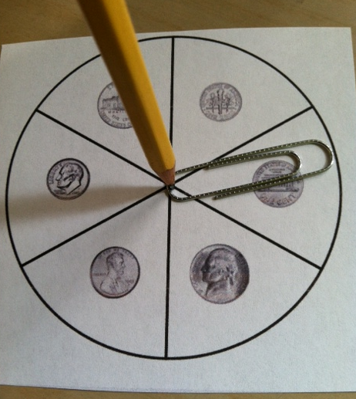
If time permits, partners may play Coin Trade. The object of the game is to continue to trade coins, always having 10 cents.
Directions: Each player has 10 pennies and the spinner with a paper clip and pencil.
- Partner A spins the spinner.
- Partner A trades pennies for the coin landed on. (For instance, if the student lands on a nickel, he trades 5 pennies for 1 nickel. If he lands on a dime, he trades 10 pennies for 1 dime. If he lands on a penny, he trades a penny for a penny.)
- Partner B takes a turn.
- The person with the most pennies at the end of the game is the winner.
As play continues, students might land on the coins they already have, such as landing on a penny when they have 10 pennies. Students may trade one of their pennies for a new penny. Play the game for about five minutes.

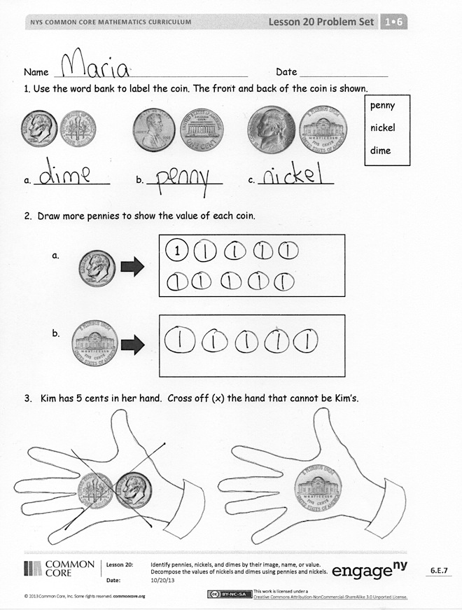
Problem Set (10 minutes)
Students should do their personal best to complete the Problem Set within the allotted 10 minutes. For some classes, it may be appropriate to modify the assignment by specifying which problems they work on first. Some problems do not specify a method for solving. Students solve these problems using the RDW approach used for Application Problems.
Student Debrief (10 minutes)
Lesson Objective: Identify pennies, nickels, and dimes by their image, name, or value. Decompose the values of nickels and dimes using pennies and nickels.
The Student Debrief is intended to invite reflection and active processing of the total lesson experience.
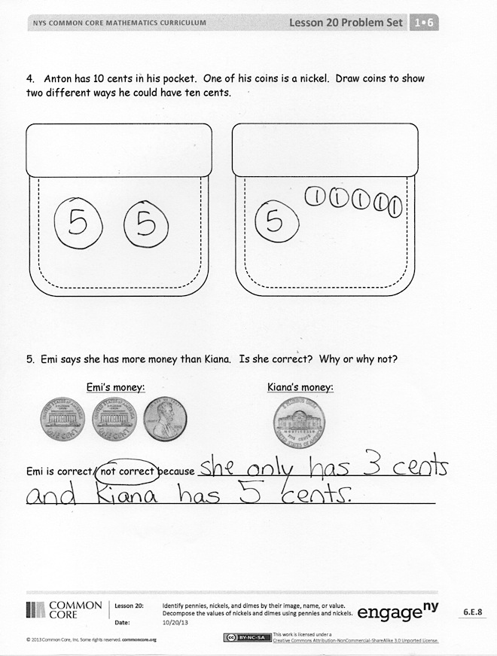
Invite students to review their solutions for the Problem Set. They should check work by comparing answers with a partner before going over answers as a class. Look for misconceptions or misunderstandings that can be addressed in the Debrief. Guide students in a conversation to debrief the Problem Set and process the lesson.
You may choose to use any combination of the questions below to lead the discussion.
- Look at Problem 1. What parts of the picture of each coin help you identify it?
- Look at Problem 4. Share your solutions. Are there only two ways to make 10 cents with your coins? How many different ways can we make 10 cents using our coins?
- If you had to carry around 10 cents all day, which combination of coins would you want to carry? Why?
- Which coin was new to us today? (Nickel.) Describe the coin in as many ways as you can.

Exit Ticket (3 minutes)
After the Student Debrief, instruct students to complete the Exit Ticket. A review of their work will help you assess the students’ understanding of the concepts that were presented in the lesson today and plan more effectively for future lessons. You may read the questions aloud to the students.
Name Date

- Use the word bank to label the coin. The front and back of the coin is shown.
penny
nickel
dime
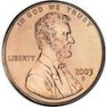
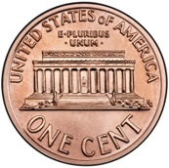
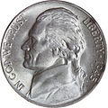
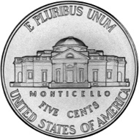
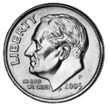
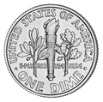

a. _____________ b. _____________ c. _____________

- Draw more pennies to show the value of each coin.

1
a.

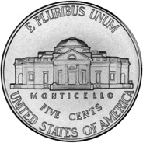
b.

- Kim has 5 cents in her hand. Cross off (x) the hand that cannot be Kim’s.
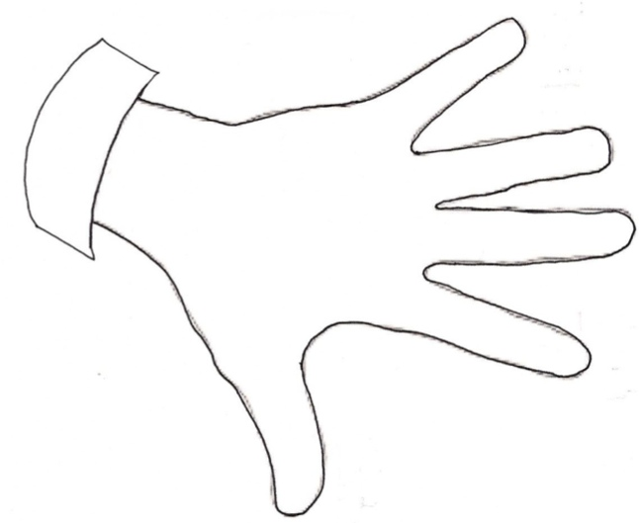
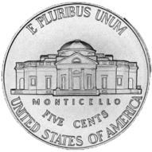
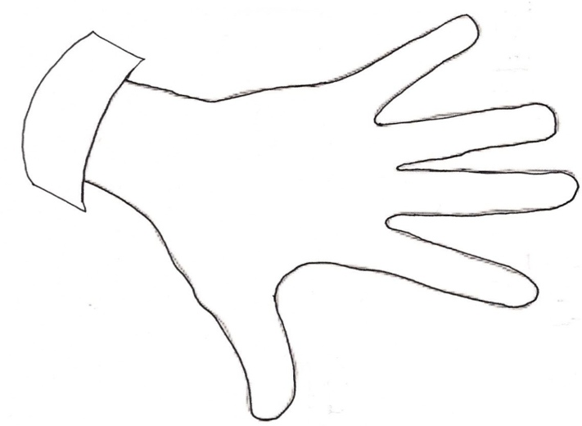
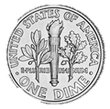
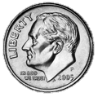

- Anton has 10 cents in his pocket. One of his coins is a nickel. Draw coins to show two different ways he could have ten cents with the coins he has in his pocket.

- Emi says she has more money than Kiana. Is she correct? Why or why not?

Emi’s Money Kiana’s Money
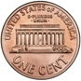

Emi is correct / not correct because _____________________________________
_________________________________________________________________

Name Date

- Match the pennies to the coin with the same value.
a.

b.

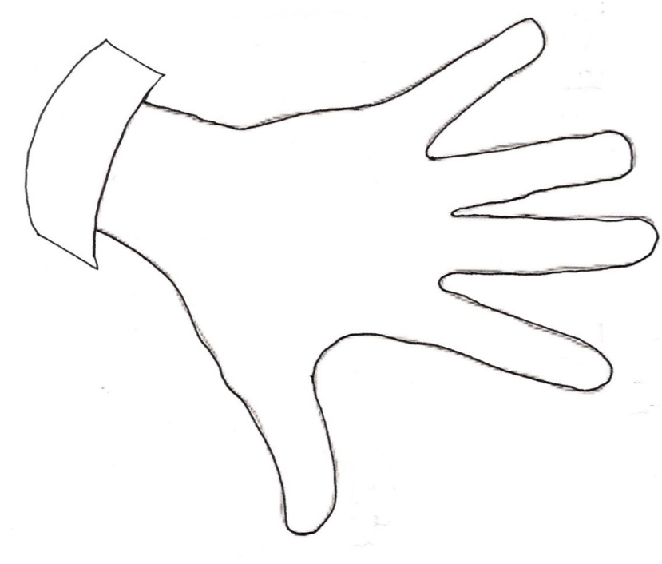
- Ben has 10 cents. He has 1 nickel. Draw more coin(s) to show what other coins he might have.

5
Name Date

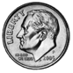
- Match.
penny
nickel
dime

- Cross off some pennies so the remaining pennies show the value of the coin to their left.
a.

b.

- Maria has 5 cents in her pocket. Draw coins to show two different ways she could have 5 cents.

- Solve. Draw a line to match the number sentence with the coin (or coins) that give the answer.
a. 10 cents + 10 cents = _____ cents

b. 10 cents - 5 cents = _____ cents

c. 20 cents - 10 cents = _____ cents

Spinner: Each group or set of partners needs 1 circle from this page. See image for use with pencil and paper clip.
d. 9 cents – 8 cents = _____ cent
