Lesson 19
Objective: Solve and share strategies for adding two-digit numbers with varied sums.

Suggested Lesson Structure
 Fluency Practice (13 minutes)
 Application Problem (5 minutes)
 Concept Development (32 minutes)
 Student Debrief (10 minutes)
Total Time (60 minutes)
Fluency Practice (13 minutes)
- Core Fluency Differentiated Practice Sets 1.OA.6 (5 minutes)
- Standards Check: True or False Number Sentences 1.OA.7 (8 minutes)
Core Fluency Differentiated Practice Sets (5 minutes)
Materials: (S) Core Fluency Practice Sets from G1–M6–Lesson 1
Note: Give the appropriate Practice Set to each student. Help students become aware of their improvement. After students do today’s Practice Sets, ask them to stand if they tried a new level today or improved their score from the previous day. Consider having students clap for each person standing to celebrate improvement.
Students complete as many problems as they can in 90 seconds. Assign a counting pattern and start number for early finishers, or have them practice make ten addition or subtraction on the back of their papers. Collect and correct any Practice Sets completed within the allotted time.
Standards Check: True or False Number Sentences (8 minutes)
Materials: (S) Personal white boards
Note: Use professional judgment to determine whether students would benefit more from repeating the previous standards check or moving on to this one. Today’s standards check reviews the meaning of the equal sign and requires students to determine if addition and subtraction equations are true or false.
T: (Write 5 = 1 + 4.) What’s 1 + 4?
S: 5
T: (Write 5 = 5 directly underneath 5 = 1 + 4.) Is 5 = 1 + 4 true or false?
S: True.
T: Why?
S: Because 5 is equal to 5. Because 5 is the same as 5!
T: Now you do the same. Rename the side of the number sentence with a plus or minus symbol as one number.
T: (Write 7 = 3 + 5.)
S: (Write 7 = 8.)
T: Show me your boards. (Pause to see.) Is 7 = 3 + 5 true or false?
S: False.
T: Why?
S: Because 7 is not the same as 8. Because 7 doesn’t equal 8!
T/S: (Draw a line through the equal sign to show 7 ≠ 3 + 5 and 7 ≠ 8 to record they are not true.)
As time permits, continue with the following suggested sequence:
a. 7 = 2 + 5
b. 3 + 6 = 9
c. 8 = 2 + 7
d. 7 – 2 = 4
e. 3 = 8 – 5
f. 3 = 9 – 7
g. 6 + 1 = 5 + 2
h. 4 + 3 = 7 + 1
i. 8 – 4 = 6 – 2
j. 8 – 5 = 9 – 4
k. 8 – 6 = 2 + 4
l. 4 + 5 = 9 – 3
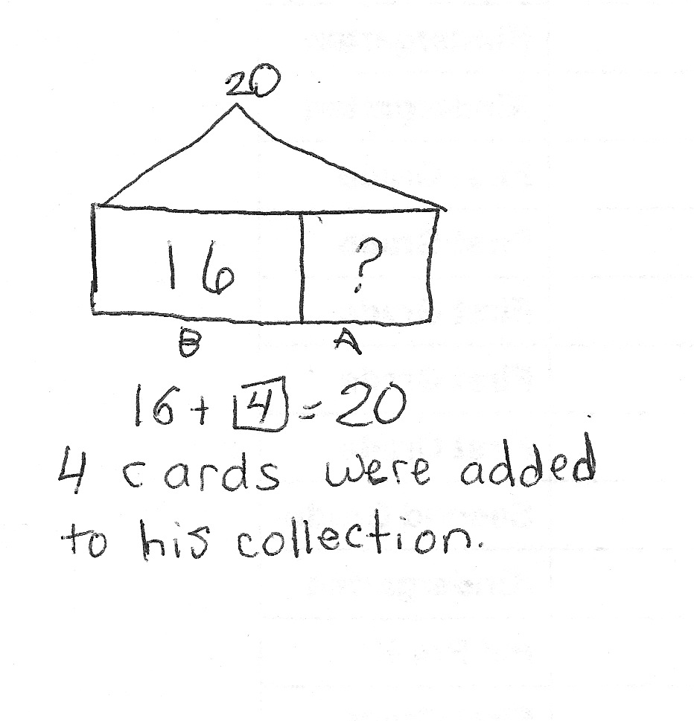
Application Problem (5 minutes)
Ben has 16 baseball cards before a card show. After the card show, he has 20 baseball cards. How many cards were added to Ben’s collection?
Note: Today's problem is an add to with change unknown problem type. As G1–M6–Topic F, which focuses on varied word problem types, approaches, begin to take note of students' strength and weakness for specific problem types.
Concept Development (32 minutes)

NOTES ON
MULTIPLE MEANS OF ACTION AND EXPRESSION:
Giving students an opportunity to share their thinking allows them to evaluate their process and practice. English language learners also benefit from hearing others explain their thinking.

Materials: (T) Projector (S) Personal white boards
Students sit at their tables next to their partner with personal boards.
T: Solve 39 + 43 using any strategy we’ve learned so far. Be ready to explain why you chose the strategy. (Circulate and note the types of strategies being used.)
S: (Solve.)
T: Turn and talk to your partner, and share your work. Explain to your partner why you chose that particular strategy. What similarities and differences do you notice between your work and your partner’s?
S: (Explain and compare strategies.)
T: (While student pairs share their work, ask two or three students to come up and write their work on the board. Be sure to include students who solved using different strategies.)
MP.5
T: Let’s hear how our friends solved 39 + 43, and why they chose to use their particular strategy.
S: (Make the next ten strategy.) I know that 39 is really close to 40, so I took 1 from 43. I saw it as 40 + 42. That’s 82.
(Vertical alignment.) It’s quick and easy for me to add 9 and 3 and 3 tens and 4 tens. I can see which digits I need to add more clearly when I line up the tens to tens and ones to ones.
(Standard algorithm.) I can line up my tens and ones without using drawings.
(Adding on tens first.) I am really good at adding tens onto any number. 39 and 40 is 79. Then I added 3 to get 82.
(Compensation.) I thought of it a different way, like a balance. 39 + 43. Add one to 39 and subtract one from 43, so it’s 40 + 42.
As each student explains the work and shares the reasons for his or her strategy choice, have students discuss questions such as the ones listed below:
- Is there another way to solve this problem?

NOTES ON
MULTIPLE MEANS
FOR ACTION AND EXPRESSION:
Continue to challenge advanced students. After they have completed the Problem Set, encourage them to write a word problem to match one of the number sentences. Have students who write word problems trade papers and try to find which number sentence the word problem matches.
- How does the number bond make it easier to add the parts?
- How is Student A’s strategy different or the same as your partner’s?
- When do you think is the best time to use the make ten strategy?
- What compliment can you give him or her?
- What advice can you give him or her to make the work better?
- Repeat the process possibly using the following suggested sequence:
66 + 29
56 + 35
18 + 78
34 + 47

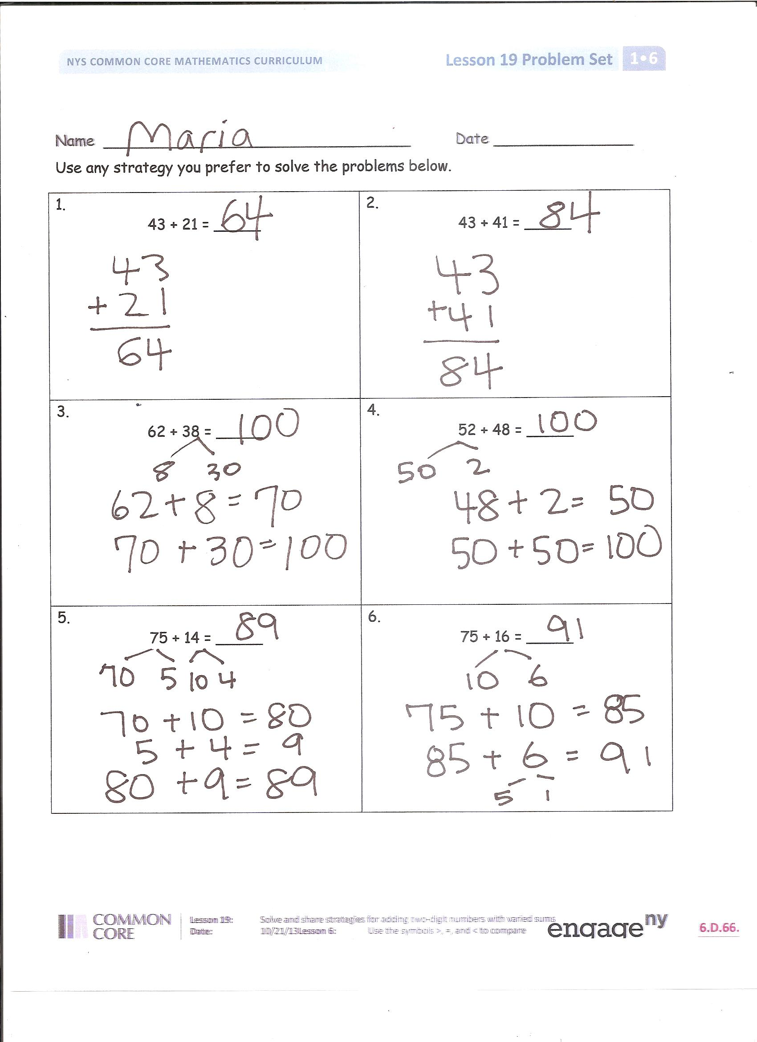
Problem Set (10 minutes)
Students should do their personal best to complete the Problem Set within the allotted 10 minutes. For some classes, it may be appropriate to modify the assignment by specifying which problems they work on first. Some problems do not specify a method for solving. Students solve these problems using the RDW approach used for Application Problems.
Student Debrief (10 minutes)
Lesson Objective: Solve and share strategies for adding two-digit numbers with varied sums.
The Student Debrief is intended to invite reflection and active processing of the total lesson experience.
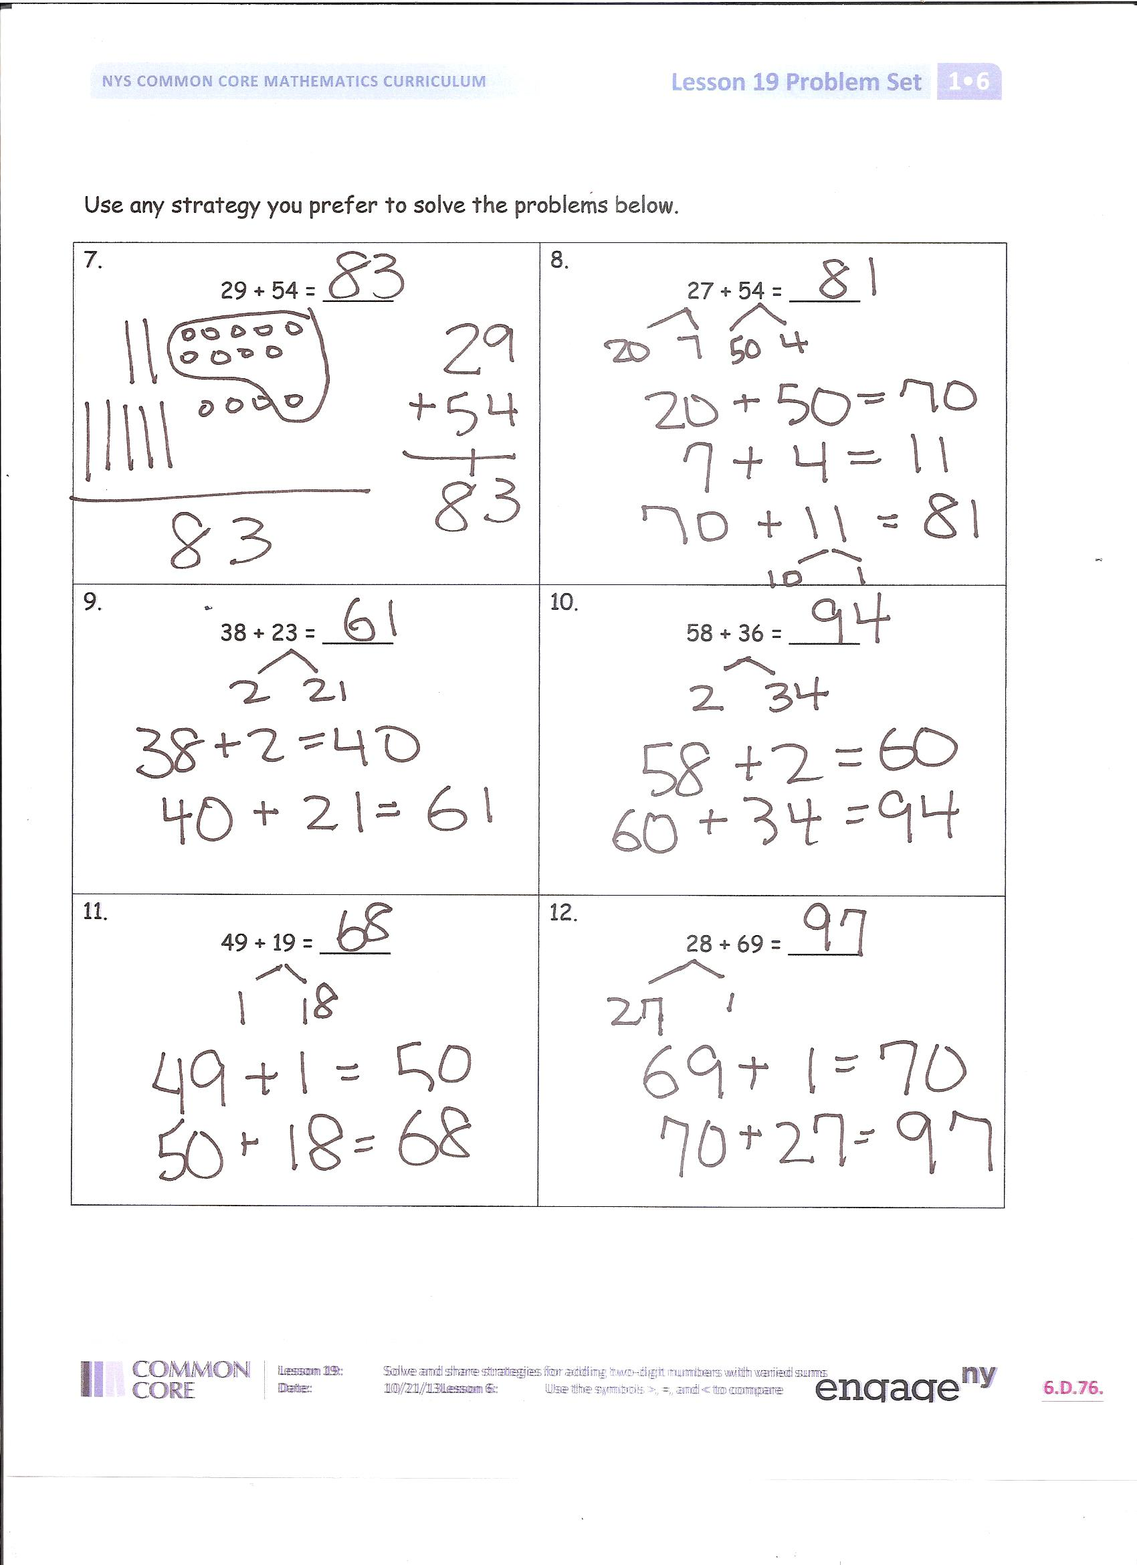
Invite students to review their solutions for the Problem Set. They should check work by comparing answers with a partner before going over answers as a class. Look for misconceptions or misunderstandings that can be addressed in the Debrief. Guide students in a conversation to debrief the Problem Set and process the lesson.
You may choose to use any combination of the questions below to lead the discussion.
- How can solving Problem 1 help you solve Problem 2?
- Explain how Problems 3 and 4 are related. Can you see that they would have the same sum without calculating the sum?
- Which strategy do you use the most? Why? Do you study the numbers and choose a specific strategy that work better with those numbers, or do you always use the same strategy? Use an example from your Problem Set to explain your reasoning.
- Today we changed our number sentences to be very simple. We changed 5 + 3 = 7 to 8 = 9. We changed 4 = 3 + 1 to 4 = 4. How did that help you see if the number sentences were true or false?
Exit Ticket (3 minutes)
After the Student Debrief, instruct students to complete the Exit Ticket. A review of their work will help you assess the students’ understanding of the concepts that were presented in the lesson today and plan more effectively for future lessons. You may read the questions aloud to the students.

Name Date

Use the strategy you prefer to solve the problems below.
1.  43 + 21 = _____ | 2.  43 + 41 = _____
3.  62 + 38 = _____ | 4.  52 + 48 = _____
5.  75 + 14 = _____ | 6.  75 + 16 = _____

Use the strategy you prefer to solve the problems below.
7.  29 + 54 = _____ | 8.  27 + 54 = _____
9.  38 + 23 = _____ | 10.  58 + 36 = _____
11.  49 + 19 = _____ | 12.  28 + 69 = _____

Name Date

1. Use the strategy you prefer to solve the problems below.
a.  24 + 38 = _____ | b.  24 + 48 = _____

Name Date

Use the strategy you prefer to solve the problems below.
1.  53 + 22 = _____ | 2.  23 + 52 = _____
3.  76 + 14 = _____ | 4.  76 + 16 = _____
5.  55 + 35 = _____ | 6.  54 + 46 = _____

Use the strategy you prefer to solve the problems below.
7.  49 + 25 = _____ | 8.  59 + 45 = _____
9.  37 + 37 = _____ | 10.  37 + 57 = _____
11.  24 + 48 = _____ | 12.  26 + 68 = _____

