Lesson 23: Base Angles of Isosceles Triangles

Classwork
Opening Exercise
Describe the additional piece of information needed for each pair of triangles to satisfy the SAS triangle congruence criteria.
- Given: $AB=DC$

Prove: $△ABC≅△DCB$

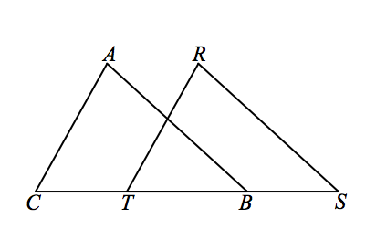
- Given: $AB=RS$
$\overline{AB}∥\overline{RS}$

Prove: $△ABC≅△RST$

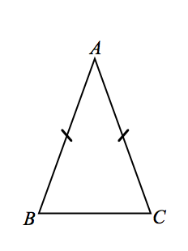
Exploratory Challenge
Today we examine a geometry fact that we already accept to be true. We are going to prove this known fact in two ways: (1) by using transformations and (2) by using SAS triangle congruence criteria.
Here is isosceles triangle $ABC$. We accept that an isosceles triangle, which has (at least) two congruent sides, also has congruent base angles.
Label the congruent angles in the figure.
Now we will prove that the base angles of an isosceles triangle are always congruent.

Prove Base Angles of an Isosceles are Congruent: Transformations
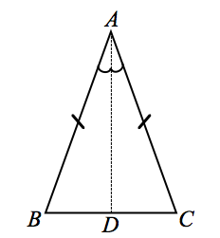
Given: Isosceles $△ABC$, with $AB=AC$
Prove: $m∠B=m∠C$

Construction: Draw the angle bisector $\vec{AD}$ of $∠A$, where$D$ is the intersection of the bisector and $\overline{BC}$. We need to show that rigid motions will map point $B$ to point $C$ and point$C$ to point $B$.

Let $r$ be the reflection through $\overset{⃡}{AD}$. Through the reflection, we want to demonstrate two pieces of information that map $B$ to point $C$ and vice versa: (1) $\vec{AB}$ maps to $\vec{AC}$, and (2) $AB=AC$.
Since $A$ is on the line of reflection, $\overset{⃡}{AD}$, $r\left(A\right)=A$. Reflections preserve angle measures, so the measure of the reflected angle $r\left(∠BAD\right)$equals the measure of $∠CAD$; therefore, $r\left(\vec{AB}\right)=\vec{AC}$. Reflections also preserve lengths of segments; therefore, the reflection of $\overline{AB}$ will still have the same length as $\overline{AB}$. By hypothesis, $AB=AC$, so the length of the reflection will also be equal to $AC$. Then $r\left(B\right)=C$. Using similar reasoning, we can show that $r\left(C\right)=B$.
Reflections map rays to rays, so $r\left(\vec{BA}\right)=\vec{CA}$ and $r\left(\vec{BC}\right)=\vec{CB}$. Again, since reflections preserve angle measures, the measure of $r\left(∠ABC\right)$ is equal to the measure of $∠ACB$.

We conclude that $m∠B=m∠C$. Equivalently, we can state that $∠B≅∠C$. In proofs, we can state that “base angles of an isosceles triangle are equal in measure” or that “base angles of an isosceles triangle are congruent.”

Prove Base Angles of an Isosceles are Congruent: SAS
Given: Isosceles $△ABC$, with $AB=AC$
Prove: $∠B≅∠C$

Construction: Draw the angle bisector $\vec{AD}$ of $∠A$, where$D$ is the intersection of the bisector and $\overline{BC}$. We are going to use this auxiliary line towards our SAS criteria.

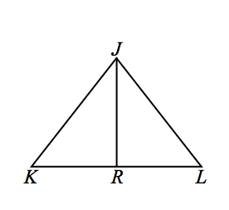
Exercises
- Given: $JK=JL$; $\overline{JR}$bisects $\overline{KL}$
Prove: $\overline{JR}⊥\overline{KL}$

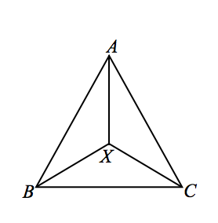
- Given: $AB=AC, XB=XC$
Prove: $\overline{AX}$ bisects $∠BAC$

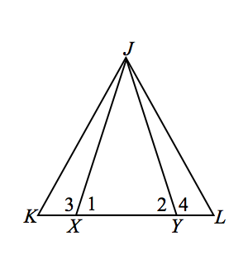
- Given: $JX=JY$, $KX=LY$
Prove: $△JKL$ is isosceles

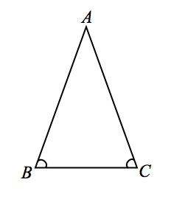
- Given: $△ABC$, with $m∠CBA= m∠BCA$
Prove: $BA=CA$
(Converse of base angles of isosceles triangle)
Hint: Use a transformation.

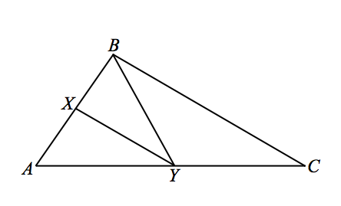
- Given: $△ABC$, with $\overline{XY }$is the angle bisector of $∠BYA$, and $\overline{BC}∥\overline{XY}$
Prove: $YB=YC$

Problem Set
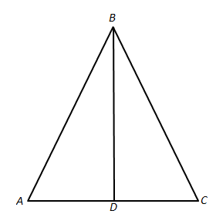
- Given: $AB=BC$, $AD=DC$
Prove: $△ADB$ and $△CDB$ are right triangles

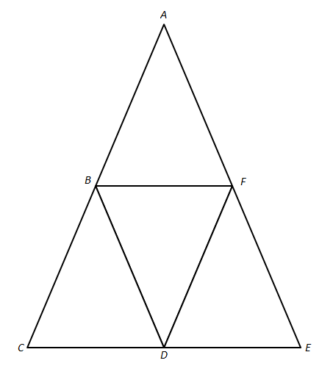
- Given: $AC=AE$ and $\overline{BF} ‖\overline{CE}$
Prove: $AB=AF$

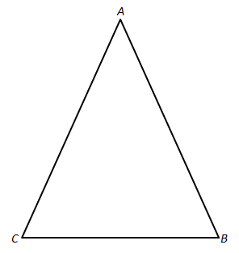
- In the diagram, $△ABC$ is isosceles with$\overline{AC}≅\overline{AB}$. In your own words, describe how transformations and the properties of rigid motions can be used to show that $∠C≅∠B$.

