Lesson 23: Base Angles of Isosceles Triangles

Student Outcomes
- Students examine two different proof techniques via a familiar theorem.
- Students complete proofs involving properties of an isosceles triangle.

Lesson Notes
In Lesson 23, students study two proofs to demonstrate why the base angles of isosceles triangles are congruent. The first proof uses transformations, while the second uses the recently acquired understanding of the SAS triangle congruency. The demonstration of both proofs will highlight the utility of the SAS criteria. Encourage students to articulate why the SAS criteria is so useful.
The goal of this lesson is to compare two different proof techniques by investigating a familiar theorem. Be careful not to suggest that proving an established fact about isosceles triangles is somehow the significant aspect of this lesson. However, if you need to, you can help motivate the lesson by appealing to history. Point out that Euclid used SAS and that the first application he made of it was in proving that base angles of an isosceles triangle are congruent. This is a famous part of the Elements. Today, proofs using SAS and proofs using rigid motions are valued equally.

Classwork
Opening Exercise (7 minutes)
Opening Exercise
Describe the additional piece of information needed for each pair of triangles to satisfy the SAS triangle congruence criteria.
- Given: $AB=DC$
$\overline{AB}⊥\overline{BC}$, $\overline{DC}⊥\overline{CB}$, or $m∠B=m∠C$
Prove: $△ABC≅△DCB$
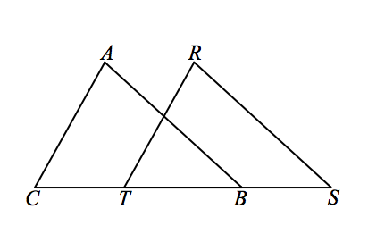
- Given: $AB=RS$
$\overline{AB}∥\overline{RS}$
$CB=TS$ or $CT=BS$
Prove: $△ABC≅△RST$

Exploratory Challenge (25 minutes)
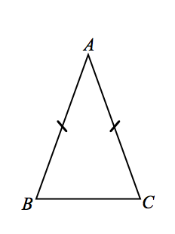
Exploratory Challenge
Today we examine a geometry fact that we already accept to be true. We are going to prove this known fact in two ways: (1) by using transformations and (2) by using SAS triangle congruence criteria.
Here is isosceles triangle $ABC$. We accept that an isosceles triangle, which has (at least) two congruent sides, also has congruent base angles.
Label the congruent angles in the figure.
Now we will prove that the base angles of an isosceles triangle are always congruent.

Prove Base Angles of an Isosceles are Congruent: Transformations
While simpler proofs do exist, this version is included to reinforce the idea of congruence as defined by rigid motions. Allow 15 minutes for the first proof.
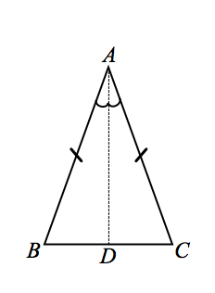
Prove Base Angles of an Isosceles are Congruent: Transformations
Given: Isosceles $△ABC$, with $AB=AC$
Prove: $m∠B=m∠C$

Construction: Draw the angle bisector $\vec{AD}$ of $∠A$, where$D$ is the intersection of the bisector and $\overline{BC}$. We need to show that rigid motions will map point $B$ to point $C$ and point$C$ to point $B$.

Let $r$ be the reflection through $\overset{⃡}{AD}$. Through the reflection, we want to demonstrate two pieces of information that map $B$ to point $C$ and vice versa: (1) $\vec{AB}$ maps to $\vec{AC}$, and (2) $AB=AC$.
Since $A$ is on the line of reflection, $\overset{⃡}{AD}$, $r\left(A\right)=A$. Reflections preserve angle measures, so the measure of the reflected angle $r\left(∠BAD\right)$equals the measure of $∠CAD$; therefore, $r\left(\vec{AB}\right)=\vec{AC}$. Reflections also preserve lengths of segments; therefore, the reflection of $\overline{AB}$ will still have the same length as $\overline{AB}$. By hypothesis, $AB=AC$, so the length of the reflection will also be equal to $AC$. Then $r\left(B\right)=C$. Using similar reasoning, we can show that $r\left(C\right)=B$.
Reflections map rays to rays, so $r\left(\vec{BA}\right)=\vec{CA}$ and $r\left(\vec{BC}\right)=\vec{CB}$. Again, since reflections preserve angle measures, the measure of $r\left(∠ABC\right)$ is equal to the measure of $∠ACB$.

We conclude that $m∠B=m∠C$. Equivalently, we can state that $∠B≅∠C$. In proofs, we can state that “base angles of an isosceles triangle are equal in measure” or that “base angles of an isosceles triangle are congruent.”

Prove Base Angles of an Isosceles are Congruent: SAS
Allow 10 minutes for the second proof.
Prove Base Angles of an Isosceles are Congruent: SAS
Given: Isosceles $△ABC$, with $AB=AC$
Prove: $∠B≅∠C$

Construction: Draw the angle bisector $\vec{AD}$ of $∠A$, where$D$ is the intersection of the bisector and $\overline{BC}$. We are going to use this auxiliary line towards our SAS criteria.

Allow students five minutes to attempt the proof on their own.
$AB=AC$ Given
$AD=AD$ Reflexive property
$m∠BAD=m∠CAD$ Definition of an angle bisector
$△ABD≅△ACD$ Side Angle Side criteria
$∠B≅∠C$ Corresponding angles of congruent triangles are congruent

Exercises (10 minutes)
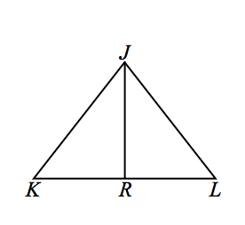
Note that in Exercise 4, students are asked to use transformations in the proof. This is intentional to reinforce the notion that congruence is defined in terms of rigid motions.
Exercises
- Given: $JK=JL$; $\overline{JR}$bisects $\overline{KL}$
Prove: $\overline{JR}⊥\overline{KL}$

$JK=JL$ Given
$∠K≅∠L$ Base angles of an isosceles triangle are congruent.
$KR=RL$ Definition of a segment bisector
$∴ △JRK≅ △JRL$ SAS
$∠JRK≅∠JRL$ Corresponding angles of congruent triangles are congruent.
$m∠JRK+m∠JRL=180°$ Linear pairs form supplementary angles.
$2\left(∠JRK\right)=180°$ Substitution property of equality
$∠JRK=90°$ Division property of equality
$∴ JR⊥KL$ Definition of perpendicular lines
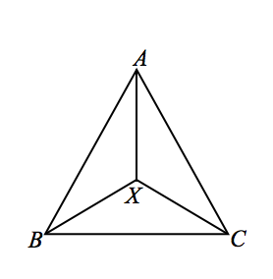
- Given: $AB=AC$, $XB=XC$
Prove: $\overline{AX}$ bisects $∠BAC$

$AB=AC$ Given
$m∠ABC=m∠ACB$ Base angles of an isosceles triangle are congruent.
$XB=XC$ Given
$m∠XBC=m∠XCB$ Base angles of an isosceles triangle are equal in measure
$m∠ABC=m∠ABX+m∠XBC$,
$m∠ACB=m∠ACX+m∠XCB$ Angle addition postulate
$m∠ABX=m∠ABC-m∠XBC$,
$m∠ACX=m∠ACB-m∠XCB$ Subtraction property of equality
$m∠ABX=m∠ACX$ Substitution property of equality
$∴ △ABX≅ △ACX$ SAS
$∠BAX≅∠CAX$ Corresponding part of congruent triangles are congruent
$∴ \overline{AX}$ bisects $∠BAC$. Definition of an angle bisector
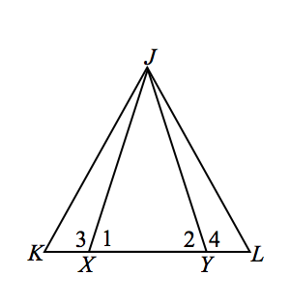
- Given: $JX=JY$, $KX=LY$
Prove: $△JKL$ is isosceles

$JX=JY$ Given
$KX=LY$ Given
$m∠1=m∠2$ Base angles of an isosceles triangle are equal in measure
$m∠1+m∠3=180°$ Linear pairs form supplementary angles
$m∠2+m∠4=180°$ Linear pairs form supplementary angles
$m∠3=180°-m∠1$ Subtraction property of equality
$m∠4=180°-m∠3$ Subtraction property of equality
$m∠3=m∠4$ Substitution property of equality
$∴ △JKX≅△JYL$ SAS
$\overline{JK}≅\overline{JL}$ Corresponding segments of congruent triangles are congruent.
$∴ △JKL$ is isosceles Definition of an isosceles triangle

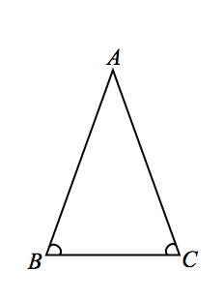
- Given: $△ABC$, with $m∠CBA= m∠BCA$
Prove: $BA=CA$
(Converse of base angles of isosceles triangle)
Hint: Use a transformation.

Proof:
We can prove that $AB=AC$ by using rigid motions. Construct the perpendicular bisector $l$ to $\overline{BC}$. Note that we do not know whether the point $A$ is on $l$. If we did, we would know immediately that $AB=AC$, since all points on the perpendicular bisector are equidistant from $B$ and $C$. We need to show that $A$ is on $l$, or equivalently, that the reflection across $l$ takes $A$ to $A$.
Let $r_{l}$ be the transformation that reflects the $△ABC$ across $l$. Since $l$ is the perpendicular bisector, $r_{l}\left(B\right)=C$ and $r_{l}\left(C\right)=B$. We do not know where the transformation takes $A$; for now, let us say that $r_{l}\left(A\right)=A^{'}$.
Since $∠CBA≅∠BCA$ and rigid motions preserve angle measures, after applying $r_{l}$ to $∠BCA$, we get that $∠CBA≅∠CBA^{'}$. Angle $∠CBA$ and angle $∠CBA^{'}$ share a ray$BC$, are of equal measure, and $A$ and $A^{'}$ are both in the same half-plane with respect to line $BC$. Hence, $\vec{BA}$ and $\vec{BA'}$are the same ray. In particular, $A^{'}$ is a point somewhere on $\vec{BA}$.
Likewise, applying $r_{l}$ to $∠CBA$ gives $∠BCA≅∠BCA^{'}$, and for the same reasons in the previous paragraph, $A'$ must also be a point somewhere on $\vec{CA}$. Therefore, $A'$ is common to both $\vec{BA}$ and $\vec{CA}$.
The only point common to both $\vec{BA}$ and$\vec{CA}$ is point $A$; thus, $A$ and $A^{'}$ must be the same point, i.e., $A=A^{'}$.
Hence, the reflection takes $A$ to $A$, which means $A$ is on the line $l$ and $r_{l}\left(\overline{BA}\right)=\overline{CA^{'}}=\overline{CA}$, or $BA=CA$.

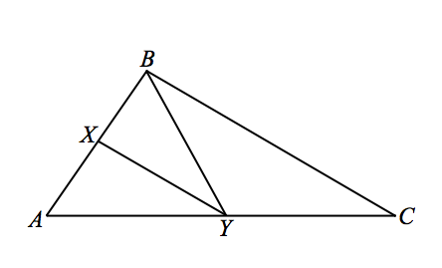
- Given: $△ABC$, with $\overline{XY }$is the angle bisector of $∠BYA$, and $\overline{BC}∥\overline{XY}$
Prove: $YB=YC$

$\overline{BC}∥\overline{XY}$ Given
$m∠XYB=m∠CBY$ When two parallel lines are cut by a transversal, the alternate interior angles are equal
$m∠XYA=m∠BCY$ When two parallel lines are cut by a transversal, the corresponding angles are equal
$m∠XYA=m∠XYB$ Definition of an angles bisector
$m∠CBY=m∠BCY$ Substitution property of equality
$YB=YC$ When the base angles of a triangle are equal in measure, the triangle is isosceles

Exit Ticket (3 minutes)
Name ___________________________________________________ Date____________________
Lesson 23: Base Angles of Isosceles Triangles

Exit Ticket

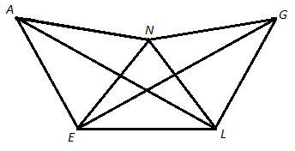

For each of the following, if the given congruence exists, name the isosceles triangle and name the pair of congruent angles for the triangle based on the image above.
- $\overline{AE}≅\overline{EL}$ | - $\overline{LE}≅\overline{LG}$
- $\overline{AN}≅\overline{LN}$ | - $\overline{EN}≅\overline{NG}$
- $\overline{NG}≅\overline{GL}$ | - $\overline{AE}≅\overline{EN}$

Exit Ticket Sample Solutions

For each of the following, if the given congruence exists, name the isosceles triangle and name the pair of congruent angles for the triangle based on the image above.
- $\overline{AE}≅\overline{EL}$  $△AEL$, $∠EAL≅∠ELA$ | - $\overline{LE}≅\overline{LG}$  $△LEG$, $∠LEG≅∠LGE$
- $\overline{AN}≅\overline{LN}$  $△NLA$, $∠NLA≅∠NAL$ | - $\overline{EN}≅\overline{NG}$  $△NGE$, $∠NGE≅∠NEG$
- $\overline{NG}≅\overline{GL}$  $△GLN$, $∠GNL≅∠GLN$ | - $\overline{AE}≅\overline{EN}$  $△AEN$, $∠ENA≅∠EAN$

Problem Set Sample Solutions
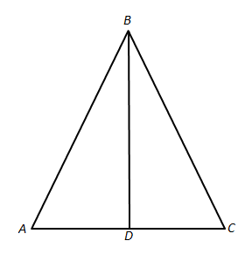
- Given: $AB=BC$, $AD=DC$
Prove: $△ADB$ and $△CDB$ are right triangles

$AB=BC$ Given
$△ABC$ is isosceles Definition of isosceles triangle
$m∠A=m∠C$ Base angles of an isosceles triangle are equal in measure
$AD = DC$ Given
$△ADB≅ △CDB$ SAS
$m∠ADB=m∠CDB$ Corresponding angles of congruent triangles are equal in measure
$m∠ADB+m∠CDB=180°$ Linear pairs form supplementary angles
$2\left(m∠ADB\right)=180°$ Substitution property of equality
$m∠ADB=90°$ Division property of equality
$m∠CDB=90°$ Transitive property
$△ADB$ and $△CDB$ are right triangles Definition of a right triangle
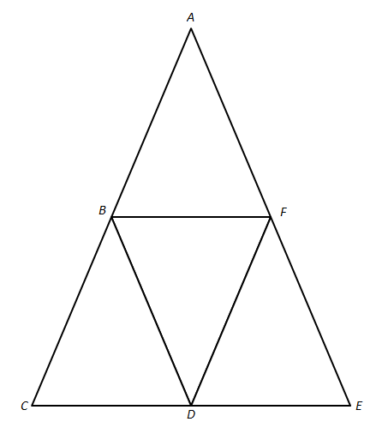
- Given: $AC=AE$ and $\overline{BF} ‖\overline{CE}$
Prove: $AB=AF$

$AC=AE$ Given
$△ACE$ is isosceles Definition of isosceles triangle
$m∠ACE=m∠AEC$ Base angles of an isosceles triangle are equal in measure
$\overline{BF} ‖ \overline{CE}$ Given
$m∠ACE=m∠ABF$ If parallel lines are cut by a transversal, then corresponding angles are equal in measure
$m∠AFB=m∠AEC$ If parallel lines are cut by a transversal, then corresponding angles are equal in measure
$m∠AFB=m∠ABF$ Transitive property
$△ABF$ is isosceles If the base angles of a triangle are equal in measure, the triangle is isosceles
$AB=AF$ Definition of an isosceles triangle

- In the diagram, $△ABC$ is isosceles with$\overline{AC}≅\overline{AB}$. In your own words, describe how transformations and the properties of rigid motions can be used to show that $∠C≅∠B$.
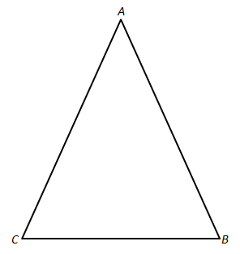
Answers will vary. A possible response would summarize the key elements of the proof from the lesson, such as the response below.
It can be shown that $∠C≅∠B$ using a reflection across the bisector of $∠A$. The two angles formed by the bisector of $∠A$ would be mapped onto one another since they share a ray, and rigid motions preserve angle measure.
Since segment length is also preserved, $B$ is mapped onto $C$ and vice versa.
Finally, since rays are taken to rays and rigid motions preserve angle measure, $\vec{CA}$ is mapped onto $\vec{BA}$ , $\vec{CB}$ is mapped onto $\vec{BC}$, and $∠C$ is mapped onto $∠B$. From this, we see that $∠C≅∠B$.

