Lesson 18
Objective: Add a pair of two-digit numbers with varied sums in the ones, and compare the results of different recording methods.

Suggested Lesson Structure
 Fluency Practice (13 minutes)
 Application Problem (5 minutes)
 Concept Development (32 minutes)
 Student Debrief (10 minutes)
Total Time (60 minutes)
Fluency Practice (13 minutes)
- Standards Check: Commutative Property 1.OA.3, 1.OA7 (5 minutes)
- Standards Check: Subtraction as Unknown Addend 1.OA.4 (8 minutes)
Standards Check: Commutative Property (5 minutes)
Materials: (S) Pair of dice, personal white board
Note: In the remaining lessons, there will be a variety of fluency activities that can be used to monitor students’ mastery of grade level standards. Take note of any students who may need additional support or particular standards-based activities that may be useful to include in summer practice.
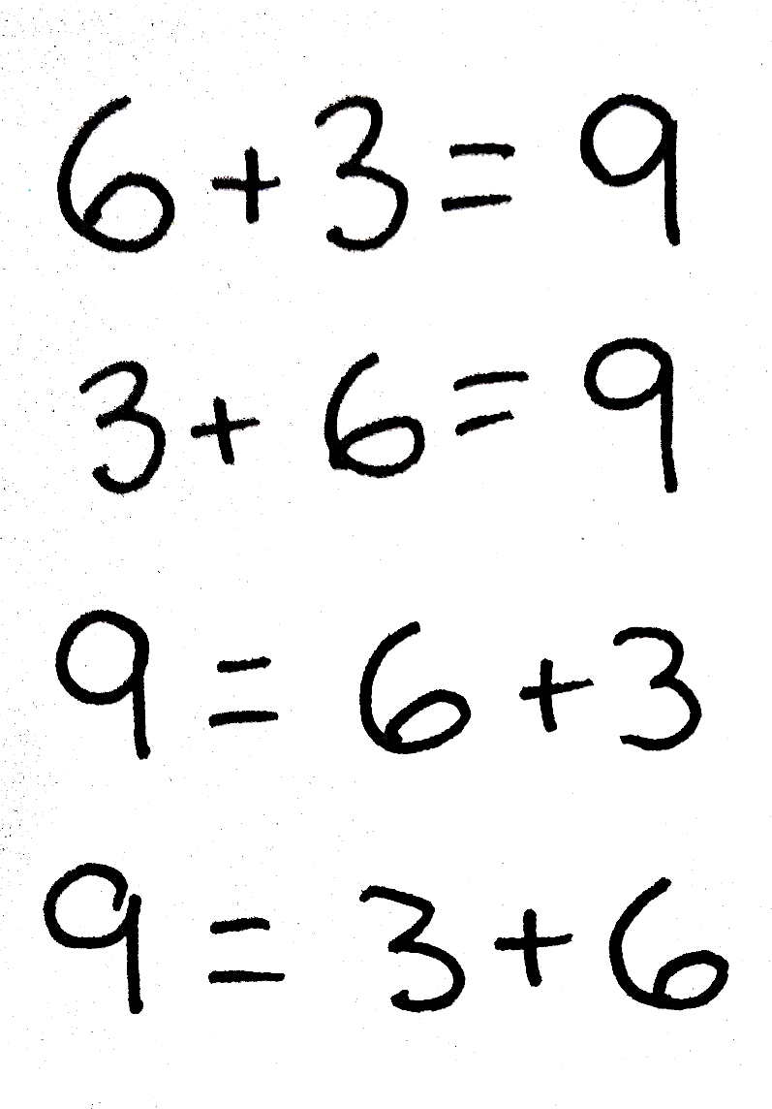
This activity reviews the commutative property of addition (e.g., if 6 + 3 = 9 is known, then 3 + 6 = 9 is also known) (1.OA.3) and requires students to understand the meaning of the equal sign (1.OA.7).
- Assign partners.
- Both partners roll a die, and then write four addition sentences using the rolled numbers as addends.
- Partners check each other’s work.
Standards Check: Subtraction as Unknown Addend (8 minutes)
Materials: (S) Pattern Sheet List A or B
Note: This activity provides review with converting subtraction expressions to unknown addend equations.
- Assign partners of equal ability, and give one partner List A and the other List B.
- Students convert the subtraction expressions on their list to addition equations with unknown addends (e.g., for 10 – 9, the student would write 9 + ___ = 10).
- Partners exchange lists and solve.
Application Problem (5 minutes)
A farmer counted 12 bunnies in their cages in the morning. In the afternoon he only counted 4 bunnies in their cages. How many bunnies disappeared from their cages?
Note: Today's problem is a take away with change unknown problem type. As G1–Topic F, which focuses on varied problem types, approaches, begin to take note of students' strength and weakness for specific problem types.
Concept Development (32 minutes)
Materials: (T) Student work samples (template at end of lesson), projector (S) Personal white boards

Have students sit at their tables or in the meeting area with their personal boards.
T: (Write 58 + 37 on the board.) Solve this problem. (Pause while students work. Quietly post a second problem for early finishers.)
T: The answer is?
S: 95!
T: Take a moment to discuss your strategy or correct your work with your partner.
T: (Project work from Student A and Student B.) Let’s compare Student A’s work to Student B’s work. What is the same and what is different about their solution strategies? Turn and talk to your partner.
S: They both used number bonds. Both students broke apart 37. They both used tens to solve.
T: I have two labels. Read them to me.
S: Make a Ten First. Count On by Tens First.
T: Talk to your partner. Which label best describes the solution strategy of each student? Explain why.
S: Student A made the next ten first. Student A broke 37 into 2 and 35 so he could add 2 and 58 to make 60. Student B counted on by tens. That’s why he broke apart 37 into 30 and 7. 58 and 30 is 88. Student B added the tens first. I don’t think he counted on by tens, but I guess that label fits the best.
T: (Label Student A’s work Make a New Ten First. Label Student B’s work Count On by Tens First.)
T: Can both students’ work be correct even though they used tens in different ways?
MP.3
S: Yes!

NOTES ON
MULTIPLE MEANS OF REPRESENTATION:
Facilitate student discussions to provide opportunities for comprehension. Guide students to recognize strategies that can make math easier, for example, breaking a larger number into number bonds as well as looking for patterns and structures in their work.

T: What is a compliment you can give to each of these students?
S: They drew correct number bonds. Student A showed how she made a new ten first from 58. You can see that in the number bond and in the first addition sentence. Student B did a good job by breaking apart the tens from 37 so he could add 3 tens to 58 first.
T: What are some ways they could improve their work?
S: Student B could write an addition sentence that showed how he got 88. But maybe he did that in his head.
T: (Project Student C’s work.) How did Student C solve 58 + 37? Turn and talk to your partner.
S: He drew quick tens and ones by lining up the tens to tens and the ones to ones. Then he showed exactly how he added using just the numbers.
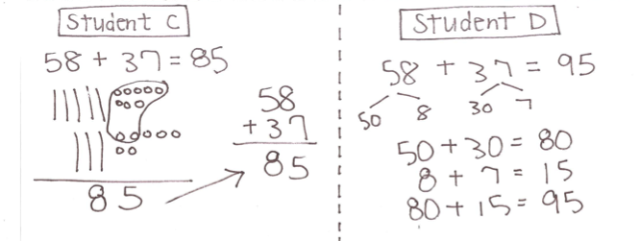
T: (Label the work The Quick Ten Drawing – Adding Tens to Tens and Ones to Ones.)
T: This student’s answer is 85, instead of 95 like we got. What happened? Can we find the error in his work?
S: When he added the ones together, he made a new ten with 8 and 2 from the 7. But when he added the tens, he forgot about the new ten! You can see that when he used just the numbers. He didn’t remember the new ten. It’s easier to remember a new ten when you write it in the tens place. There should be a total of 9 tens, not 8 tens. The answer is 9 tens 5 ones. 95.
T: Discuss with your partner. What are some ways this student can improve his work?
S: He can work more carefully and realize that he made a new ten. He can record the new ten. Then he can catch his mistake. The student can look at his picture to check his work.
T: Yes! It is important to record when you have made a new ten. It helps to keep track of all of your thinking.
T: Rewrite this student’s work on your board, solving it correctly. When you’re finished, check your work with your partner.
S: (Work with partners to solve using quick ten drawings. As students finish, teacher chooses a pair of students to show their work on the board as the new work for Student C.)
T: (Project Student D’s work.) Let’s compare Student D’s work to Student C’s new work. What similarities and differences do you notice? Turn and talk to your partner.
S: They look different because Student D used number bonds and three addition sentences to solve the problem. But our new work for Student C shows quick ten drawings with lined up numbers to add tens with tens and ones with ones. They both added ones to ones then tens to tens! They both added 8 and 7 and got 15. Then they added 5 tens and 3 tens to get 8 tens. Then they both added the new ten and got 95.
T: (Write 47 + 36 on the board.) Solve a new problem. You may use any method to solve but you must show your work.
Have students swap boards with their partner and discuss the following:

NOTES ON
MULTIPLE MEANS
OF ENGAGEMENT:
Appropriate scaffolds help all students feel successful. As students are working, observe closely to determine if any would benefit from one-on-one problem solving assistance.

- How did your partner show her solution?
- How was her work different from your work?
- How was your work the same?
- Give your partner a compliment on her work.
- Give a suggestion for how she could improve her work.
Project three or four work samples from the class, showing each of the methods: vertical alignment, make a new ten, count on by tens, and add ones to ones then tens to tens using number bonds.
T: How is the student work shown different from your partner’s work?
If time allows, have students solve 26 + 65, and then share another set of student work from the class.
Problem Set (10 minutes)
Students should do their personal best to complete the Problem Set within the allotted 10 minutes. For some classes, it may be appropriate to modify the assignment by specifying which problems they work on first. Some problems do not specify a method for solving. Students solve these problems using the RDW approach used for Application Problems.

Student Debrief (10 minutes)
Lesson Objective: Add a pair of two-digit numbers with varied sums in the ones, and compare the results of different recording methods.
The Student Debrief is intended to invite reflection and active processing of the total lesson experience.
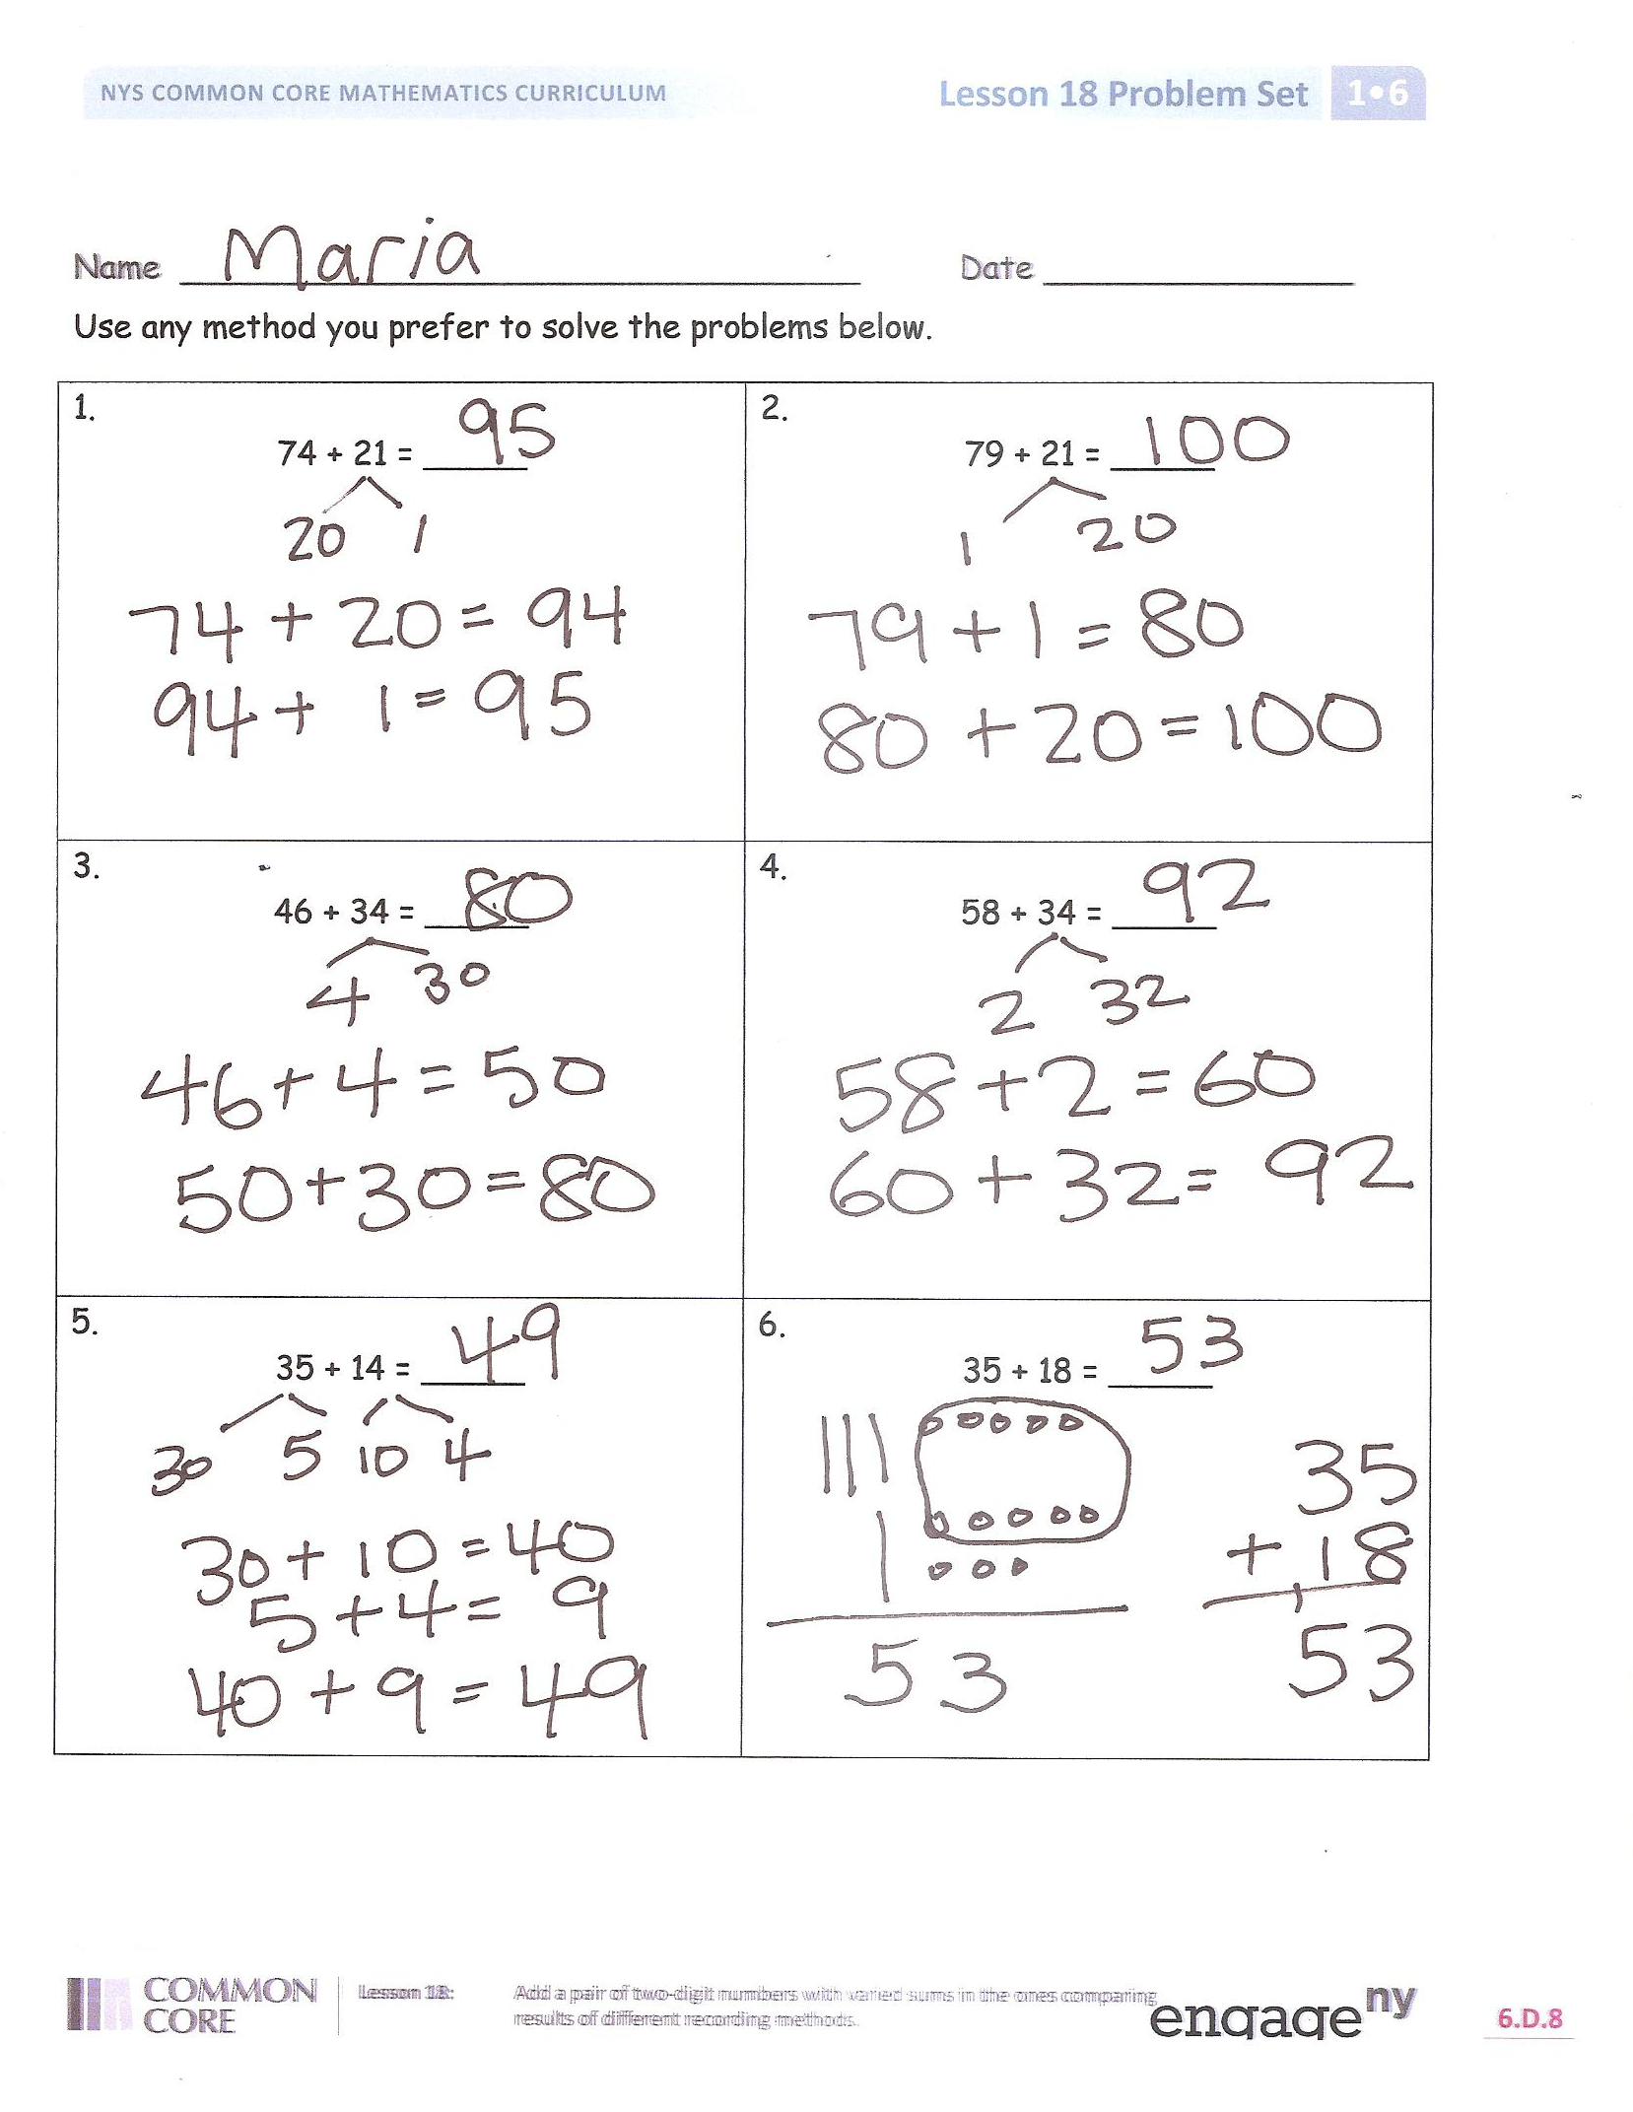
Invite students to review their solutions for the Problem Set. They should check work by comparing answers with a partner before going over answers as a class. Look for misconceptions or misunderstandings that can be addressed in the Debrief. Guide students in a conversation to debrief the Problem Set and process the lesson.
You may choose to use any combination of the questions below to lead the discussion.
- Look at Problem 2. Which strategy, count on by tens first or make the next ten first, would you use to solve? Explain your choice.
- Why didn’t most of us use the make the next ten strategy when solving Problem 1?
- The make the next ten strategy and another strategy, too, can be used for Problem 1. Explain why these number sentences are correct to your partner. (Write 74 + 21 = 80 + 15, 74 + 21 = 65 + 30, and 74 + 21 = 75 + 20.)
- How can solving Problem 5 help you solve Problem 6?
- Which strategy do you find yourself using the most? Why do you prefer that strategy?
Exit Ticket (3 minutes)
After the Student Debrief, instruct students to complete the Exit Ticket. A review of their work will help you assess the students’ understanding of the concepts that were presented in the lesson today and plan more effectively for future lessons. You may read the questions aloud to the students.

Name  Partner  Example  Step 1: Rewrite 4 – 1 = ___ as 1 + ___ = 4.  Step 2: Exchange papers and solve.  List A  - 10 – 9  - 10 – 8  - 9 – 8  - 9 – 6  - 8 – 6  - 7 – 4  - 7 – 5  - 8 - 5  - 9 – 5  - 9 - 6 | Name  Partner  Example  Step 1: Rewrite 4 – 1 = ___ as 1 + ___ = 4.  Step 2: Exchange papers and solve.  List B  - 10 - 8  - 10 – 7  - 8 – 7  - 8 – 6  - 9 – 6  - 7 – 6  - 7 – 5  - 7 - 4  - 8 – 5  - 6 - 4

Name Date
Use any method you prefer to solve the problems below.
1.  74 + 21 = _____ | 2.  79 + 21 = _____
3.  46 + 34 = _____ | 4.  58 + 34 = _____
5.  35 + 14 = _____ | 6.  35 + 18 = _____

Name Date

- Circle the work that is correct.

In the extra space, correct the mistake in the other solution using the same solution strategy the student tried to use.

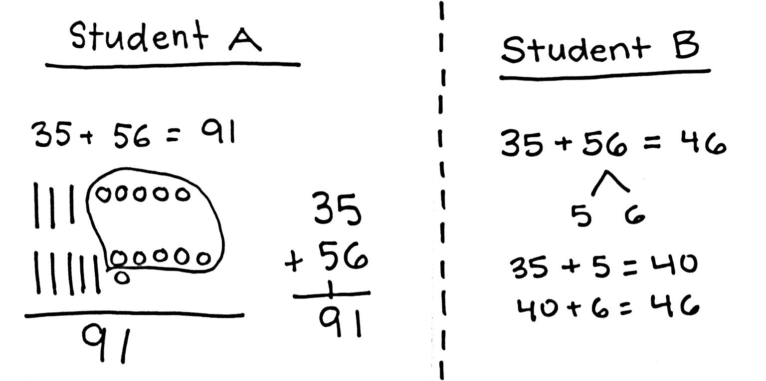

Name Date
Use any method you prefer to solve the problems below.
1.  61 + 15 = _____ | 2.  16 + 51 = _____
3.  37 + 45 = _____ | 4.  27 + 46 = _____
5.  58 + 27 = _____ | 6.  38 + 48 = _____

