Lesson 22: Congruence Criteria for Triangles—SAS

Classwork

Opening Exercise

Answer the following question. Then discuss your answer with a partner.

Do you think it is possible to know that there is a rigid motion that takes one triangle to another without actually showing the particular rigid motion? Why or why not?

_________________________________________________________________________________________

_________________________________________________________________________________________

_________________________________________________________________________________________  
Discussion

It is true that we will not need to show the rigid motion to be able to know that there is one. We are going to show that there are criteria that refer to a few parts of the two triangles and a correspondence between them that guarantee congruency (i.e., existence of rigid motion). We start with the Side-Angle-Side (SAS) criteria.

**Side-Angle-Side Triangle Congruence Criteria (SAS):** Given two triangles and so that (Side), (Angle), (Side). Then the triangles are congruent.

The steps below show the most general case for determining a congruence between two triangles that satisfy the SAS criteria. Note that not all steps are needed for every pair of triangles. For example, sometimes the triangles will already share a vertex. Sometimes a reflection will be needed, sometimes not. It is important to understand that we can always use the steps below—some or all of them—to determine a congruence between the two triangles that satisfies the SAS criteria

**Proof:**  Provided the two distinct triangles below, assume (Side), (Angle), (Side).



By our definition of congruence, we will have to find a composition of rigid motions will map to . We must find a congruence so that = First, use a translation to map a common vertex.

Which two points determine the appropriate vector?

Can any other pair of points be used? ________ Why or why not? ________________________________________________________________________________________

State the vector in the picture below that can be used to translate : _____________

Using a dotted line, draw an intermediate position of as it moves along the vector:



****After the translation (below), shares one vertex with , . In fact, we can say  
.

Next, use a clockwise rotation to bring the sides to (or counterclockwise rotation to bring to ).



A rotation of appropriate measure will mapto, but how can we be sure that vertex maps to ? Recall that part of our assumption is that the lengths of sides in question are equal, ensuring that the rotation maps to . (; the translation performed is a rigid motion, and thereby did not alter the length when became .)

After the rotation , a total of two vertices are shared with , and . Therefore**,**

Finally, if and are on opposite sides of the line that joins , a reflection brings to the same side as .   
Since a reflection is a rigid motion and it preserves angle measures, we know that and so maps to . If, however, coincides with , can we be certain that actually maps to ? We can, because not only are we certain that the rays coincide but also by our assumption that . (Our assumption began as , but the translation and rotation have preserved this length now as .) Taken together, these two pieces of information ensure that the reflection over brings to .

Another way to visually confirm this is to draw the marks of the ­­­______________________construction for .

Write the transformations used to correctly notate the congruence (the composition of transformations) that take :

_________

_________

­­­_________

We have now shown a sequence of rigid motions that takes to with the use of just three criteria from each triangle: two sides and an included angle. Given any two distinct triangles, we could perform a similar proof.   
There is another situation when the triangles are not distinct, where a modified proof will be needed to show that the triangles map onto each other. Examine these below. Note that when using the Side-Angle-Side triangle congruence criteria as a reason in a proof, you need only state the congruence and “SAS.”

Example 1

What if we had the SAS criteria for two triangles that were not distinct? Consider the following two cases. How would the transformations needed to demonstrate congruence change?

|  |  |  |
| --- | --- | --- |
| **Case** | **Diagram** | **Transformations Needed** |
| Shared Side |  |  |
| Shared Vertex |  |  |

Exercises 1–4

1. Given: Triangles with a pair of corresponding sides of equal length and a pair of included angles of equal measure. Sketch and label three phases of the sequence of rigid motions that prove the two triangles to be congruent.

|  |  |  |
| --- | --- | --- |
|  |  |  |
|  |  |  |

Justify whether the triangles meet the SAS congruence criteria; explicitly state which pairs of sides or angles are congruent and why. If the triangles do meet the SAS congruence criteria, describe the rigid motion(s) that would map one triangle onto the other.

Given: Triangles with a pair of corresponding sides of equal length and a pair of included angles of equal measure. Sketch and label three phases of the sequence of rigid motions that prove the two triangles to be congruent.

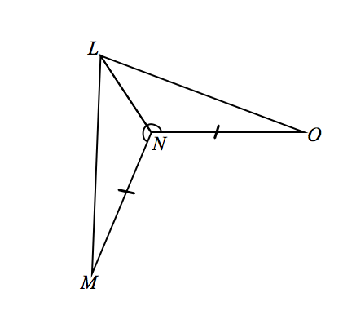

1. Given: ,.

Do and meet the SAS criteria?

1. 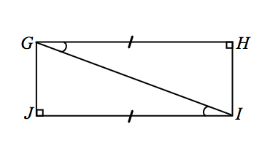Given: ,.

Do and meet the SAS criteria?

1. Is it true that we could also have proved and meet the SAS criteria if we had been given that and ? Explain why or why not.

Problem Set

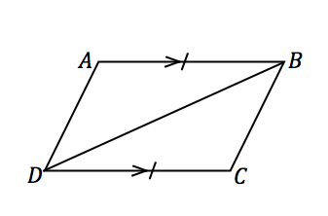Justify whether the triangles meet the SAS congruence criteria; explicitly state which pairs of sides or angles are congruent and why. If the triangles do meet the SAS congruence criteria, describe the rigid motion(s) that would   
map one triangle onto the other.

1. Given: ,

Do and meet the SAS criteria?

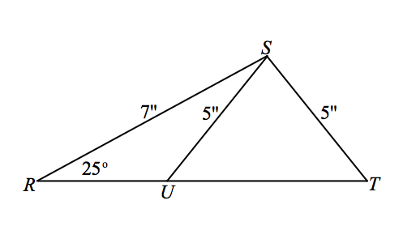

1. Given: , ,,

Do and meet the SAS criteria?

1. 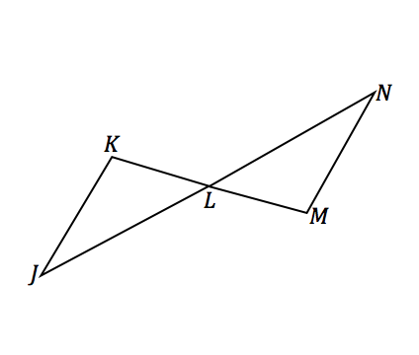Given: and bisect each other.

Do and meet the SAS criteria?

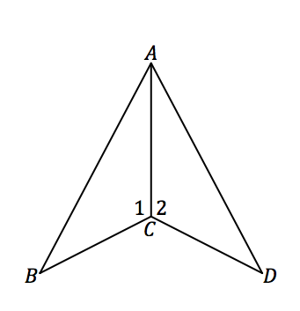

1. Given: ,

Do and meet the SAS criteria?

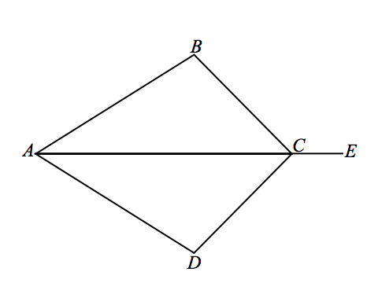

1. Given: bisects angle,

Do and meet the SAS criteria?

1. 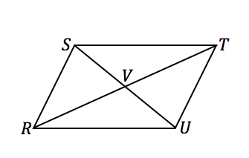Given: and bisect each other

Do and meet the SAS criteria?

1. 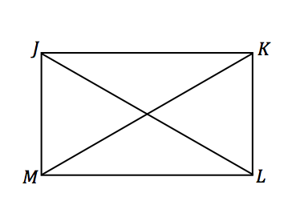Given: , ,

Do and meet the SAS criteria?

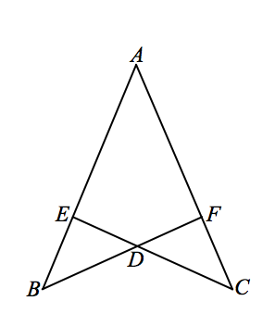

1. Given: ,

Do and meet the SAS criteria?

1. 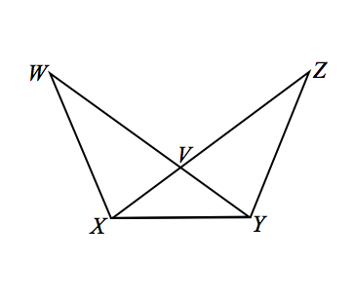Given:

Do and meet the SAS criteria?

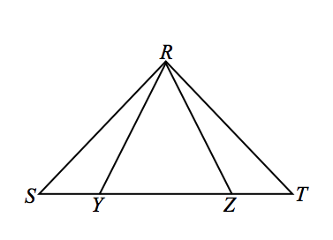

1. Given: is isosceles, .

Do and meet the SAS criteria?