|  |
| --- |
|  |

Lesson 22: Congruence Criteria for Triangles—SAS

**Student Outcomes**

* Students learn why any two triangles that satisfy the SAS congruence criterion must be congruent.

Lesson Notes

In Lesson 22, we begin to investigate criteria, or the indicators, of triangle congruence. Students are introduced to the concept in Grade 8, but have justified the criteria of triangle congruence (i.e., ASA, SAS, and SSS) in a more hands-on manner, manipulating physical forms of triangles through rigid motions to determine whether or not a pair of triangles is congruent. In this course, students formally prove the triangle congruency criteria.

Note that in the lessons that follow, proofs may employ *both* statements of equality of measure of angles and lengths of segments and statements of congruence of angles and segments. While not introduced formally, it is intuitively clear that two segments will be congruent if and only if they are equal in length; similarly, two angles are equal in measure if and only if they are congruent. That is, a segment can be mapped onto another if and only if they are equal in length, and an angle can be mapped onto another if and only if they are equal in measure. Another implication is that some of our key facts and discoveries may also be stated in terms of congruence, such as “Vertical angles are *congruent*” or “If two lines are cut by a transversal such that a pair of alternate interior angles are *congruent*, then the lines are parallel.” Discuss these results with your students. Exercise 4 within this Lesson is designed for students to develop understanding of the logical equivalency of these statements.

Classwork

Opening Exercise (5 minutes)

Opening Exercise

Answer the following question. Then discuss your answer with a partner.

Do you think it is possible to know that there is a rigid motion that takes one triangle to another without actually showing the particular rigid motion? Why or why not?

Answers may vary. Some students may think it is not possible because it is necessary to show the transformation as proof of its existence. Others may think it is possible by examining the triangles carefully.

It is common for curricula to take indicators of triangle congruence such as SAS and ASA as axiomatic, but this curriculum, defines congruence in terms of rigid motions (as defined in the **G-CO** domain). However, it can be shown that these commonly used statements (SAS, ASA, etc.) *follow from* this definition of congruence and the properties of basic rigid motions (**G-CO.B.8**). Thus, these statements are indicators of whether rigid motions exist to take one triangle to the other. In other words, we have agreed to use the word *congruent* to mean *there exists a composition of basic rigid motion of the plane that maps one figure to the other.* We will see that SAS, ASA, and SSS imply the existence of the rigid motion needed, but precision demands that we explain how and why.

While there are multiple proofs that show that SAS follows from the definition of congruence in terms of rigid motions and the properties of basic rigid motions, the one that appears in this lesson is one of the versions most accessible for students.

Discussion (20 minutes)

Discussion

It is true that we will not need to show the rigid motion to be able to know that there is one. We are going to show that there are criteria that refer to a few parts of the two triangles and a correspondence between them that guarantee congruency (i.e., existence of rigid motion). We start with the Side-Angle-Side (SAS) criteria.

Side-Angle-Side Triangle Congruence Criteria (SAS): Given two triangles and so that (Side), (Angle), (Side). Then the triangles are congruent.

The steps below show the most general case for determining a congruence between two triangles that satisfy the SAS criteria. Note that not all steps are needed for every pair of triangles. For example, sometimes the triangles will already share a vertex. Sometimes a reflection will be needed, sometimes not. It is important to understand that we can always use the steps below—some or all of them—to determine a congruence between the two triangles that satisfies the SAS criteria.

Proof: Provided the two distinct triangles below, assume (Side), (Angle), (Side).

By our definition of congruence, we will have to find a composition of rigid motions will map to . We must find a congruence so that . First, use a translation to map a common vertex.

Which two points determine the appropriate vector?

,

Can any other pair of points be used? Why or why not?

No. We use and because only these angles are congruent by assumption.

State the vector in the picture below that can be used to translate .

Using a dotted line, draw an intermediate position of as it moves along the vector:

After the translation (below), shares one vertex with , . In fact, we can say

.



Next, use a clockwise rotation to bring the sides to (or counterclockwise rotation to bring to ).

A rotation of appropriate measure will map to , but how can we be sure that vertex maps to ? Recall that part of our assumption is that the lengths of sides in question are equal, ensuring that the rotation maps to . (; the translation performed is a rigid motion, and thereby did not alter the length when became .)

After the rotation , a total of two vertices are shared with , and . **Therefore**,

.

Finally, if and are on opposite sides of the line that joins , a reflection brings to the same side as .

Since a reflection is a rigid motion and it preserves angle measures, we know that and so maps to . If, however, coincides with , can we be certain that actually maps to ? We can, because not only are we certain that the rays coincide but also by our assumption that . (Our assumption began as , but the translation and rotation have preserved this length now as .) Taken together, these two pieces of information ensure that the reflection over brings to .

Another way to visually confirm this is to draw the marks of the **perpendicular bisector**  construction for .

Write the transformations used to correctly notate the congruence (the composition of transformations) that take   
 :

Translation

Rotation

Reflection

We have now shown a sequence of rigid motions that takes to with the use of just three criteria from each triangle: two sides and an included angle. Given any two distinct triangles, we could perform a similar proof.   
There is another situation when the triangles are not distinct, where a modified proof will be needed to show that the triangles map onto each other. Examine these below. Note that when using the Side-Angle-Side triangle congruence criteria as a reason in a proof, you need only state the congruence and “SAS.”

Example 1 (5 minutes)

Students try an example based on the Discussion.

Example 1

What if we had the SAS criteria for two triangles that were not distinct? Consider the following two cases. How would the transformations needed to demonstrate congruence change?

|  |  |  |
| --- | --- | --- |
| Case | Diagram | Transformations Needed |
| Shared Side |  | reflection |
| Shared Vertex |  | rotation, reflection |

Exercises 1–4 (7 minutes)

Exercises 1–4

1. Given: Triangles with a pair of corresponding sides of equal length and a pair of included angles of equal measure. Sketch and label three phases of the sequence of rigid motions that prove the two triangles to be congruent.



|  |  |  |
| --- | --- | --- |
| Translation | Rotation | Reflection |
|  |  |  |

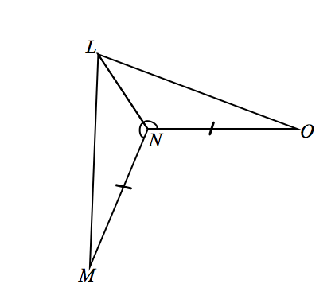Justify whether the triangles meet the SAS congruence criteria; explicitly state which pairs of sides or angles are congruent and why. If the triangles do meet the SAS congruence criteria, describe the rigid motion(s) that would   
map one triangle onto the other.

1. Given: ,

Do and meet the SAS criteria?

*Given*

Given

Reflexive property

SAS

The triangles map onto one another with a reflection over .

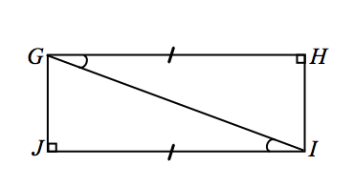

1. Given: ,

Do and meet the SAS criteria?

*Given*

Given

Reflexive property

SAS

The triangles map onto one another with a rotation about the midpoint of the diagonal.

1. Is it true that we could also have proved and meet the SAS criteria if we had been given that and ? Explain why or why not.

Yes, this is true. Whenever angles are equal, they can also be described as congruent. Since rigid motions preserve angle measure, for two angles of equal measure, there always exists a sequence of rigid motions that will carry one onto the other. Additionally, since rigid motions preserve distance, for two segments of equal length, there always exists a sequence of rigid motions that will carry one onto the other.

Exit Ticket (8 minutes)Name ___________________________________________________ Date____________________

Lesson 22: Congruence Criteria for Triangles—SAS

Exit Ticket

If two triangles satisfy the SAS criteria, describe the rigid motion(s) that would map one onto the other in the following cases.

1. The two triangles shared a single common vertex?
2. The two triangles were distinct from each other?
3. The two triangles shared a common side?

Exit Ticket Sample Solutions

If two triangles satisfy the SAS criteria, describe the rigid motion(s) that would map one onto the other in the following cases.

1. The two triangles shared a single common vertex?

Rotation, reflection

1. The two triangles were distinct from each other?

Translation, rotation, reflection

1. The two triangles shared a common side?

Reflection

Problem Set Sample Solutions

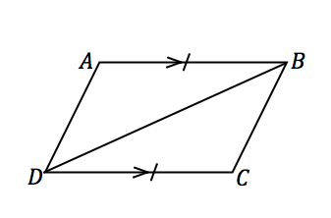Justify whether the triangles meet the SAS congruence criteria; explicitly state which pairs of sides or angles are congruent and why. If the triangles do meet the SAS congruence criteria, describe the rigid motion(s) that would   
map one triangle onto the other.

1. Given: ,

Do and meet the SAS criteria?

, Given

Reflexive property

*If a transversal intersects two parallel lines, then the measures of the alternate interior angles are equal in measure*

SAS

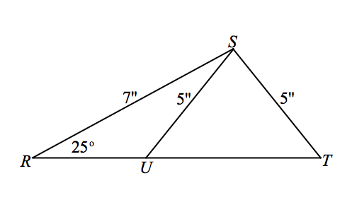The triangles map onto one another with a rotation about the midpoint of the diagonal.

1. Given: ,, ,

Do and meet the SAS criteria?

Not enough information given.

1. 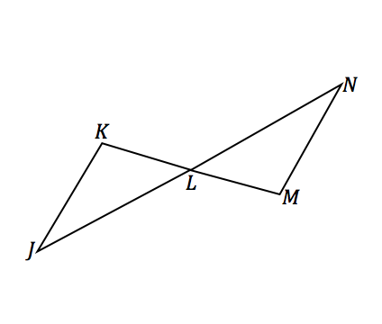Given: and bisect each other.

Do and meet the SAS criteria?

and bisect each other Given

*Vertical angles are equal in measure*

Definition of a segment bisector

Definition of a segment bisector

SAS

The triangles map onto one another with a rotation about .

1. 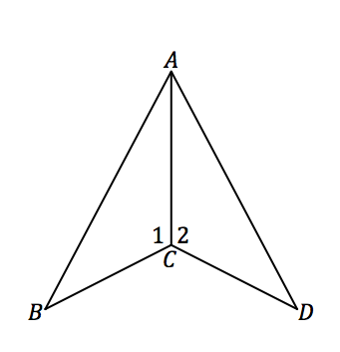Given: ,

Do and meet the SAS criteria?

*Given*

Given

Reflexive property

Side Angle Side criteria

The triangles map onto one another with a reflection over .

1. 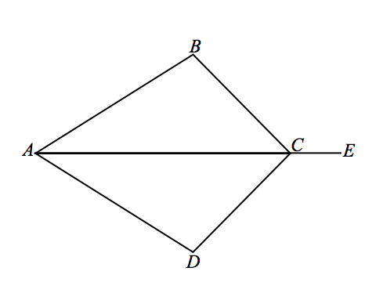Given: bisects angle,

Do and meet the SAS criteria?

bisects angle Given

*Definition of an angle bisector*

Given

Reflexive property

SAS

The triangles map onto one another with a reflection over

1. 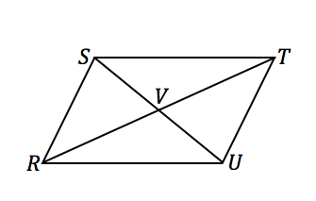Given: and bisect each other

Do and meet the SAS criteria?

and bisect each other Given

Definition of a segment bisector

Definition of a segment bisector

*Vertical angles are equal in measure*

SAS

The triangles map onto one another with a rotation about .

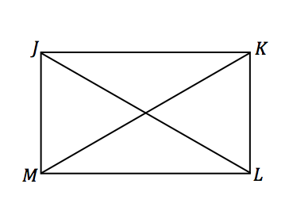

1. Given: , ,

Do and meet the SAS criteria?

Given

, Given

*, Definition of perpendicular lines*

*Transitive property*

Reflexive property

SAS

The triangles map onto one another with a reflection over the perpendicular bisector of .

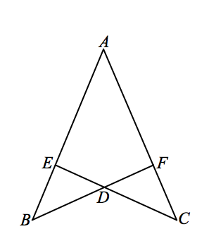

1. Given:

Do and meet the SAS criteria?

Not enough information given.

1. 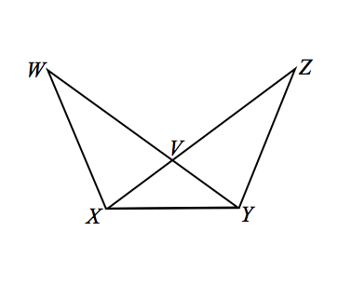Given:

Do and meet the SAS criteria?

Not enough information given.

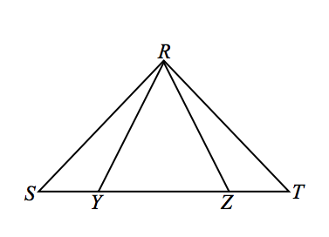

1. Given is isosceles with ,   
   Do and meet the SAS criteria?

is isosceles with Given

*Base angles of an isosceles triangle are equal in measure*

Given

SAS