Lesson 21: Correspondence and Transformations

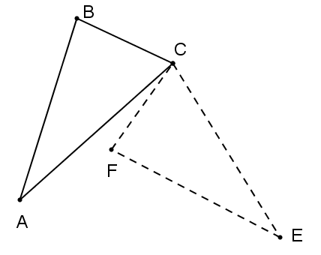Classwork

Opening Exercise

The figure to the right represents a rotation of around vertex . Name the triangle formed by the image of . Write the rotation in function notation, and name all corresponding angles and sides.

Discussion

In the Opening Exercise, we explicitly showed a single rigid motion, which mapped every side and every angle of onto . Each corresponding pair of sides and each corresponding pair of angles was congruent. When each side   
and each angle on the pre-image maps onto its corresponding side or angle on the image, the two triangles are congruent. Conversely, if two triangles are congruent, then each side and angle on the pre-image is congruent to its corresponding side or angle on the image.

Example 1

is a square, and is one diagonal of the square. is a reflection of across segment . Complete the table below identifying the missing corresponding angles and sides.



|  |  |
| --- | --- |
| Corresponding angles | Corresponding sides |
|  |  |

* 1. Are the corresponding sides and angles congruent? Justify your response.
  2. Is ? Justify your response.

Exercises 1–3

Each exercise below shows a sequence of rigid motions that map a pre-image onto a final image. Identify each rigid motion in the sequence, writing the composition using function notation. Trace the congruence of each set of corresponding sides and angles through all steps in the sequence, proving that the pre-image is congruent to the final image by showing that every side and every angle in the pre-image maps onto its corresponding side and angle in the image. Finally, make a statement about the congruence of the pre-image and final image.

|  |  |
| --- | --- |
| Sequence of rigid motions (2) |  |
| Composition in function notation |  |
| Sequence of corresponding sides |  |
| Sequence of corresponding angles |  |
| Triangle congruence statement |  |

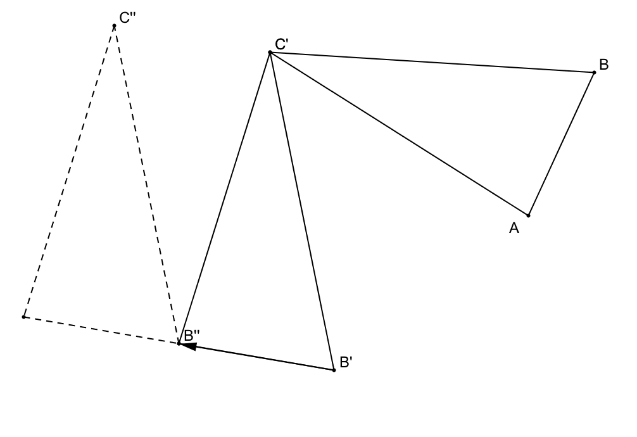

1. 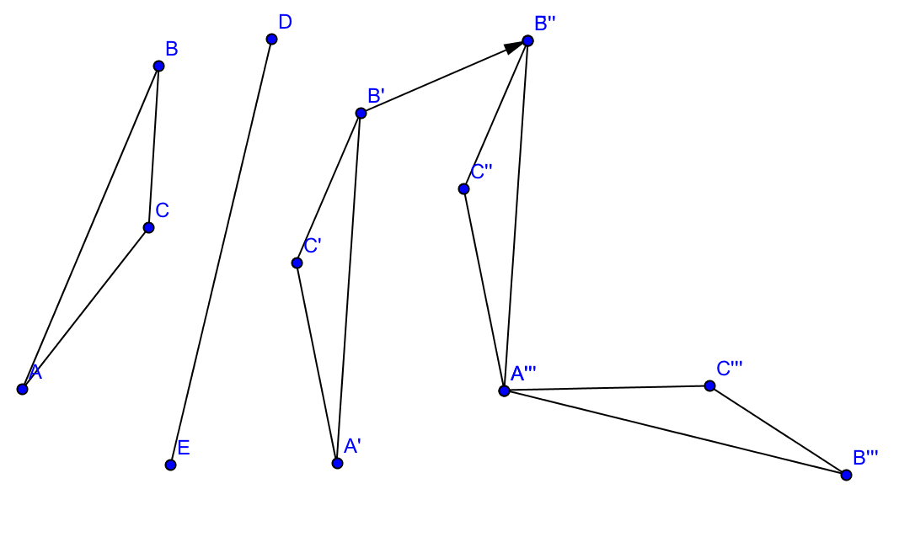

|  |  |
| --- | --- |
| Sequence of rigid motions (3) |  |
| Composition in function notation |  |
| Sequence of corresponding sides |  |
| Sequence of corresponding angles |  |
| Triangle congruence statement |  |

|  |  |
| --- | --- |
| Sequence of rigid motions (3) |  |
| Composition in function notation |  |
| (Sequence of corresponding sides |  |
| Sequence of corresponding angles |  |
| Triangle congruence statement |  |

1. 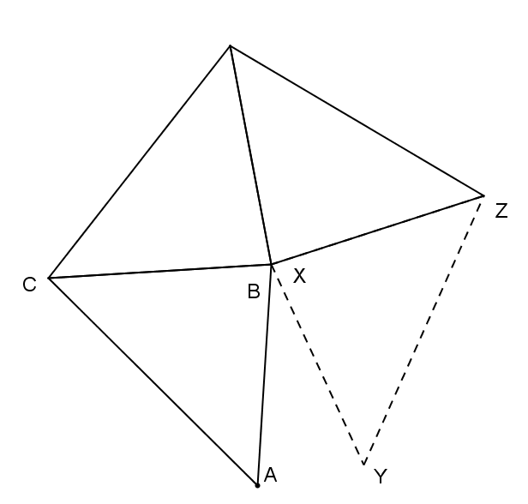

Problem Set

1. Exercise 3 above mapped onto in three “steps.” Construct a fourth step that would map back onto .
2. Explain triangle congruence in terms of rigid motions. Use the terms corresponding sides and corresponding angles in your explanation.