|  |
| --- |
|  |

Lesson 21: Correspondence and Transformations

**Student Outcomes**

* Students practice applying a sequence of rigid motions from one figure onto another figure in order to demonstrate that the figures are congruent.

Lesson Notes

In Lesson 21, we will consolidate our understanding of congruence in terms of rigid motions with our knowledge of corresponding vertices and sides of triangles. We will identify specific sides and angles in the pre-image of a triangle that map onto specific angles and sides of the image. If a rigid motion results in every side and every angle of the pre-image mapping onto every corresponding side and angle of the image, we will assert that the triangles are congruent.

Classwork

Opening Exercise (7 minutes)

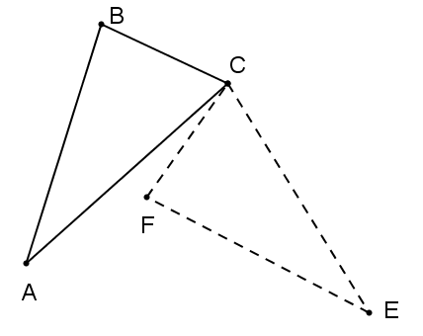  
Opening Exercise

The figure to the right represents a rotation of around vertex . Name the triangle formed by the image of . Write the rotation in function notation, and name all corresponding angles and sides.

|  |  |
| --- | --- |
| Corresponding angles | Corresponding sides |
|  |  |

Discussion (5 minutes)

Discussion

In the Opening Exercise, we explicitly showed a single rigid motion, which mapped every side and every angle of onto . Each corresponding pair of sides and each corresponding pair of angles was congruent. When each side   
and each angle on the pre-image maps onto its corresponding side or angle on the image, the two triangles are congruent. Conversely, if two triangles are congruent, then each side and angle on the pre-image is congruent to its corresponding side or angle on the image.

Example 1 (8 minutes)

Example 1

is a square, and is one diagonal of the square. is a reflection of across segment . Complete the table below identifying the missing corresponding angles and sides.

|  |  |
| --- | --- |
| Corresponding angles | Corresponding sides |
|  |  |



* 1. Are the corresponding sides and angles congruent? Justify your response.

Since the triangle is a rigid transformation, all angles and sides maintain their size.

* 1. Is ? Justify your response.

Yes. Since is a reflection of , they must be congruent.

**Exercises 1–3 (20 minutes)**

Exercises 1–3

Each exercise below shows a sequence of rigid motions that map a pre-image onto a final image. Identify each rigid motion in the sequence, writing the composition using function notation. Trace the congruence of each set of corresponding sides and angles through all steps in the sequence, proving that the pre-image is congruent to the final image by showing that every side and every angle in the pre-image maps onto its corresponding side and angle in the image. Finally, make a statement about the congruence of the pre-image and final image.

|  |  |
| --- | --- |
| Sequence of rigid motions (2) | rotation, translation |
| Composition in function notation |  |
| Sequence of corresponding sides |  |
| Sequence of corresponding angles |  |
| Triangle congruence statement |  |

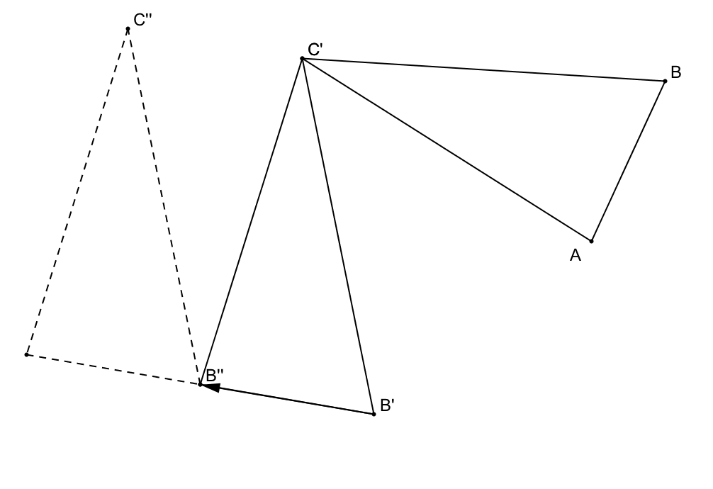

A’’

A’

|  |  |
| --- | --- |
| Sequence of rigid motions (3) | reflection, translation, rotation |
| Composition in function notation |  |
| Sequence of corresponding sides |  |
| Sequence of corresponding angles |  |
| Triangle congruence statement |  |

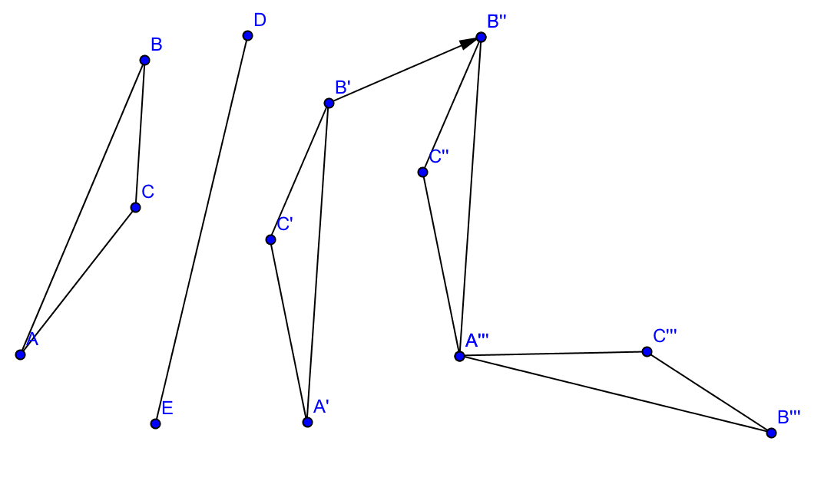

|  |  |
| --- | --- |
| Sequence of rigid motions (3) | reflections |
| Composition in function notation |  |
| Sequence of corresponding sides |  |
| Sequence of corresponding angles |  |
| Triangle congruence statement |  |

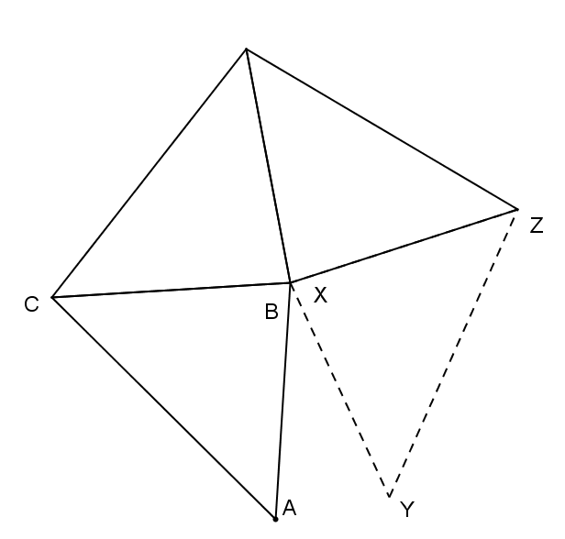

**Exit Ticket (5 minutes)**

Name ___________________________________________________ Date____________________

Lesson 21: Correspondence and Transformations

Exit Ticket

Complete the table based on the series of rigid motions performed on below.

|  |  |
| --- | --- |
| Sequence of rigid motions (2) |  |
| Composition in function notation |  |
| Sequence of corresponding sides |  |
| Sequence of corresponding angles |  |
| Triangle congruence statement |  |

 Exit Ticket Sample Solutions

|  |  |
| --- | --- |
| Sequence of rigid motions (2) | rotation, reflection |
| Composition in function notation |  |
| Sequence of corresponding sides |  |
| Sequence of corresponding angles |  |
| Triangle congruence statement |  |

Complete the table based on the series of rigid motions performed on below.



Problem Set Sample Solutions

1. Exercise 3 above mapped onto in three *steps.* Construct a fourth step that would map back onto .

Construct an angle bisector for the , and reflect over that line.

1. Explain triangle congruence in terms of rigid motions. Use the terms corresponding sides and corresponding angles in your explanation.

Triangle congruence can be found using a series of rigid motions in which you map an original or pre-image of a figure onto itself. By doing so, all the corresponding sides and angles of the figure will map onto their matching corresponding sides or angles, which proves the figures are congruent.