Lesson 17
Objective: Add a pair of two-digit numbers when the ones digits have a sum greater than 10 with drawing. Record the new ten below.

Suggested Lesson Structure
 Application Problem (5 minutes)
 Fluency Practice (13 minutes)
 Concept Development (32 minutes)
 Student Debrief (10 minutes)
Total Time (60 minutes)
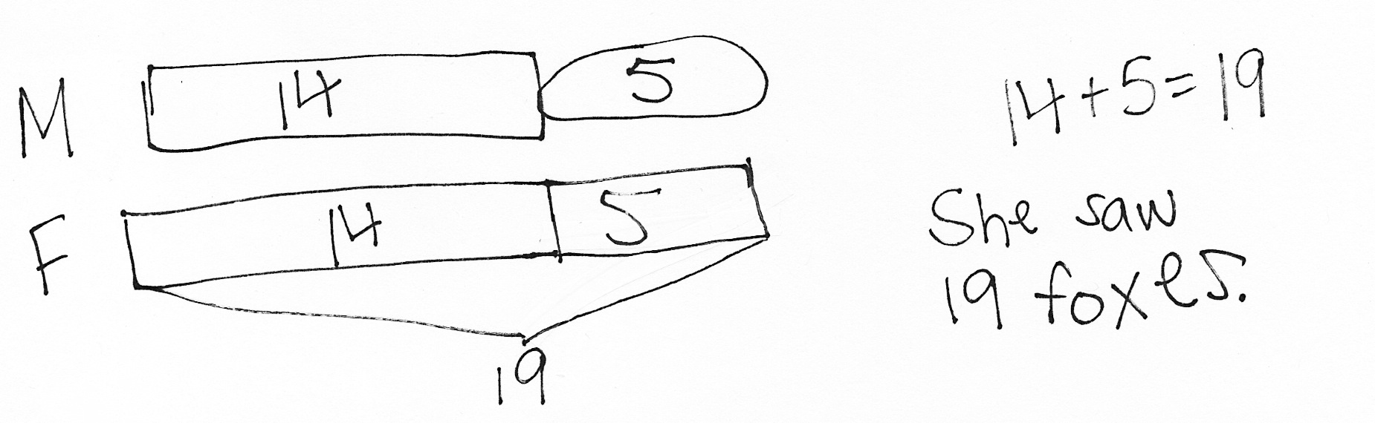Application Problem (5 minutes)
Rose saw 14 monkeys at the zoo. She saw 5 fewer monkeys than foxes. How many foxes did Rose see?
Note: Today’s problem is a comparison with larger unknown where fewer suggests the wrong operation problem type. Students should be exposed to these problems, but mastery is not expected until the end of Grade 2.
Fluency Practice (13 minutes)
- Grade 1 Core Fluency Sprint 1.OA.6 (10 minutes)
- Analogous Addition Sentences 1.OA.6, 1.NBT.4 (3 minutes)
Grade 1 Core Fluency Sprint (10 minutes)
Materials: (S) Core Fluency Sprint (G1−M5−Lesson 1)
Note: Based on the needs of the class, select a Sprint from yesterday’s materials. There are several possible options available.
- Re-administer the Sprint from the day before.
- Administer the next Sprint in the sequence.
- Differentiate. Administer two different Sprints. Simply have one group do a counting activity on the back of their Sprint while the other Sprint is corrected.

Analogous Addition Sentences (3 minutes)
Note: This fluency activity encourages students to use sums within 10 to solve more challenging problems.
T: Say the number sentence with the answer. 5 + 2.
S: 5 + 2 = 7.
T: 45 + 2.
S: 45 + 2 = 47.
T: 42 + 5.
S: 42 + 5 = 47.
T: 5 + 42.
S: 5 + 42 = 47.
Continue with the following suggested sequence:
4 + 3 6 + 3 5 + 4
84 + 3 76 + 3 95 + 4
83 + 4 73 + 6 94 + 5
4 + 83 6 + 73 5 + 94
Concept Development (32 minutes)

NOTES ON
MULTIPLE MEANS OF ACTION AND EXPRESSION:
Continue to challenge advanced students. After they have completed the Problem Set, encourage them to write a word problem adding a pair of two-digit numbers. Have students who write a word problem trade papers to solve each other’s problem.
Materials: (T) Chart paper (S) Personal white board with recording tens and ones template from G1−M6−Lesson 16 (optional), numeral cards
Students sit at their tables with their personal boards.
Lesson 17’s Concept Development can be used to solidify the learning acquired in G1–M6–Lessons 15 and 16. Three sets of problems have been provided for students who are ready to extend their double-digit addition skills. The teaching sequence from G1–M6–Lesson 16 may be used to guide instruction and students should be encouraged to solve by using quick ten drawings as well as the standard algorithm. Encourage students to use place value language to describe strategies for solving.

NOTES ON
MULTIPLE MEANS
OF ENGAGEMENT:
Appropriate scaffolds help all students feel successful. As students are working, observe closely to determine if any would benefit from one-on-one problem solving assistance.

Problems 1–4 Problems 5–8 Problems 9–12
25 + 13 49 + 25 55 + 39
29 + 13 58 + 32 36 + 57
39 + 23 67 + 28 15 + 78
38 + 25 67 + 26 27 + 73
If time allows, have student pairs use numeral cards to generate two-digit addition problems to solve with their partners. This will also give the teacher an opportunity to work with students who need extra support in a small group.
- Create a tens pile (digits 0−4) and a ones pile (digits 5−9) using numeral cards from both players and put them face-down.
- Put the place value chart template between the partners and add an addition sign in between the charts.
- Partner A creates the first addend by drawing a card from the tens and ones pile and places them in the first place value chart.
- Partner B creates the second addend in the same way and places them in the second place value chart.
- Each student solves the problem with a quick ten drawing and the standard algorithm on her personal board.
Problem Set (10 minutes)
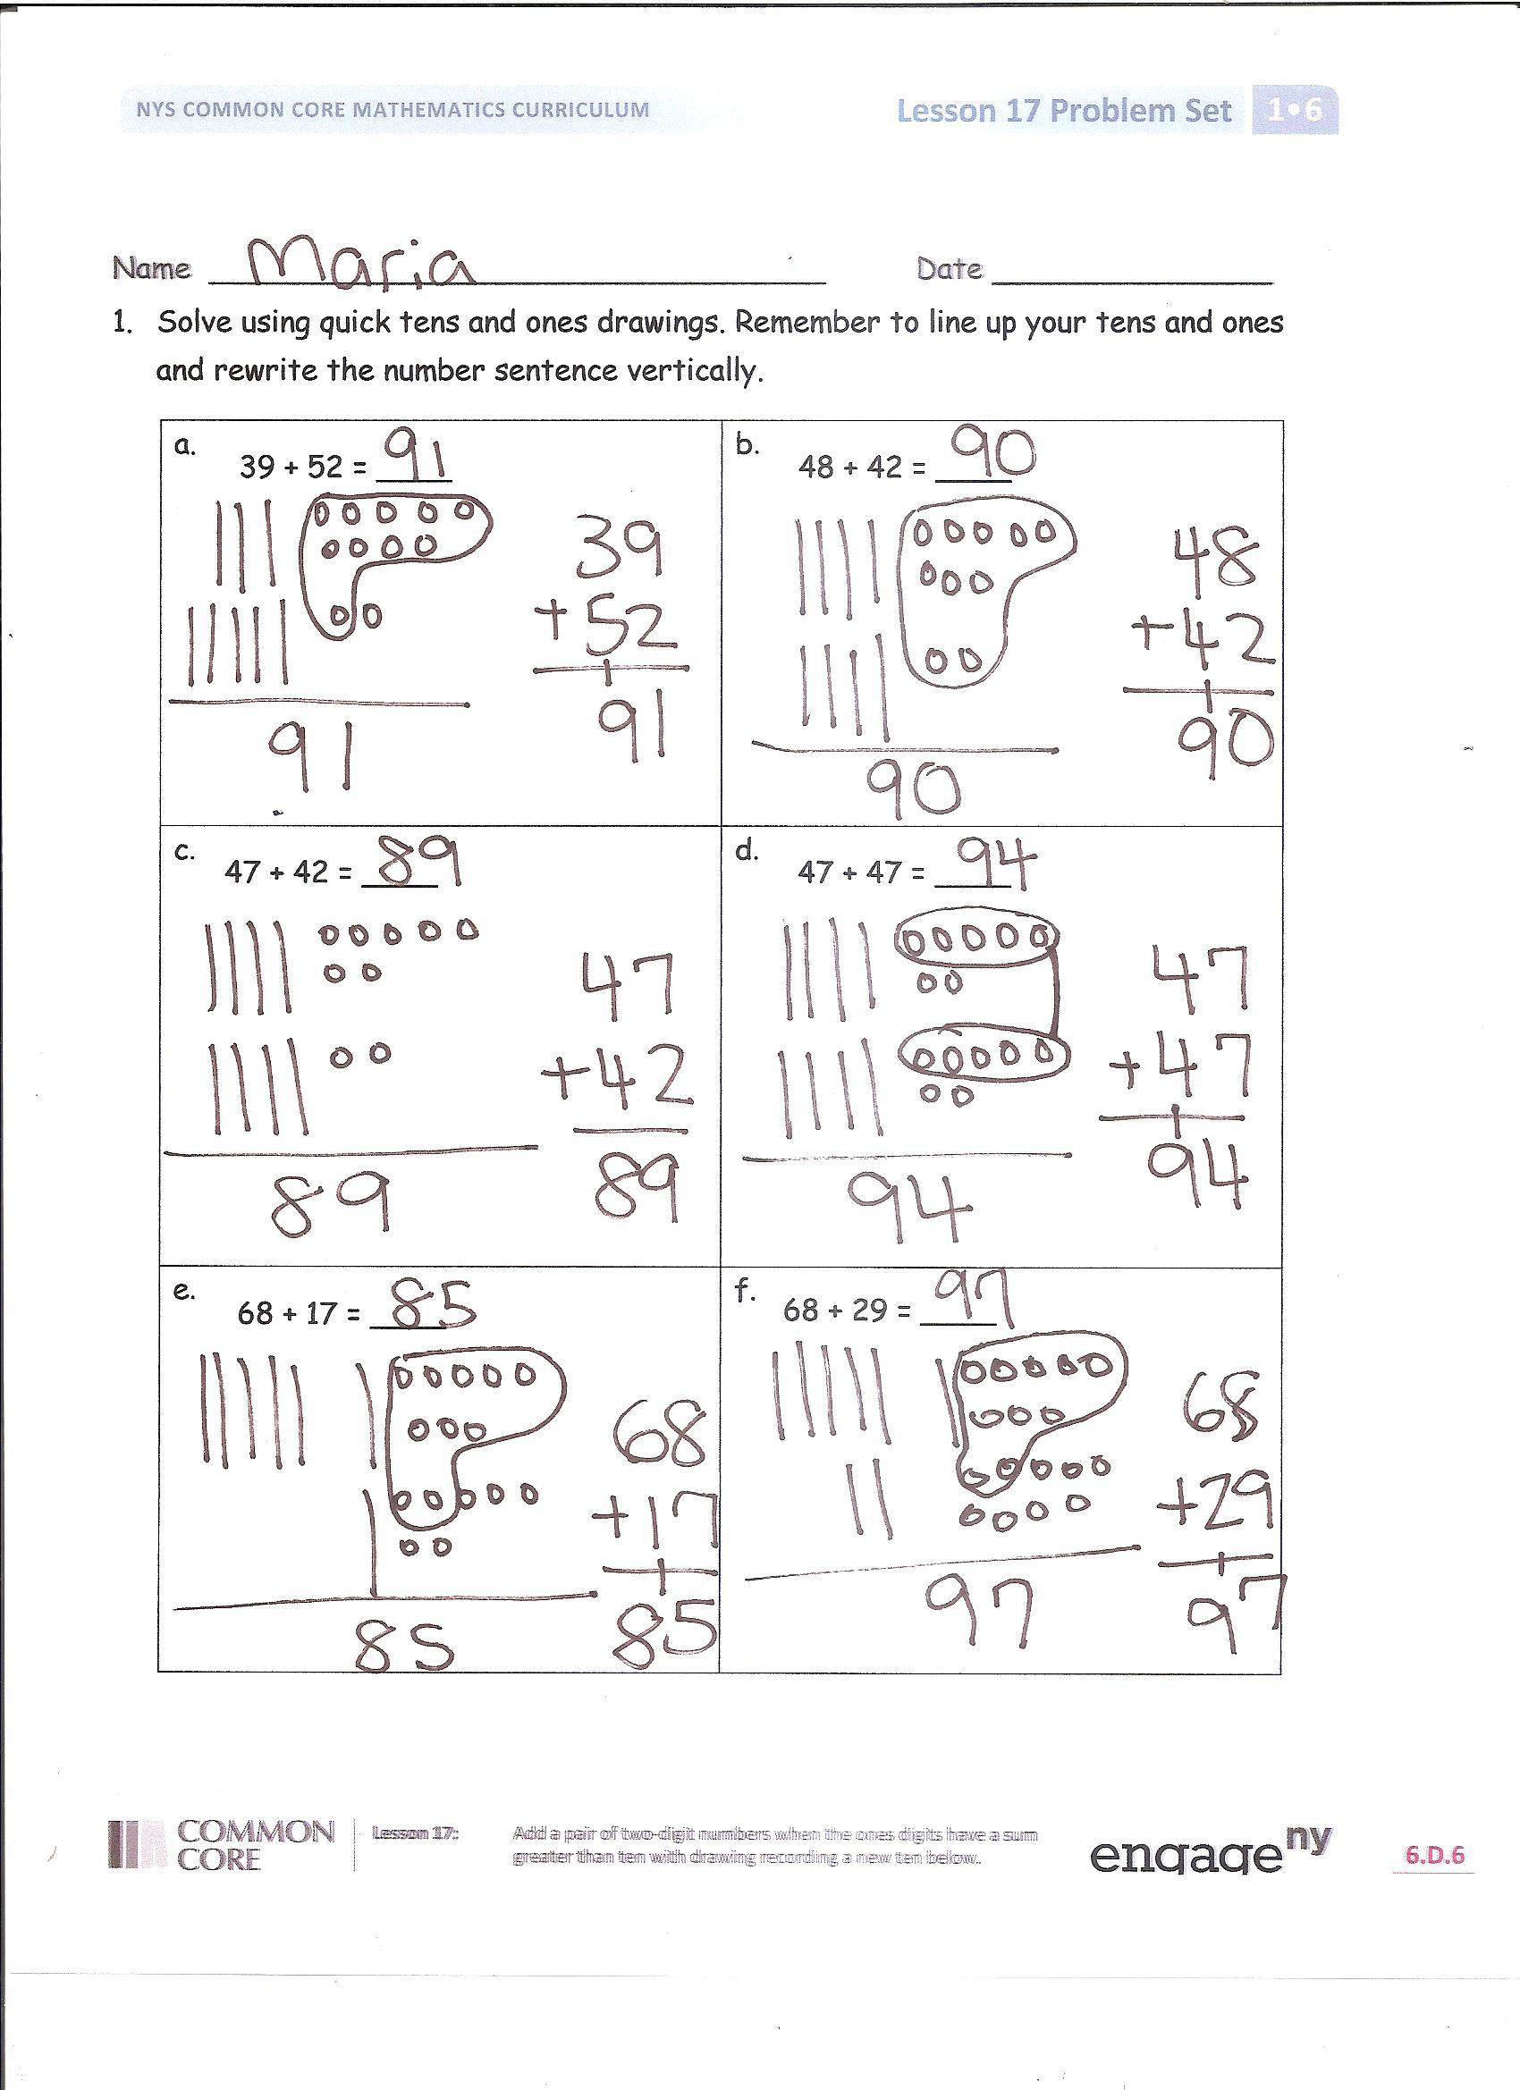
Students should do their personal best to complete the Problem Set within the allotted 10 minutes. For some classes, it may be appropriate to modify the assignment by specifying which problems they work on first. Some problems do not specify a method for solving. Students solve these problems using the RDW approach used for Application Problems.
Student Debrief (10 minutes)
Lesson Objective: Add a pair of two-digit numbers when the ones digits have a sum greater than 10 with drawing. Record the new ten below.
The Student Debrief is intended to invite reflection and active processing of the total lesson experience.
Invite students to review their solutions for the Problem Set. They should check work by comparing answers with a partner before going over answers as a class. Look for misconceptions or misunderstandings that can be addressed in the Debrief. Guide students in a conversation to debrief the Problem Set and process the lesson.
You may choose to use any combination of the questions below to lead the discussion.
- How can solving Problem 1(b) help you solve 1(c)?
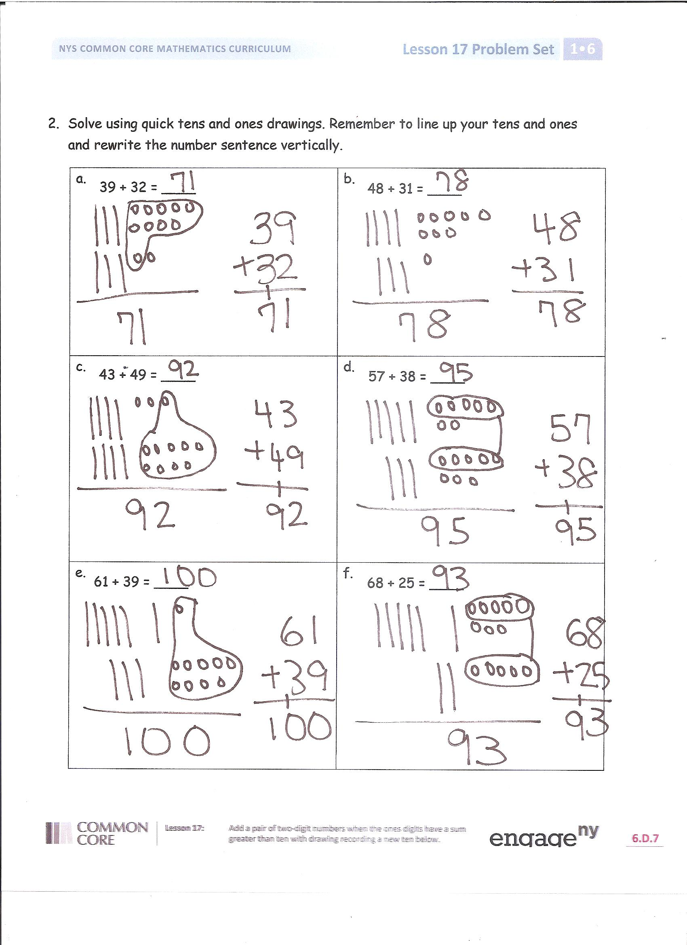
- Look at your quick ten drawing for 2(d). How did you make a new ten? Show another way to make a new ten.
- Look at Problems 1(a) and 2(a) with a partner. How are these problems related? How can solving 1(a) help you solve 2(a)? Think of another problem you could solve that is related to Problems 1(a) and 2(a).
- Look at Problems 1(c) and 1(d). How are these problems alike? Why is the total of 47 and 42 a number in the 80s and the total of 47 and 45 is a number in the 90s?
- Which addition strategy do you prefer? Explain your thinking.
- How did today’s Analogous Addition Sentences help you with addition during today’s lesson?
Exit Ticket (3 minutes)
After the Student Debrief, instruct students to complete the Exit Ticket. A review of their work will help you assess the students’ understanding of the concepts that were presented in the lesson today and plan more effectively for future lessons. You may read the questions aloud to the students.

Name Date

- Solve using quick tens and ones drawings. Remember to line up your tens and ones and rewrite the number sentence vertically.
a.  39 + 52 = ____ | b.  48 + 42 = ____
c.  47 + 42 = ____ | d.  47 + 47 = ____
e.  68 + 17 = ____ | f.  68 + 29 = ____
- Solve using quick tens and ones drawings. Remember to line up your tens and ones and rewrite the number sentence vertically.
a.  39 + 32 = ____ | b.  48 + 31 = ____
c.  43 + 49 = ____ | d.  57 + 38 = ____
e.  61 + 39 = ____ | f.  68 + 25 = ____

Name Date

- Solve using quick tens and ones drawings. Remember to line up your tens and ones and rewrite the number sentence vertically.
a.  39 + 47 = ____ | b.  58 + 32 = ____
c.  49 + 44 = ____ | d.  58 + 39 = ____

Name Date

- Solve using quick tens and ones drawings. Remember to line up your tens and ones and rewrite the number sentence vertically.
a.  49 + 33 = ____ | b.  68 + 32 = ____
c.  36 + 43 = ____ | d.  27 + 67 = ____
e.  78 + 17 = ____ | f.  69 + 28 = ____
- Solve using quick tens and ones drawings. Remember to line up your tens and ones and rewrite the number sentence vertically.
a.  29 + 52 = ____ | b.  58 + 31 = ____
c.  73 + 26 = ____ | d.  67 + 28 = ____
e.  41 + 59 = ____ | f.  48 + 45 = ____

Numeral Cards
0 | 1 | 2 | 3
4 | 5 | 6 | 7
8 | 9 | 10 | 10
10 | 10 | 5 | 5

