Lesson 16
Objective: Add a pair of two-digit numbers when the ones digits have a sum greater than 10 with drawing. Record the new ten below.

Suggested Lesson Structure
 Application Problem (5 minutes)
 Fluency Practice (13 minutes)
 Concept Development (32 minutes)
 Student Debrief (10 minutes)
Total Time (60 minutes)
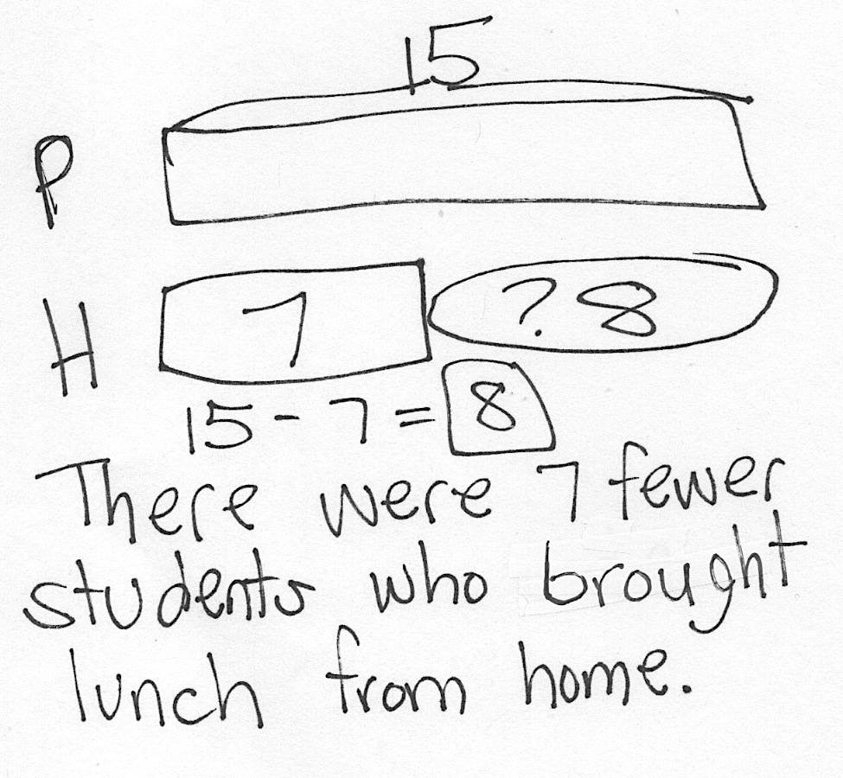
Application Problem (5 minutes)
Fifteen students ordered pizza for lunch. Seven students brought their lunch from home. How many fewer students brought their lunch from home than ordered lunch?
Note: Today’s Application Problem is a compare with difference unknown problem type. Consider altering the meal choice to match your school’s lunch menu for the day.
Fluency Practice (13 minutes)
- Grade 1 Core Fluency Sprint 1.OA.6 (10 minutes)
- Coin Drop 1.NBT.5, 1.MD.3 (3 minutes)
Grade 1 Core Fluency Sprint (10 minutes)
Materials: (S) Core Fluency Sprint from G1−M5−Lesson 1
Note: Choose a Sprint based on the needs of the class.
- Core Addition Sprint
- Core Addition Sprint 2
- Core Subtraction Sprint
- Core Fluency Sprint: Totals of 5, 6, and 7
- Core Fluency Sprint: Totals of 8, 9, and 10
Coin Drop (3 minutes)
Materials: (T) 4 dimes, 10 pennies, can

NOTES ON
MULTIPLE MEANS OF ENGAGEMENT:
After playing Coin Drop with pennies then dimes, mix pennies and dimes so that students have to add based on the changing value of the coin. This will challenge students and keep them listening for what will come next.
Note: In this activity, students practice adding and subtracting ones and tens within 100.
T: (Hold up a penny.) Name my coin.
S: A penny.
T: How much is it worth?
S: 1 cent.
T: Listen carefully as I drop coins in my can. Count along in your minds.
Drop in some pennies and ask how much money is in the can. Take out some pennies and show them. Ask how much money is still in the can. Continue adding and subtracting pennies for a minute. Then repeat the activity with dimes. For the final minute, begin with some pennies in the can and add and subtract dimes.
Concept Development (32 minutes)
Materials: (T) Chart paper (S) Personal white boards with the recording tens and ones template inserted

NOTES ON
MULTIPLE MEANS OF ACTION AND EXPRESSION:
Giving students an opportunity to share their thinking allows students to evaluate their process and practice. English language learners will also benefit from hearing other students explain their thinking.

Gather students in the meeting area with their materials.
T: (Write 39 + 26 = ___ on the board.) On your personal board, make a quick ten drawing to solve.
S: (Solve as the teacher circulates and selects one student to share with the class.)
T: (Choose a student, Student 1, to model the drawing on the board.) As Student 1 draws and explains what he did, I’m going to stop him after every step to show how we can record using just numbers.
S1: (Draws 39.) I drew 3 tens and 9 ones.
T: Stop! He made 3 tens, so I write 3 in the tens place. He made 9 ones, so I write the 9 in the…?
S: Ones place!
T: (Write 39.)
S1: (Draws 26 vertically aligned to 39.) I drew 2 tens and 9 ones right below so I can add tens to tens and ones to ones.
T: Stop! Watch me as I match exactly what Student 1 did with his drawing. (Write 26.) I’m adding the 2 tens to the 3 tens, 6 ones to the 9 ones, just like the picture. (Draw the equal sign.)

S1: Then I added the ones together. 9 needs 1 from 6 to get to 10. (Frames 10.) 10 and 5 is 15.
T: Stop! Student 1 made 15 by adding 9 and 6. (Point to the digits in the ones place.) That’s 1 ten 5 ones. Watch where I record that new ten. (Record the new ten below the second addend in the tens place as shown to the right.) I didn’t write the 1 ten where the answer goes yet because I have more tens to add later. 15 is 1 ten and…?
S: 5 ones.
T: (Write 5 in the ones place.)
S1: Then I added 3 tens and 2 tens plus the 1 ten I made when I added 9 and 5. That’s 6 tens. (Writes 6 in the tens place.)
T: Ah, ha! So he added 3 tens and 2 tens (Point to the digits 3 and 2.) plus this new ten we wrote in from 15 when we added the ones. So 3 tens + 2 tens + 1 ten is…?

NOTES ON
MULTIPLE MEANS OF ACTION AND EXPRESSION:
Continue to challenge advanced students. Encourage students to write a creative word problem to match one of the number sentences they solved today.
S: 6 tens.
T: So, what is 39 + 26? Say the number sentence.
S: 39 + 26 = 65.
T: Let’s try some more.
Continue with the following process using the suggested sequence as you feel your students are ready:
39 + 36, 59 + 37, 28 + 43, 47 + 35, 26 + 67.
- Have another student model the quick ten drawings as the teacher represents the drawings with numbers.
MP.4
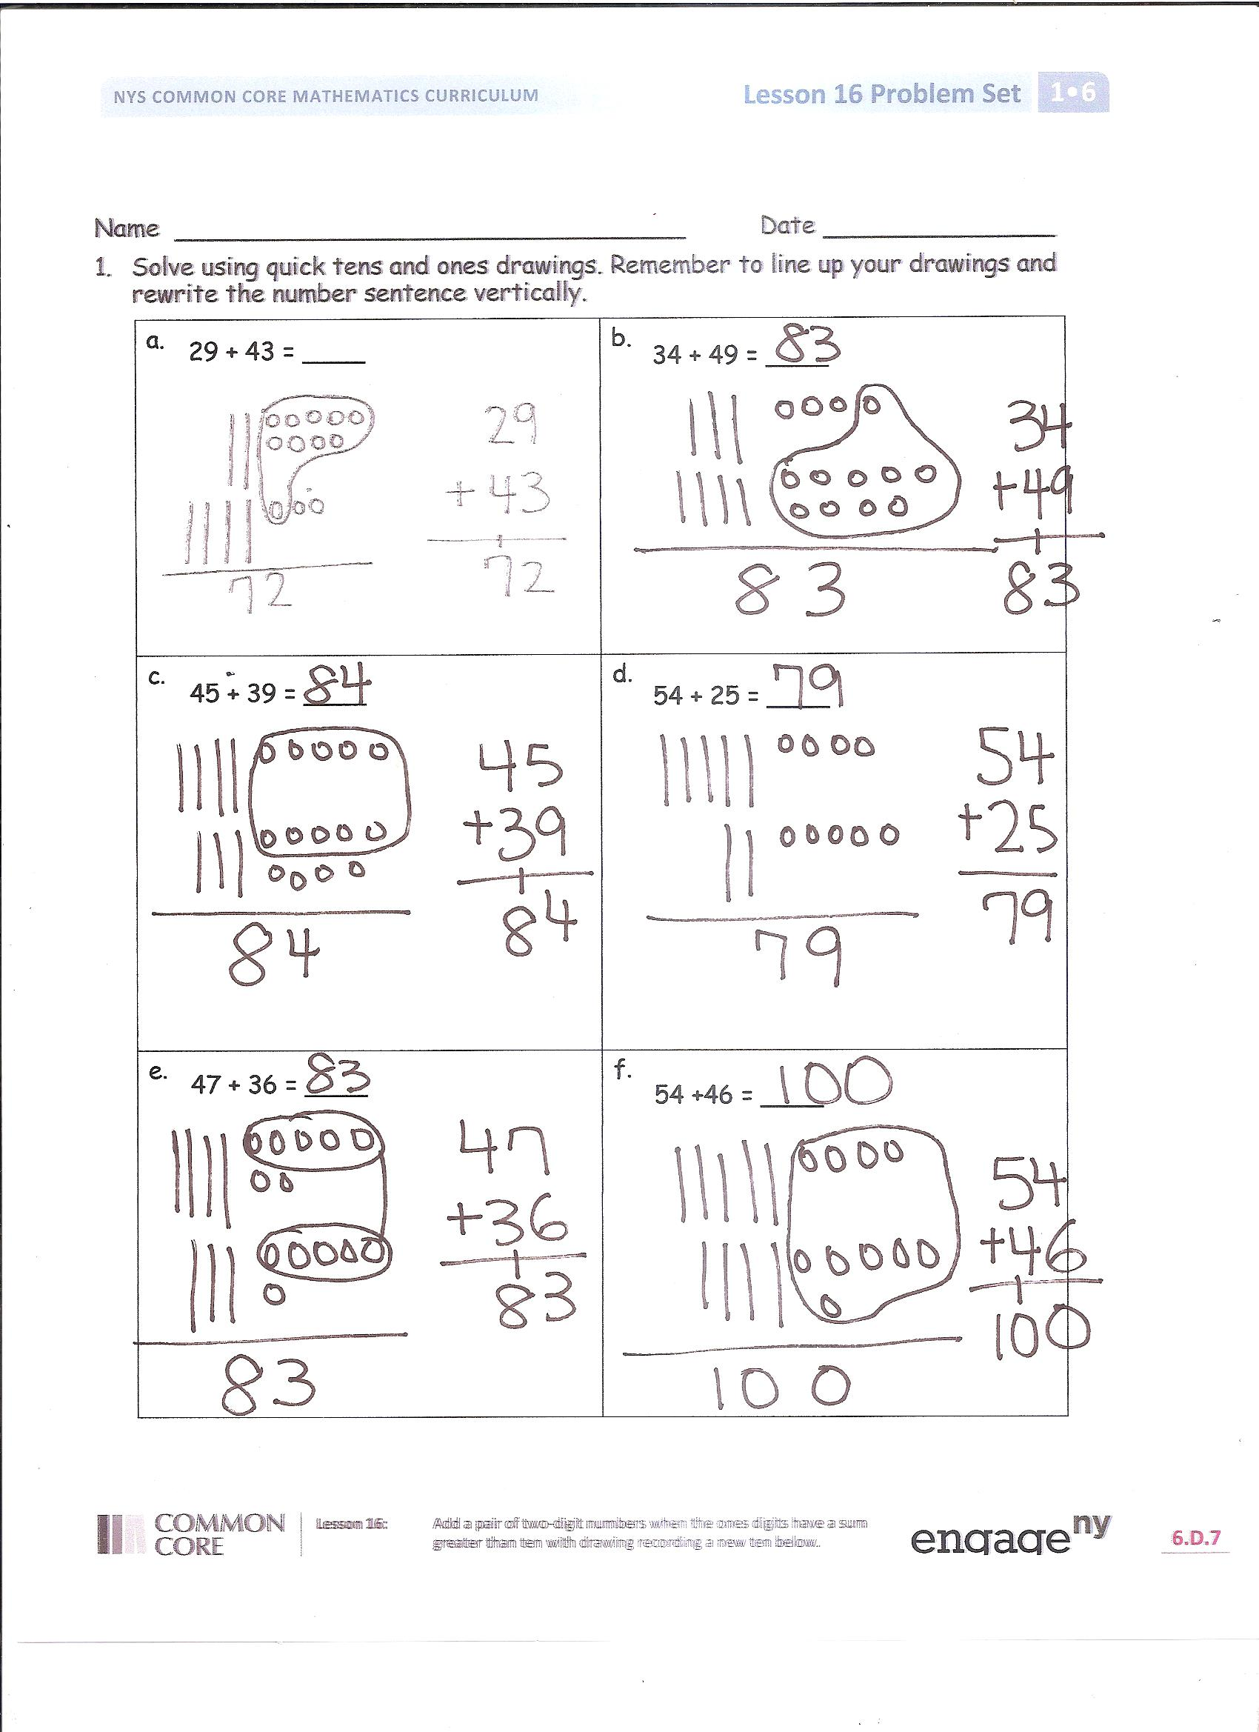
- Teacher draws the quick ten drawings and students represent the drawings with just numbers on the place value chart.
- Students make the quick ten drawings and represent them with just numbers side by side.
Problem Set (10 minutes)
Students should do their personal best to complete the Problem Set within the allotted 10 minutes. For some classes, it may be appropriate to modify the assignment by specifying which problems they work on first. Some problems do not specify a method for solving. Students solve these problems using the RDW approach used for Application Problems.

Student Debrief (10 minutes)
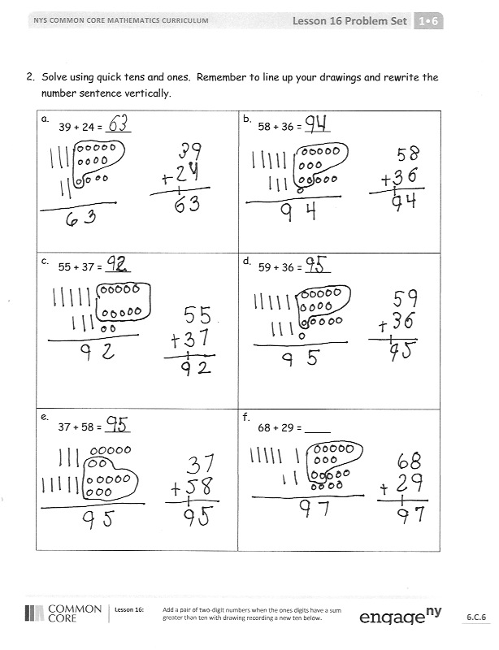
Lesson Objective: Add a pair of two-digit numbers when the ones digits have a sum greater than 10 with drawing. Record the new ten below.
The Student Debrief is intended to invite reflection and active processing of the total lesson experience.
Invite students to review their solutions for the Problem Set. They should check work by comparing answers with a partner before going over answers as a class. Look for misconceptions or misunderstandings that can be addressed in the Debrief. Guide students in a conversation to debrief the Problem Set and process the lesson.
You may choose to use any combination of the questions below to lead the discussion.
- Look at page 1 of your Problem Set. What is different about Problem 1(d) compared to the others?
- Look at Problem 1(f). Why is there a zero in the ones place in the answer when we added some ones together in the problem?
- What new math notation did we use today to communicate how we added precisely?
- Do you prefer to add by lining up your tens and ones or by using the number bond to add?
Exit Ticket (3 minutes)
After the Student Debrief, instruct students to complete the Exit Ticket. A review of their work will help you assess the students’ understanding of the concepts that were presented in the lesson today and plan more effectively for future lessons. You may read the questions aloud to the students.

Name Date

- Solve using quick tens and ones drawings. Remember to line up your drawings and rewrite the number sentence vertically.
a.  29 + 43 = ____ | b.  34 + 49 = ____
c.  45 + 39 = ____ | d.  54 + 25 = ____
e.  47 + 36 = ____ | f.  54 +46 = ____
- Solve using quick tens and ones. Remember to line up your drawings and rewrite the number sentence vertically.
a.  39 + 24 = ____ | b.  58 + 36 = ____
c.  55 + 37 = ____ | d.  59 + 36 = ____
e.  37 + 58 = ____ | f.  68 + 29 = ____

Name Date

- Solve using quick tens and ones. Remember to line up your drawings and rewrite the number sentence vertically.
a.  49 + 26 = ____ | b.  58 + 37 = ____
c.  55 + 37 = ____ | d.  69 + 26 = ____

Name Date
- Solve using quick tens and ones drawings. Remember to line up your drawings and rewrite the number sentence vertically.
a.  39 + 45 = ____ | b.  64 + 28 = ____
c.  47 + 38 = ____ | d.  53 + 27 = ____
e.  38 + 48 = ____ | f.  53 +45 = ____
- Solve using quick tens and ones. Remember to line up your drawings and rewrite the number sentence vertically.
a.  79 + 14 = ____ | b.  28 + 47 = ____
c.  58 + 33 = ____ | d.  19 + 66 = ____
e.  39 + 59 = ____ | f.  49 + 48 = ____

Recording Tens and Ones Template

