|  |
| --- |
|  |

Lesson 19: Construct and Apply a Sequence of Rigid Motions

Student Outcomes

* Students begin developing the capacity to speak and write articulately using the concept of congruence. This involves being able to repeat the definition of congruence and use it in an accurate and effective way.

Classwork

Opening (20 minutes)

Opening

We have been using the idea of congruence already (but in a casual and unsystematic way). In Grade 8, we introduced and experimented with concepts around congruence through *physical models, transparencies or geometry software.* Specifically, we had to

(1) *Understand that a two-dimensional figure is congruent to another if the second can be obtained from the first by a sequence of rotations, reflections, and translations. And (2) describe a sequence that exhibits the congruence between two congruent figures*. (8.G.A.2)

As with so many other concepts in high school Geometry, congruence is familiar, but we now study it with greater precision and focus on the language with which we discuss it.

Let us recall some facts related to congruence that appeared previously in this unit.

1. We observed that rotations, translations, and reflections—and thus all rigid motions—preserve the lengths of segments and the measures of angles. We think of two segments (respectively, angles) as the *same* in an important respect if they have the same length (respectively, degree measure), and thus, sameness of these objects relating to measure is well characterized by the existence of a rigid motion mapping one thing to another. Defining *congruence* by means of rigid motions extends this notion of sameness to arbitrary figures, while clarifying the meaning in an articulate way.
2. We noted that a symmetry is a rigid motion that carries a figure to itself.

So how do these facts about rigid motions and symmetry relate to congruence? We define two figures in the plane as congruent if there exists a finite composition of basic rigid motions that maps one figure onto the other.

It might seem easy to equate two figures being congruent to having same size same shape. The phrase “same size and same shape” has intuitive meaning and helps to paint a mental picture, but is not a definition. As in a court of law, to establish guilt it is not enough to point out that the defendant looks like a sneaky, unsavory type. We need to point to exact pieces of evidence concerning the specific charges. It is also not enough that the defendant did something bad. It must be a violation of a specific law. Same size, same shape is on the level of, “He looks like a sneaky, bad guy who deserves to be in jail.”

It is also not enough to say that they are alike in all respects except position in the plane. We are saying that there is some particular rigid motion that carries one to another. Almost always, when we use congruence in an explanation or proof, we need to refer to the rigid motion. To show that two figures are congruent, we only need to show that there is a transformation that maps one directly onto the other. However, once we know that there is a transformation, then we know that there are actually many such transformations and it can be useful to consider more than one. We see this when discussing the symmetries of a figure. A symmetry is nothing other than a congruence of an object with itself.   
A figure may have many different rigid motions that map it onto itself. For example, there are six different rigid motions that take one equilateral triangle with side length 1 to another such triangle. Whenever this occurs, it is because of a symmetry in the objects being compared.

Lastly, we discuss the relationship between *congruence* and *correspondence*. A correspondence between two figures is a function from the parts of one figure to the parts of the other, with no requirements concerning same measure or existence of rigid motions. If we have rigid motion that takes one figure to another, then we have a correspondence between the parts. For example, if the first figure contains segment , then the second includes a corresponding segment . But we do not need to have a congruence to have a correspondence. We might list the parts of one figure and pair them with the parts of another. With two triangles, we might match vertex to vertex. Then the sides and angles in the first have corresponding parts in the second. But being able to set up a correspondence like this does not mean that there is a rigid motion that produces it. The sides of the first might be paired with sides of different length in the second. Correspondence in this sense is important in triangle similarity.

Discussion/Examples (20 minutes)

Discussion

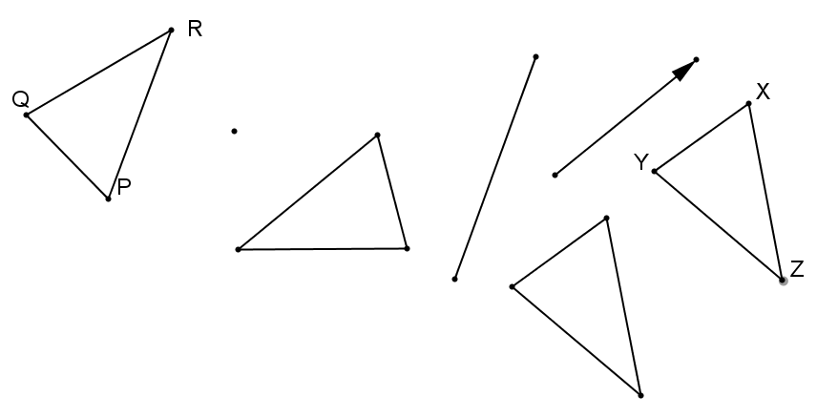

RD,120°

EF

D

F

E

We now examine a figure being mapped onto another through a composition of rigid motions.

To map to here, we first rotate (), around the point, . Then reflect the image () across . Finally, translate the second image ( ) along the given vector to obtain . Since each transformation is a rigid motion, . We use function notation to describe the composition of the rotation, reflection, and translation:

Notice that (as with all composite functions) the innermost function/transformation (the rotation) is performed first, and the outermost (the translation) last.

Example 1

* + 1. Draw and label a triangle in the space below.
    2. Use your construction tools to apply one of each of the rigid motions we have studied to it in a sequence of your choice.
    3. Use function notation to describe your chosen composition here. Label the resulting image as : _____________________________________
    4. Complete the following sentences: (Some blanks are single words, others are phrases.)

Triangle is *congruent* to because *rigid motions*  map point to point , point to point , and point to point . Rigid motions map segments onto *segments of equal length*  and angles onto *angles of equal measure* .

Example 2

On a separate piece of paper, trace the series of figures in your composition but do NOT include the center of rotation, the line of reflection, or the vector of the applied translation.

Swap papers with a partner and determine the composition of transformations your partner used. Use function   
notation to show the composition of transformations that renders .

Exit Ticket (5 minutes)

Name ___________________________________________________ Date____________________

Lesson 19: Construct and Apply a Sequence of Rigid Motions

Exit Ticket

Assume that the following figures are drawn to scale. Use your understanding of congruence to explain why square and rhombus are not congruent.



Exit Ticket Sample Solutions

Assume that the following figures are drawn to scale. Use your understanding of congruence to explain why square and rhombus are not congruent.

Rigid motions map angles onto angles of equal measure, and the measures of the angles of square are all , whereas the angles of rhombus are not. Therefore, there is no rigid motion that will map square onto rhombus .

Problem Set Sample Solutions

1. Use your understanding of congruence to explain why a triangle cannot be congruent to a quadrilateral.
   1. Why can’t a triangle be congruent to a quadrilateral?

A triangle cannot be congruent to a quadrilateral because there is no rigid motion that takes a figure with three vertices to a figure with four vertices.

* 1. Why can’t an isosceles triangle be congruent to a triangle that is not isosceles?

An isosceles triangle cannot be congruent to a triangle that is not isosceles because rigid motions map segments onto segments of equal length and the lengths of an isosceles triangle differ from those of a triangle that is not isosceles.

1. Use the figures below to answer each question:
   1. . What rigid motion(s) maps onto ? Find two possible solutions.

A rotation about the midpoint of .

A reflection over the line that joins the midpoints of and , followed by another reflection over the line that joins the midpoints of and .

* 1. All of the smaller triangles are congruent to each other. What rigid motion(s) map onto ? Find two possible solutions.

A translation

A rotation about the midpoint of followed by a rotation about the midpoint of .