Lesson 15
Objective: Add a pair of two-digit numbers when the ones digits have a sum greater than 10 with drawing. Recording the total below.

Suggested Lesson Structure
 Application Problem (5 minutes)
 Fluency Practice (10 minutes)
 Concept Development (35 minutes)
 Student Debrief (10 minutes)
Total Time (60 minutes)
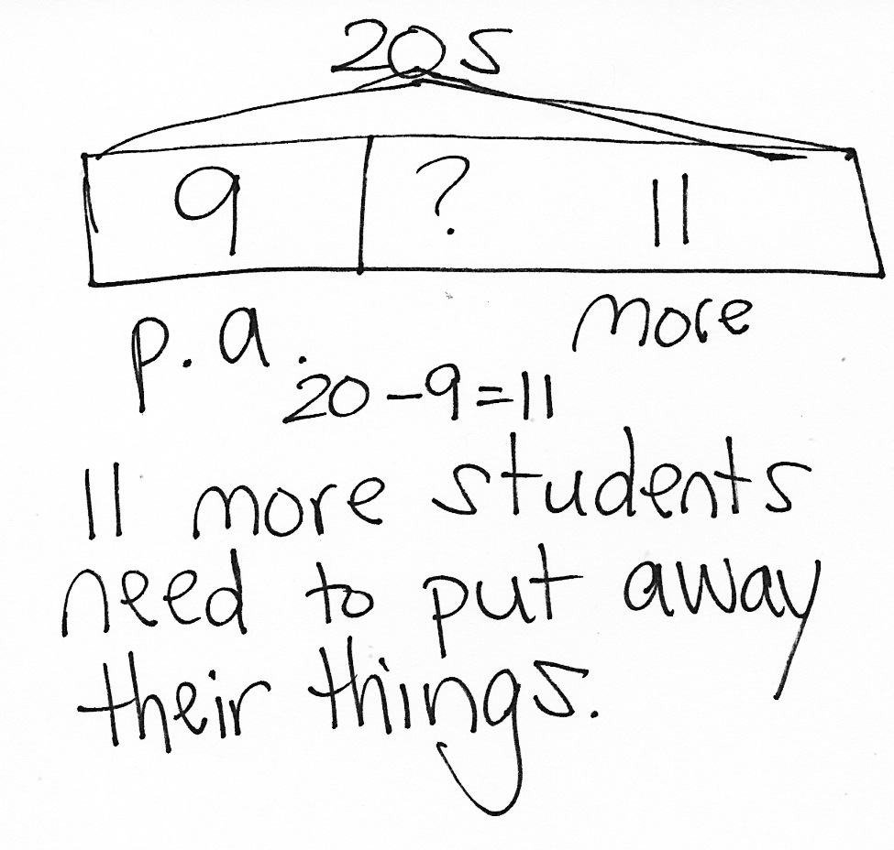
Application Problem (5 minutes)
There are 20 students in class. Nine students put away their backpacks. How many more students still need to put away their backpacks?
Note: This is a take apart with addend unknown problem type that is set in a typical classroom context. Take note of students’ independent choices to solve using addition or subtraction number sentences.
Fluency Practice (10 minutes)
- Core Fluency Differentiated Practice Sets 1.OA.6 (5 minutes)
- Take Out Ones 1.OA.6, 1.NBT.4 (5 minutes)
Core Fluency Differentiated Practice Sets (5 minutes)
Materials: (S) Core Fluency Practice Sets from G1−M6−Lesson 1
Note: Give the appropriate Practice Set to each student. Help students become aware of their improvement. After students complete today’s Practice Sets, ask them to stand if they tried a new level today or improved their score from the previous day. Consider having students clap once for each person standing to celebrate improvement.
Students complete as many problems as they can in 90 seconds. Assign a counting pattern and start number for early finishers, or have them practice make ten addition or subtraction on the back of their papers. Collect and correct any Practice Sets completed within the allotted time.
Take Out Ones (5 minutes)
Materials: (S) Personal white boards
Note: Taking out some ones from a two-digit number strengthens students’ ability to apply the make ten strategy when adding two two-digit numbers.
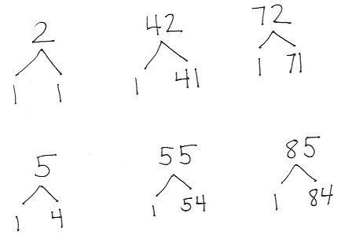
Repeat from the previous lesson. Give students a sequence of three related numbers at a time and have them write number bonds on their personal boards. Challenge early finishers to think of additional related number bonds for each sequence. Suggested sequence:
- Take out 1: 2, 42, 72; 5, 55, 85.
- Take out 2: 7, 47, 67; 9, 69, 99.
- Take out 3: 8, 58, 78; 7, 67, 97, 107.
- Take out 4: 6, 46, 86, 106; 9, 79, 109, 119.
Concept Development (35 minutes)
Materials: (T) 10 ten-sticks (5 red, 5 yellow) (S) 5 ten-sticks, personal white board, place value chart (from G1−M6−Lesson 3)
Students sit in the meeting area with their materials in a semi-circle formation.
T: (Write 59 + 34 = ___.) I want to show this problem with the ten-sticks. What is the total number of tens in the first addend?
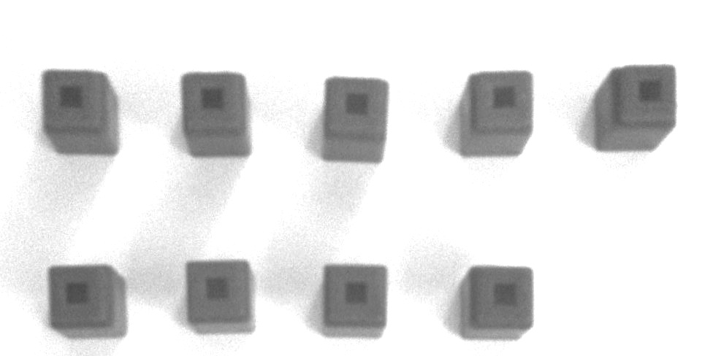
S: 5 tens.
T: (Project 5 ten-sticks onto the white board.) How many ones are in 59?
S: 9 ones.
T: (Project 9 cubes arranged in a 5-group formation shown to the right.)

NOTES ON
MULTIPLE MEANS OF REPRESENTATION:
Support students who may have difficulty lining up their numbers to add vertically. These students may benefit from more concrete or pictorial supports while adding. Have them use the place value chart more regularly until they are able to line up the digits independently.

T: How many tens are in 34?
S: 3 tens.
T: Will we be adding 3 tens to the ones or to the tens?
S: To the tens.
T: (Vertically align 3 ten-sticks to the 5 ten-sticks.) How many ones are in 34?
S: 4 ones.
T: We should add them to?
S: The ones!

T: (Vertically align 3 ones to 9 ones as shown.) Our cubes are arranged so we are ready to add. What is 9 ones and 4 ones? Turn and talk to your partner about what I can do with the ones.
S: 13 ones. 9 needs 1 more to make ten. Take 1 from the 4. Now we have 10 and 3.
T: (Group the 9 and 1 cube on the board.) Now that we made a new ten, how many ones do we still have?
S: 3 ones.
T: (Write 3 in the ones place.) How many tens do we have now? Explain your thinking to your partner.
S: 9 tens. 5 tens and 3 tens is 8 tens. We also made a new ten when we added 9 and 3, so that makes 9 tens altogether.
T: (Write 9 in the tens place.) So, what is 59 + 34? Say the number sentence.
S: 59 + 34 = 93!
Repeat the process using the following sequence:
- 49 + 35

NOTES ON
MULTIPLE MEANS OF REPRESENTATION:
Students demonstrate a true understanding of math concepts when they make connections and apply them in a variety of situations. By scaffolding questioning you guide connections, analysis, and mastery in your students.

- 43 + 36
- 38 + 47
- 17 + 65
- 38 + 52
- 38 + 62
Beginning at 17 + 65, have students make quick ten drawings to show their work.
T: (Write 17 + 65 = ___.) Make a quick ten drawing to show the first addend.
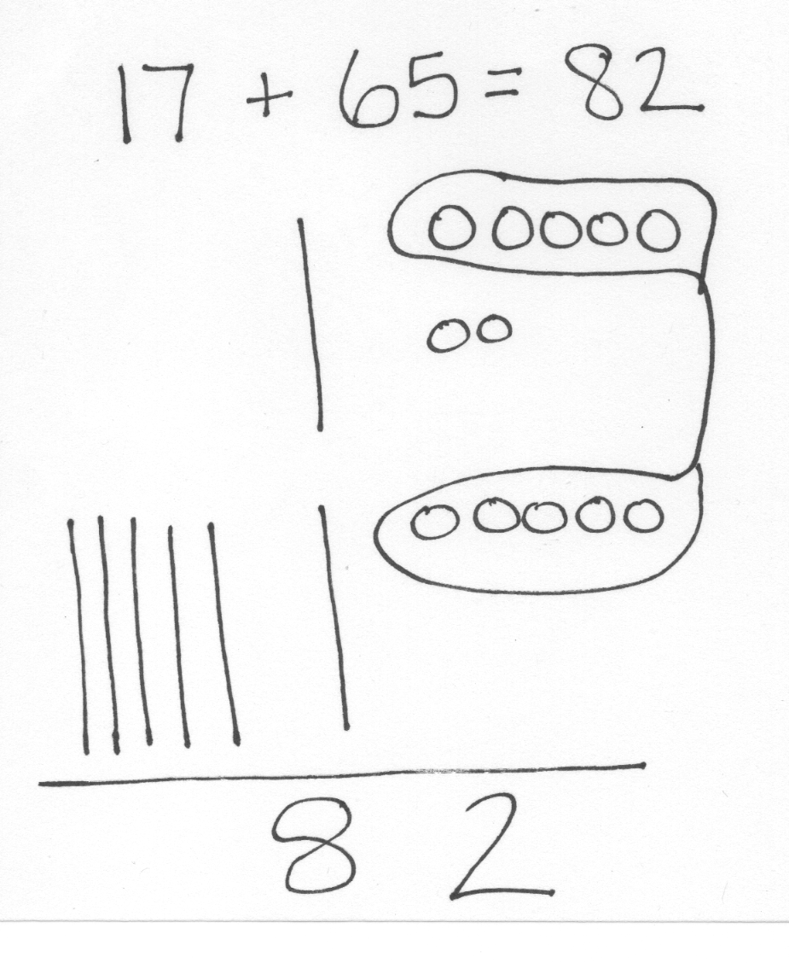
S: (Draw 1 quick ten and 7 ones.
T: (Circulate and make sure the students arrange their 7 circles in 5-groups.)
T: Let’s get ready to draw 65. Where should we draw the 6 quick tens?
S: Under the tens, right below the 1 ten from 17.
T: Where should we draw the 5 ones?
S: Under the ones, right below the 7 ones from 17.
T: Draw 65 and solve. (Circulate and support students as needed.)

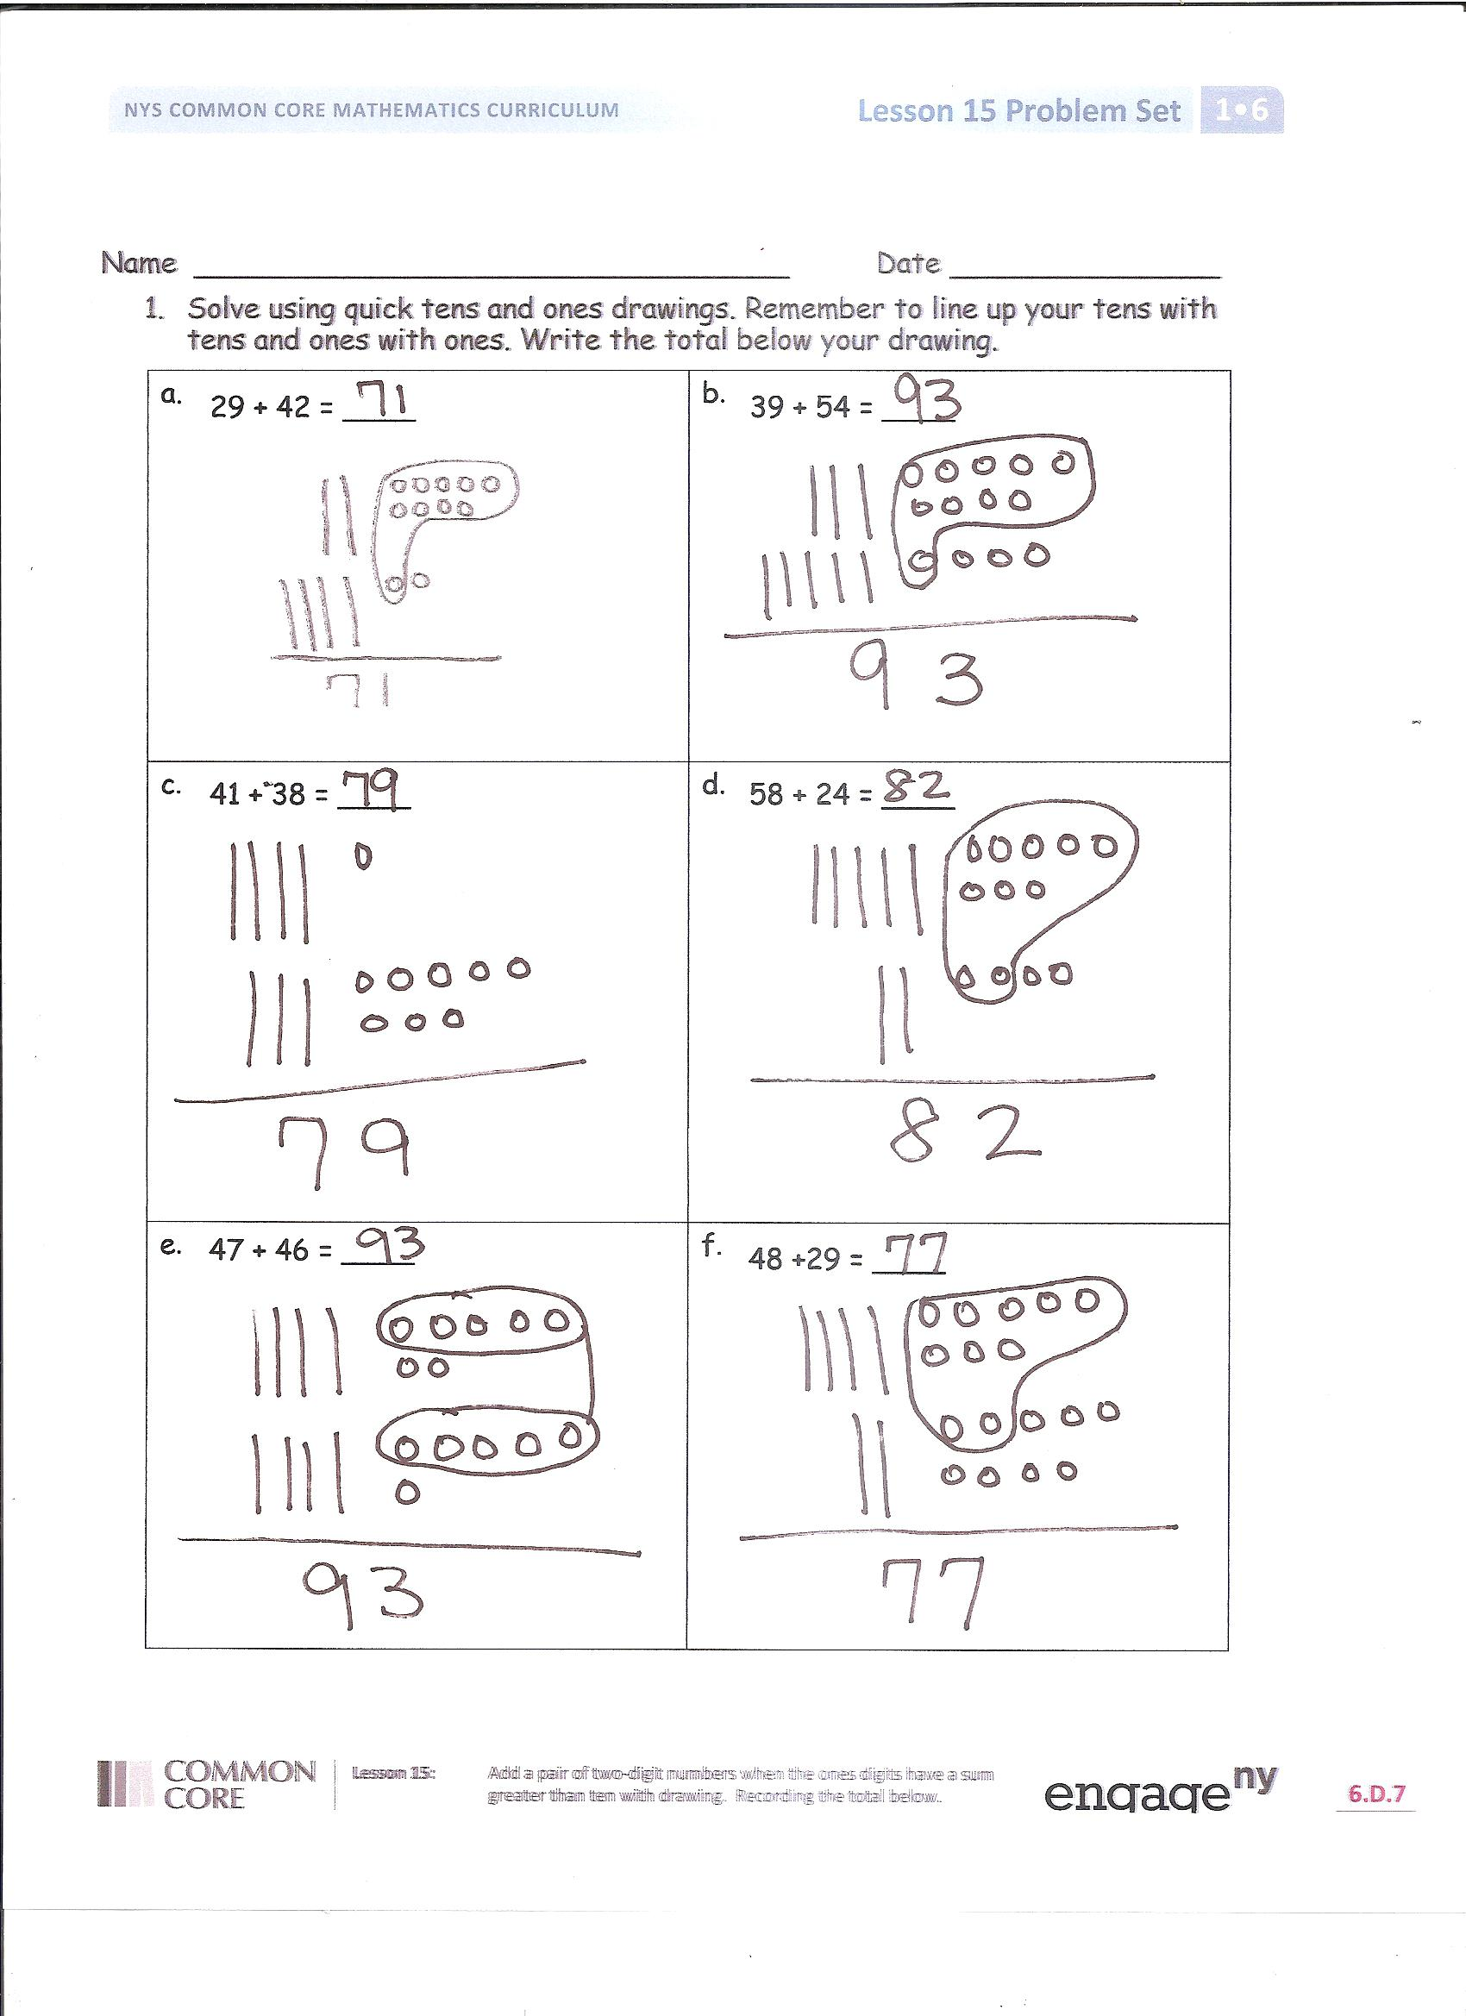
Problem Set (10 minutes)
Students should do their personal best to complete the Problem Set within the allotted 10 minutes. For some classes, it may be appropriate to modify the assignment by specifying which problems they work on first. Some problems do not specify a method for solving. Students solve these problems using the RDW approach used for Application Problems.
Student Debrief (10 minutes)
Lesson Objective: Add a pair of two-digit numbers when the ones digits have a sum greater than 10 with drawing. Recording the total below.
The Student Debrief is intended to invite reflection and active processing of the total lesson experience.
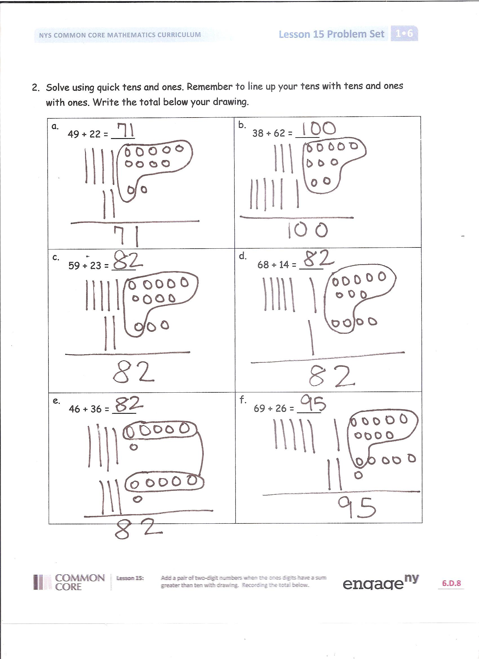
Invite students to review their solutions for the Problem Set. They should check work by comparing answers with a partner before going over answers as a class. Look for misconceptions or misunderstandings that can be addressed in the Debrief. Guide students in a conversation to debrief the Problem Set and process the lesson.
You may choose to use any combination of the questions below to lead the discussion.
- Look at Problems 2(c), 2(d), and 2(e). How can they have the same answer but different numbers?
- Look at Problem 1(b) or 1(d). Why is it more efficient to add the ones first instead of the tens?
- How does lining up the ones and tens help us with adding?
- How is lining up the ones and tens similar and different than using the make ten strategy to add?
- Which is easier for you? Adding by lining up our ones and tens or using the number bonds? Explain your thinking.
- How did the today’s fluency activity help you solve today’s addition problems?
Exit Ticket (3 minutes)
After the Student Debrief, instruct students to complete the Exit Ticket. A review of their work will help you assess the students’ understanding of the concepts that were presented in the lesson today and plan more effectively for future lessons. You may read the questions aloud to the students.

Name Date

- Solve using quick tens and ones drawings. Remember to line up your tens with tens and ones with ones. Write the total below your drawing.
a.  29 + 42 = ____ | b.  39 + 54 = ____
c.  41 + 38 = ____  47 + 46 = ____ | d.  58 + 24 = ____
e. | f.  48 +29 = ____
- Solve using quick tens and ones. Remember to line up your tens with tens and ones with ones. Write the total below your drawing.
a.  49 + 22 = ____ | b.  38 + 62 = ____
c. | d.  68 + 14 = ____  59 + 23 = ____
e.  46 + 36 = ____ | f.  69 + 26 = ____

Name Date

- Solve using quick tens and ones drawings. Remember to line up your drawings and write the total below your drawing.
a.  49 + 34 = ____ | b.  57 + 36 = ____

Name Date

- Solve using quick tens and ones drawings. Remember to line up your tens with tens and ones with ones. Write the total below your drawing.
a.  39 + 42 = ____ | b.  48 + 36 = ____
c.  31 + 48 = ____  57 + 39 = ____ | d.  47 + 34 = ____
e. | f.  58 +27 = ____
- Solve using quick tens and ones. Remember to line up your tens with tens and ones with ones. Write the total below your drawing.
a.  59 + 25 = ____ | b.  48 + 42 = ____
c. | d.  78 + 14 = ____  39 + 53 = ____
e.  57 + 25 = ____ | f.  69 + 27 = ____

