Lesson 14
Objective: Add a pair of two-digit numbers when the ones digits have a sum greater than 10 using decomposition.

Suggested Lesson Structure
 Application Problem (5 minutes)
 Fluency Practice (13 minutes)
 Concept Development (32 minutes)
 Student Debrief (10 minutes)
Total Time (60 minutes)
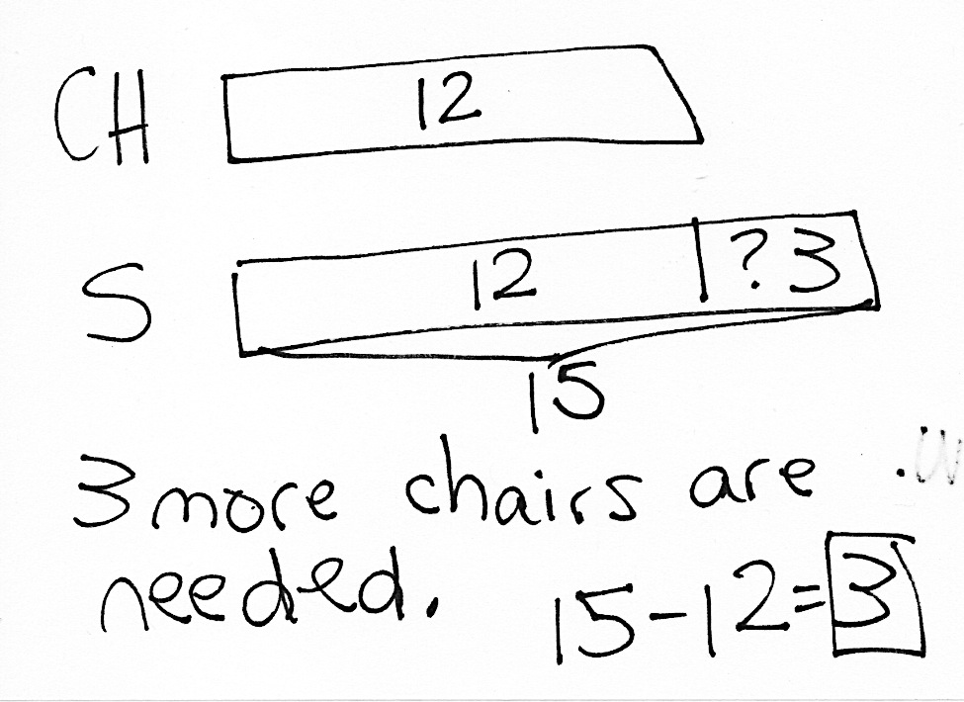Application Problem (5 minutes)
There are 12 chairs at the lunch table and 15 students. How many more chairs are needed so that every student has a chair?
Note: Today’s problem is a comparison with difference unknown problem type. Students who have struggled with comparison problems may successfully solve this common real life problem. Before moving on to Fluency Practice, have students briefly discuss the solution.
Fluency Practice (13 minutes)
- Core Fluency Differentiated Practice Sets 1.OA.6 (5 minutes)
- Add Tens 1.NBT.4 (3 minutes)
- Take Out Ones 1.OA.6, 1.NBT.4 (5 minutes)
Core Fluency Differentiated Practice Sets (5 minutes)
Materials: (S) Core Fluency Practice Sets from G1−M6−Lesson 1
Note: Give the appropriate Practice Set to each student. Students who completed all questions correctly on their most recent Practice Set should be given the next level of difficulty. All other students should try to improve their scores on their current levels.
Students complete as many problems as they can in 90 seconds. Assign a counting pattern and start number for early finishers, or have them practice make ten addition or subtraction on the back of their papers. Collect and correct any Practice Sets completed within the allotted time.
Add Tens (3 minutes)
Materials: (S) Personal white boards, die per pair of students
Note: This fluency activity reviews adding multiples of 10 to two-digit numbers.
- Partner A writes or draws a number (with quick tens and ones) between 10 and 40 (e.g., 25).
- Partner B rolls the die to determine the number of tens to add (e.g., if she rolls 5, add 5 tens).
- Both partners write the number sentence on their personal boards and check each other’s work (e.g., 25 + 50 = 75).
Take Out Ones (5 minutes)
Materials: (S) Personal white boards
Note: Taking out some ones from a two-digit number strengthens students’ ability to apply the make ten strategy when adding two two-digit numbers.
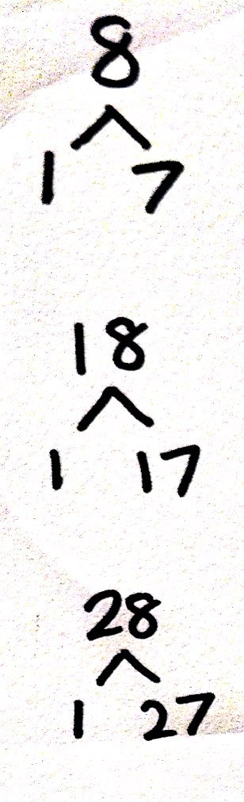
Give students a sequence of three related numbers at a time and have them write number bonds on their personal boards. Challenge early finishers to think of additional related number bonds for each sequence. Suggested sequence:
- Take out 1: 8, 18, 28; 6, 56, 86.
- Take out 2: 5, 15, 25; 7, 37, 97.
- Take out 3: 6, 36, 76; 9, 69, 99, 109.
- Take out 4: 8, 48, 88, 108; 7, 77, 107, 117.
Concept Development (32 minutes)

NOTES ON
MULTIPLE MEANS OF ACTION AND EXPRESSION:
Students may choose how they want to solve problems—with drawings, number bonds, or the arrow way. Students should begin to move away from drawing to the more abstract methods of problem solving. However, not all students will be ready so support students wherever they are in their learning and guide them as they progress.

Materials: (T) Chart paper, document camera if available
(S) personal white boards
Begin today’s lesson with students at their desks or tables with their personal boards.
Similar to the last two days, today’s lesson provides opportunities for students to practice solving two-digit addition problems.
However today, in each set, a string of problems is related to one another, e.g., 56 + 21, 56 + 24, and 56 + 27. For students who need additional support, the movement through the problems from simple to complex can help them choose a solution strategy.
Challenge students who are becoming proficient at solving two-digit addition problems to identify the relationship between each problem and create other strings that would exemplify the same set of relationships. Use their problems in the class if possible.
As in G1–M6– Lessons 12 and 13, invite students to share their method for solving using place value language and explaining why they chose to solve using this method.
Problems 1−6 use easier combinations of ones, as they create sums in the ones place that are equal to or greater than 10.
Problems 7−12 use combinations of ones that are typically more challenging for students.
Problems 1–6 Problems 7–12

NOTES ON
MULTIPLE MEANS OF ACTION AND EXPRESSION:
Continue to challenge advanced students. Change some of the expressions into number sentences with missing addends or give students some word problems to solve with similar numbers.
65 + 15 56 + 28
65 + 16 46 + 28
65 + 19 38 + 56
48 + 33 37 + 57
48 + 53 37 + 47
38 + 63 45 + 37
Below are some of the various methods and explanations that students might share:

I added 20 to 46 first.
I made a ten first.
I added the 4 tens to 2 tens first.

Problem Set (10 minutes)
Students should do their personal best to complete the Problem Set within the allotted 10 minutes. For some classes, it may be appropriate to modify the assignment by specifying which problems they work on first. Some problems do not specify a method for solving. Students solve these problems using the RDW approach used for Application Problems.

Student Debrief (10 minutes)
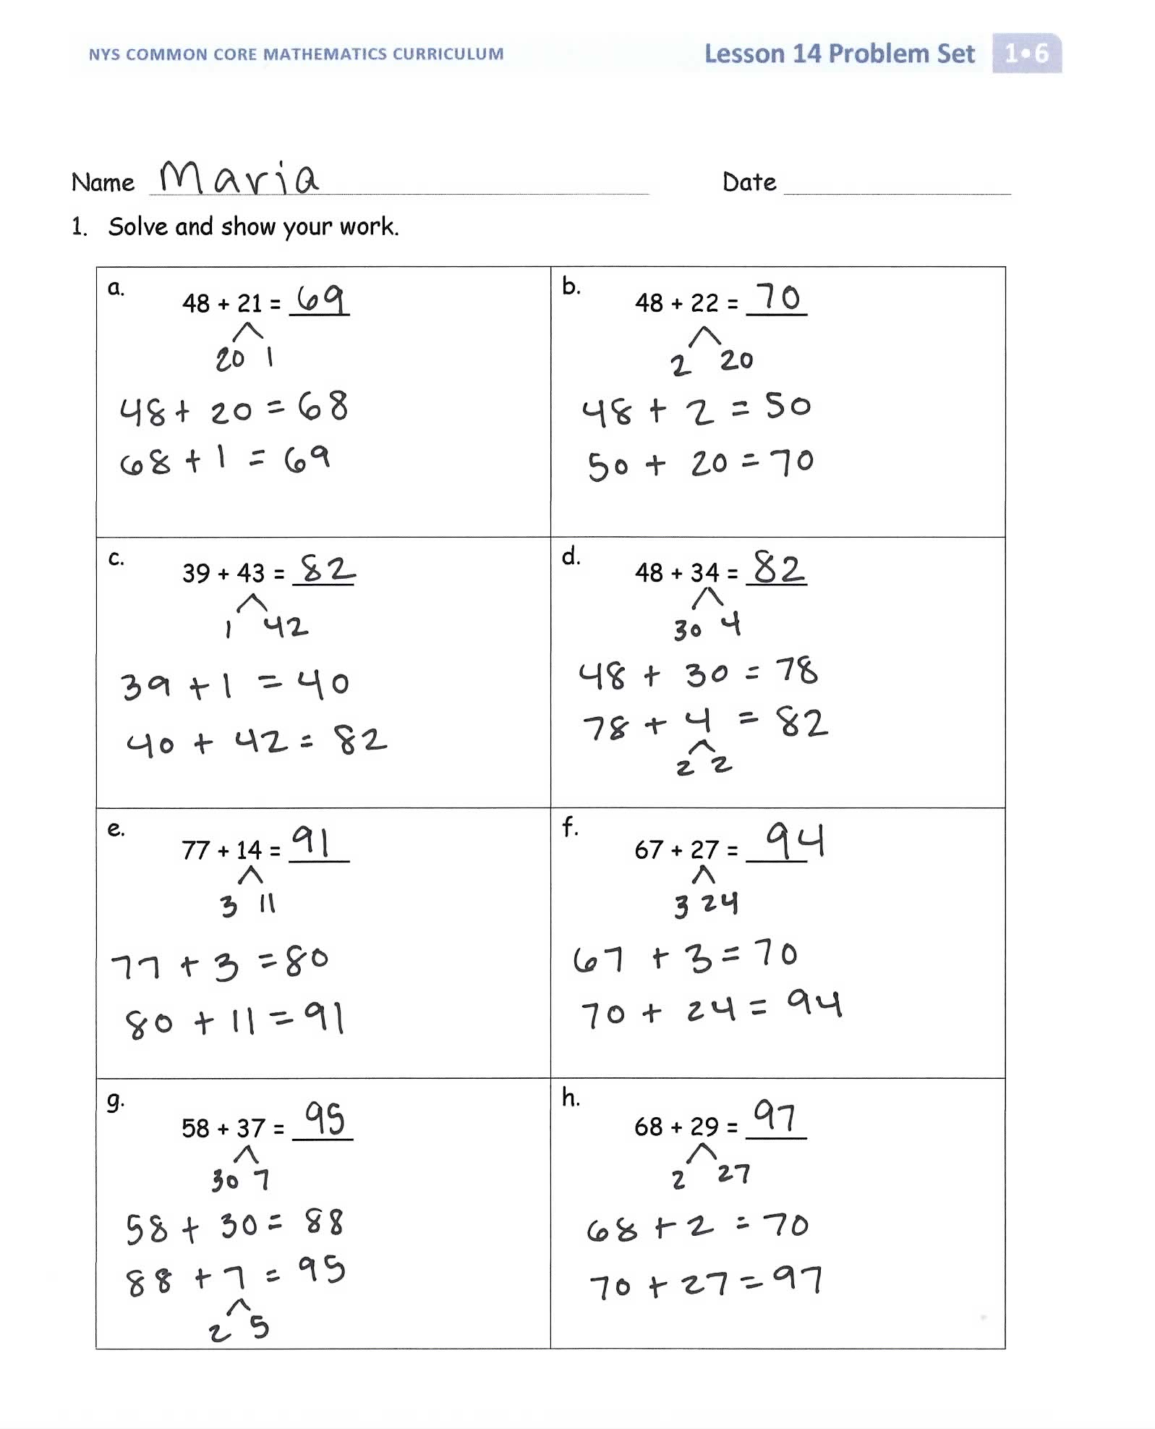
Lesson Objective: Add a pair of two-digit numbers when the ones digits have a sum greater than 10 using decomposition.
The Student Debrief is intended to invite reflection and active processing of the total lesson experience.
Invite students to review their solutions for the Problem Set. They should check work by comparing answers with a partner before going over answers as a class. Look for misconceptions or misunderstandings that can be addressed in the Debrief. Guide students in a conversation to debrief the Problem Set and process the lesson.
You may choose to use any combination of the questions below to lead the discussion.
- Look at Problems 1(a) and 1(b). How can solving 1(a) help you solve 1(b)?
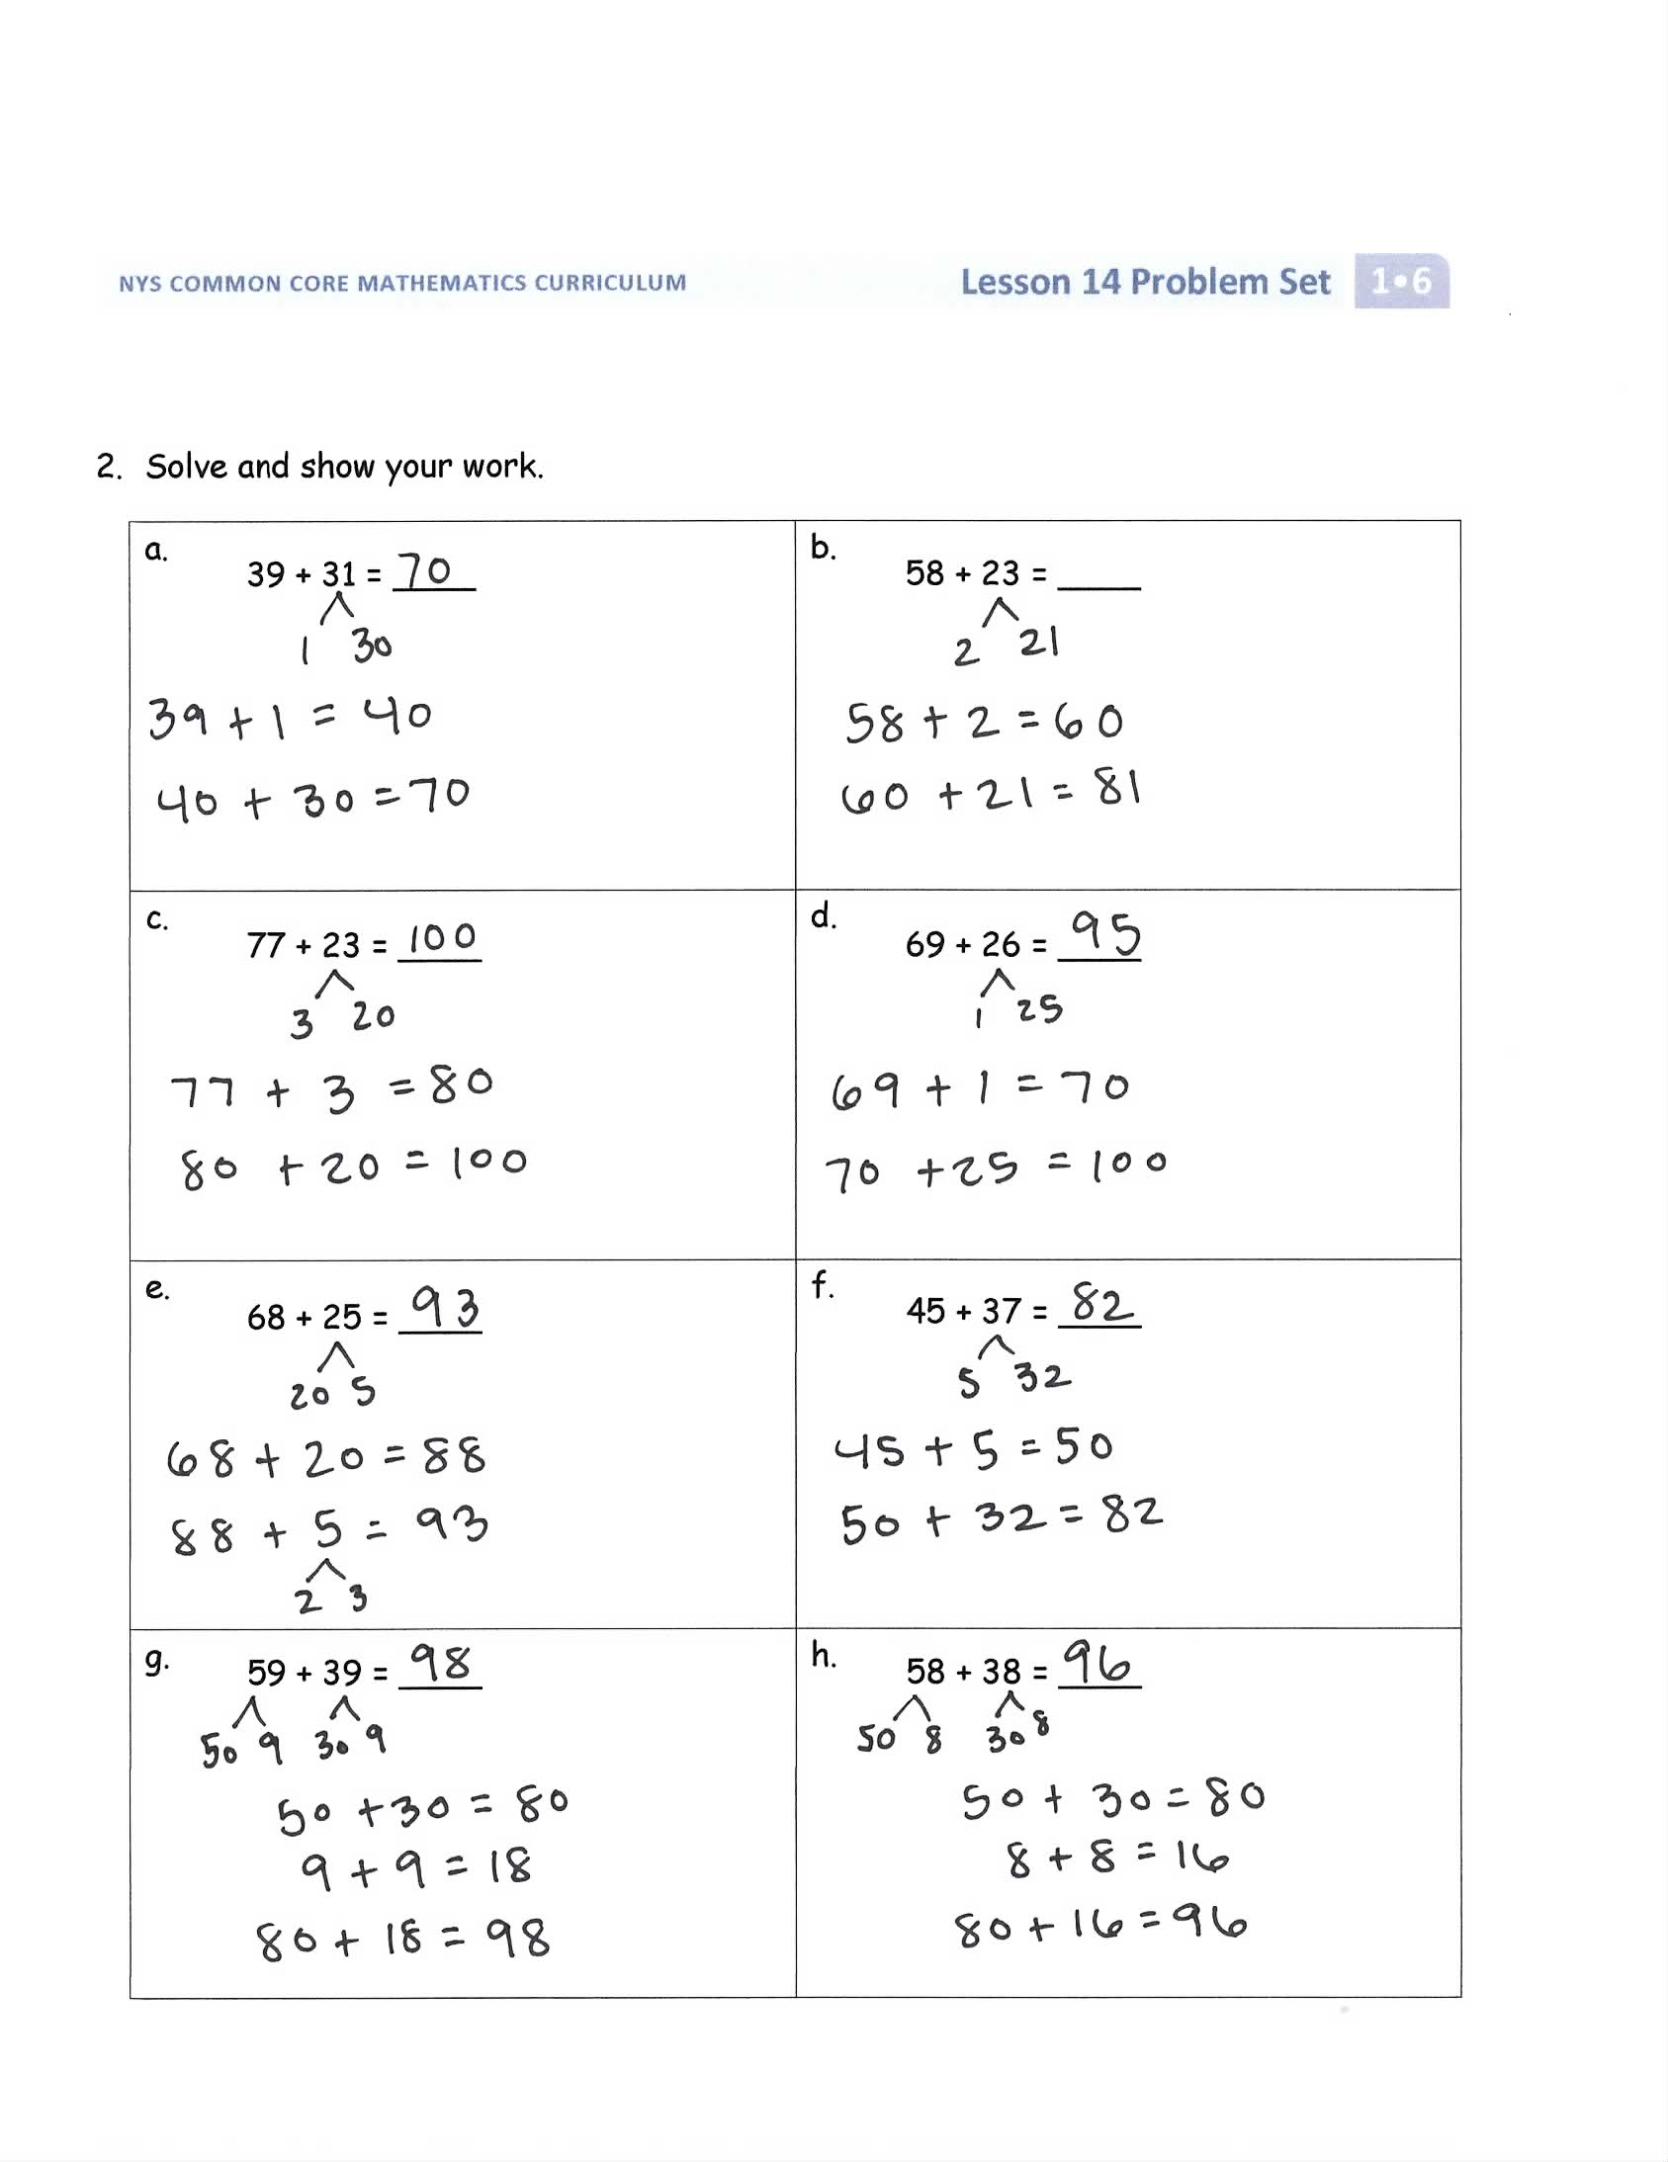
- Look at Problems 2(g) and 2(h). How are they related? How could solving one help you solve the other?
- Think about Take Out Ones in our Fluency Practice today. How did it help you when you were solving the more challenging problems?
Exit Ticket (3 minutes)
After the Student Debrief, instruct students to complete the Exit Ticket. A review of their work will help you assess the students’ understanding of the concepts that were presented in the lesson today and plan more effectively for future lessons. You may read the questions aloud to the students.
Name Date

- Solve and show your work.
a.  48 + 21 = ____ | b.  48 + 22 = ____
c.  39 + 43 = ____ | d.  48 + 34 = ____
e.  77 + 14 = ____ | f.  67 + 27 = ____
g.  58 + 37 = ____ | h.  68 + 29 = ____
- Solve and show your work.
a.  39 + 31 = ____ | b.  58 + 23 = ____
c.  77 + 23 = ____ | d.  69 + 26 = ____
e.  68 + 25 = ____ | f.  45 + 37 = ____
g.  59 + 39 = ____ | h.  58 + 38 = ____

Name Date

- Solve and show your work.
a.  47 + 42 = ____ | b.  78 + 22 = ____
c.
56 + 38 = ____

Name Date

- Solve and show your work.
a.  68 + 21 = ____ | b.  59 + 32 = ____
c.  39 + 44 = ____ | d.  58 + 36 = ____
e.  76 + 17 = ____ | f.  68 + 26 = ____
g.  56 + 39 = ____ | h.  58 + 29 = ____
- Solve and show your work.
a.  39 + 41 = ____ | b.  48 + 43 = ____
c.  87 + 13 = ____ | d.  59 + 25 = ____
e.  65 + 27 = ____ | f.  27 + 67 = ____
g.  49 + 39 = ____ | h.  38 + 58 = ____

