Lesson 13
Objective: Add a pair of two-digit numbers when the ones digits have a sum greater than 10 using decomposition.

Suggested Lesson Structure
 Application Problem (5 minutes)
 Fluency Practice (14 minutes)
 Concept Development (31 minutes)
 Student Debrief (10 minutes)
Total Time (60 minutes)
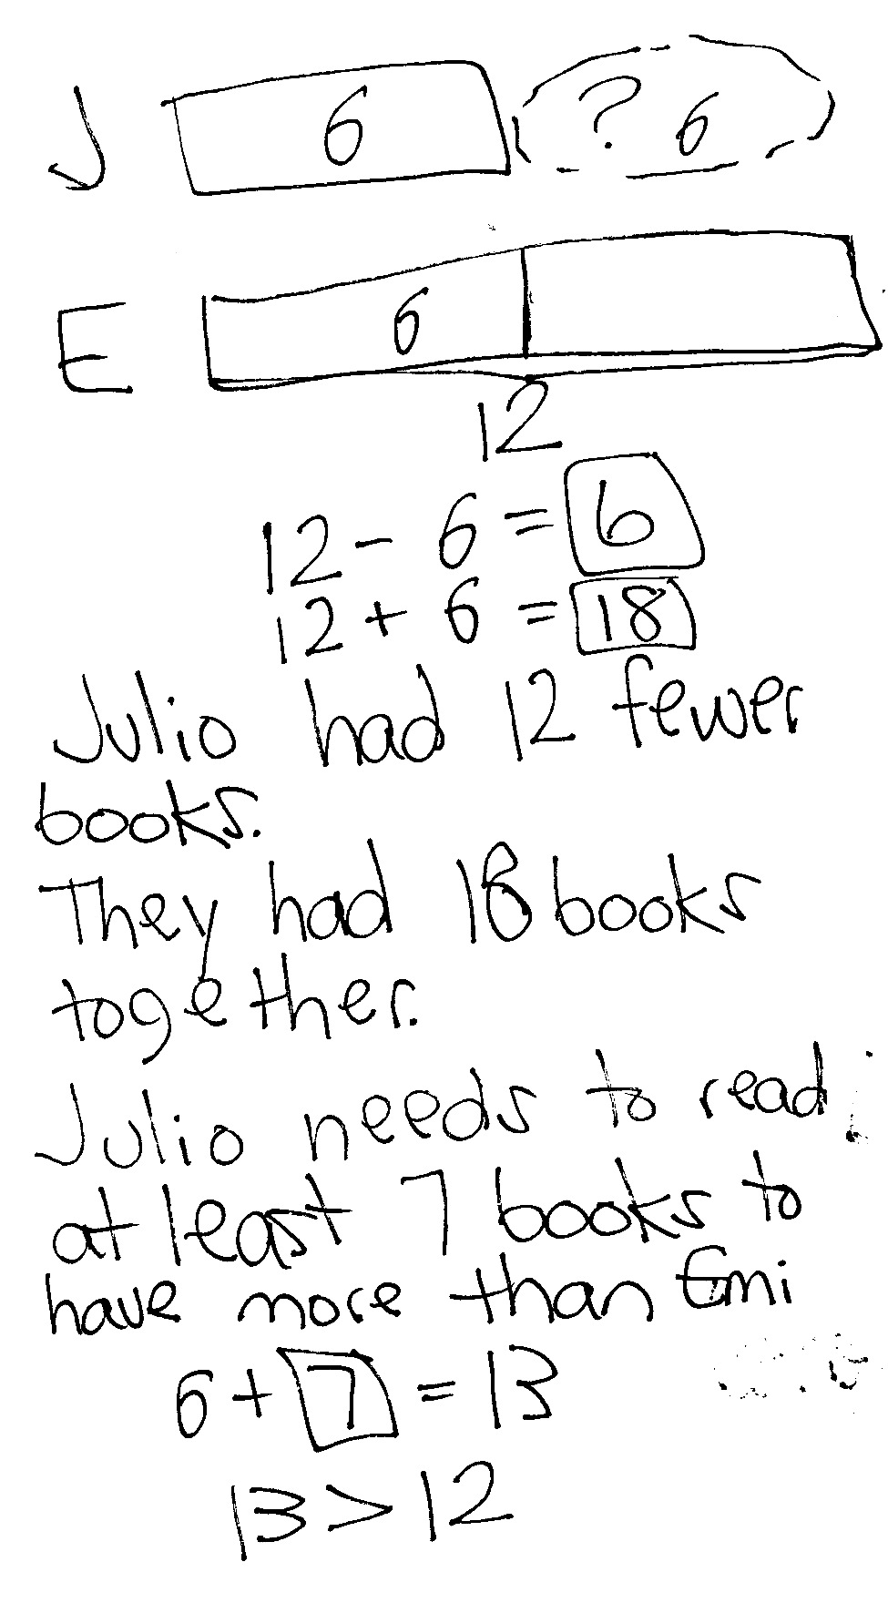Application Problem (5 minutes)
Julio read 6 books this week. Emi read 12 books this week. How many fewer books did Julio read than Emi? How many books did they read in all? How many more books does Julio have to read so that he has read one more book than Emi?
Note: Today’s problem begins with a comparison with difference unknown. Each of the succeeding questions can help students contrast this type of question with the both the put together with result unknown problem type and the add to with change unknown problem type.
Fluency Practice (14 minutes)
- Grade 1 Core Fluency Sprint 1.OA.6 (10 minutes)
- Make Ten Addition with Partners 1.OA.6 (4 minutes)
Grade 1 Core Fluency Sprint (10 minutes)
Materials: (S) Core Fluency Sprint (G1−M5−Lesson 1)
Note: Based on the needs of the class, select a Sprint from yesterday’s materials. There are several possible options available.
- Re-administer the Sprint from the day before.
- Administer the next Sprint in the sequence.
- Differentiate. Administer two different Sprints. Simply have one group do a counting activity on the back of their Sprint while the other Sprint is corrected.
Make Ten Addition with Partners (4 minutes)
Materials: (S) Personal white boards
Note: This fluency activity reviews how to use the Level 3 strategy of making ten to add two single-digit numbers. Reviewing the make ten strategy will prepare students for today’s lesson, in which they will make ten to add two two-digit numbers.
- Assign partners of equal ability.

NOTES ON
MULTIPLE MEANS OF ENGAGEMENT:
Careful selection of pairs for collaborative work is essential to achieving expected outcomes. Some lessons lend themselves to groupings of students with similar skill sets while others work better when students are heterogeneously grouped. Some students would benefit from the opportunity to work independently and share with the teacher or another pair after they have completed the task.

- Partners choose an addend for each other from 1 to 10.
- On their personal boards, students add their numbers to 9, 8, and 7. Remind students to write the two addition sentences they learned in G1–Module 2.
- Partners then exchange boards and check each other’s work.
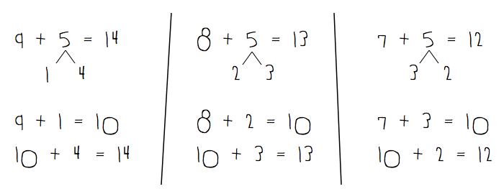

Concept Development (31 minutes)

NOTES ON
MULTIPLE MEANS OF ACTION AND EXPRESSION:
Students may choose how they want to solve problems—with drawings, number bonds, or the arrow way. Students should begin to move away from drawing to the more abstract method of problem solving. However, not all students will be ready to abstractly solve problems, so support students wherever they are in their learning and guide them as they progress.

Materials: (T) Chart paper, document camera (if available)
(S) Personal white boards
Gather students in the meeting area with their materials in a semi-circle formation.
Three sets of problems extend students’ double-digit addition skills from G1–Module 4. Although it may be tempting to review a particular method to solve two-digit addition problems, refrain from doing so. Instead, encourage and remind students of the same tools they used in G1–M6–Lesson 12.
MP.5

After each problem, have students share their solutions. Invite one or two students to explain their strategy for solving. They may redraw their work or display the work using a document camera. Select work that represents a variety of strategies, including decomposing to get to the next ten, adding the tens and then the ones, and adding the ones and then the tens.
MP.5
Encourage students to use place value language to describe how their strategy works. Ask questions such as, “Why did you choose your method?”
Problems 1−4 review work from G1–M4–Lessons 26 and 27 with analogous problems now between 40 and 100.
Problems 5−12 provide a scaffold-less opportunity to add pairs of two-digit numbers.
Problems 1–4 Problems 5–12

NOTES ON
MULTIPLE MEANS OF ACTION AND EXPRESSION:
Continue to challenge advanced students. Change some of the expressions into number sentences with missing addends or give students some word problems to solve with similar numbers.
19 + 11, 59 + 11, 59 + 21 49 + 12
19 + 13, 59 + 13, 59 + 33 59 + 22
18 + 15, 68 + 25 48 + 24
17 + 16, 37 + 56 54 + 48
37 + 37
37 + 46
78 + 22
33 + 67
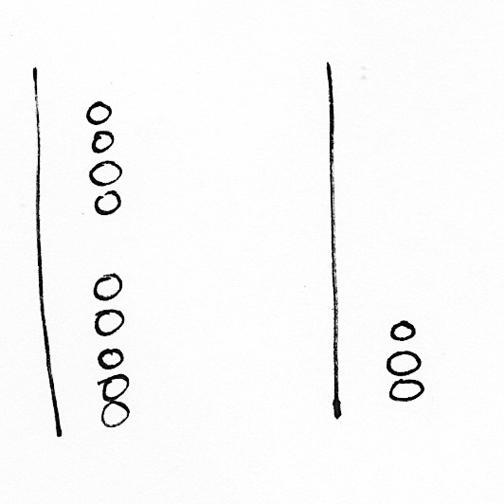
Should students need additional support, the following dialogue presents a more guided approach to Problems 2−4. Problems 1(a), 1(b), and 1(c) practice the work from yesterday’s lesson to segue into today’s objective.
T: (Write 19 + 13 = ___ on the chart.) Use quick tens to show these two numbers. Then solve for the total. (Circulate as students work to assess students’ ability to solve independently and identify common errors.)
T: 19 plus 13 equals?
S: 32!
T: Talk with your partner about how you solved the problem. Try to show your thinking using number bonds with your number sentence. (Circulate as students explain their solution methods and create written notation of their methods.)
T: I heard many of you say you started with 19 and added 10. (Select a student who used this method to show the class. Walk through the steps of breaking apart 13 into 10 and 3. 19 + 10 is 29. Then to add 29 + 3, the student may have broken 3 into 1 and 2, for a total of 32, as shown to the right. If the student’s written notation is appropriate, have her share her written notation. If it is not, then model the number sentence and number bond work as the student describes her process.)
T: 19 is so close to 20. You are all very good at adding multiples of ten. How could I break 13 to make the next ten and then add the rest? How much more does 19 need to make 20?
S: 1 more!
T: I would break 13 into 1 and? (Begin written notation to show the bond below 13.)
S: 12!
T: Our first number sentence would be 19 + 1 is?
S: 20.
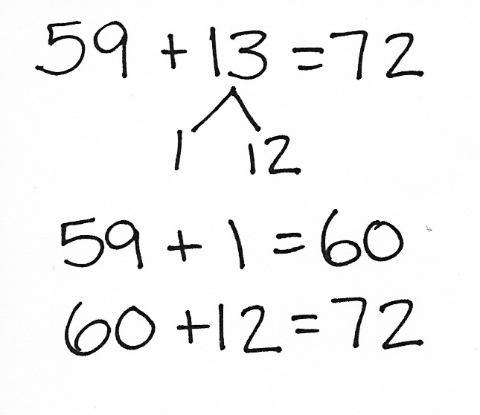
T: Then we would have?
S: 20 + 12 = 32.
Repeat the process with the analogous problem of 59 + 13 and then with 59 + 33. As you move on to Problems 3 and 4, consider asking students to take on more of the demonstrations and explanations.
Problem Set (10 minutes)
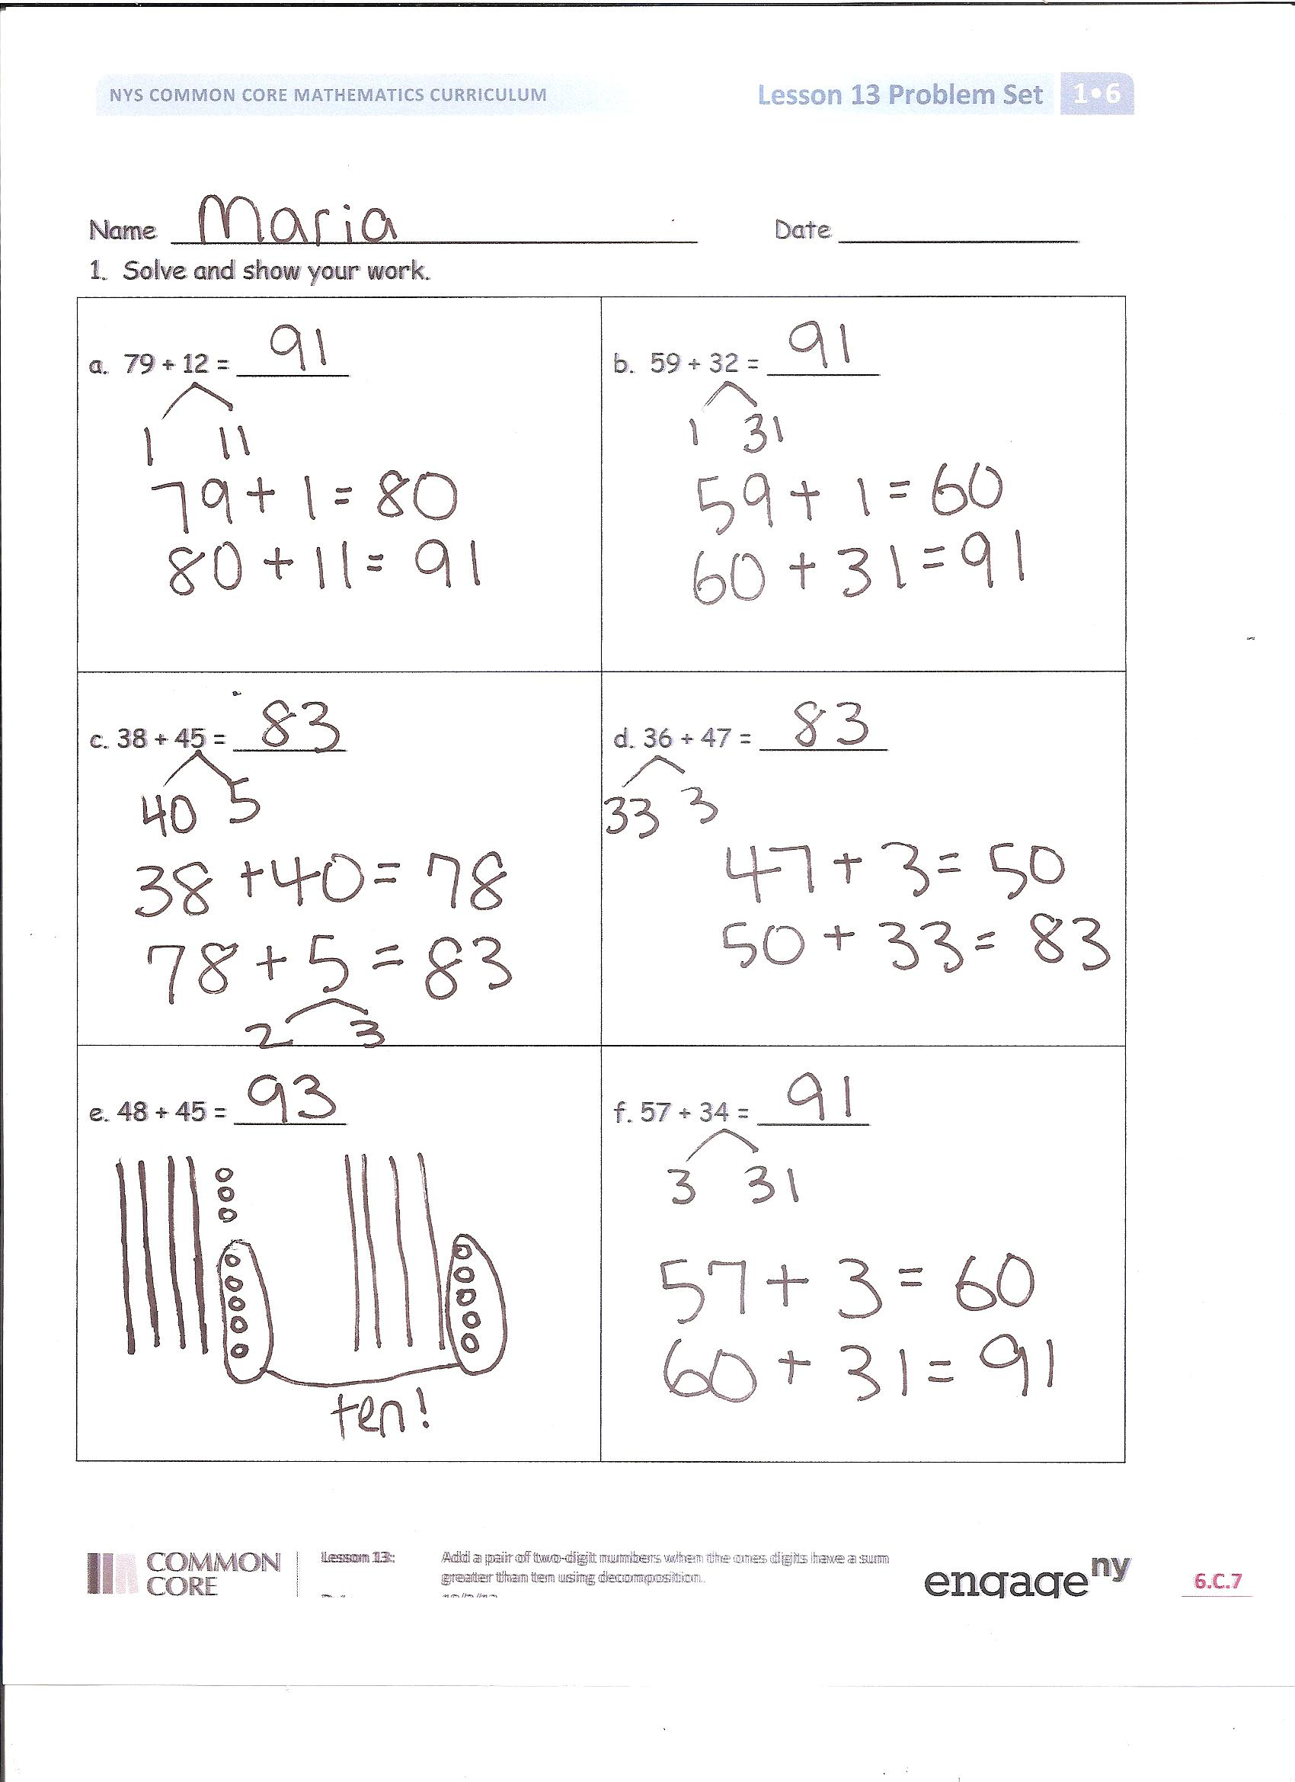
Students should do their personal best to complete the Problem Set within the allotted 10 minutes. For some classes, it may be appropriate to modify the assignment by specifying which problems they work on first. Some problems do not specify a method for solving. Students solve these problems using the RDW approach used for Application Problems.
Student Debrief (10 minutes)
Lesson Objective: Add a pair of two-digit numbers when the ones digits have a sum greater than 10 using decomposition.
The Student Debrief is intended to invite reflection and active processing of the total lesson experience.
Invite students to review their solutions for the Problem Set. They should check work by comparing answers with a partner before going over answers as a class. Look for misconceptions or misunderstandings that can be addressed in the Debrief. Guide students in a conversation to debrief the Problem Set and process the lesson.
You may choose to use any combination of the questions below to lead the discussion.
- Which problem was the easiest for you to solve? What made it easy for you?
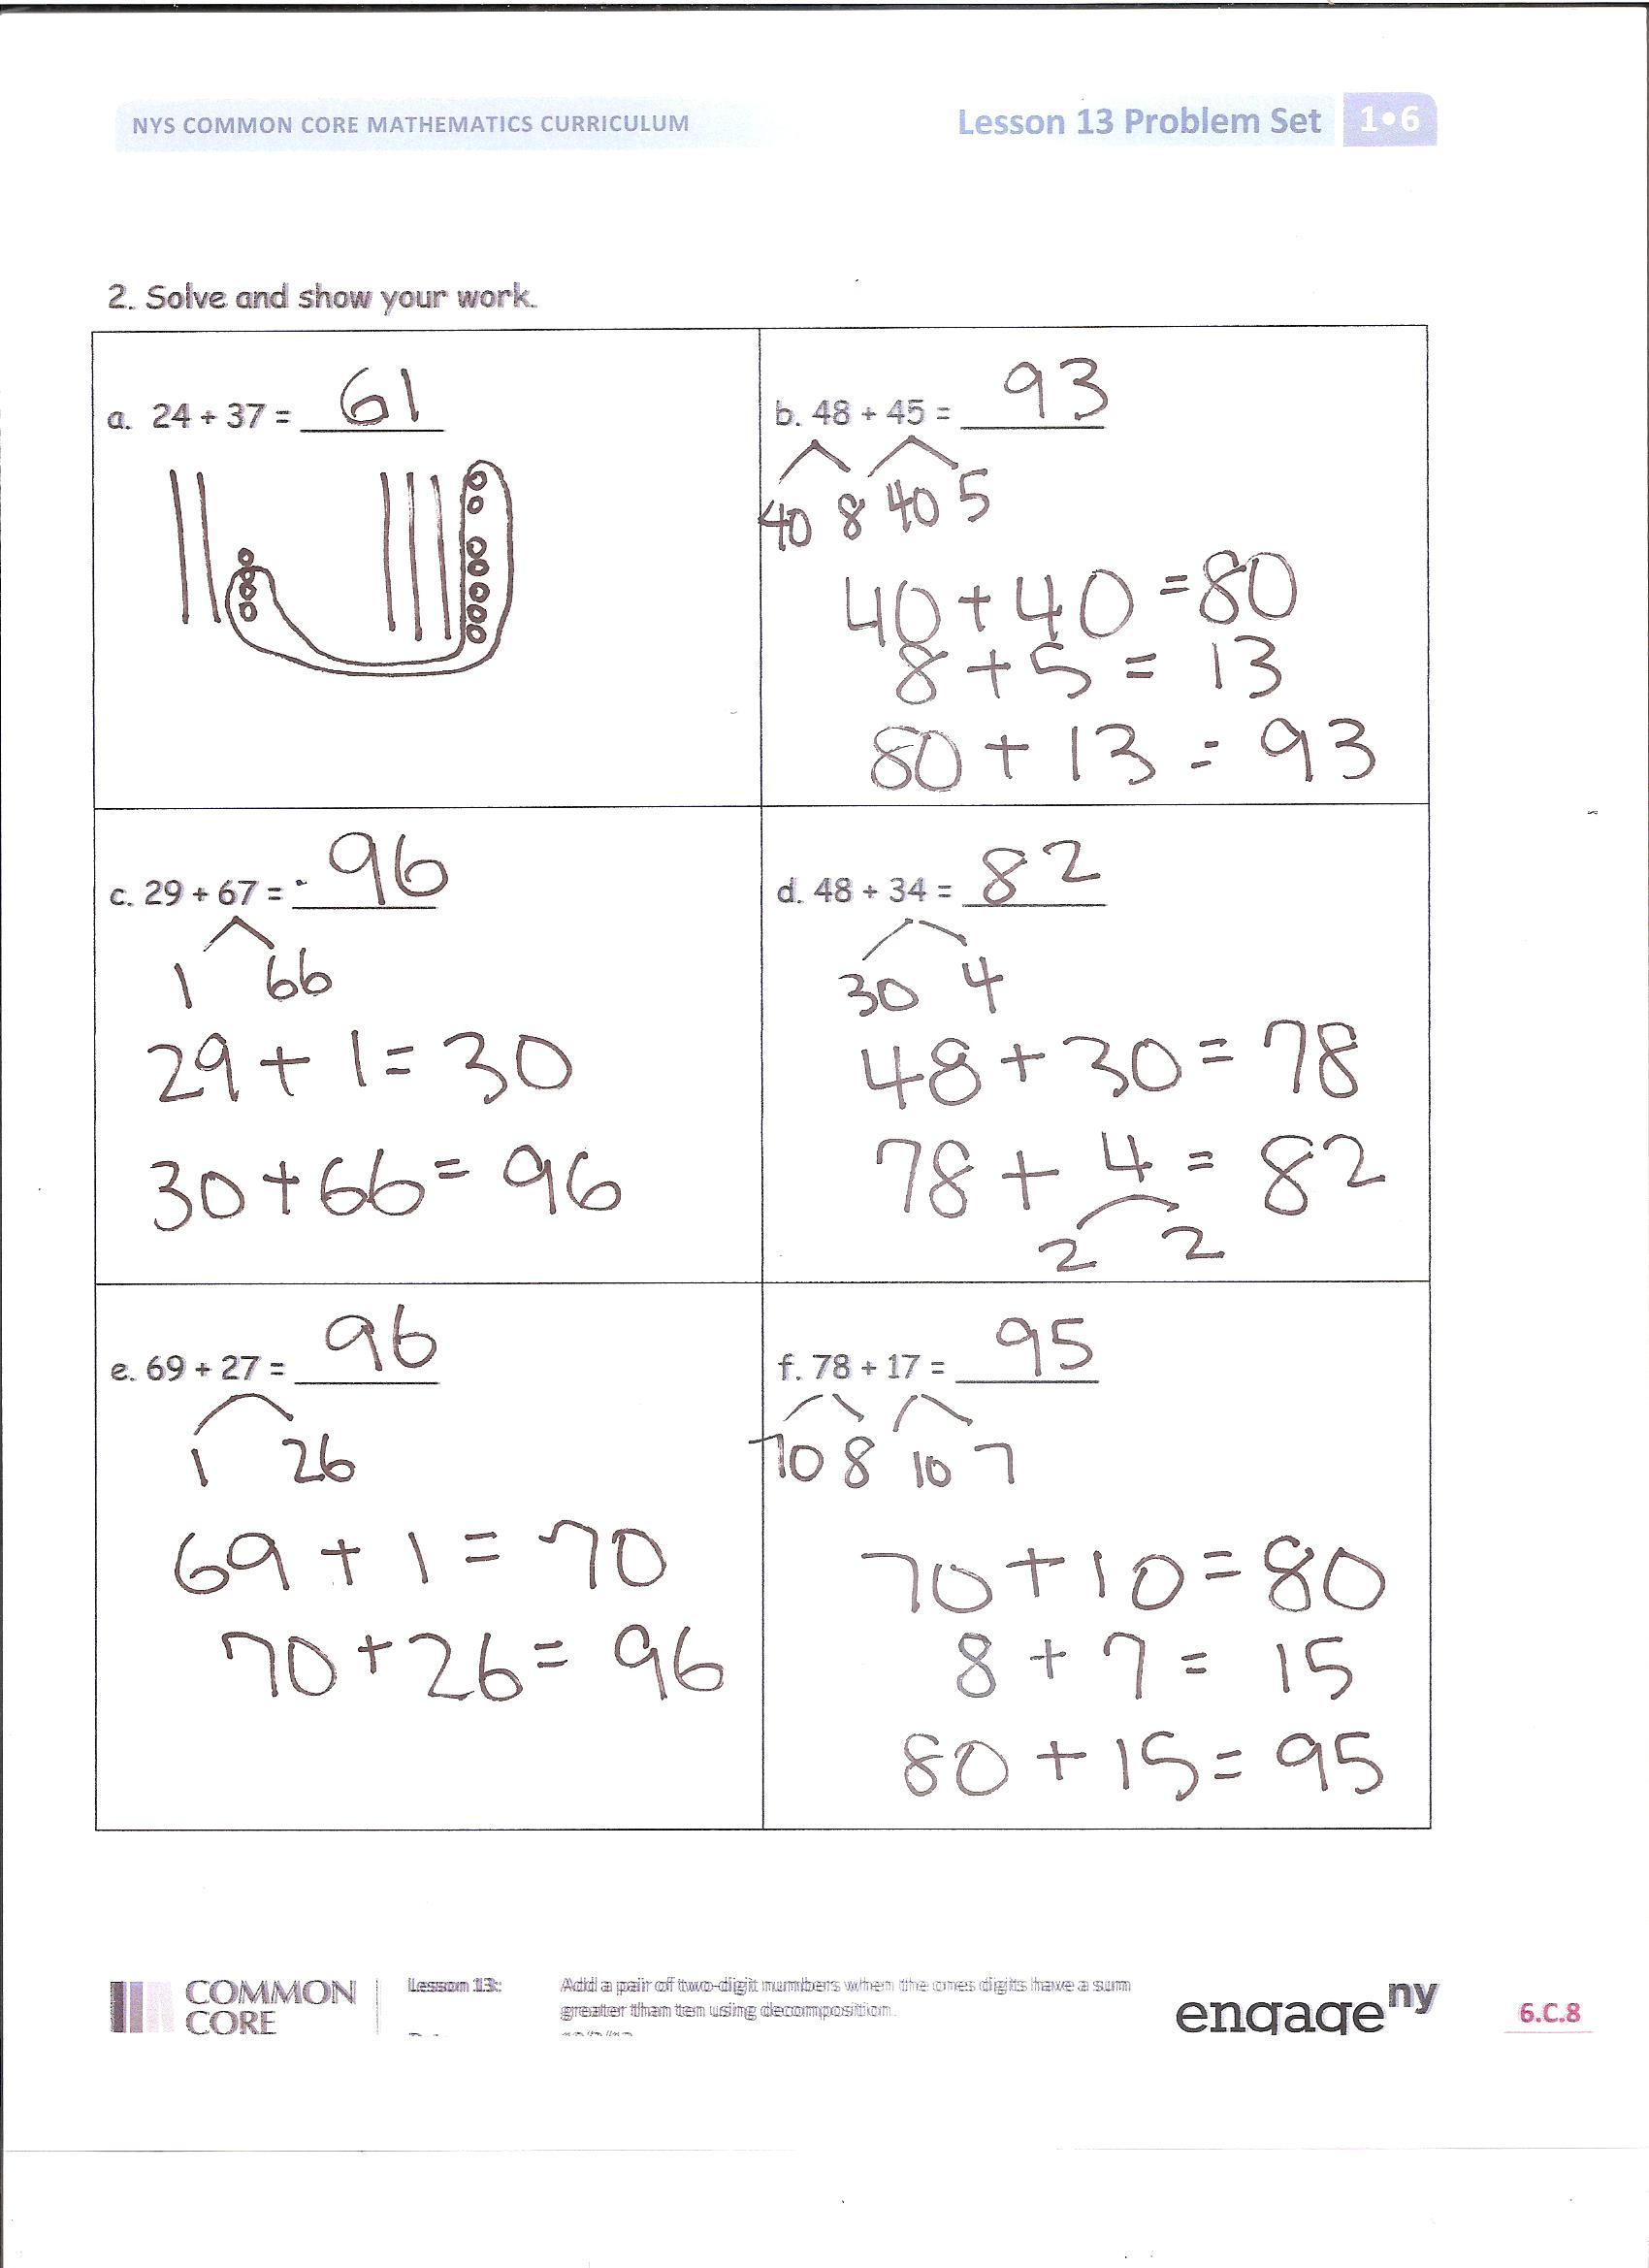
- Find two problems in your Problem Set that are related in some way. Explain your thinking.
- How is Make Ten Addition from today’s Fluency Practice related to some of the work you did on your Problem Set?
Exit Ticket (3 minutes)
After the Student Debrief, instruct students to complete the Exit Ticket. A review of their work will help you assess the students’ understanding of the concepts that were presented in the lesson today and plan more effectively for future lessons. You may read the questions aloud to the students.

Name Date

- Solve and show your work.
a. 79 + 12 = _______ | b. 59 + 32 = _______
c. 38 + 45 = _______ | d. 36 + 47 = _______
e. 48 + 45 = _______ | f. 57 + 34 = _______
- Solve and show your work.
a. 24 + 37 = _______ | b. 48 + 45 = _______
c. 29 + 67 = _______ | d. 48 + 34 = _______
e. 69 + 27 = _______ | f. 78 + 17 = _______

Name Date

1. Solve and show your work.
a. 49 + 37 = _______ | b. 56 + 38 = _______

Name Date

- Solve and show your work.
a. 15 + 26 = _______ | b. 46 + 49 = _______ | c. 28 + 54 = _______
d. 69 + 13 = _______ | e. 69 + 23 = _______ | f. 69 + 19 = _______
g. 49 + 43 = _______ | h. 67 + 36 = _______ | i. 68 + 23 = _______
- Solve and show your work.
a. 34 + 47 = _______ | b. 38 + 45 = _______ | c. 68 + 23 = _______
d. 39 + 57 = _______ | e. 38 + 44 = _______ | f. 17 + 76 = _______
g. 68 + 24 = _______ | h. 18 + 77 = _______ | i. 14 + 67 = _______

