Lesson 12
Objective: Add a pair of two-digit numbers when the ones digits have a sum less than or equal to 10.

Suggested Lesson Structure
 Application Problem (5 minutes)
 Fluency Practice (15 minutes)
 Concept Development (30 minutes)
 Student Debrief (10 minutes)
Total Time (60 minutes)
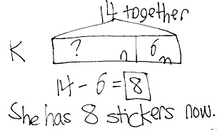
Application Problem (5 minutes)
Kiana wants to have 14 stickers in her folder. She needs 6 more stickers to make her goal. How many stickers does she have right now?
Note: Today’s problem is an add to with start unknown problem type. This can be challenging because some students associate the word more in a problem as meaning they must add.
Fluency Practice (15 minutes)
- Grade 1 Core Fluency Sprint 1.OA.6 (10 minutes)
- Add Tens 1.NBT.4 (3 minutes)
- Analogous Addition Sentences 1.OA.6, 1.NBT.4 (2 minutes)
Grade 1 Core Fluency Sprint (10 minutes)
Materials: (S) Core Fluency Sprint from G1–M5–Lesson 1
Note: Choose an appropriate Sprint based on the needs of the class. As students work, pay attention to their strategies and the number of problems they are answering. If the majority of students complete the first three quadrants today, try giving them the next level of difficulty when administering the next Sprint. If many students are not making it to the third quadrant, consider repeating today’s Sprint.

Core Fluency Sprint List:
- Core Addition Sprint
- Core Addition Sprint 2
- Core Subtraction Sprint
- Core Fluency Sprint: Totals of 5, 6, and 7
- Core Fluency Sprint: Totals of 8, 9, and 10
Add Tens (3 minutes)
Materials: (S) Personal white boards, die per pair of students
Note: This fluency activity reviews adding multiples of 10 to two-digit numbers, which helps prepare students for today’s lesson.
Choose a student to help model the activity. Then assign partners of equal ability to work together.
- Partner A writes or draws a number (with quick tens and ones) between 10 and 40 (e.g., 25).
- Partner B rolls the die to determine the number of tens to add (e.g., if she rolls 5, add 5 tens).
- Both partners write the number sentence on their personal boards and check each other’s work (e.g., 25 + 50 = 75).
Analogous Addition Sentences (2 minutes)
Note: This fluency activity encourages students to use sums within 10 to solve more challenging problems. Reviewing adding a one-digit number to a two-digit number when the ones have a sum less than or equal to 10 prepares students for today’s lesson.
T: Say the number sentence with the answer. 3 + 2.
S: 3 + 2 = 5.
T: 43 + 2.
S: 43 + 2 = 45.
T: 42 + 3.
S: 42 + 3 = 45.
T: 3 + 42.
S: 3 + 42 = 45.
Continue with the following suggested sequence:

6 + 2
56 + 2
96 + 2
42 + 6
4 + 3
64 + 3
63 + 4
4 + 63
6 + 3
96 + 3
93 + 6
6 + 93

Concept Development (30 minutes)

NOTES ON
MULTIPLE MEANS OF ACTION AND EXPRESSION:
Some students may benefit from more concrete or pictorial supports. Use linking cubes in ten-sticks and ones as well as quick ten drawings for these students. While supporting students with these materials, be sure to connect them with number sentences with decomposed bonds to support increased understanding. See G1−M4−Lesson 24 for examples of how these materials have been used for similar instructional objectives.

Materials: (T) Chart paper (S) Personal white boards
Begin today’s lesson with students sitting at their desks or tables with their materials.
Three sets of problems have been provided for students to extend their double-digit addition skills from G1–Module 4. Choose the appropriate set, or portion of a set, that best meets students’ needs. Although it may be tempting to begin with a review of a particular method to solve problems, refrain from doing so at the onset of the lesson. Instead, encourage and remind students of their tool kit: number sentences, the place value chart, linking cubes, drawings, number bonds, counting on, etc. Although students may ask questions, resist giving hints or solving the problem as a class, but continue to ask questions that will prompt students to use their tool kit. For example, “How can this be solved? What method could you use?”
MP.5
After each problem, have students share their solutions and invite one or two students to explain their strategy. Today, try to pre-select students that have used varied strategies, such as adding ones first or adding tens first. Encourage students to use place value language to describe strategies for solving. Ask questions such as, “What is another way this can be solved? Why did you choose your method?”
In Problems 1–4 pairs of two-digit numbers from G1–Module 4–Lessons 24 and 25 are presented with an analogous problem using numbers from 40 to 100 from G1–Module 6.
Problems 5–8 provide a scaffold-less opportunity to add pairs of two-digit numbers.
Problems 9–12 encourage students to identify the missing number in varied positions within the number sentence.
Problems 1–4 Problems 5–8 Problems 9–12
24 + 13, then solve 54 + 13 76 + 23 63 + ____ = 84
15 + 13, then solve 45 + 23 23 + 57 48 + ____ = 100
15 + 15, then solve 45 + 45 41 + 39 ____ + 59 = 70
26 + 14, then solve 66 + 34 34 + 53 32 + ____ = 100
Should students need additional support, the following dialogue presents a more guided approach to Problems 1–4.
T: (Write 24 + 10 on chart paper.) Use quick tens to show and solve this problem. (Wait as students draw on their personal boards.)
T: 24 + 10 is…?

NOTES ON
MULTIPLE MEANS OF ACTION AND EXPRESSION:
Encourage students to explain their thinking about adding or subtracting tens. Students may learn as much from each other’s reasoning as from the lesson. This also provides the opportunity for the teacher to learn more about a student’s level of thinking and ability to express that thinking.
S: 34!
T: (Write 24 + 13 on chart paper.) Use quick tens to show and solve this problem. (Wait as students draw on their personal boards.)
T: 24 + 13 is…?
S: 37!
T: What did you do to solve this problem? Turn and talk with a partner. (Wait as students discuss.)
S: I took apart 13, making it 10 and 3. I added 10 first, that’s 34, and then 3 more makes 37. I already know 24 + 10 was 34, so 3 more was 37.
T: (As students explain, use number bonds with number sentences to record their process.)
T: Great job adding the tens and then adding the rest of the ones.
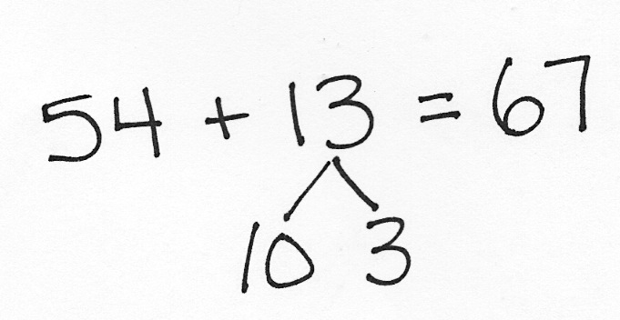
T: (Write 54 + 13 on chart paper.) Solve this problem using your same thinking. If quick tens will help you, use them, or challenge yourself to use number bonds with your number sentence to solve the problem. (Wait as students draw on personal boards.)
T: 54 + 13 is…?
S: 67!
Invite students to share how they solved this problem. Emphasize their process of decomposing at least one number into tens and ones as they put the addends together. Repeat this process for 15 + 13 and 45 + 13. When beginning 15 + 15, note that students may choose to add the ones first as shown demonstrated below.

T: (Write 15 + 15 on chart paper.) Solve this problem. (Wait as students solve.)
T: 15 + 15 is…?
S: 30!
T: What did you do to solve this problem?
S: I took apart the second 15, making it 10 and 5. I added 10 first; that’s 25, and then 5 more makes it 30. I started the same way, but I added 15 + 5 first; that’s 20, and then added 10 more to make 30. I made both fifteens into 10 and 5. I added 5 and 5 to make 10, so then I had 3 tens. That’s 30.
Use number bonds and number sentences to record students’ methods. If all students add the tens first, pose the other methods as ways that you solved the problem, as an opportunity to consider alternative methods.
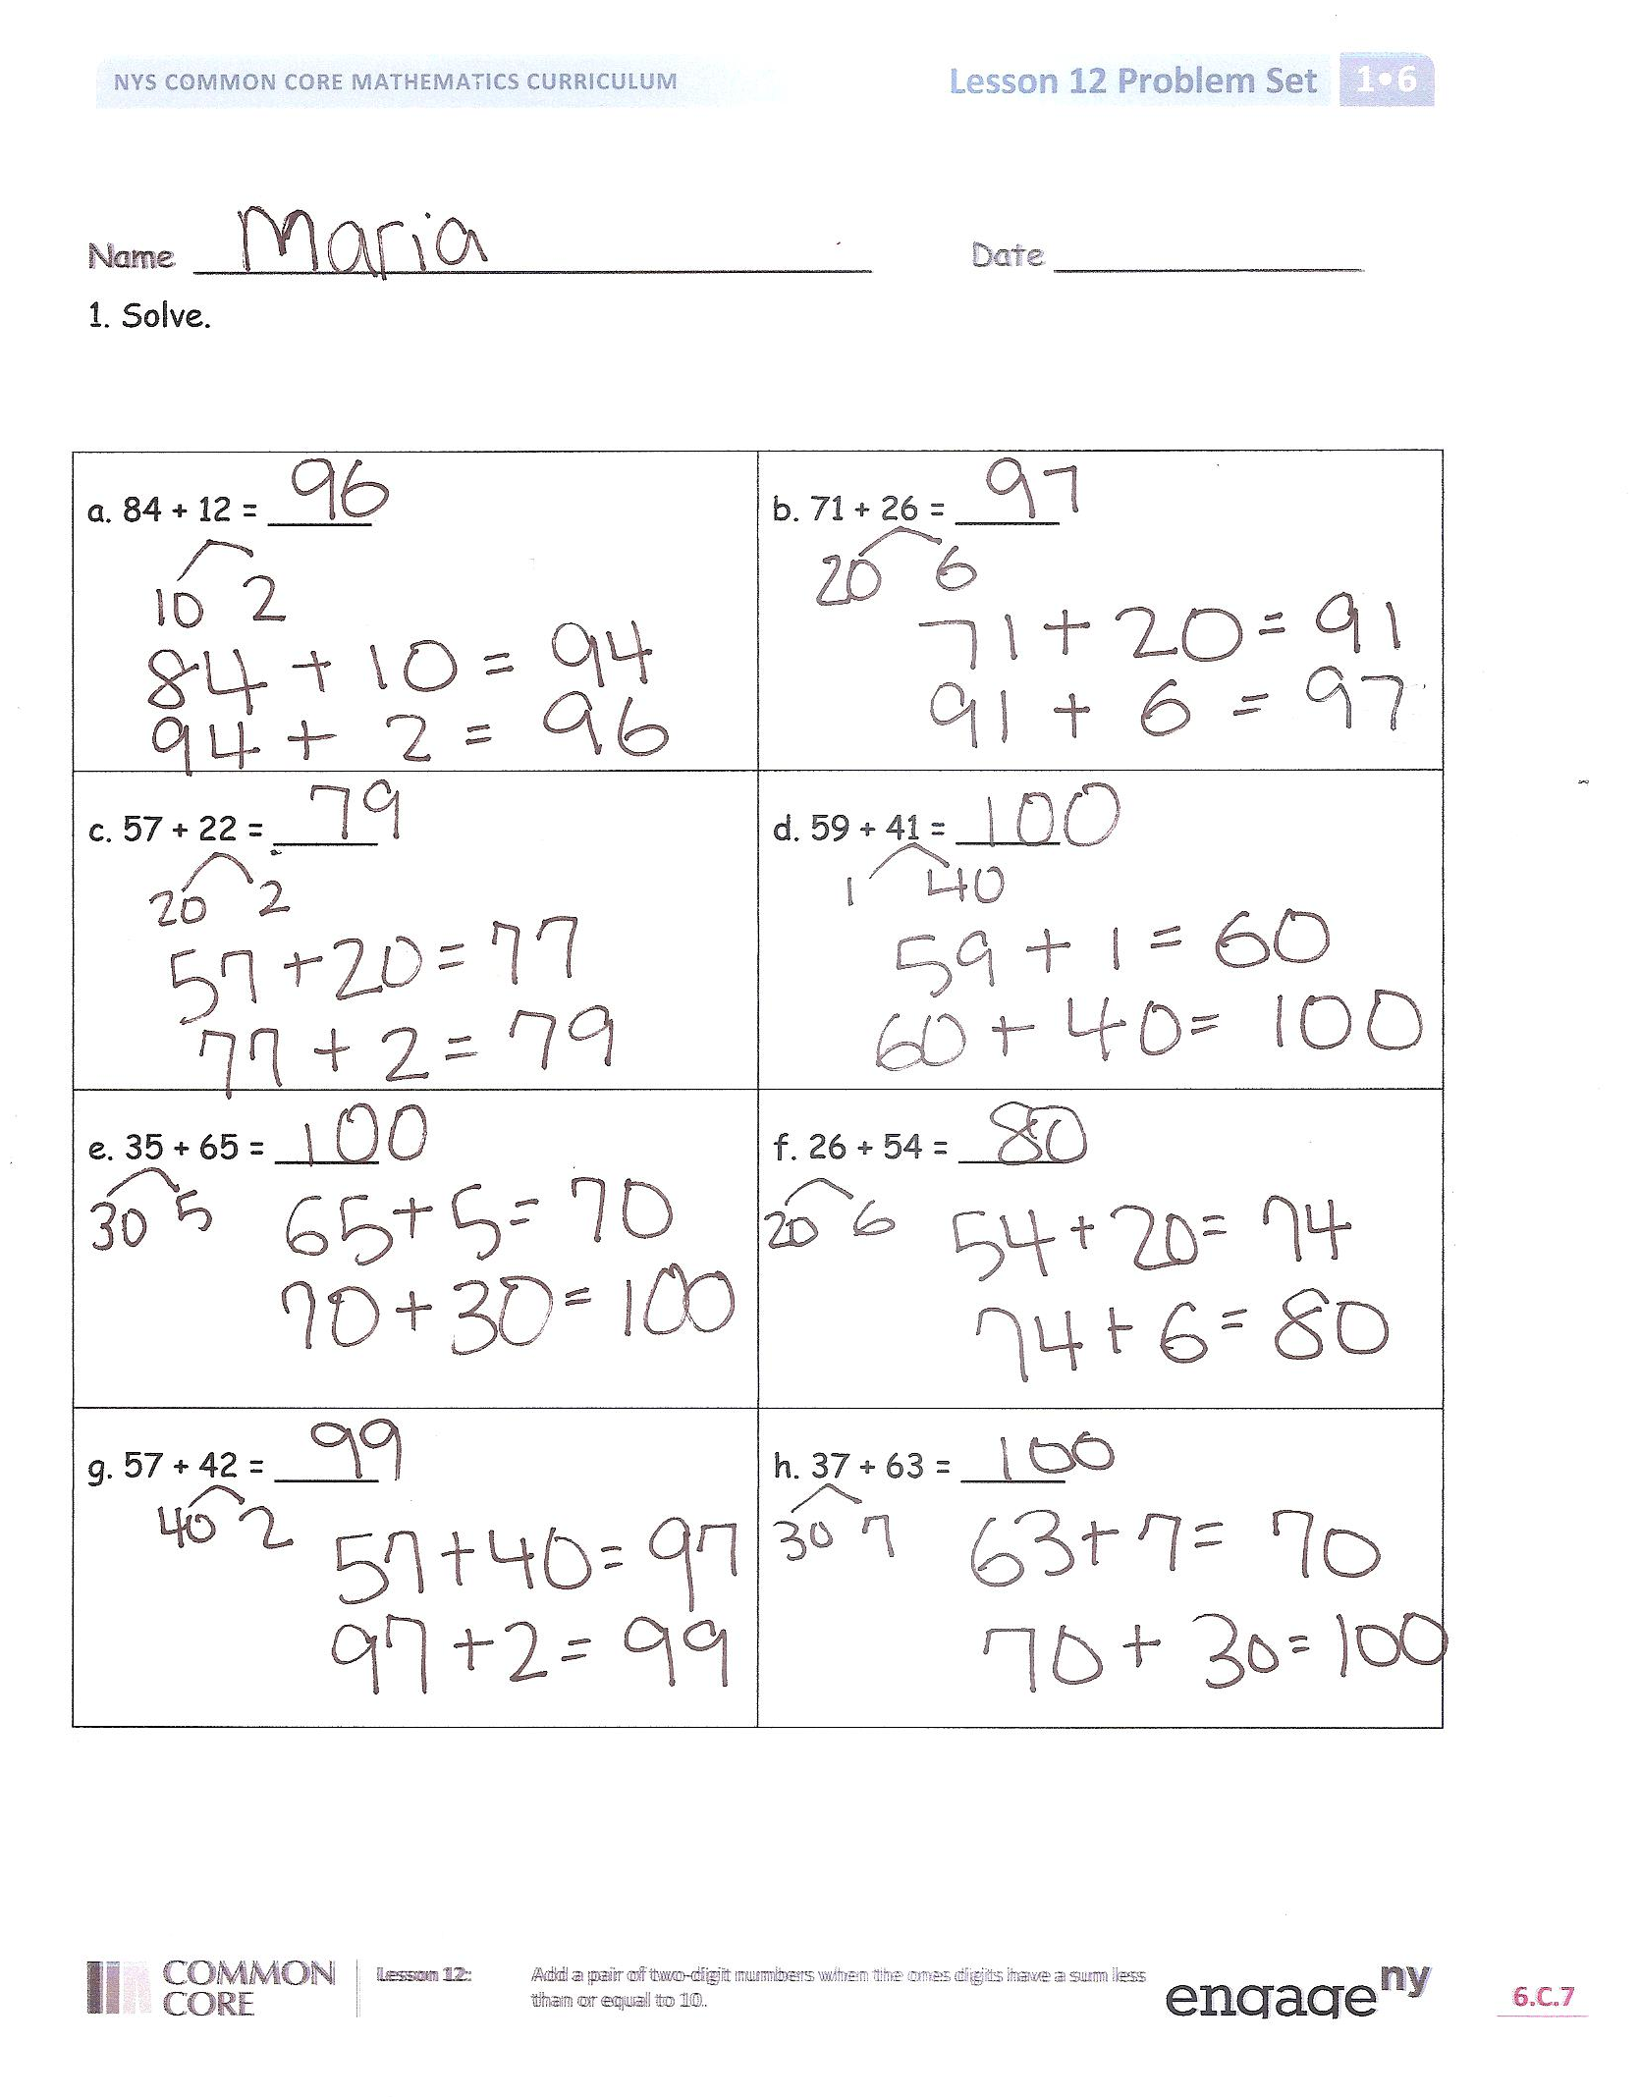
T: (Point to the example while describing each method.) Some of you broke the second 15 into tens and ones and added the tens first and then the ones. Some of you broke the second 15 into tens and ones and added the ones first and then the tens. A few of you broke both fifteens into tens and ones and added ones with ones and tens with tens. Did you all find the total of 30?
S: Yes!
Have students work on the following problems or repeat the same process with the following 45 + 45, 26 + 14, and 66 + 34.
Problem Set (10 minutes)
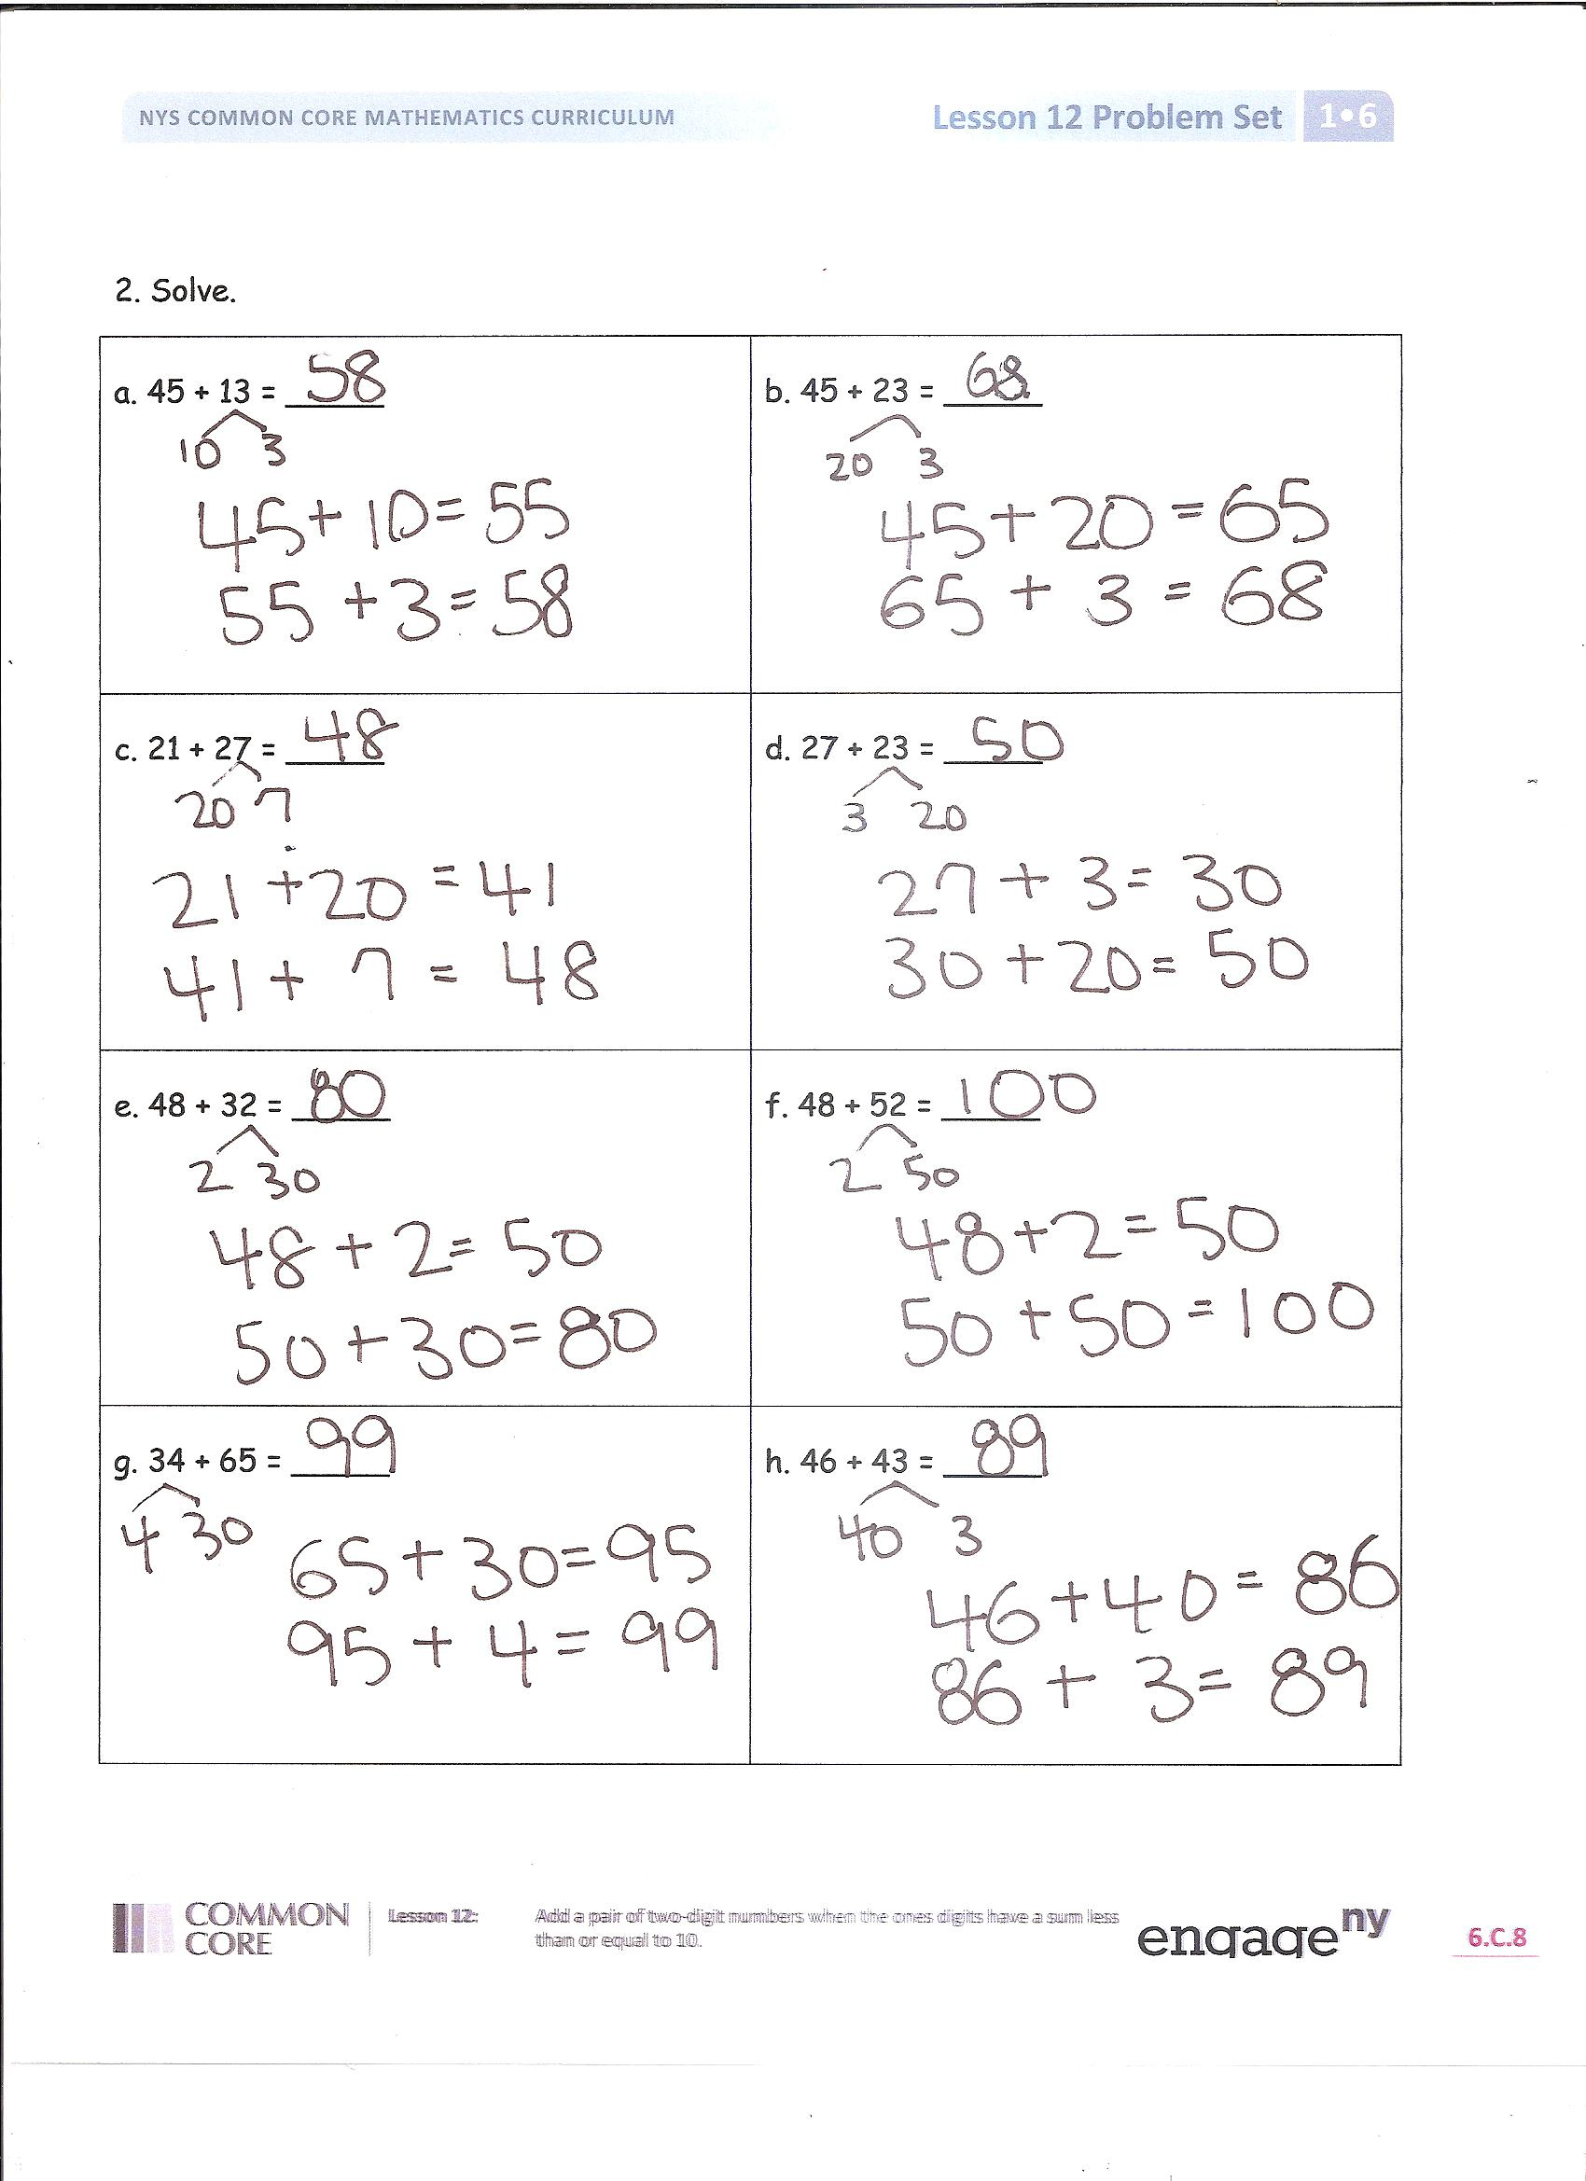
Students should do their personal best to complete the Problem Set within the allotted 10 minutes. For some classes, it may be appropriate to modify the assignment by specifying which problems they work on first. Some problems do not specify a method for solving. Students solve these problems using the RDW approach used for Application Problems.
Student Debrief (10 minutes)
Lesson Objective: Add a pair of two-digit numbers when the ones digits have a sum less than or equal to 10.
The Student Debrief is intended to invite reflection and active processing of the total lesson experience.
Invite students to review their solutions for the Problem Set. They should check work by comparing answers with a partner before going over answers as a class. Look for misconceptions or misunderstandings that can be addressed in the Debrief. Guide students in a conversation to debrief the Problem Set and process the lesson.
You may choose to use any combination of the questions below to lead the discussion.
- Look at Problem 1. Did you solve all of your problems the same way? What was your strategy?
- Did anyone solve some problems one way, and then use a different strategy to solve other problems? Explain your reasoning.
- How does yesterday’s work with adding multiples of 10 connect to today’s work?
- How did your fluency work today help you with today’s problems? Use specific examples to explain your thinking.
- Look at your Application Problem. Share your solution and your strategy for solving.
Exit Ticket (3 minutes)
After the Student Debrief, instruct students to complete the Exit Ticket. A review of their work will help you assess the students’ understanding of the concepts that were presented in the lesson today and plan more effectively for future lessons. You may read the questions aloud to the students.

Name Date

- Solve.
a. 84 + 12 = _____ | b. 71 + 26 = _____
c. 57 + 22 = _____ | d. 59 + 41 = _____
e. 35 + 65 = _____ | f. 26 + 54 = _____
g. 57 + 42 = _____ | h. 37 + 63 = _____
- Solve.
a. 45 + 13 = _____ | b. 45 + 23 = _____
c. 21 + 27 = _____ | d. 27 + 23 = _____
e. 48 + 32 = _____ | f. 48 + 52 = _____
g. 34 + 65 = _____ | h. 46 + 43 = _____

Name Date

- Solve using number bonds. You may choose to add the ones or tens first. Write the two number sentences to show what you did.
a. 56 + 43 = _____ | b. 22 + 75 = _____

Name Date

- Solve.

a. 46 + 22 = _____ | b. 74+ 23 = _____
c. 54 + 25 = _____ | d. 68 + 31 = _____
e. 45 + 55 = _____ | f. 86 + 13 = _____
g. 37 + 52 = _____ | h. 47 + 52 = _____
- Solve using number bonds. You may choose to add the ones or tens first. Write the two number sentences to show what you did.
a. 76 + 23 = _____ | b. 45 + 33 = _____
c. 31 + 67 = _____ | d. 57 + 32 = _____
e. 58 + 21 = _____ | f. 25 + 63 = _____
g. 44 + 55 = _____ | h. 47 + 53 = _____

