Lesson 11
Objective: Add a multiple of 10 to any two-digit number within 100.

Suggested Lesson Structure
 Application Problem (5 minutes)
 Fluency Practice (10 minutes)
 Concept Development (35 minutes)
 Student Debrief (10 minutes)
Total Time (60 minutes)
Application Problem (5 minutes)
Ben sharpened 5 pencils. He has 8 more unsharpened pencils than sharpened pencils. How many unsharpened pencils does Ben have?
Note: Today’s comparison with bigger unknown poses the additional challenge that there is only one person in the story. If students are still struggling with comparison problem types, you may want to alter the problem so that two students’ pencils are being compared. Have a brief student discussion of the solution before moving on to Fluency Practice.
Fluency Practice (10 minutes)
- Core Fluency Differentiated Practice Sets 1.OA.6 (5 minutes)
- Coin Drop 1.NBT.5, 1.MD.3 (3 minutes)
- Get to the Next Ten 1.NBT.4 (2 minutes)
Core Fluency Differentiated Practice Sets (5 minutes)
Materials: (S) Core Fluency Practice Sets from G1−M6−Lesson 1
Note: Give the appropriate Practice Set to each student. Help students become aware of their improvement. After students do today’s Practice Sets, ask them to stand if they tried a new level today or improved their score from the previous day. Consider having students clap once for each person standing to celebrate improvement.
Students complete as many problems as they can in 90 seconds. Assign a counting pattern and start number for early finishers, or have them practice make ten addition or subtraction on the backs of their papers. Collect and correct any Practice Sets completed within the allotted time.
Coin Drop (3 minutes)
Materials: (T) 10 dimes, 10 pennies, can
Note: This activity reviews yesterday’s lesson, where students added and subtracted tens within 100.
Repeat from G1−M6−Lesson 5. Now that students have learned to add and subtract multiples of 10 from multiples of 10, you may take out more than one dime at a time and have students calculate the remaining dimes.
Get to the Next Ten (2 minutes)
Note: This fluency activity builds on yesterday’s Get to Ten(s) activity to prepare students for G1–M6–Lesson 13.
Say a number. Students say an addition sentence to get to the next multiple of 10. For the first few problems, begin with a number from 0 to 9 to provide students with a helper problem on which to build. Then, say numbers without providing the helper problem.
T: Say the addition sentence to get to the next ten. 9.
S: 9 + 1 = 10.
T: 59.
S: 59 + 1 = 60.
Continue with the following suggested sequence: 5, 65; 8, 78; 7, 87; 6, 96; etc.
Concept Development (35 minutes)

NOTES ON
MULTIPLE MEANS OF ENGAGEMENT:
At this point in the year, students should be able to add a multiple of ten to any multiple of 10 within 100. If there are students who are struggling, have them use linking cubes in ten-sticks or quick ten drawings for more concrete or pictorial supports. Use the language of place value so that the dialogue begins to become part of their independent thinking. Work towards solving without the concrete.
Materials: (T) 100-bead Rekenrek (S) Personal white boards
Have students gather in the meeting area in a semi-circle formation with their materials.
T: (Write 40 + 30 = ? on chart paper.) On your personal board, write the number sentence and replace the question mark with the missing number. (Wait as students complete the task.)
T: 40 + 30 is…?
S: 70.
T: Explain how you know that 40 + 30 equals 70. You can draw or write on the chart paper to explain your thinking.

S: If you use the Rekenrek, you slide 4 tens over and then 3 tens over, and that’s 7 tens or 70. Four tens plus 3 tens is 7 tens. That’s 70. In the Place Value Chart, you add 3 tens to the 4 tens you have. (Post or show yesterday’s chart paper if available. Draw the place value chart and the number bond on today’s chart paper.)
T: (Draw a line to start a new section of the chart paper. Write 45 + 30 = ? Move over 45 beads on the 100-bead Rekenrek.) On your personal board, write this number sentence and replace the question mark with the solution.
T: (Wait as students complete the task. If students do not know the answer right away, provide more time for them to remember solution strategies, e.g., quick ten drawings, the Rekenrek, counting on, decomposing, and composing).
T: 45 + 30 is…?
S: 75!
T: Who would like to share how they solved 45 + 30? Listen to your friends’ ideas and be ready to ask questions or comment. (As students are explaining, record their examples on the chart using number bonds and place value charts.)
S: On the Rekenrek there are 4 rows and 3 rows, and 5 extra beads, so that’s 7 tens and 5 ones. 75.
T: Does anyone have a question or comment about the Rekenrek solution?
S: Why did you say row? The five extras are a row, too.
S: Because I meant a row of ten. I guess I should say a full row.
T: Did anyone solve 45 + 30 in a different way?
S: I started at 45 and counted on ten 3 times. 45, 55, 65, 75.
T: Does anyone have a question or comment about the counting on solution?
MP.3

NOTES ON
MULTIPLE MEANS OF ACTION AND EXPRESSION:
Some students may get confused with all of the strategies available to them for solving problems. As the teacher, it might help these students to include one consistent method for solving. Then students can share alternative strategies to allow exposure but consistency really helps students who are struggling.
S: Could you start counting on at 30?
S: Sure, I guess so. 30, 40, 50, 60, 70, 75. It’s just easier for me the other way.
T: Did anyone solve 45 + 30 in a different way?
S: I broke 45 into 40 and 5 with the number bond, and then I added 40 and 30 first, 70, and added on 5 to make 75.
T: Questions or comments about the number bond solution?
S: That’s easy for me. I like that better than my way.
T: Why?
S: Because it’s like I could just see it better. I counted on and it seemed slower, too.
T: Did anyone solve 45 + 30 in a different way?
S: I thought of the place value chart, and just added 3 tens to 4 tens and left the 5 ones alone. That gave me 75.
T: Comments and questions about the place value chart solution?
S: I don’t understand what you mean that you left the 5 ones alone.
MP.3
S: I mean when I was adding the tens the ones didn’t change.
T: It is important to really listen to your friends’ solution strategies so you could comment and ask questions.
Provide time for students to solve the following suggested sequence of problems. Students who would benefit from more concrete or pictorial support may use linking cubes in ten-sticks and ones, dimes and pennies, or quick ten drawings.
- 51 + 40
- 24 + 60
- 50 + 38
- 62 cents + 3 dimes
- 8 dimes + 12 cents
- 63 + ____ = 93
- 14 + ____ = 74
- ____ + 39 = 59
- ____ + 40 = 98
After each problem, have one or two students share a different method for solving the problem.
Problem Set (10 minutes)
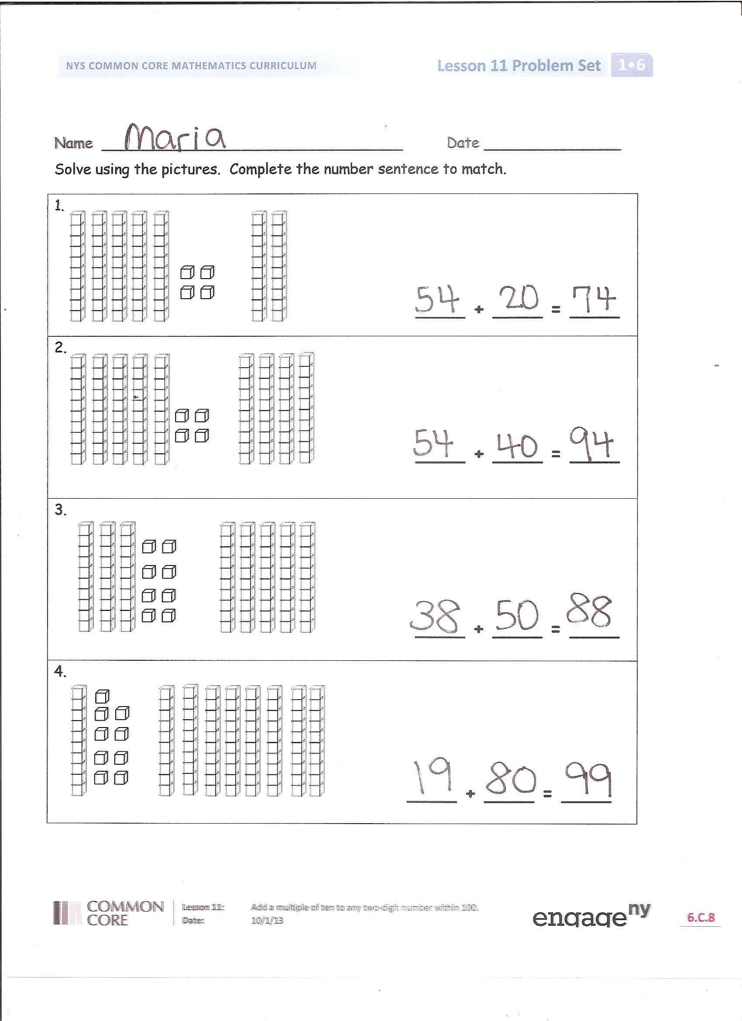
Students should do their personal best to complete the Problem Set within the allotted 10 minutes. For some classes, it may be appropriate to modify the assignment by specifying which problems they work on first. Some problems do not specify a method for solving. Students solve these problems using the RDW approach used for Application Problems.
Student Debrief (10 minutes)
Lesson Objective: Add a multiple of 10 to any two-digit number within 100.
The Student Debrief is intended to invite reflection and active processing of the total lesson experience.
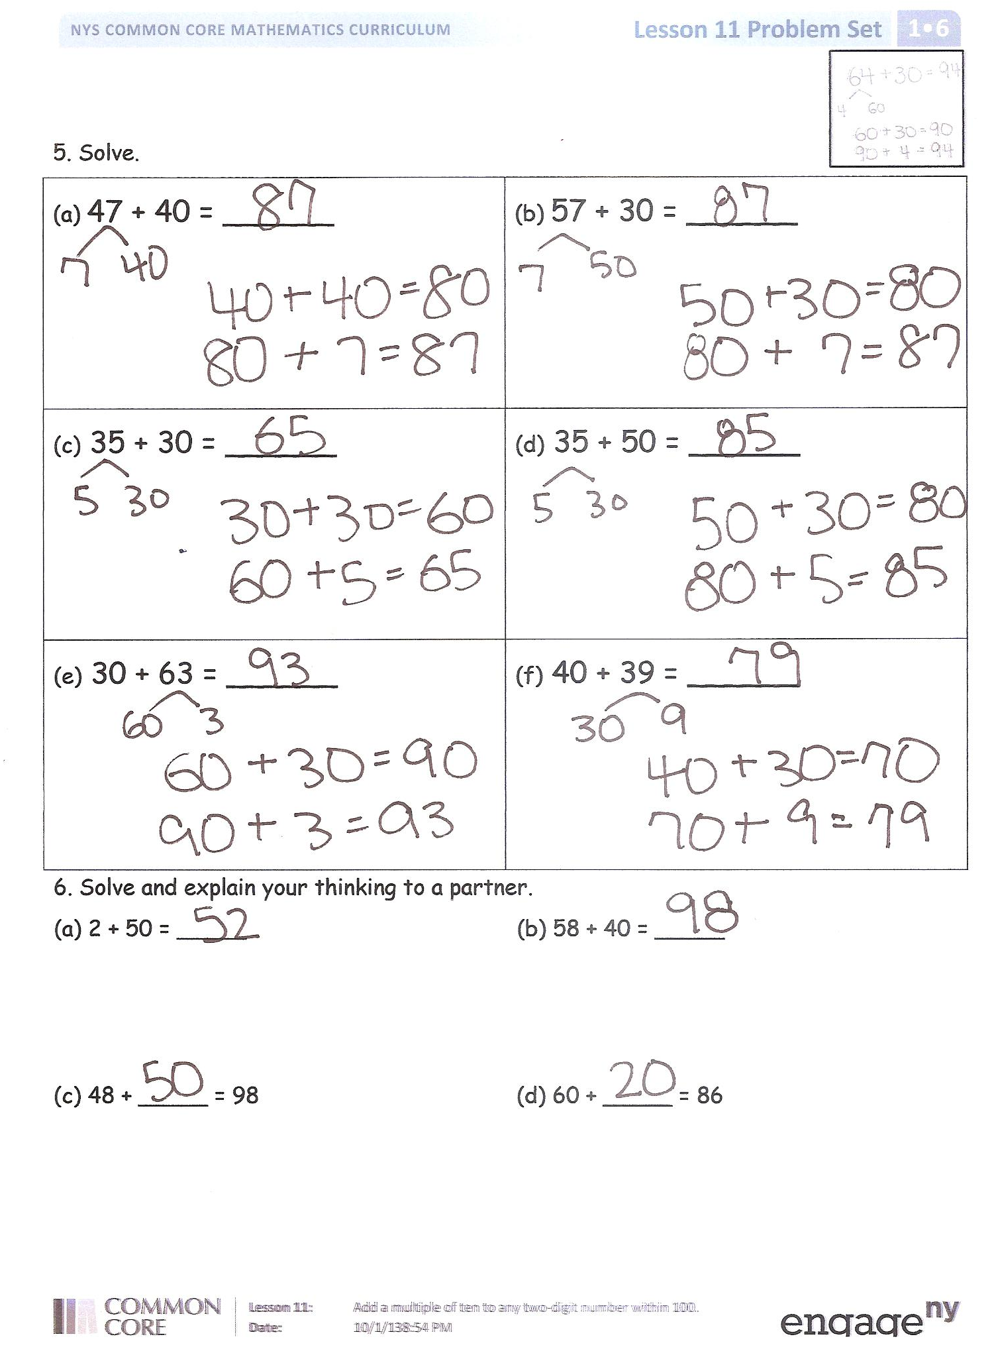
Invite students to review their solutions for the Problem Set. They should check work by comparing answers with a partner before going over answers as a class. Look for misconceptions or misunderstandings that can be addressed in the Debrief. Guide students in a conversation to debrief the Problem Set and process the lesson.
You may choose to use any combination of the questions below to lead the discussion.
- Look at Problems 5(c) and 5(d). How could solving 5(c) help you solve 5(d)?
- Look at Problems 6(a) and 6(b). Did you or your partner use a different strategy than the number bond work from the top of the page? If so, explain your strategy.
- Look at Problems 6(c) and 6(d). How did you find the missing addends? Explain your thinking.
- How is today’s work similar to and different from yesterday’s work?
- How did the coin drop fluency activity help you get better at adding tens?
Exit Ticket (3 minutes)
After the Student Debrief, instruct students to complete the Exit Ticket. A review of their work will help you assess the students’ understanding of the concepts that were presented in the lesson today and plan more effectively for future lessons. You may read the questions aloud to the students.

Name Date

Solve using the pictures. Complete the number bond and number sentence to match.

____ + ____ = ____

____ + ____ = ____

____ + ____ = ____

____ + ____ = ____

- Solve.
a. 47 + 40 = ______ | b. 57 + 30 = ______
c. 35 + 30 = ______ | d. 35 + 50 = ______
e. 30 + 63 = ______ | f. 40 + 39 = ______

- Solve and explain your thinking to a partner.
- 2 + 50 = _____ b. 58 + 40 = _____

- 48 + _____ = 98 d. 60 + _____ = 86

Name Date

1. Solve. Use quick tens and ones drawings or number bonds.
a. 42 + 50 = ______ | b. 30 + 57 = ______

Name Date

- Solve using the pictures. Complete the number sentence to match.

____ + ____ = ____

____ + ____ = ____

____ + ____ = ____

____ + ____ = ____

- Use number bonds to solve.
a. 38 + 40 = ______ | b. 54 + 30 = ______
c. 46 + 40 = ______ | d. 30 + 57 = ______
e. 20 + 68 = ______ | f. 25 + 70 = ______

- Use number bonds to solve.
- 72 + 20 = _____ b. 48 + 50 = _____

- 46 + _____ = 96 d. _____ + 40 = 87

