Lesson 10
Objective: Add and subtract multiples of 10 from multiples of 10 to 100, including dimes.

Suggested Lesson Structure
 Application Problem (5 minutes)
 Fluency Practice (13 minutes)
 Concept Development (32 minutes)
 Student Debrief (10 minutes)
Total Time (60 minutes)
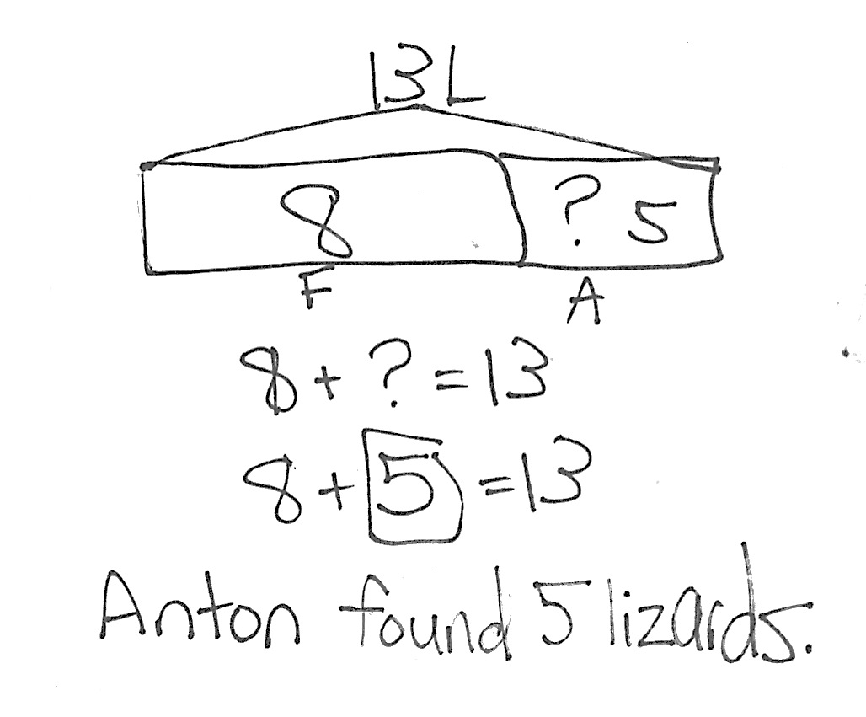
Application Problem (5 minutes)
Fran had 8 lizards. Anton gave some lizards to Fran. Fran now has 13 lizards. How many lizards did Anton give Fran?
Note: Today’s problem is an add to with change unknown problem type. Some students may use a double tape diagram to solve, while others choose to use a single tape diagram to solve.
Fluency Practice (13 minutes)
- Core Fluency Differentiated Practice Sets 1.OA.6 (5 minutes)
- Race to the Top 1.OA.6 (5 minutes)
- Get to Ten(s) 1.NBT.4 (3 minutes)
Core Fluency Differentiated Practice Sets (5 minutes)
Materials: (S) Core Fluency Practice Sets from G1–M6–Lesson 1
Note: Give the appropriate Practice Set to each student. Students who completed all questions correctly on their most recent Practice Set should be given the next level of difficulty. All other students should try to improve their scores on their current levels.
Students complete as many problems as they can in 90 seconds. Assign a counting pattern and start number for early finishers, or have them practice make ten addition or subtraction on the back of their papers. Collect and correct any Practice Sets completed within the allotted time.
Race to the Top (5 minutes)
Materials: (S) Personal white boards with Race to the Top insert, 2 dice per pair of students
Note: This fluency activity primarily targets the core fluency for Grade 1. Remember to closely monitor the strategies of students who are not performing well on the Practice Sets or Sprints. For students whose fine motor skills are not well developed, activities like Race to the Top will allow them to demonstrate their growing fluency.
Assign partners. Students take turns rolling the dice, saying an addition sentence, and recording the sums on the graph. The game ends when time runs out or one of the columns reaches the top of the graph.
Get to Ten(s) (3 minutes)
Materials: (T) 100-bead Rekenrek
Note: In this fluency activity, students apply their knowledge of partners to ten to find analogous partners to multiples of 10. Students will need this skill when they learn to apply the make ten strategy to add two two-digit numbers in G1–M6–Lesson 13.
Model with the Rekenrek for the first few problems. Then, put the Rekenrek away to give students practice mentally getting to the next ten.
T: (Show 9.) Say the number.
S: 9.
T: Say the number sentence to make ten.
S: 9 + 1 = 10.
T: (Move 1 bead to make 10. Show 19.)
T: Say the number.
S: 19.
T: Say the number sentence to make 20.
S: 19 + 1 = 20.
Suggested sequence: 59, 79, 99; 5, 65, 85, 95; 8, 48, 78, 98; 7, 37, 87, 97; etc.
Concept Development (32 minutes)
Materials: (T) Chart paper, 10 dimes (S) Personal white boards with triple number bond/number sentence template, 5 dimes
Students sit in the meeting area in a semi-circle formation.
T: (Write 4 + 3 on the chart. Call up two volunteers.) Using your magic counting sticks, show us 4 + 3.
S: (Student A shows 4 fingers; Student B shows 3 fingers.)
T: How many fingers are there? Say the number sentence.
S: 4 + 3 = 7.
T: (Complete the number sentence on the chart.) Yes. 3 fingers + 4 fingers = 7 fingers.
On their boards, have students write the number sentence, use math drawings to show 4 + 3 = 7, and make a number bond as you record the information on a chart.
T: Let’s pretend these circles stand for bananas! Say the number sentence using bananas as the unit.
S: 4 bananas + 3 bananas = 7 bananas.
T: (Call for five additional volunteers to join the two volunteers.) Show us 4 tens + 3 tens using your magic counting sticks.
S: (Clasp hands to show 4 tens and 3 tens.)
T: (Help the first four students stand closer together to show 4 tens.)
T: (Point to the first four students.) How many tens do we have here?
S: 4 tens.

NOTES ON
MULTIPLE MEANS OF REPRESENTATION:
Students demonstrate a true understanding of math concepts when they can apply them in a variety of situations. Some students may not be able to make the connection between different number bonds as seen in this lesson. Their path to abstract thinking may be a little longer than others. Support these students with use of manipulatives (linking cubes and coins) and plenty of practice on their personal white boards.

T: (Point to the last three students closely standing next to each other.) How many tens do we have here?
S: 3 tens.
T: How many tens are there in all?
S: 7 tens.
T: Say the number sentence the Say Ten way. (If students struggle, say, “Say the number sentence starting with 4 tens.”)
S: 4 tens + 3 tens = 7 tens.
T: Say the number sentence the regular way starting with 40.
S: 40 + 30 = 70.
T: (Record the number sentence on the chart.)
Direct students write the number sentence, use math drawings, and make a number bond as you chart their responses as shown to the right.
Repeat the process using the following suggested sequence and have the students solve each problem using the Say Ten way and the regular way:
- 7 tens – 4 tens
- 30 + 60
- 9 dimes – 3 dimes
- 60 cents + 20 cents
- 70 + 30
- 10 tens – 4 tens
T: (Write 6 dimes – 4 dimes on the chart.) Draw a number bond for this subtraction problem and share your thinking with your partner.
S: 6 dimes is the total. 4 dimes is one of the parts. We know one part. The mystery is the other part to make 60. 6 dimes take away 4 dimes is 2 dimes. The total take away a part finds the unknown. (Show the number bond with 2 dimes still missing.)
T: What addition sentence can we write to match this number bond? Remember, we can say unknown or mystery number.
S: 4 dimes + the mystery number = 6 dimes. (Record on the chart.)
T: What is the missing part?
S: 2 dimes!
T: Say the subtraction sentence and the related addition sentence the Say Ten way.
S: 6 dimes – 4 dimes = 2 dimes. 4 dimes + 2 dimes = 6 dimes.
T: Let’s say it the regular way, too.
S: 60 – 40 = 20. 40 + 20 = 60.
Repeat the process as needed to support students’ understanding.
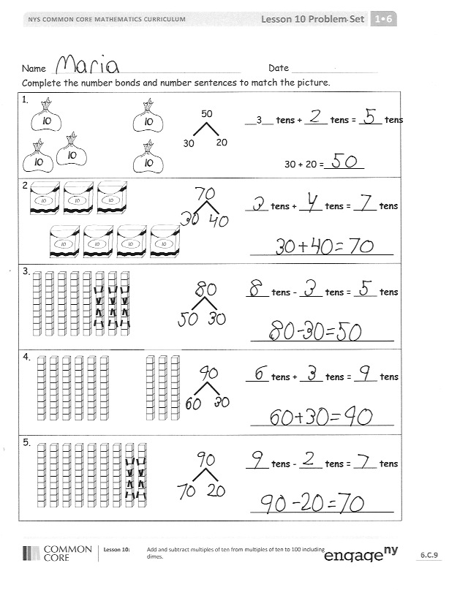
Problem Set (10 minutes)
Students should do their personal best to complete the Problem Set within the allotted 10 minutes. For some classes, it may be appropriate to modify the assignment by specifying which problems they work on first. Some problems do not specify a method for solving. Students solve these problems using the RDW approach used for Application Problems.
Student Debrief (10 minutes)
Lesson Objective: Add and subtract multiples of 10 from multiples of 10 to 100, including dimes.
The Student Debrief is intended to invite reflection and active processing of the total lesson experience.
Invite students to review their solutions for the Problem Set. They should check work by comparing answers with a partner before going over answers as a class. Look for misconceptions or misunderstandings that can be addressed in the Debrief. Guide students in a conversation to debrief the Problem Set and process the lesson.
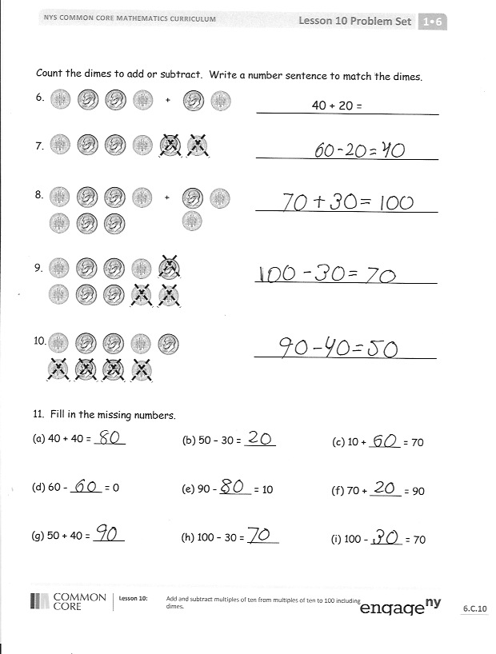
You may choose to use any combination of the questions below to lead the discussion.
- Look at Problems 1 and 2. Did you show your bonds the regular way or the Say Ten way?
- What did you notice about Problems 6 and 7? Can you find another set of problems that show a similar pattern?
- Use Problem 10 and create a related problem by drawing a picture and writing the number sentence in the same way that Problem 6 and 7 go together.
- Write all the ways you can make a total of 10 tens or 100 using only tens. You may use three addends!
- Explain how knowing 3 + 6 can help solve 30 + 60.
- How can Race to the Top and the Core Fluency Practice Sets help you solve addition and subtraction problems from today’s lesson?
Exit Ticket (3 minutes)
After the Student Debrief, instruct students to complete the Exit Ticket. A review of their work will help you assess the students’ understanding of the concepts that were presented in the lesson today and plan more effectively for future lessons. You may read the questions aloud to the students.

Names Date
Race to the Top!

2 | 3 | 4 | 5 | 6 | 7 | 8 | 9 | 10 | 11 | 12

Name Date
Complete the number bonds and number sentences to match the picture.
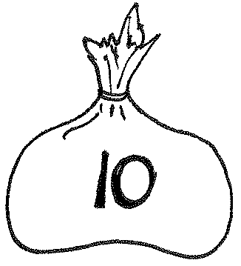
1.
__3__ tens + ____ tens = ____ tens

30 + 20 =_______
20
30
50
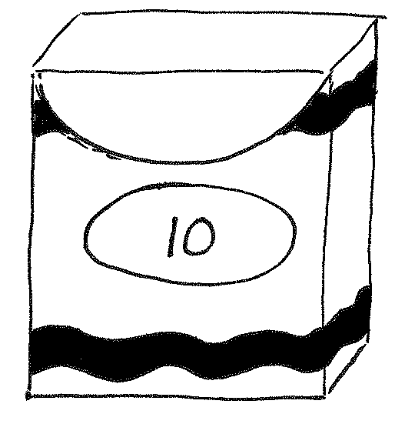
2.
____ tens + ____ tens = ____ tens

_________________________

3.
____ tens – ____ tens = ____tens

_________________________

4.
____ tens + ____ tens = ____ tens

_________________________

5.
____ tens – ____ tens = ____ tens

_________________________

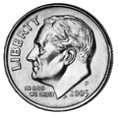
Count the dimes to add or subtract. Write a number sentence to match the dimes.
40 + 20 =
+
_____________________________
6.
_____________________________

7.
+
_____________________________
8.

_____________________________
9.

_____________________________
10.

11. Fill in the missing numbers.
a. 40 + 40 = _____ b. 50 – 30 = _____ c. 10 + _____ = 70

d. 60 – _____ = 0 e. 90 – _____ = 10 f. 70 + _____ = 90

g. 50 + 40 = _____ h. 100 – 30 = _____ i. 100 – _____ = 70

Name Date

- Fill in the missing numbers.

a. 40 + 50 = _____ b. 80 – 60 = _____ c. 30 + _____ = 70

- Write a number sentence to match the picture.
_____________________________
Name Date

- Complete the number bond or number sentence, and find the matching picture.
90
30

a.

b.
_____ – 40 = 60

60
40

c.

d.
80 – _____ = 60
- Fill in the missing numbers.
a. 70 + _____ = 90 b. _____ + 30 = 80 c. 100 – _____ = 20

d. 30 + 60 = _____ e. 70 – _____ = 20 f. 20 + _____ = 60

g. _____ – 20 = 60 h. 90 – _____ = 20 i. 50 + _____ = 100

- Count the dimes to add or subtract. Write a number sentence to match the dimes.
a.
40 + 20 =

b.
_____________________________

c.
_____________________________
+
+
_____________________________

d.
_____________________________

_____ _____ _____

_____ ten _____ ten _____ ten

______ ______ ______

