Lesson 18: Looking More Carefully at Parallel Lines

Classwork
Opening Exercise
Exchange Problem Sets with a classmate. Solve the problems posed by your classmate while he or she solves yours. Compare your solutions, and then discuss and resolve any discrepancies. Why were you asked only to locate the point of rotation, rather than to rotate a pre-image to obtain the image? How did you use perpendicular bisectors in constructing your solutions?

Discussion
We say that two lines are parallel if they lie in the same plane and do not intersect. Two segments or rays are parallel if the lines containing them are parallel.

Example 1
Why is the phrase in the plane critical to the definition of parallel lines? Explain and illustrate your reasoning.

In Lesson 7, we recalled some basic facts learned in earlier grades about pairs of lines and angles created by a transversal to those lines. One of those basic facts is the following:
Suppose a transversal intersects a pair of lines. The lines are parallel if and only if a pair of alternate interior angles are equal in measure.
Our goal in this lesson is to prove this theorem using basic rigid motions, geometry assumptions, and a geometry assumption we will introduce in this lesson called the parallel postulate. Of all of the geometry assumptions we have given so far, the parallel postulate gets a special name because of the special role it played in the history of mathematics. (Euclid included a version of the parallel postulate in his books, and for $2,000$ years people tried to show that it was not a necessary assumption. Not only did it turn out that the assumption was necessary for Euclidean geometry, but study of the parallel postulate lead to the creation of non-Euclidean geometries.)
The basic fact above really has two parts, which we prove separately:
- Suppose a transversal intersects a pair of lines. If two alternate interior angles are equal in measure, then the pair of lines are parallel.
- Suppose a transversal intersects a pair of lines. If the lines are parallel, then the pair of alternate interior angles are equal in measure.
The second part turns out to be an equivalent form of the parallel postulate. To build up to the theorem, first we need to do a construction.

Example 2
Given a line $l$ and a point $P$not on the line, follow the steps below to rotate $l$ by $180˚$ to a line $l^{'}$ that passes through $P$:

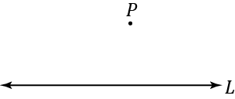

  - Label any point $A$ on $l$.

  - Find the midpoint of segment $AP$ using a ruler. (Measure the length of segment $AP$, and locate the point that is distance $\frac{AP}{2}$ from $A$ between $A$ and $P.$) Label the midpoint $C$.

  - Perform a $180˚$ rotation around center $C$. To quickly find the image of 𝒍 under this rotation by hand:
    - Pick another point $B$ on $l$.
    - Draw $\overset{⃡}{CB}$.
    - Draw circle: center $C,$ radius $CB$
    - Label the other point where the circle intersects $\overset{⃡}{CB}$ by $Q$.
    - Draw $\overset{⃡}{PQ}$.

  - Label the image of the rotation by $180˚$ of $l$ by $l^{'}=R_{C,180}(l)$.

How does your construction relate to the geometry assumption stated above to rotations? Complete the statement below to clarify your observations:
$R_{C,180}$ is a $180°$___________ around $C$. Rotations preserve __________ therefore $R_{C,180}$ maps the line $l$ to the line ___________. What is $R_{C,180}\left(A\right)$? ___________.
Example 3
The lines$l$and $l^{'}$ in the picture above certainly look parallel, but we do not have to rely on “looks.”
Claim: In the construction above, $l$is parallel to $l^{'}$.
Proof: We will show that assuming they are not parallel leads to a contradiction. If they are not parallel, then they must intersect somewhere, call that point $X$. Since $X$ is on $l^{'}$, it must be the image of some point $S$ on $l$ under the $R_{C,180}$ rotation, i.e., $R_{C,180}\left(S\right)=X$. Since $R_{C,180}$ is a 180˚ rotation, $S$ and $X$ must be the endpoints of a diameter of a circle that has center $C$. In particular, $\overset{⃡}{SX}$ must contain $C$. Since $S$ is a point on $l$, and $X$ is a different point on $l$ (it was the intersection of both lines), we have that $l=\overset{⃡}{SX}$ because there is only one line through two points. But $\overset{⃡}{SX}$ also contains $C$, which means that $l$ contains $C$. However, $C$ was constructed so that it was not on $l$. This is absurd.
There are only two possibilities for any two distinct lines $l$ and $l^{'}$ in a plane: either the lines are parallel or they are not parallel. Since assuming the lines were not parallel lead to a false conclusion, the only possibility left is that $l$ and $l^{'}$ were parallel to begin with.

Example 4
The construction and claim together implies the following theorem.
Theorem: Given a line $l$ and a point $P$ not on the line, then there exists line $l^{'}$ that contains $P$ and is parallel to $l$.

This is a theorem we have justified before using compass and straightedge constructions, but now we see it follows directly from basic rigid motions and our geometry assumptions.

Example 5
We are now ready to prove the first part of the basic fact above. We have two lines, $l$ and $l^{'}$, and all we know is that a transversal $\overset{⃡}{AP}$ intersects $l$ and $l^{'}$ such that a pair of alternate interior angles are equal in measure. (In the picture below we are assuming $m∠QPA=m∠BAP.$)
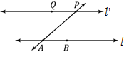

Let $C$ be the midpoint of $\overline{AP}$. What happens if you rotate $180˚$ around the center $C$? Is there enough information to show that $R_{C,180}\left(l\right)=l^{'}$?

  - What is the image of the segment $AP$?

  - In particular, what is the image of the point $A$?

  - Why are the points $Q$ and $R_{C,180}(B)$ on the same side of $\overset{⃡}{AP}$?

  - What is the image of $R_{C,180}(∠BAP)$? $∠QPA$ Why?

  - Why is $R_{C,180}\left(l\right)=l^{'}$?

We have just proved that a rotation by $180˚$takes $l$ to $l^{'}$. By the claim in Example 3, lines $l$ and $l^{'}$ must be parallel, which is summarized below.
Theorem: Suppose a transversal intersects a pair of lines. If a pair of alternate interior angles are equal in measure, then the pair of lines are parallel.

Discussion
In Example 5, suppose we had used a different rotation to construct a line parallel to $l$that contains $P$. Such constructions are certainly plentiful. For example, for every other point $D$ on $l$, we can find the midpoint of segment
$PD$, and use the construction in Example 2 to construct a different 180˚ rotation around a different center such that the image of the line $l$ is a parallel line through the point $P$. Are any of these parallel lines through $P$ different? In other words,
Can we draw a line other than the line $l^{'}$ through $P$ that never meets $l$?
The answer may surprise you; it stumped mathematicians and physicists for centuries. In nature, the answer is that it is sometimes possible and sometimes not. This is because there are places in the universe (near massive stars, for example) where the model geometry of space is not “plane-like” or flat, but is actually quite curved. To rule out these other types of “strange but beautiful” geometries, we must assume that the answer to the question above is only one line. That choice becomes one of our geometry assumptions:
(Parallel Postulate) Through a given external point there is at most one line parallel to a given line.
In other words, we assume that for any point $P$ in the plane not lying on a line $l$, every line in the plane that contains $P$ intersects $l$ except at most one line—the one we call parallel to $l$.

Example 6
We can use the parallel postulate to prove the second part of the basic fact.
Theorem: Suppose a transversal intersects a pair of lines. If the pair of lines are parallel, then the pair of alternate interior angles are equal in measure.
Proof: Suppose that a transversal $\overset{⃡}{AP}$ intersects line $l$ at $A$ and $l^{'}$ at $P$; pick and label another point $B$ on $l$ and choose a point $Q$ on $l^{'}$ on the opposite side of $\overset{⃡}{AP}$ as $B$. The picture might look like the figure below:
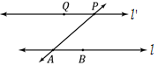

Let $C$ be the midpoint of segment $\overline{AP}$, and apply a rotation by 180˚ around the center $C$. As in previous discussions, the image of $l$ is the line $R_{C,180}\left(l\right)$ which is parallel to $l$ and contains point $P$. Since $l^{'}$ and $R_{C,180}\left(l\right)$ are both parallel to $l$ and contain $P$, by the parallel postulate, they must be the same line: $R_{C,180}\left(l\right)=l^{'}$. In particular, $R_{C,180}\left(∠BAP\right)=∠QPA$. Since rotations preserve angle measures, $m∠BAP=m∠QPA$, which was what we needed to show.
Discussion
It is important to point out that, although we only proved the alternate interior angles theorem, the same sort of proofs can be done in the exact same way to prove the corresponding angles theorem and the interior angles theorem. Thus, all of the proofs we have done so far (in class and in the Problem Sets) that use these facts are really based, in part, on our assumptions about rigid motions!
Example 7
We end this lesson with a theorem that we will just state, but can be easily proved using the parallel postulate.
Theorem: If three distinct lines $l_{1}$, $l_{2}$, and $l_{3}$ in the plane have the property that $l_{1}∥l_{2}$ and $l_{2}∥l_{3}$, then $l_{1}∥l_{3}$. (In proofs, this can be written as, “If two lines are parallel to the same line, then they are parallel to each other.”)
Relevant Vocabulary
Parallel: Two lines are parallel if they lie in the same plane and do not intersect. Two segments or rays are parallel if the lines containing them are parallel lines.
Transversal: Given a pair of lines $l$ and $m$ in a plane, a third line $t$is a transversal if it intersects $l$ at a single point and intersects $m$ at a single but different point.
The definition of transversal rules out the possibility that any two of the lines $l$, $m$, and $t$ are the same line.
Alternate Interior Angles: Let line $t$be a transversal to lines $l$ and $m$ such that $t$intersects $l$ at point $P$and intersects $m$ at point $Q$. Let $R$ be a point on $l$ and $S$ be a point on $m$ such that the points $R$ and $S$ lie in opposite half-planes of $t$. Then the angle $∠RPQ$ and the angle $∠PQS$ are called alternate interior angles of the transversal $t$ with respect to $m$ and $l$.
Corresponding Angles: Let line $t$be a transversal to lines $l$ and $m$. If $∠x$ and $∠y$ are alternate interior angles, and $∠y$ and $∠z$ are vertical angles, then $∠x$ and $∠z$ are corresponding angles.
Problem Set

Notice that we are frequently asked two types of questions about parallel lines. If we are told that two lines are parallel, then we may be required to use this information to prove the congruence of two angles (corresponding, alternate interior, etc.). On the other hand, if we are given the fact that two angles are congruent (or perhaps supplementary), we may have to prove that two lines are parallel.
- In the figure, $AL∥BM$, $AL CF$, and $GK BM$. Prove that $CF∥GK$.
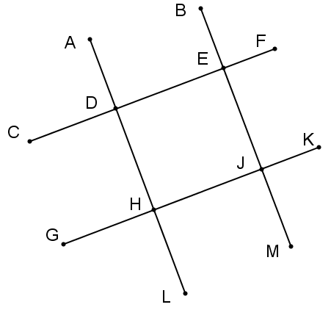

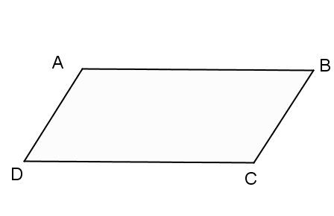
- Given that ∠$B$ and ∠$C$ are supplementary and $mA=$ $mC$, prove that $AD∥BC$.

- Mathematicians state that if a transversal to two parallel lines is perpendicular to one of the lines, then it is perpendicular to the other. Prove this statement. (Include a labeled drawing with your proof.)

- In the figure, $AB∥CD$ and $EF∥GH$. Prove that ∠$AFE =$∠$DKH$.
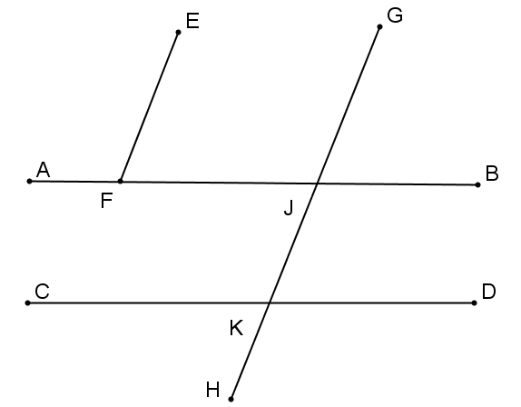

- In the figure, ∠$E$ and ∠$AFE$ are complementary and ∠$C$ and ∠$BDC$ are complementary. Prove that $AE∥ CB$.
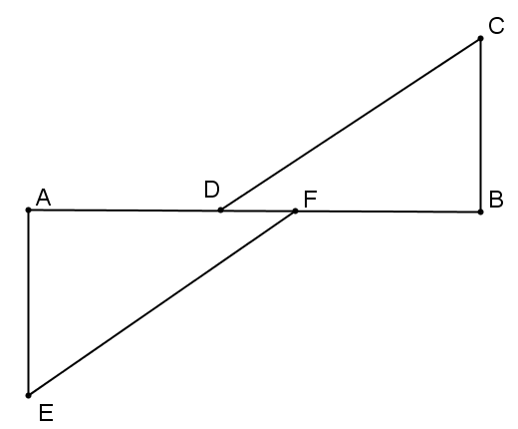

- Given a line $l$ and a point $P$ not on the line, the following directions can be used to draw a line $m$ perpendicular to the line $l$ through the point $P$ based upon a rotation by $180˚$:
  - Pick and label a point $A$ on the line $l$ so that the circle (center $P$, radius $AP$) intersects $l$ twice.
  - Use a protractor to draw a perpendicular line $n$ through the point $A$ (by constructing a $90˚$ angle).
  - Use the directions in Example 2 to construct a parallel line $m$ through the point $P$.
Do the construction. Why is the line $m$ perpendicular to the line $l$ in the figure you drew? Why is the line $m$ the only perpendicular line to $l$ through $P$?
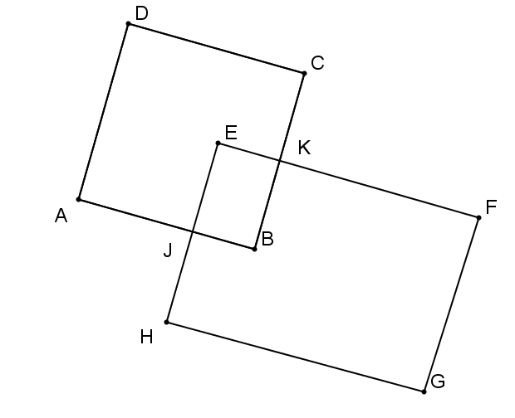
Problems 7–10 all refer to the figure to the right. The exercises are otherwise unrelated to each other.

- $\overline{AD}$⎟⎜$\overline{BC}$ and $EJB$ is supplementary to $JBK$. Prove that $\overline{AD}$⎟⎜$\overline{JE}$.

- $\overline{AD}∥\overline{FG}$ and $\overline{EJ}∥\overline{FG}$. Prove that ∠$DAJ$ and ∠$EJA$ are supplementary.

- $mC = mG$ and $B$ is supplementary to $G$. Prove that $\overline{DC}∥\overline{AB}$.

- $\overline{AB}∥\overline{EF}$, $\overline{EF}$ ⊥ $\overline{CB}$, and $EKC$ is supplementary to $KCD$. Prove that $\overline{AB}∥\overline{DC}$.

