|  |
| --- |
|  |

Lesson 16: Translations

Student Outcome

* Students learn the precise definition of a translation and perform a translation by construction.

Lesson Notes

In Lesson 16, students precisely define translations and use the construction of a parallelogram to demonstrate how to apply a translation to a figure. The students then use vectors to describe the translations. This may be the first time many students have seen vectors, so some additional explanation may be needed (a vector is a directed line segment that has both length and direction).

Refer to Lesson 2 of Grade 8, Module 2 for supplementary materials on use of vectors, as well as on translations in general.

Classwork

Exploratory Challenge (5 minutes)

Exploratory Challenge

In Lesson 4, you completed a construction exercise that resulted in a pair of parallel lines (Problem 1 from the Problem Set). Now we examine an alternate construction.

Construct the line parallel to a given line through a given point .

1. Draw circle : Center , radius .
2. Draw circle : Center , radius .
3. Label the intersection of circle and circle as .
4. Draw .

*Note:* Circles and intersect in two locations. Pick the intersection so that points and are in opposite half-planes of line .



The construction shows that and are equal, alternate interior angles. Hence, by the alternate interior angles converse, .

Discussion (10 minutes)

Discussion

To perform a translation, we need to use the above construction. Let us investigate the definition of translation.

For vector , the *translation along* is the transformation of the plane defined as follows:

1. For any point on the line , is the point on so that has the same length and the same direction as , and
2. For any point not on , is the point obtained as follows. Let be the line passing through and parallel to . Let be the line passing through and parallel to line . The point is the intersection of and .

*Note:* The parallel line construction above shows a quick way to find the point in part 2 of the definition of translation!

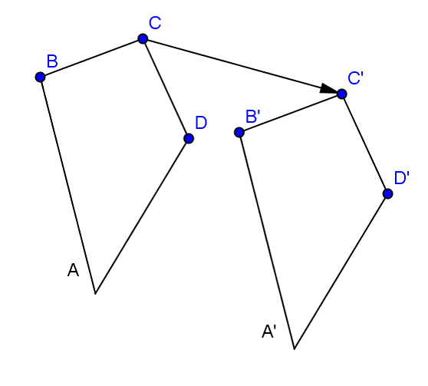  
In the figure to the right, quadrilateral has been translated the length and direction of vector . Notice that the distance and direction from each vertex to its corresponding vertex on the image are identical to that of .

**Example 1 (8 minutes)**

**Example 1**

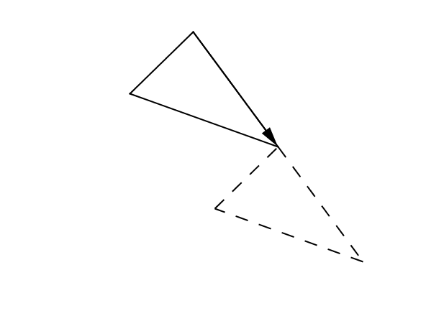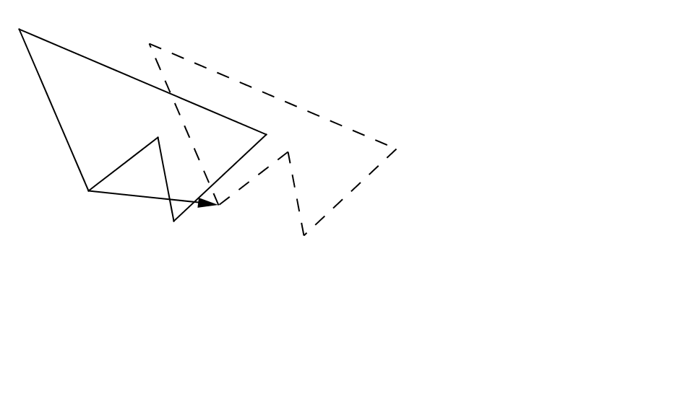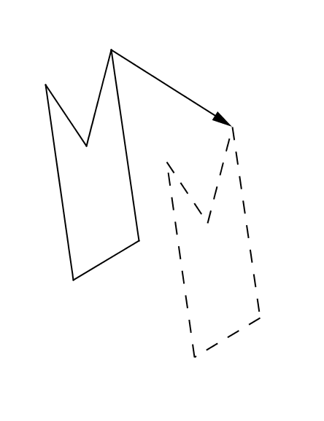

**D**raw the vector that defines each translation below.

Finding the vector is relatively straightforward. Applying a vector to translate a figure is more challenging. To translate a figure, we must construct parallel lines to the vector through the vertices of the original figure and then find the points on those parallel lines that are the same direction and distance away as given by the vector.

Example 2 (8 minutes)

  
Example 2

Use your compass and straightedge to apply to segment .

*Note:* Use the steps from the Exploratory Challenge *twice* for this question, creating two lines parallel to : one through and one through .

Example 3 (8 minutes)

Example 3

Use your compass and straightedge to apply to .



Relevant Vocabulary

Parallel: Two lines are parallel if they lie in the same plane and do not intersect. Two segments or rays are parallel if the lines containing them are parallel lines.

Closing

Lesson Summary

* A translation carries segments onto segments of equal length.
* A translation carries angles onto angles of equal measure.

Exit Ticket (5 minutes)

Name ___________________________________________________ Date____________________

Lesson 16: Translations

Exit Ticket

Translate the image one unit down and three units right. Draw the vector that defines the translation.

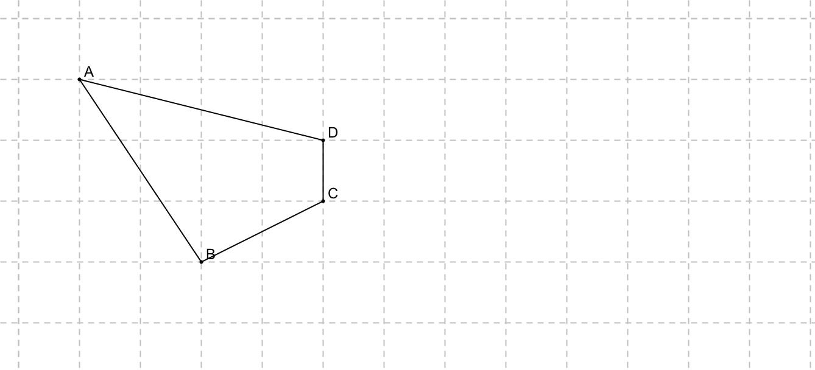

Exit Ticket Sample Solutions

Translate the figure one unit down and three units right. Draw the vector that defines the translation.

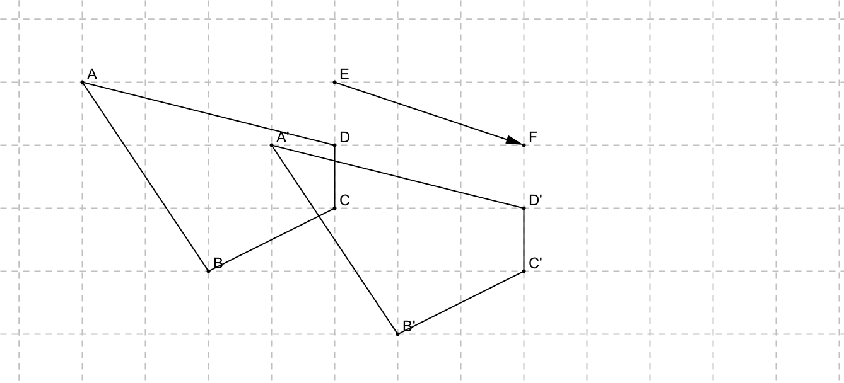

Problem Set Sample Solutions

Translate each figure according to the instructions provided.

|  |  |
| --- | --- |
| 1. 2 units down and 3 units left.   Draw the vector that defines the translation. | 1. 1 unit up and 2 units right.   Draw the vector that defines the translation. |

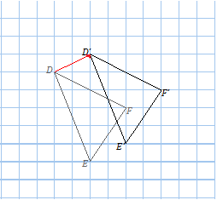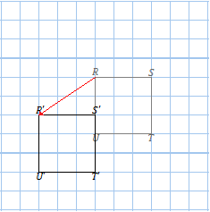

1. Use your compass and straightedge to apply to the circle below (center , radius ).

To translate the circle is to translate its radius.



1. Use your compass and straightedge to apply to the circle below.

*Hint:* You will need to first find the center of the circle. You can use what you learned in Lesson 4 to do this.

* To find the center of the circle (and thereby also the radius of the circle), draw any chord within the circle. Construct the perpendicular bisector of the chord, and mark the diameter of the circle, which contains the center of the circle. Finally, use a perpendicular bisector to find the midpoint of the diameter.
* Once the center has been established, the problem is similar to Problem 3.



Two classic toothpick puzzles appear below. Solve each puzzle.

1. 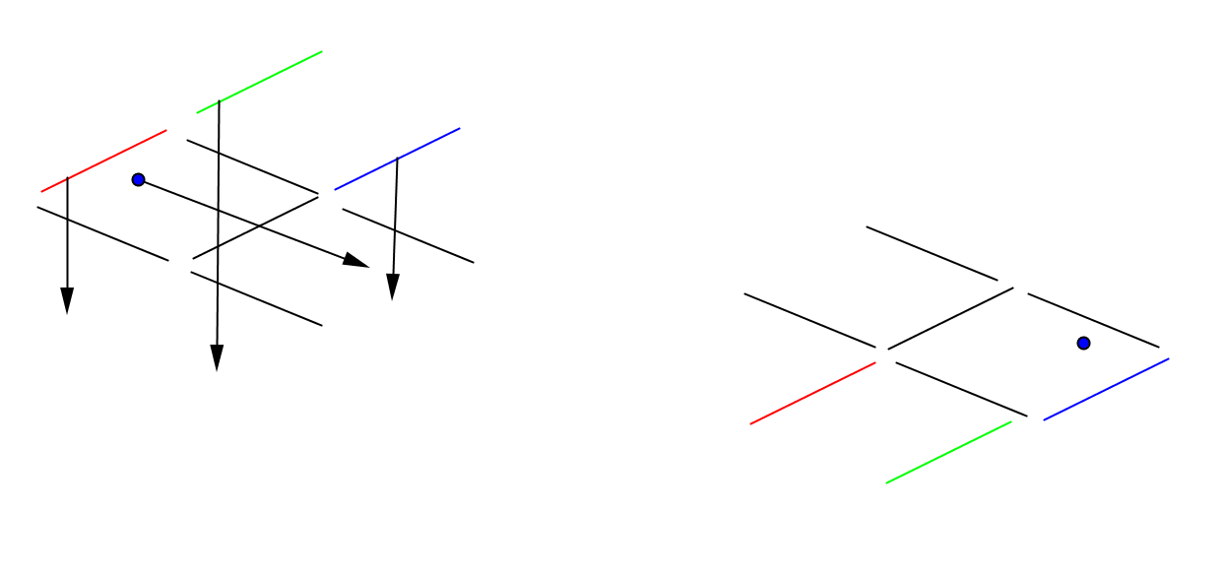Each segment on the fish represents a toothpick. Move (translate) exactly three toothpicks and the eye to make the fish swim in the opposite direction. Show the translation vectors needed to move each of the three toothpicks and the eye.

1. Again, each segment represents a single toothpick. Move (translate) exactly three toothpicks to make the “triangle” point downward. Show the translation vectors needed to move each of the three toothpicks.

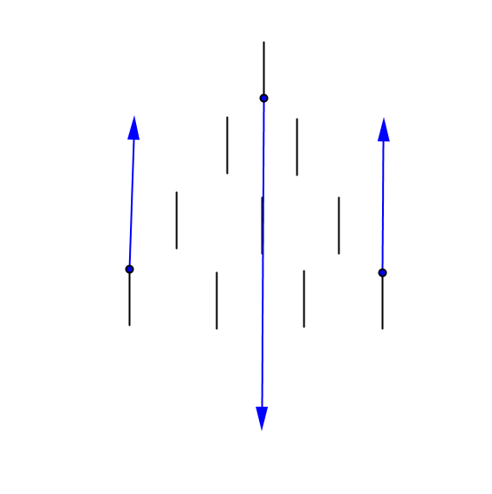

1. Apply to translate .

