|  |
| --- |
|  |

Lesson 15: Rotations, Reflections, and Symmetry

Student Outcomes

* Students learn the relationship between a reflection and a rotation.
* Students examine rotational symmetry within an individual figure.

Lesson Notes

In Lesson 15, students investigated how rotations and reflections can elicit the symmetries within a rectangle, parallelogram, trapezoids, and regular polygons. Students explore the differences between line symmetry and rotational symmetry and how to identify and apply each type of symmetry.

Classwork

Opening Exercise (5 minutes)

Opening Exercise

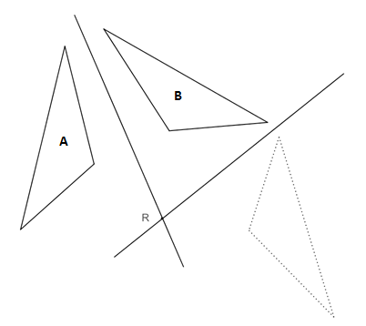The original triangle, labeled with “A,” has been reflected across the first line, resulting in the image labeled with “B.” Reflect the image across the second line.

Carlos looked at the image of the reflection across the second line and said, “That’s not the image of triangle “A” after two reflections, that’s the image of triangle “A” after a rotation!” Do you agree? Why or why not?

While a rotation was not performed in this example, Carlos is correct that reflecting a figure twice over intersecting lines yields the same result as a rotation. The point R is the center of rotation.

Discussion (2 minutes)

Discussion

When you reflect a figure across a line, the original figure and its image share a line of symmetry, which we have called the line of reflection. When you reflect a figure across a line, then reflect the image across a line that intersects the first line, your final image is a rotation of the original figure. The center of rotation is the point at which the two lines of reflection intersect. The angle of rotation is determined by connecting the center of rotation to a pair of corresponding vertices on the original figure and the final image. The figure above is a rotation (or clockwise rotation).

Exploratory Challenge (25 minutes)

Exploratory Challenge

Line of Symmetry of a Figure: This is an isosceles triangle. By definition, an isosceles triangle has at least two congruent sides. A line of symmetry of the triangle can be drawn from the top vertex to the midpoint of the base, decomposing the original triangle into two congruent right triangles. This line of symmetry can be thought of as a reflection across itself that takes the isosceles triangle to itself. Every point of the triangle on one side of the line of symmetry has a corresponding point on the triangle on the other side of the line of symmetry, given by reflecting the point across the line. In particular, the line of symmetry is equidistant from all corresponding pairs of points. Another way of thinking about line symmetry is that a figure has line symmetry if there exists a line (or lines) such that the image of the figure when reflected over the line is itself.

Does every figure have a line of symmetry?

No.

Which of the following have multiple lines of symmetry?

The rectangle and hexagon have multiple lines of symmetry.

Use your compass and straightedge to draw one line of symmetry on each figure above that has at least one line of symmetry. Then, sketch any remaining lines of symmetry that exist. What did you do to justify that the lines you constructed were, in fact, lines of symmetry? How can you be certain that you have found all lines of symmetry?

Students may have measured angles or used patty paper to prove the symmetry.

Rotational Symmetry of a Figure: A nontrivial rotational symmetry of a figure is a rotation of the plane that maps the figure back to itself such that the rotation is greater than but less than . Three of the four polygons above have a nontrivial rotational symmetry. Can you identify the polygon that does not have such symmetry?

**The triangle does not have such symmetry.**

When we studied rotations two lessons ago, we located both a center of rotation and an angle of rotation.

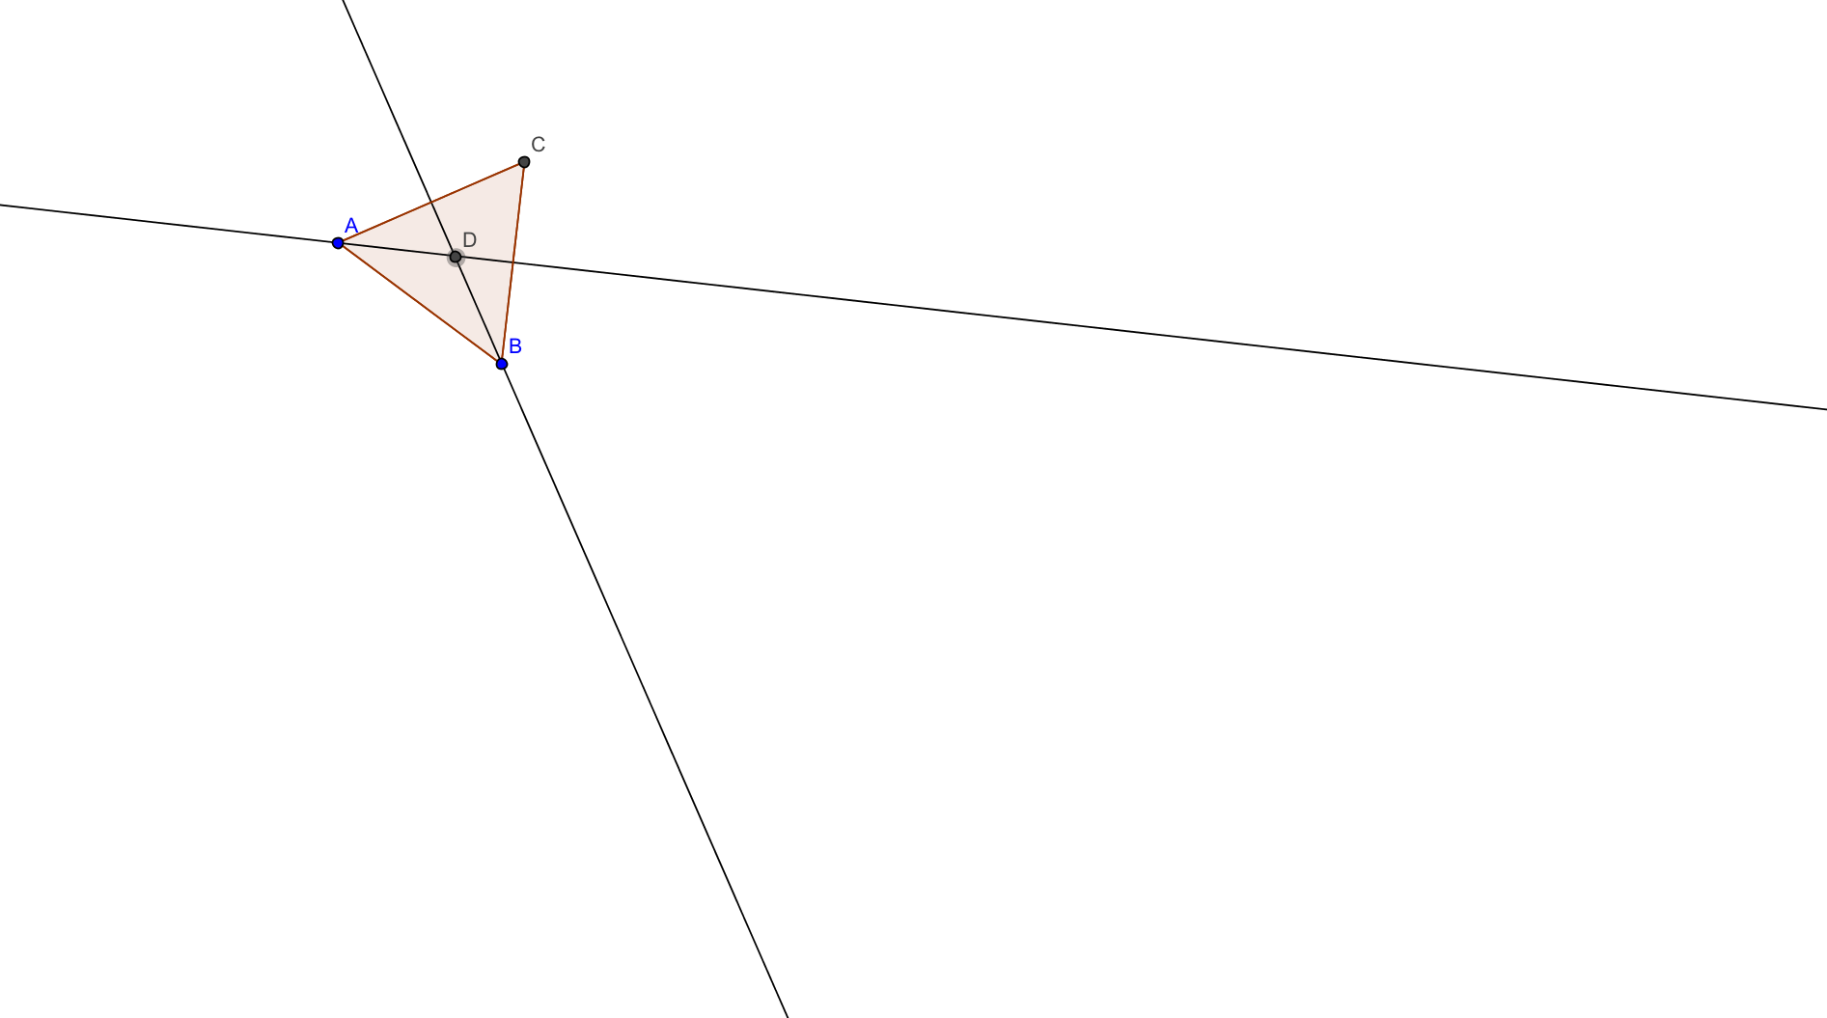  
Identify the center of rotation in the equilateral triangle below and label it . Follow the directions in the paragraph below to locate the center precisely.

To identify the center of rotation in the equilateral triangle, the simplest method is finding the perpendicular bisector of at least two of the sides. The intersection of these two bisectors gives us the center of rotation. Hence, the center of rotation of an equilateral triangle is also the circumcenter of the triangle. In Lesson 5 of this module, you also located another special point of concurrency in triangles—the incenter. What do you notice about the incenter and circumcenter in the equilateral triangle?

They are the same point.

In any regular polygon, how do you determine the angle of rotation? Use the equilateral triangle above to determine the method for calculating the angle of rotation, and try it out on the rectangle, hexagon, and parallelogram above.

Identity Symmetry: A symmetry of a figure is a basic rigid motion that maps the figure back onto itself. There is a special transformation that trivially maps any figure in the plane back to itself called the *identity transformation*. This transformation, like the function defined on the real number line by the equation , maps each point in the plane back to the same point (in the same way that maps to , to , and so forth). It may seem strange to discuss the “do nothing” identity symmetry (the symmetry of a figure under the identity transformation), but it is actually quite useful when listing all of the symmetries of a figure.

Let us look at an example to see why. The equilateral triangle above has two nontrivial rotations about its circumcenter , a rotation by and a rotation by . Notice that performing two rotations back-to-back is the same as performing one rotation. We can write these two back-to-back rotations explicitly, as follows:

* First, rotate the triangle by about : .
* Next, rotate the image of the first rotation by: .

Rotating by twice in a row is the same as rotating once by . Hence, rotating by twice is equivalent to one rotation by :

In later lessons, we will see that this can be written compactly as . What if we rotated by one more time? That is, what if we rotated by three times in a row? That would be equivalent to rotating once by or . But a rotation by is equivalent to doing nothing, i.e., the identity transformation! If we use to denote the identity transformation ( for every point in the plane), we can write this equivalency as follows:

Continuing in this way, we see that rotating by four times in a row is the same as rotating once by , rotating five times in a row is the same as , and so on. In fact, for a whole number , rotating by times in a row is equivalent to performing one of the following three transformations:

Hence, by including identity transformation in our list of rotational symmetries, we can write any number of rotations of by using only three transformations. For this reason, we include the identity transformation as a type of symmetry as well.

Exercises 1–3 (10 minutes)

  
Exercises 1–3

Figure 1

Use Figure 1 to answer the questions below.

1. Draw all lines of symmetry. Locate the center of rotational symmetry.
2. Describe all symmetries explicitly.
   1. What kinds are there?

Line symmetry, rotational symmetry, and the identity symmetry

* 1. How many are rotations? (Include “ rotational symmetry,” i.e., the identity symmetry.)

(, , , )

* 1. How many are reflections?

1. Prove that you have found all possible symmetries.
   1. How many places can vertex be moved to by some symmetry of the square that you have identified? (Note that the vertex to which you move by some specific symmetry is known as the image of under that symmetry. Did you remember the identity symmetry?)

– Vertex A can be moved to either , , , or .

* 1. For a given symmetry, if you know the image of , how many possibilities exist for the image of ?
  2. Verify that there is symmetry for all possible images of and .

is the identity is reflection along , is a rotation by , etc.

* 1. Using part (b), count the number of possible images of and . This is the total number of symmetries of the square. Does your answer match up with the sum of the numbers from Exercise 2 parts (b) and (c)?

Relevant Vocabulary

Regular Polygon: A polygon is *regular* if all sides have equal length and all interior angles have equal measure.

Exit Ticket (3 minutes)

Name ___________________________________________________ Date____________________

Lesson 15: Rotations, Reflections, and Symmetry

Exit Ticket

What is the relationship between a rotation and reflection? Sketch a diagram that supports your explanation.

Exit Ticket Sample Solutions

What is the relationship between a rotation and reflection? Sketch a diagram that supports your explanation.

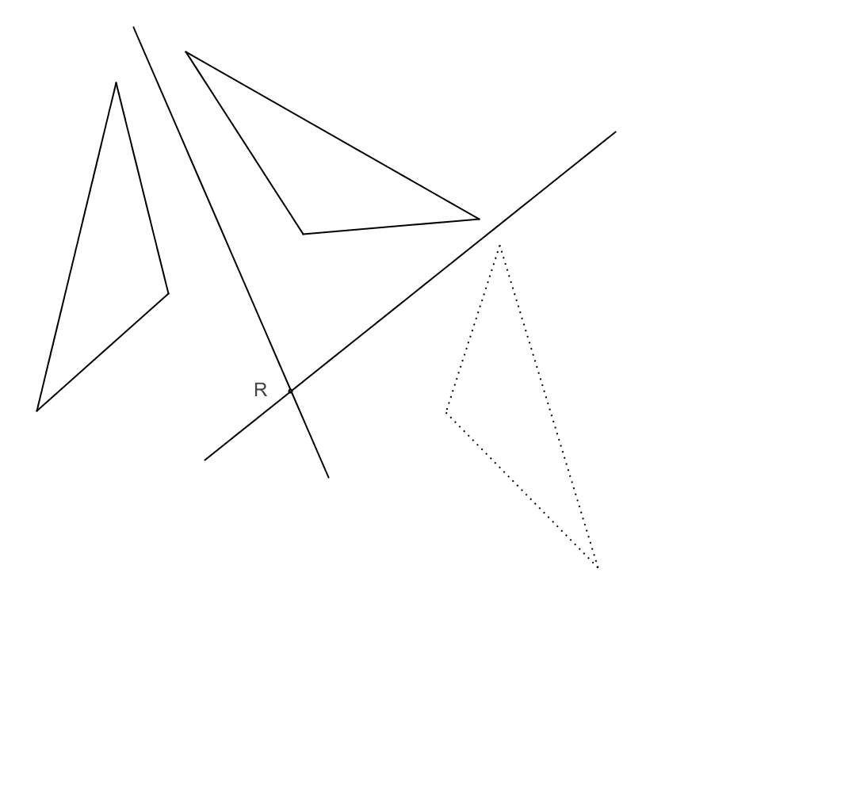Reflecting a figure twice over intersecting lines yields the same result as a rotation.

Problem Set Sample Solutions

Use Figure 1 to answer Problems 1–3.

Figure 1

1. Draw all lines of symmetry. Locate the center of rotational symmetry.
2. Describe all symmetries explicitly.
   1. What kinds are there?

Rotational symmetry, line symmetry, and the identity symmetry

* 1. How many are rotations (including the identity symmetry)?
  2. How many are reflections?

1. Now that you have found the symmetries of the pentagon, consider these questions:
   1. How many places can vertex be moved to by some symmetry of the pentagon? (Note that the vertex to which you move A by some specific symmetry is known as the image of under that symmetry. Did you remember the identity symmetry?)

– Vertex A can be moved to either , , , or .

* 1. For a given symmetry, if you know the image of , how many possibilities exist for the image of ?

is the identity, is reflection along , is a rotation by , etc.

* 1. Verify that there is symmetry for all possible images of and .
  2. Using part (b), count the number of possible images of and . This is the total number of symmetries of the figure. Does your answer match up with the sum of the numbers from Problem 2 parts (b) and (c)?

Use Figure 2 to answer Problem 4.

Figure 2

1. Shade exactly two of the nine smaller squares so that the resulting figure has
   1. Only one vertical and one horizontal line of symmetry.
   2. Only two lines of symmetry about the diagonals.
   3. Only one horizontal line of symmetry.
   4. Only one line of symmetry about a diagonal.
   5. No line of symmetry.

Possible answers:

a. b. c. d. e.

Use Figure 3 to answer Problem 5.

Figure 3

1. 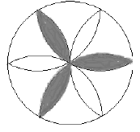Describe all the symmetries explicitly.
   1. How many are rotations (including the identity symmetry)?
   2. How many are reflections?
   3. How could you shade the figure so that the resulting figure only has three possible rotational symmetries (including the identity symmetry)?

See the figure for an example.

1. Decide whether each of the statements is true or false. Provide a counterexample if the answer is false.
   1. If a figure has exactly two lines of symmetry, it has exactly two rotational symmetries (including the identity symmetry).

True

* 1. If a figure has at least three lines of symmetry, it has at least three rotational symmetries (including the identity symmetry).

True

* 1. If a figure has exactly two rotational symmetries (including the identity symmetry), it has exactly two lines of symmetry.

False; e.g., a parallelogram

* 1. 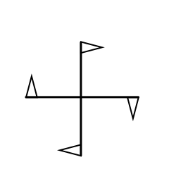If a figure has at least three rotational symmetries (including the identity symmetry), it has at least three lines of symmetry.

False; e.g.,