|  |
| --- |
|  |

Lesson 14: Reflections

Student Outcomes

* Students learn the precise definition of a reflection.
* Students construct the line of reflection of a figure and its reflected image. Students construct the image of a figure when provided the line of reflection.

Lesson Notes

In Lesson 14, students precisely define a reflection and will construct reflections using a perpendicular bisector and circles. Students continue focusing on their use of vocabulary throughout the lesson with their discussion of the constructions. The exploratory nature of this lesson allows for students to discover uses for the skills they have learned in previous construction lessons in addition to the vocabulary they have been working on.

*Teachers should continue to stress that reflections preserve the lengths of segments (distance-preserving) and the measures of the angles of the figures being reflected (angle-preserving).*

Reflections are one of the three basic rigid motions used to form the definition of one the main ideas in geometry, which is congruence. Essential to students’understanding of the definition of congruence is the realization (1) that reflections preserve distances and angle measures and (2) that a reflection can be performed across *any line* in the plane.

Note that in many cases, it will be assumed that the “prime” notation indicates the image of a figure after a transformation (e.g., is the image of ).

Classwork

Exploratory Challenge (10 minutes)

*Note to Teacher:*

Due to space limitations, only the perpendicular bisector of has been shown here.

Students will discuss that each of the perpendicular bisectors they drew lined up exactly with the line of reflection. The class can discuss whether they think this will always be the case and why the distance to the perpendicular bisector from each point is equivalent. Help students to create a set of guidelines for constructing reflections using precise vocabulary.

Exploratory Challenge

Think back to Lesson 12 where you were asked to describe to your partner how to reflect a figure across a line. The greatest challenge in providing the description was using the precise vocabulary necessary for accurate results. Let’s explore the language that will yield the results we are looking for.

is reflected across and maps onto .

Use your compass and straightedge to construct the perpendicular bisector of each of the segments connecting to , to , and to . What do you notice about these perpendicular bisectors?

Label the point at which intersects as point . What is true about and ? How do you know this is true?

. I constructed the perpendicular bisector, and is the point where the perpendicular bisector crosses , so it is halfway between and .

**Examples 1–5 (32 minutes)**

Discussion

You just demonstrated that the line of reflection between a figure and its reflected image is also the perpendicular bisector of the segments connecting corresponding points on the figures.

In the Exploratory Challenge, you were given both the pre-image, image, and the line of reflection. For your next challenge, try finding the line of reflection provided a pre-image and image.

Example 1

Construct the segment that represents the line of reflection for quadrilateral and its image .

**MP.5**

What is true about each point on and its corresponding point on with respect to the line of reflection?

Each pair of corresponding points is equidistant from the line of reflection.

Notice one very important fact about reflections. Every point in the original figure is carried to a corresponding point on the image by the same rule—a reflection across a specific line. This brings us to a critical definition:

Reflection: For a line in the plane, a *reflection across* is the transformation of the plane defined as follows:

**MP.6**

1. For any point on the line , , and
2. For any point not on , is the point so that is the perpendicular bisector of the segment .

If the line is specified using two points, as in , then the reflection is often denoted by . Just as we did in the last lesson, let’s examine this definition more closely:

* *A transformation of the plane*—the entire plane is transformed; what was once on one side of the line of reflection is now on the opposite side;

**MP.6**

* *means that the points on line are left fixed*—the only part of the entire plane that is left fixed is the line of reflection itself;
* is the point —the transformation maps the point to the point ;
* So that is the perpendicular bisector of the segment —to find , first construct the perpendicular line to the line that passes through the point . Label the intersection of and as . Then locate the point on on the other side of such that .

Examples 2–3

Construct the line of reflection across which each image below was reflected.

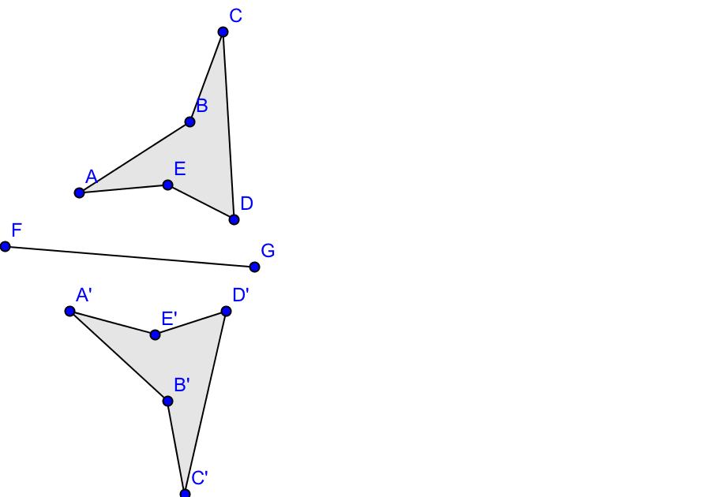2. 3.

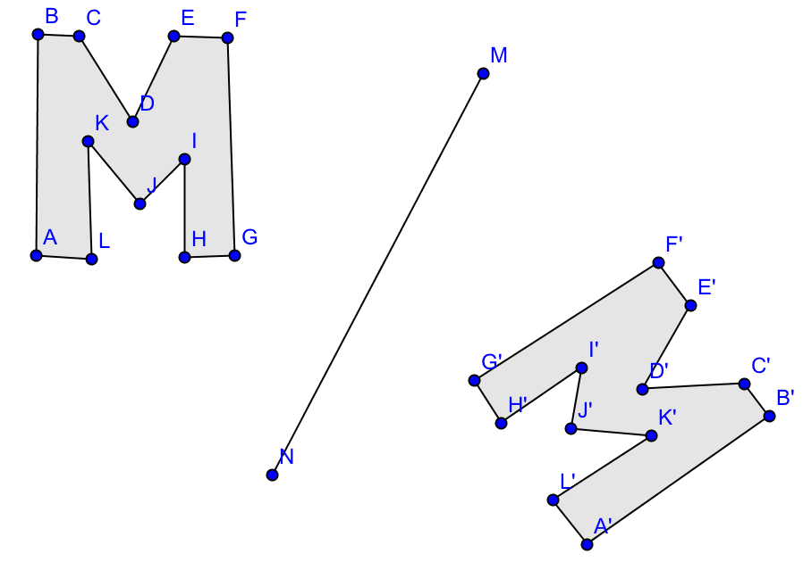

Next, students complete a reflection using circles. The teacher may wish to go through the steps with the students or give the steps to the students and have them work independently. As the students work, encourage them to think and discuss why using circles allows us to construct a reflection. Remind them of what they discovered in the Exploratory Challengeas well as Euclid’s use of circles when constructing equilateral triangles. Consider also asking students to confirm the properties of reflections and conclude that they preserve the lengths of segments and the measures of the angles of the figures being reflected.

You have shown that a line of reflection is the perpendicular bisector of segments connecting corresponding points on a figure and its reflected image. You have also constructed a line of reflection between a figure and its reflected image. Now we need to explore methods for constructing the reflected image itself. The first few steps are provided for you in this next stage.

Example 4

The task at hand is to construct the reflection of over line . Follow the steps below to get started; then complete the construction on your own.

1. Construct circle : center, with radius such that the circle crosses at two points (labeled and ).
2. Construct circle : center, radius , and circle : center , radius . Label the [unlabeled] point of intersection between circles and as point . This is the reflection of vertex across .
3. Repeat steps 1 and 2 for vertices and to locate and .
4. Connect , , and to construct the reflected triangle.

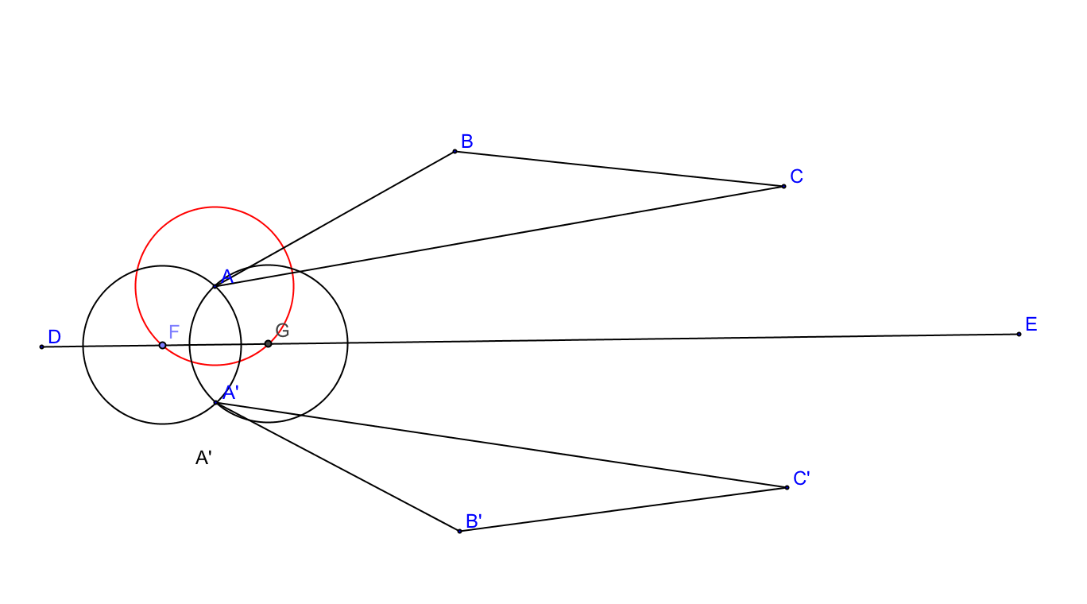

**MP.6**

*Things to consider:*

When you found the line of reflection earlier, you did this by constructing perpendicular bisectors of segments joining two corresponding vertices. How does the reflection you constructed above relate to your earlier efforts at finding the line of reflection itself? Why did the construction above work?

Example 5

Now try a slightly more complex figure. Reflect across line .

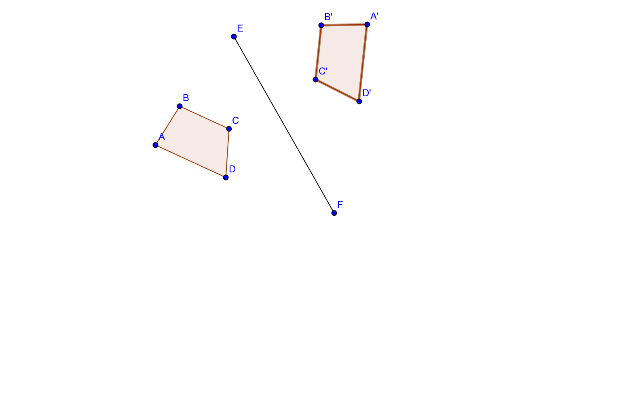

Lesson Summary

A reflection carries segments onto segments of equal length.

A reflection carries angles onto angles of equal measure.

Exit Ticket (3 minutes)

Name ___________________________________________________ Date____________________

Lesson 14: Reflections

Exit Ticket

1. Construct the line of reflection for the figures.

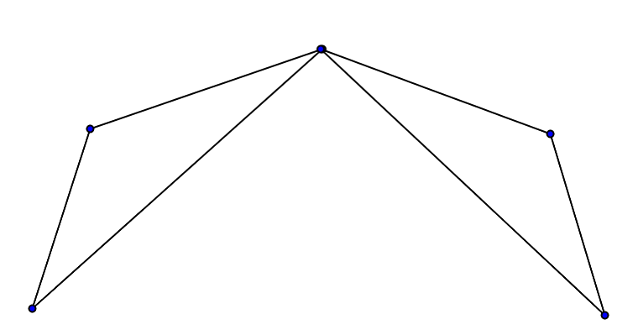

1. 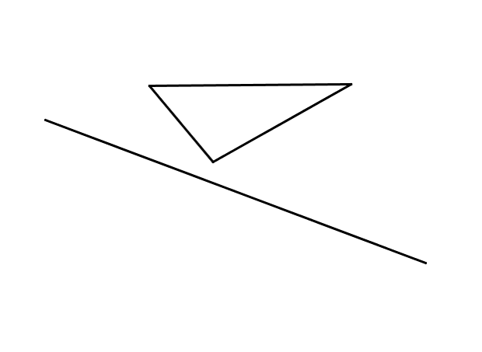Reflect the given figure across the line of reflection provided.

Exit Ticket Sample Solutions

1. Construct the line of reflection for the figures.

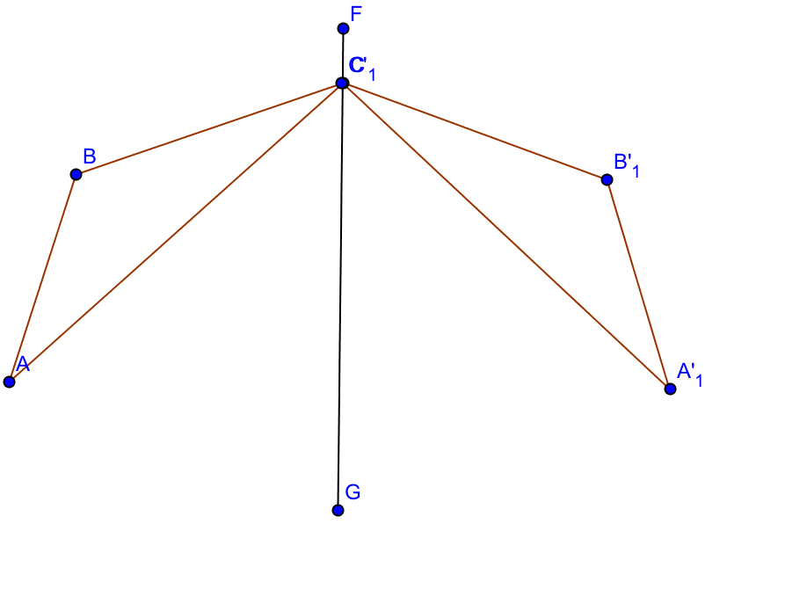

1. Reflect the given pre-image across the line of reflection provided.

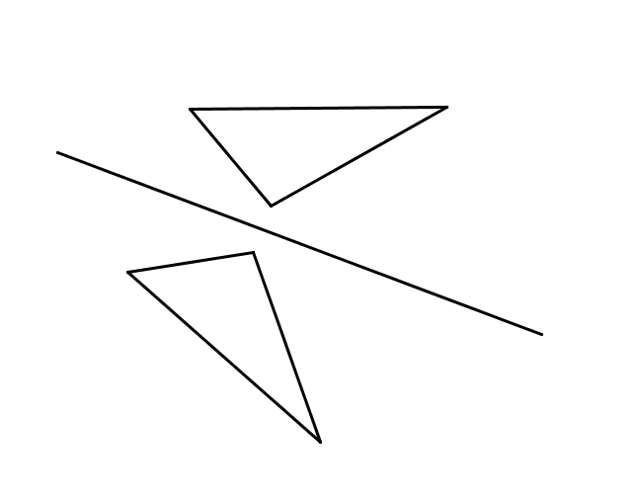

Problem Set Sample Solutions

Construct the line of reflection for each pair of figures below.

|  |  |
| --- | --- |
| ’ |  |

|  |  |
| --- | --- |
|  | 1. Reflect the given pre-image across the line of reflection provided. |

1. Draw a triangle . Draw a line through vertex so that it intersects the triangle at more than just the vertex. Construct the reflection across .

Answers will vary.

