Lesson 13: Rotations

Classwork
Opening Exercise
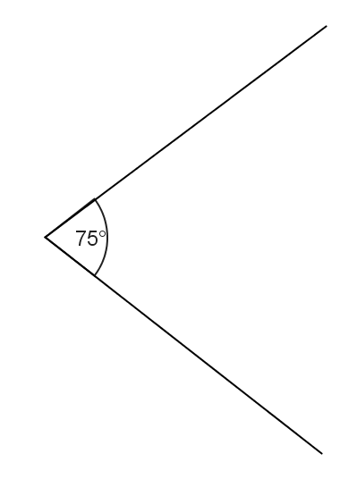
You will need a pair of scissors and a ruler.
Cut out the $75°$ angle at the right and use it as a guide to rotate the figure below $75°$ counterclockwise around the given center of rotation (Point $P$).
- Place the vertex of the $75°$ angle at point $P$.
- Line up one ray of the $75°$ angle with vertex $A$ on the figure. Carefully measure the length from point $P$ to vertex $A$.
- Measure that same distance along the other ray of the reference angle, and mark the location of your new point, $A'$.
- Repeat these steps for each vertex of the figure, labeling the new vertices as you find them.
- Connect the six segments that form the sides of your rotated image.

Discussion
First, we need to talk about the direction of the rotation. If you stand up and spin in place, you can either spin to your left or spin to your right. This spinning to your left or right can be rephrased using what we know about analog clocks: spinning to your left is spinning in a counterclockwise direction and spinning to your right is spinning in a clockwise direction. We need to have the same sort of notion for rotating figures in the plane. It turns out that there is a way to always choose a “counterclockwise half-plane" for any ray: The counterclockwise half-plane of a ray $CP$ is the half-plane of $\overset{⃡}{CP}$ that lies to the left as you move along $\vec{CP}$ in the direction from $C$ to $P$. (The “clockwise half-plane” is then the half-plane that lies to the right as you move along $\vec{CP}$ in the direction from $C$ to $P$.) We use this idea to state the definition of rotation.
For $0°<θ<180°$, the rotation of $θ$ degrees around the center $C$ is the transformation $R_{C,θ}$ of the plane defined as follows:
- For the center point $C$, $R_{C,θ}\left(C\right)=C$, and
- For any other point $P$, $R_{C,θ}\left(P\right)$ is the point $Q$ that lies in the counterclockwise half-plane of $\vec{CP}$, such that $CQ=CP$ and $m∠PCQ=θ°$.
A rotation of $0$ degrees around the center $C$ is the identity transformation, i.e., for all points $A$ in the plane, it is the rotation defined by the equation $R_{C,0}(A)=A$.
A rotation of $180°$ around the center $C$ is the composition of two rotations of $90°$ around the center $C$. It is also the transformation that maps every point $P$ (other than $C$) to the other endpoint of the diameter of circle with center $C$ and radius $CP$.
Let’s examine that definition more closely.
- A rotation leaves the center point $C$ fixed. $R_{C,θ}\left(C\right)=C$ states exactly that. The rotation function $R$ with center point $C$ that moves everything else in the plane $θ°$, leaves only the center point itself unmoved.
- For every other point $P$, every point in the plane moves the exact same degree arc along the circle defined by the center of rotation and the angle $θ°$.
- Found by turning in a counterclockwise direction along the circle from $P$ to $Q$, such that $m∠QPC=θ°$—all positive angle measures $θ$ assume a counterclockwise motion; if citing a clockwise rotation, the answer should be labeled with “CW”$.$
- $R_{C,θ}\left(P\right)$ is the point $Q$ that lies in the counterclockwise half-plane of ray $\vec{CP}$ such that $CQ=CP$. Visually, you can imagine rotating the point $P$ in a counterclockwise arc around a circle with center $C$ and radius $CP$ to find the point $Q$.
- $m∠PCQ=θ°$ — the point $Q$ is the point on the circle with center $C$ and radius $CP$ such that the angle formed by the rays $\vec{CP}$ and $\vec{CQ}$ has an angle measure $θ°$.
A composition of two rotations applied to a point is the image obtained by applying the second rotation to the image of the first rotation of the point. In mathematical notation, the image of a point $A$ after “a composition of two rotations of $90°$ around the center $C$” can be described by the point $R_{C,90}\left(R_{C,90}\left(A\right)\right)$. The notation reads, “Apply $R_{C,90}$ to the point $R_{C,90}\left(A\right)$.” So, we lose nothing by defining $R_{C,180}(A)$ to be that image. Then, $R_{C,180}\left(A\right)=R_{C,90}\left(R_{C,90}\left(A\right)\right)$ for all points $A$ in the plane.
In fact, we can generalize this idea to define a rotation by any positive degree: For $θ°>180°$, a rotation of $θ°$around the center $C$ is any composition of three or more rotations, such that each rotation is less than or equal to a $90°$ rotation and whose angle measures sum to $θ°$. For example, a rotation of $240°$ is equal to the composition of three rotations by $80°$ about the same center, the composition of five rotations by $50°$,$50°$,$50°$,$50°$, and $40°$ about the same center, or the composition of $240$ rotations by $1°$ about the same center.
Notice that we have been assuming that all rotations rotate in the counterclockwise direction. However, the inverse rotation (the rotation that “undoes” a given rotation) can be thought of as rotating in the clockwise direction. For example, rotate a point $A$ by $30°$ around another point $C$ to get the image $R_{C,30}\left(A\right)$. We can “undo” that rotation by rotating by $30°$ in the clockwise direction around the same center $C$. Fortunately, we have an easy way to describe a “rotation in the clockwise direction.” If all positive degree rotations are in the counterclockwise direction, then we can define a negative degree rotation as a rotation in the clockwise direction (using the clockwise half-plane instead of the counterclockwise half-plane). Thus, $R_{C,-30}$ is a $30°$ rotation in the clockwise direction around the center $C$. Since a composition of two rotations around the same center is just the sum of the degrees of each rotation, we see that
$$R_{C,-30}\left(R_{C,30}\left(A\right)\right)=R_{C,0}\left(A\right)=A\text{,}$$
for all points $A$ in the plane. Thus, we have defined how to perform a rotation for by any number of degrees—positive or negative.
As this is our first foray into close work with rigid motions, we emphasize an important fact about rotations. Rotations are one kind of rigid motion or transformation of the plane (a function that assigns to each point $P$ of the plane a unique point $F(P)$) that preserves lengths of segments and measures of angles. Recall that Grade 8 investigations involved manipulatives that modeled rigid motions (e.g., transparencies) because you could actually see that a figure was not altered, as far as length or angle was concerned. It is important to hold onto this idea while studying all of the rigid motions.
Constructing rotations precisely can be challenging. Fortunately, computer software is readily available to help you create transformations easily. Geometry software (such as Geogebra) allows you to create plane figures and rotate them a given number of degrees around a specified center of rotation. The figures below were rotated using Geogebra. Determine the angle and direction of rotation that carries each pre-image onto its (dashed-line) image. Assume both angles of rotation are positive. The center of rotation for the Exercise 1 is point $D$ and for Figure 2 is point $E$.

Exercises 1–3

To determine the angle of rotation, you measure the angle formed by connecting corresponding vertices to the center point of rotation. In Exercise 1, measure $∠AD'A'$. What happened to $∠D$? Can you see that $D$ is the center of rotation, therefore, mapping $D'$ onto itself? Before leaving Exercise 1, try drawing $∠BD'B'$. Do you get the same angle measure? What about $∠CD'C'$?

Try finding the angle and direction of rotation for Exercise 2 on your own.
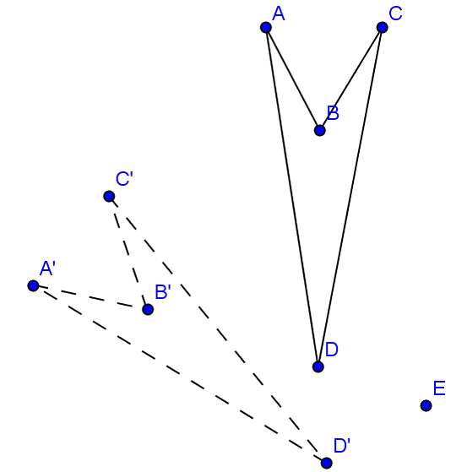

Did you draw $∠DED'$ or $∠CEC'$?

Now that you can find the angle of rotation, let’s move on to finding the center of rotation. Follow the directions below to locate the center of rotation taking the figure at the top right to its image at the bottom left.

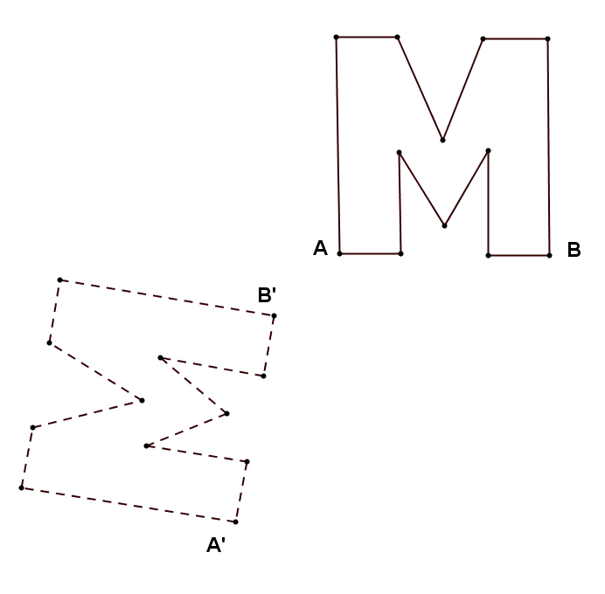

- Draw a segment connecting points $A$ and $A'$.
- Using a compass and straightedge, find the perpendicular bisector of this segment.
- Draw a segment connecting points $B$ and $B'$.
- Find the perpendicular bisector of this segment.
- The point of intersection of the two perpendicular bisectors is the center of rotation. Label this point $P$.

Justify your construction by measuring angles $∠APA'$ and $∠BPB'$. Did you obtain the same measure?

Exercises 4–5
Find the centers of rotation and angles of rotation for Exercises 4 and 5.
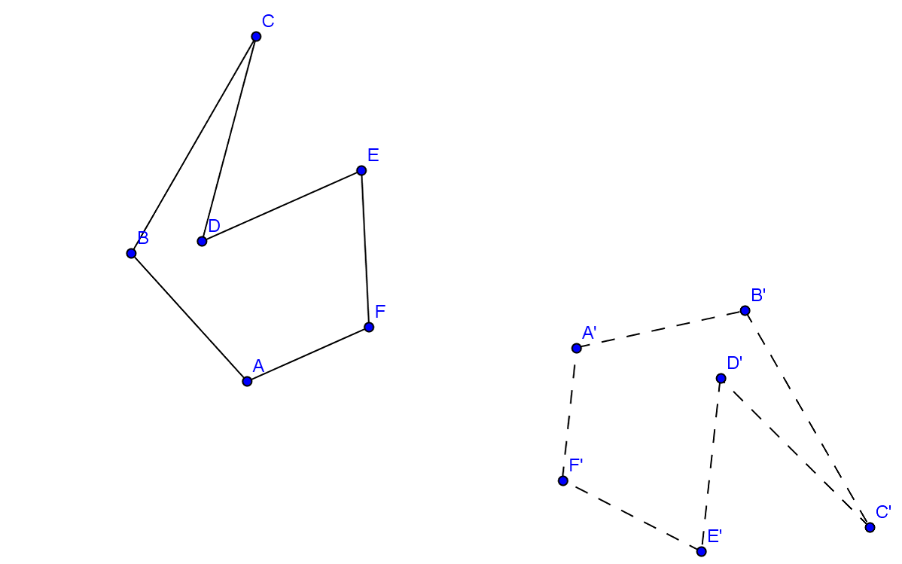

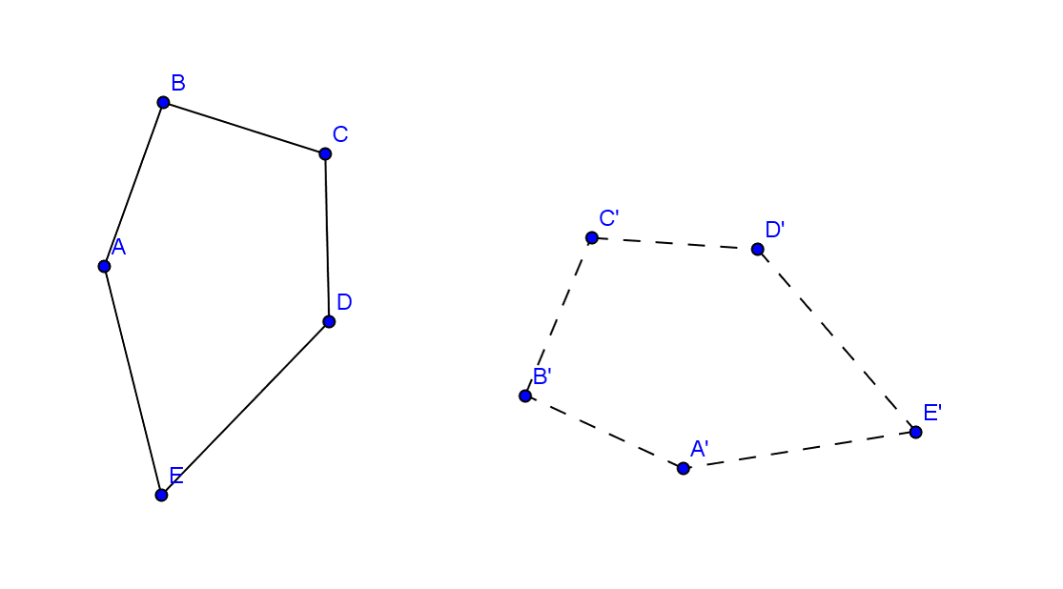

Lesson Summary
A rotation carries segments onto segments of equal length.
A rotation carries angles onto angles of equal measure.

Problem Set

- Rotate the triangle $ABC$ $60°$ around point $F$ using a compass and straightedge only.
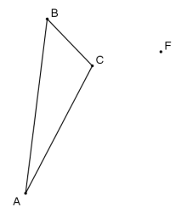

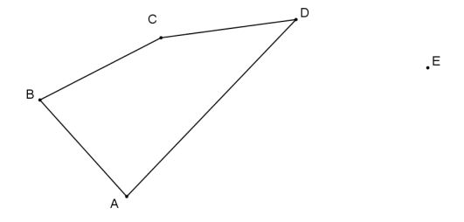
- Rotate quadrilateral $ABCD$ $120°$ around point $E$ using a straightedge and protractor.

- On your paper, construct a $45°$ angle using a compass and straightedge. Rotate the angle $180°$ around its vertex, again using only a compass and straightedge. What figure have you formed, and what are its angles called?

- Draw a triangle with angles $90°$, $60°$, and $30°$ using only a compass and straightedge. Locate the midpoint of the longest side using your compass. Rotate the triangle $180°$ around the midpoint of the longest side. What figure have you formed?

- On your paper, construct an equilateral triangle. Locate the midpoint of one side using your compass. Rotate the triangle $180°$ around this midpoint. What figure have you formed?
- Use either your own initials (typed using WordArt on a word processor) or the initials provided below. If you create your own WordArt initials, copy, paste, and rotate to create a design similar to the one below. Find the center of rotation and the angle of rotation for your rotation design.

